**Minke Whale detector instructions**

X.Mouy – 2023-09-07

**Setting up the detector (only needs to be done once)**

1. Download and install Anaconda for Windows

<https://www.anaconda.com/>

1. Download the script and demo data from the Google Drive
   1. Go to : <https://drive.google.com/drive/folders/1uVlE1WU_3S4gcyYmZabHwTAdrq67jiZI?usp=drive_link>
   2. Download the entire folder “Minke_detector”. Make sure the path of this folder on your machine has no special characters or spaces.
   3. You should have the following folder structure:  
      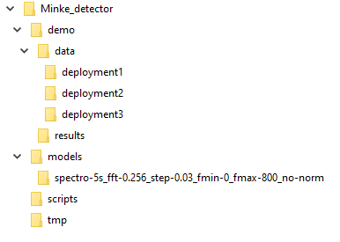
2. Create a new python environment:
   1. Open Anaconda Navigator
   2. Click on the “Environments” tab on the left panel (1)
   3. Click on the “Create” button at the bottom of the window (2)
   4. In the dialog window, name the new environment “ketos-env”, select python 3.9, then click the “create ” (3).
   5. After a few seconds the environment “ketos-env” will appear in the list of environments in Anaconda Navigator (4)  
      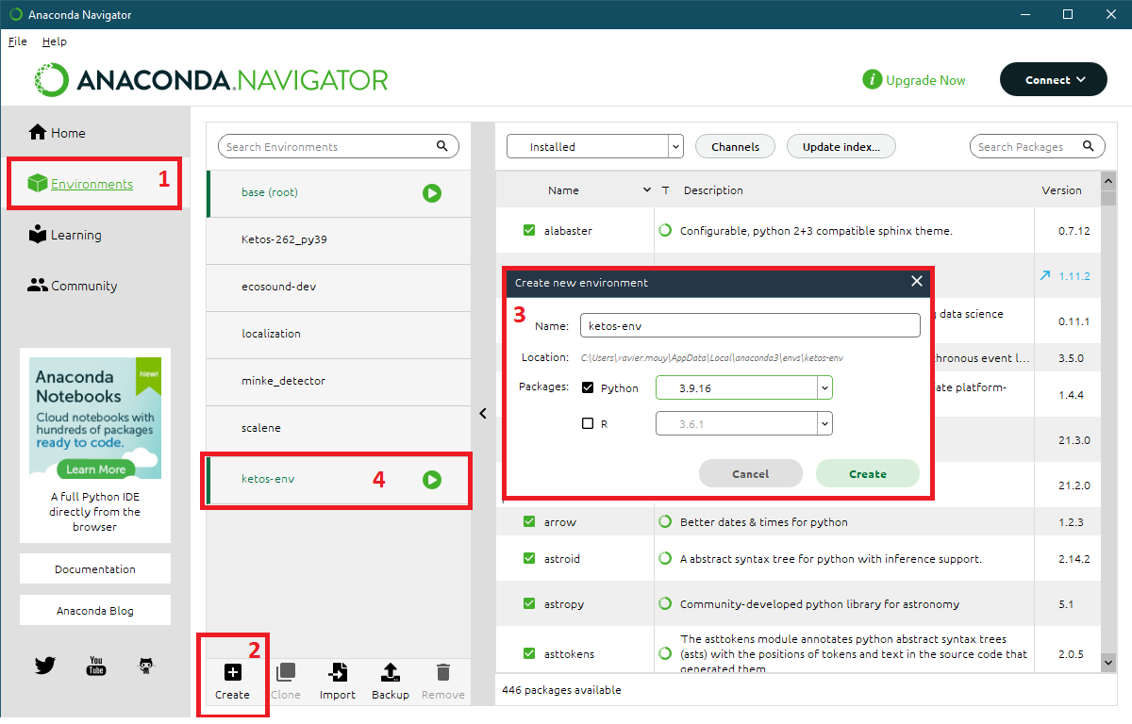
3. Install required libraries to the python environment:
   1. Click the green button on the right side of the “ketos-env” environment (1)
   2. Select “Open Terminal” (2) and a terminal window will open (3)  
      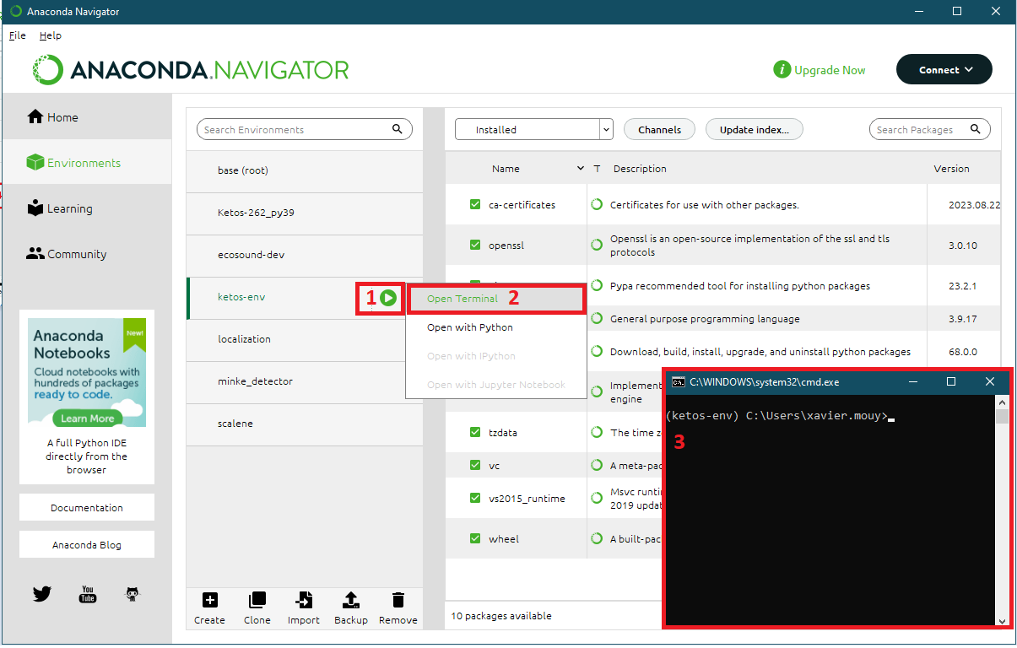
   3. In the terminal window, type the following commands sequentially (one line at a time). Note that if may take several seconds or minutes after each command

pip install soundfile>0.10

pip install ketos==2.6.2

pip install ecosound==0.0.23

pip install pandas==2.0.2

**Running the detector**

1. Create a batch file for the deployment to process
   1. Make a copy of the *job_script_template.bat* file located in the detector *scripts* folder and open it with a text editor like NotePad++

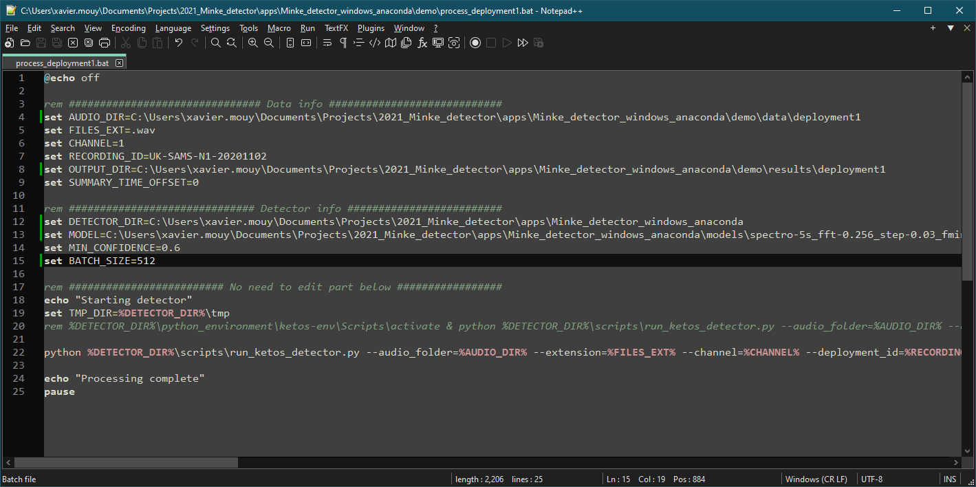

* 1. Edit the file and change the different parameters required. The first section of the file (“data info”) needs to be change for each deployment. The second section is specific to the location of the detector on your machine and of the threshold to use. Consequently this section will most likely only need to be edited the first time you use the detector and can be kept the same thereafter. The last section of the file does not need to be edited.

Here are the different deployment specific parameters:

* AUDIO_DIR: Path of the audio data to analyze. Any subfolders will also be analyzed.
* FILES_EXT: Extension of the audio files to analyze (e.g., .wav)
* CHANNEL: Define the audio channel to analyze (e.g., 1)
* RECORDING_ID: A unique ID for the deployment being analyzed (e.g., UK-SAMS-N1-20201102).
* OUTPUT_DIR: Path of the folder where the detection results will be saved. If the folder does not exist, it will be automatically created.
* SUMMARY_TIME_OFFSET: Time offset (in hours) to use for the daily detection summaries. Can be positive or negative number. For example, it would need to be set to -5 to obtain daily summaries in local time for data collected in Cape Cod and recorded with a UTC timestamp.

Here are the detector specific parameters:

* DETECTOR_DIR: Path of the “Minke_detector” folder
* MODEL: Path of the classification model to use. Models ate the files ketos_model.kt in the “models” subfolder of the “Minke_detector” folder.
* MIN_CONFIDENCE: Minimum confidence threshold for detections. Values between 0 and 1.
* BATCH_SIZE: Number of spectrogram snippets to process at the same time. Large values will make the processing faster but may cause memory issues. Suggest starting high (e.g. 1024), and decrease progressively if memory errors occur (e.g., 512, 256, etc.)

1. Start the detector
   1. In Anaconda Navigator, click the green button on the right side of the “ketos-env” environment (1), select “Open Terminal” (2) and a terminal window will open (3)  
      
   2. Change the current directory to the location of the .bat file using the *cd* command. For example: *cd C:\Users\xavier.mouy\Documents\Minke_detector\demo*
   3. Type the name of the .bat file to run. For example: *process_deployment1.bat*
   4. The processing will start and the results will be save in the OUTPUT_DIR folder defined in the .bat file.