Compete against AWS Sagemaker AI in a BattleSnake video game

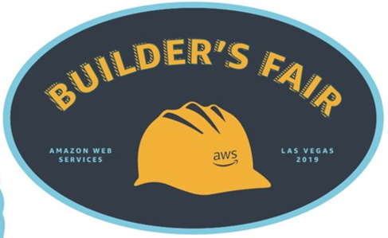*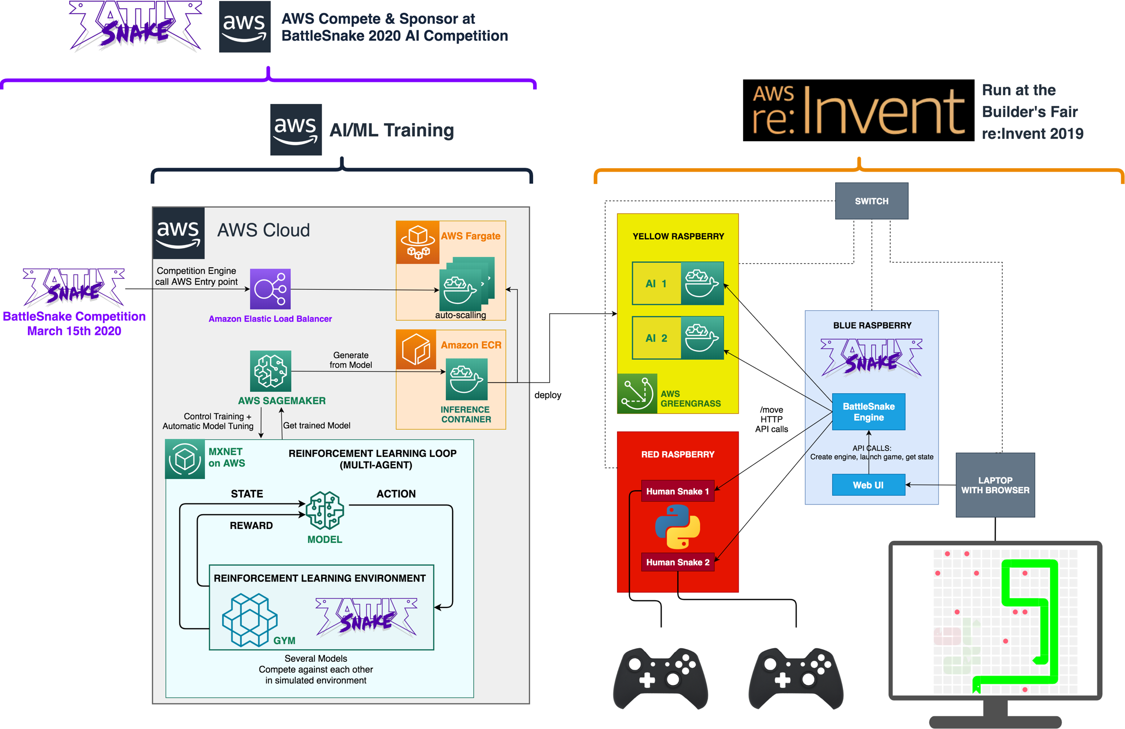*

*Can you beat the machine?*

About

BattleSnake is an international AI competition.

All snakes in the game are control by an AI

AWS is a Sponsor of the event and competitor in the Sponsor category

AWS MXNet Team have built a snake AI with Sagemaker for the competition

For the re:Invent 2019 Builder’s Fair AWS Solutions Architect have created “human snakes” controlled by a game pad and created the first human/AI BattleSnake compete environment