User Interface Design

for

North Shore Extension

Version 1.0 approved

Prepared by Garrett Grube, Jeff Deely, Ritesh Misra, Spencer Worms, Xavier Torgerson

Blue Team

9/24/2016

Table of Contents

Table of Contents ii

Revision History ii

1. Introduction 1

1.1 Purpose 1

2. User Interface Design 1

2.1 CTC Office 1

2.2 Track Controller 1

2.3 Track Model 3

2.4 Train Model 3

2.5 Train Controller 4

Revision History

|  |  |  |  |
| --- | --- | --- | --- |
| **Name** | **Date** | **Reason For Changes** | **Version** |
| Garrett Grube | 9/24/16 | Document Created | 1.0 |
| Garrett Grube | 9/25/16 | Added Train Controller section | 1.1 |
| Jeff Deely | 9/27/16 | Fixed Train Controller Section | 1.2 |
| Spencer Worms | 9/28/16 | Added Train Model Section | 1.3 |
|  |  |  |  |

# Introduction

## Purpose

The purpose of this document is to detail the user interface design of the North Shore Extension project software. This document will include an image of each UI, and describe it.

# User Interface Design

## CTC Office

### Intended User

### Screenshot

### Description

## Track Controller

### Intended User

### Screenshot

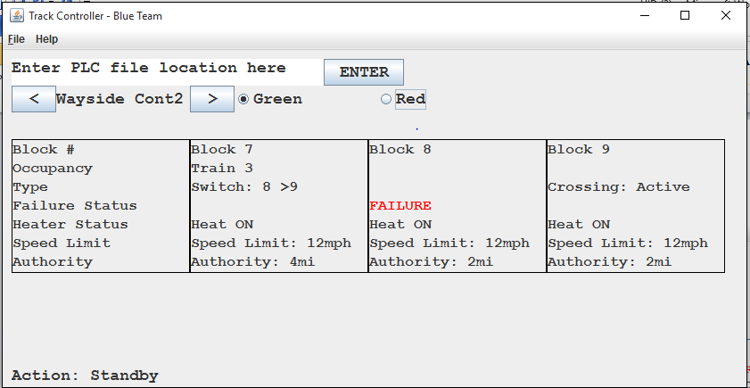

A:

B:

C:

D:

E:

### Description

There are 5 sections of the UI labeled on the screenshot. Each has their own components and functionality

#### Section A: Menu Bar

Consists of two pull down menus, “File” and “Help”

Displays file and help menus when clicked on

#### Section B: PLC Updater

Allows user to enter PLC code from their computer into the wayside controller

Consists of the “PLC text box” and the “enter button”

#### PLC test box

The PLC code’s file location is entered into the “PLC text box”

When the “enter button” is pressed the wayside controller will find the PLC code and save it into its memory

If the PLC code’s file location does not exist, then an error message will appear on the text box

#### Section C: Wayside Controller Selector

Used to select which wayside controller, will be viewed

Consists of the “Section Label” and two buttons, “Next section Button (>)” and “Previous Section Button (<)”

##### Section Label

displays the current wayside controller being viewed

##### Next Section Button

Loads in the next wayside controller for viewing, the next controller being the one that controls the section an inbound train will go into next

##### Previous Section Button

Loads in the previous wayside controller for viewing, the previous controller being the one that controls the section an outbound train will go into next

##### Line Buttons

Switch between red and green line by clicking on one of these buttons. These buttons allow for quick switching between wayside controllers of one line and another.

#### Section D: Block Display

Displays the internal variables for each block within the wayside controller’s section of track blocks

Displays blocks in order of a train moving from right to left while going in the inbound direction

Consists of individual “Block Panels”

#### Block Panels

Each Block Panel consists of labels displaying the following:

##### Block Number

the number assigned to the block by the track model

##### Occupancy

displays information about track occupancy

If there is a train it displays that trains’ number

If there is no train, then it is blank

##### Type

displays what type of track is located on this block

If the block is just track, then the label is blank

Each type track has two different states (except for station), by clicking on a block with a type value it will switch from one state to the other

If the block contains a railroad crossing then the label displays “crossing” and the current state of the crossing, either “inactive” or “active”

If the block contains a station, then the label displays “Station”

If the block contains a switch, then the label displays “Switch” and two numbers indicating which tracks the switch connects to

The number with a “>” before it is the block the switch track is connected to

If the block contains a light then the label displays “Light” and the current state of the light, either “Green” or “Red”

##### Failure Status

failure status for a given track block

If the track is working properly the label is blank

If there is a failure detected, then the label displays a red “FAILURE”

##### Heater Status

the state of a blocks track heater, is either “ON” or “OFF”

##### Speed Limit

the speed limit for a train on a given section of track, received from the CTC office

##### Authority

the maximum authority of a train on a given section of track, received from the CTC office

#### Section E: Current Action Label

Display’s what the wayside controller is doing at any given time

Consists of the “current action label”

## Track Model

### Intended User

### Screenshot

### Description

## Train Model

### Intended User

The intended user of the Train Model is the passengers or testers of the train model.

### Screenshot

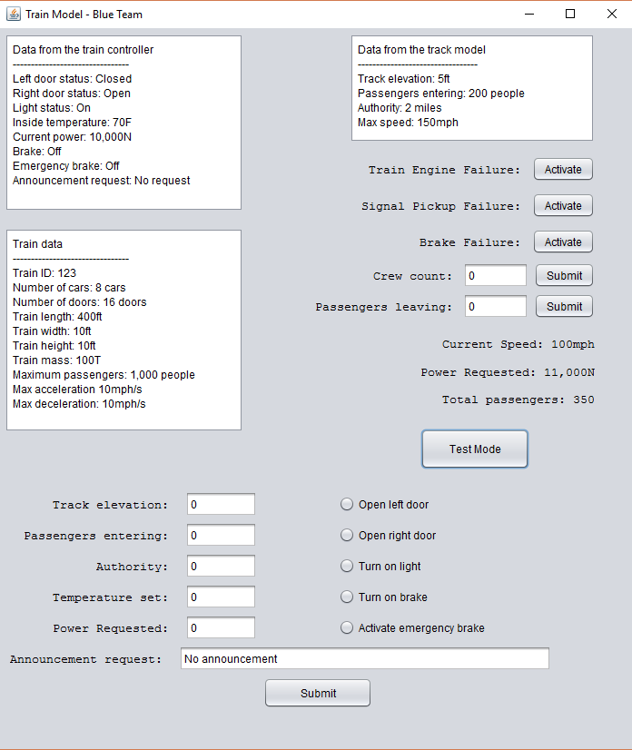

### Description

The train model consists of three main sections, a section for general data, a section for important data and user inputs, and a test section.

#### General Data Area

This is the three white boxes displaying all the general data received from the other modules and the train constants.

##### Data from the train controller

Important data received from the train controller is displayed in the top right most box. This data includes if either or both of the doors of the trains are open, if the lights are on or off in the train, the inside temperature of the train, the current power of the train, any of the brakes and emergency brakes, and any announcements requested from the train model.

##### Data from the track model

Important data received from the train controller is displayed in the top right most box. This data includes the track elevation, passengers entering the train from the station, the max speed of the train and the authority of the train.

##### Train data

Important data about the train is displayed in this area. This includes the train ID, the number of cars, the number of doors, the train length, width, height, mass, the maximum passengers, maximum acceleration, and maximum deceleration.

#### Important Data and User Inputs

In this section, there are buttons to allow the user to simulate failures of the train and any user inputs to the train. There is also the most important data about the train in this section.

##### Simulate train failures

This section allows the user to simulate any failures that will be present in the actual train. This includes any failures for the train engine, signal pickup failures, and brake failures.

##### User inputs to the train

This section includes any user inputs to the train. These inputs are the total amount of crew on the train and the passengers leaving the train currently.

##### Important train data

This section includes the most important data about the train. These pieces of data are the current speed of the train, the power request of the train, and the total amount of passengers on the train.

#### Test Mode

There is a button called test mode that opens a new section that allows the user to alter the data of the train model, without connecting it to the rest of the modules. This includes all the inputs from the train model and the track model.

## Train Controller

### Intended User

The train controller is designed to be used by a transit operator.

### Screenshot

### Description

The train controller consists of three main components: a central text area, and two control panels.

#### Central Text Area

The text area displays notification to the transit operator. It can be scrolled, but cannot be edited.

#### Vehicle Panel

This panel contains controls and statuses unrelated to the motion of the vehicle. It includes the Train ID box, Advertise button, Lights radio button group, Left Doors radio button group, Right Doors radio button group, and train mode button.

##### Train ID

Train identification is displayed in the box labeled “Train ID”, and uniquely names the train with an integer. This box can be edited to control a different train

##### Advertise

Advertise allows the transit operator to make announcements

##### Lights

The train lights can be turned off and on by clicking the radio button group labeled “Lights”. Clicking “fail” injects a light failure fault into the system

##### Left Doors

The train’s left doors can be controlled by clicking off and on by clicking the radio button group labeled “Left Doors”. Clicking “fail” injects a left door failure fault into the system

##### Right Doors

The train’s right doors can be controlled by clicking off and on by clicking the radio button group labeled “Right Doors”. Clicking “fail” injects a left door failure fault into the system

##### Train Mode

Train mode can be toggle between manual and automatic. By default, the train is in manual mode. To engage the automatic state, press the button labeled “Automatic”.

##### Vehicle Parameters

Clicking this button brings up a list of vehicle parameters in a separate window.

#### Motion Panel

This panel contains controls and statuses related to the motion of the vehicle. It includes the Speed Request box. Speed Request slider, Emergency Stop Button, Block Speed Limit box, Current Speed box, Current Power Box, and Set Point Box.

##### Speed Request

The speed request box displays the speed currently called for by the transit operator. This speed can be adjusted by moving the slider located directly below the “Speed Request” label.

##### Emergency Stop

The emergency stop button will bring the train to zero speed if pressed. This button should only be used in case of emergencies.

##### Block Speed Limit

The bock speed limit is display in the text box label “Block Speed Limit”

##### Current Speed

The current speed is displayed in the text box labeled “Current Speed”.

##### Current Power

The current power is displayed in the “Current Power” box and can be indirectly controlled by adjusting the “Speed Request” slider.

##### Set Point

Each set point is uniquely described by an integer. The set point can be adjusted in the “Set Point” box by the transit operator.