Part A
Screenshots
Packet 72: Client Hello: initiating handshake
Packet 74: Server Hello: accepting handshake
Packet 76: Handshake finishes
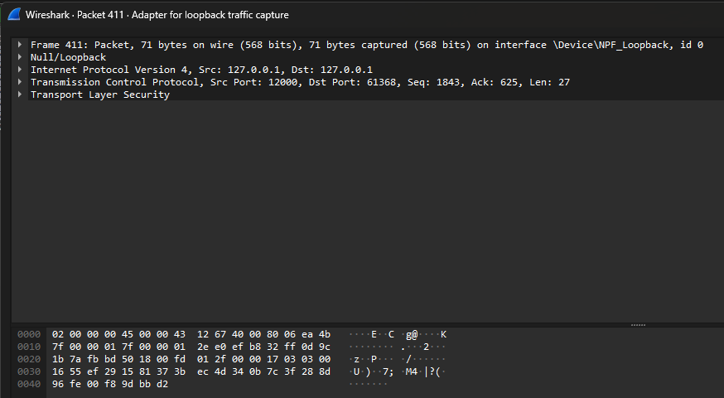
Packet 411: sent hello, but cannot see when viewing packet, unlike TCP where you can see

Part B
Client interaction with different entities:
- Server starts
  - The server starts and then creates context. It then loads the context with the appropriate certificate and keys, then creates a server socket. Then, the server wraps the socket with the context, and then is ready for a connection
- Client starts
  - The client starts and then creates a context, which is loaded with the appropriate certificate. It then creates a new client socket and wraps the client socket with the context, and then searches for a connection
- TCP handshake occurs
  - Once the client finds the server, it initiates a handshake with a SYN, then the server replies with a SYN-ACK, and then the client responds with an ACK
- TLS handshake occurs
  - After the TCP handshake occurs, the TLS handshake begins with the client sending a Client Hello message. The server responds with a Server Hello as well as its certificate, and then the client takes the certificate and compares it with its certificate for a match. Once the match is found, the TLS handshake finishes
- Connection finishes
  - The connection is finally initialized and finished when the TCP and TLS handshakes are complete
- Client sends a message
  - The client then sends an encrypted message to the server
- Server replies to message
  - The server receives the encrypted message, decrypts it, processes it, and sends a response to the client
- Client displays response
  - The client then receives the response and displays it on the screen, and then loops back to send another message
- Connection closes
  - Once the client sends exit, the connection closes on both the client and server side

How do TCP and TLS differ in their socket creation and setup?
- Both are similar for setup, but TLS requires context to be set up
- The server adds context (line 4), then loads the context with the server certificate and server key (line 5), then wraps the server socket with the context (line 9)
- The client adds context, then loads the context with the server certificate (line 5), then wraps the client socket with the context (line 7)
How do they handle connection reliability, ordering, and encryption?
- Reliability and ordering are similar, as TLS builds on top of TCP, but encryption differs as TLS adds encryption to messages sent, making the content unreadable, but TCP does not have encryption, so the messages sent are readable
What challenges did you face in implementing TLS?
- The biggest challenge I faced when implementing TLS was setting up OpenSSL, as well as the server certificate and server key. This was giving me issues for a bit but after it was set up properly, I had no more issues
- I also encountered an issue with sending blank messages, though I am unsure if this was present beforehand, so I addressed it
What are trade-offs when choosing TLS over TCP?
- Performance is affected due to the connection handshake and certificate checks, adding RTT’s and resources overhead. I noticed a longer connection time when setting up the server and then client to test the connection
- Code complexity also increases as you need to set up the context and wrap the sockets with context. In my code it only added a few lines, but this could be different for different applications
- Certificates are also needed, so setting these up and maintaining them adds more work. I had some difficulties setting them up but after that, they last for a year
Does TLS effectively address the security weaknesses you observed in TCP?
- TLS effectively addresses the issue of TCP sending data as plain, readable text, by encrypting the messages and packets sent so that they are not readable

