Xavi Gargallo Jane
E-commerce Project ( E-Digital Goods)

This project will be about an e-commerce site to sell digital goods and software and also
inform the user to the latest news about music technology, sound, effects etc...
This will be a real project for a friend who has designed and adapted several music sofware from Helix and another important makes between this field.

The designed will be a Business card website concept together with the online shop to purchase digital goods through a pay platform called Gumroad.

The project will also be extendible to sell more things in the long run if the website traffic increase
and SEO is working and making money for us.

Services of the Project
This web provides a point of technical information and news about music technology,Users will find this site searching through Google using keywords about music technology, tehchnical sounds

Also users will be able to buy digital goods through a pay platform called Gumtree.
This web will have to be extendible to adjust to new products to sell online.
The site also will provide with news and articles about music technology....

Other similar Projects
This are similar pages already published where we can study and get a feel of what we need to do, always tryig to do better than the competence in this area about music technology.

Visit links bellow:

- https://liine.net/en/products/lemur/premium/livecontrol-2/

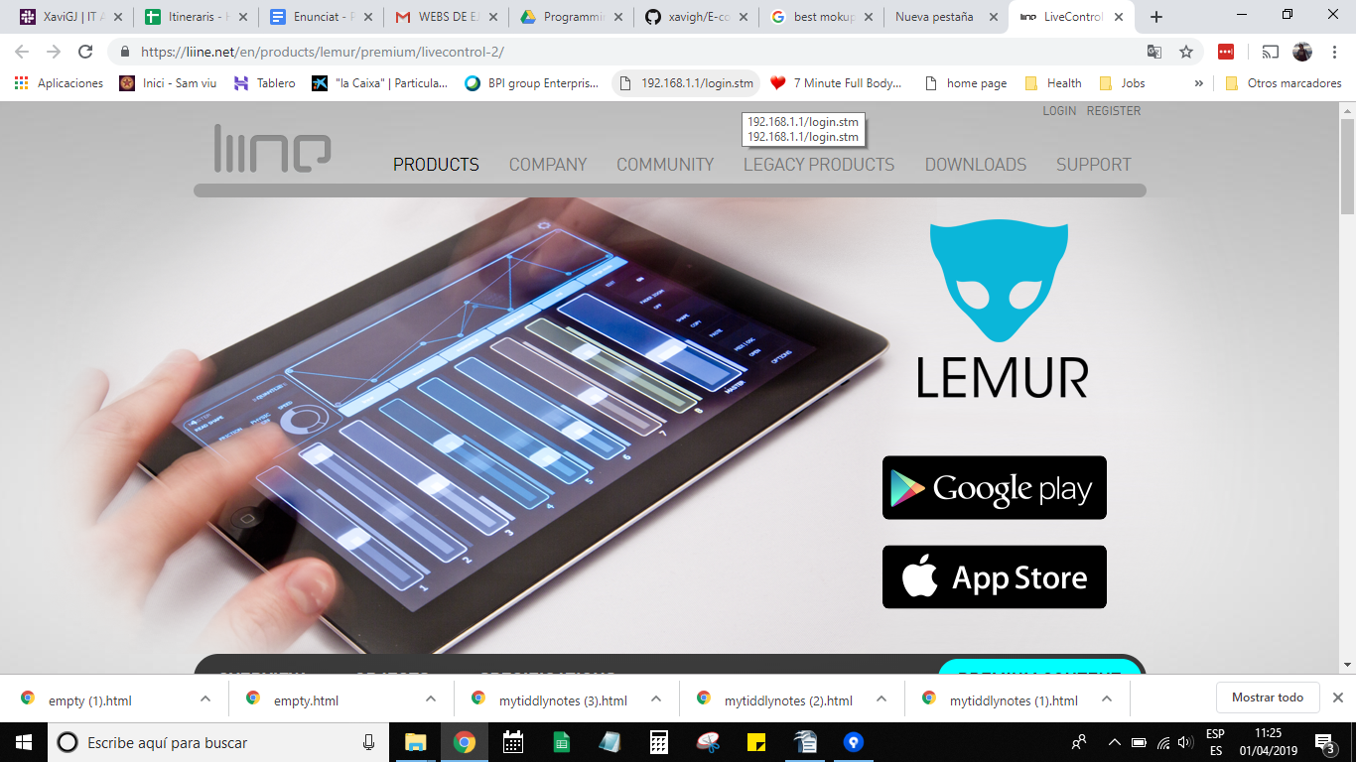

- https://line6.com/helix/

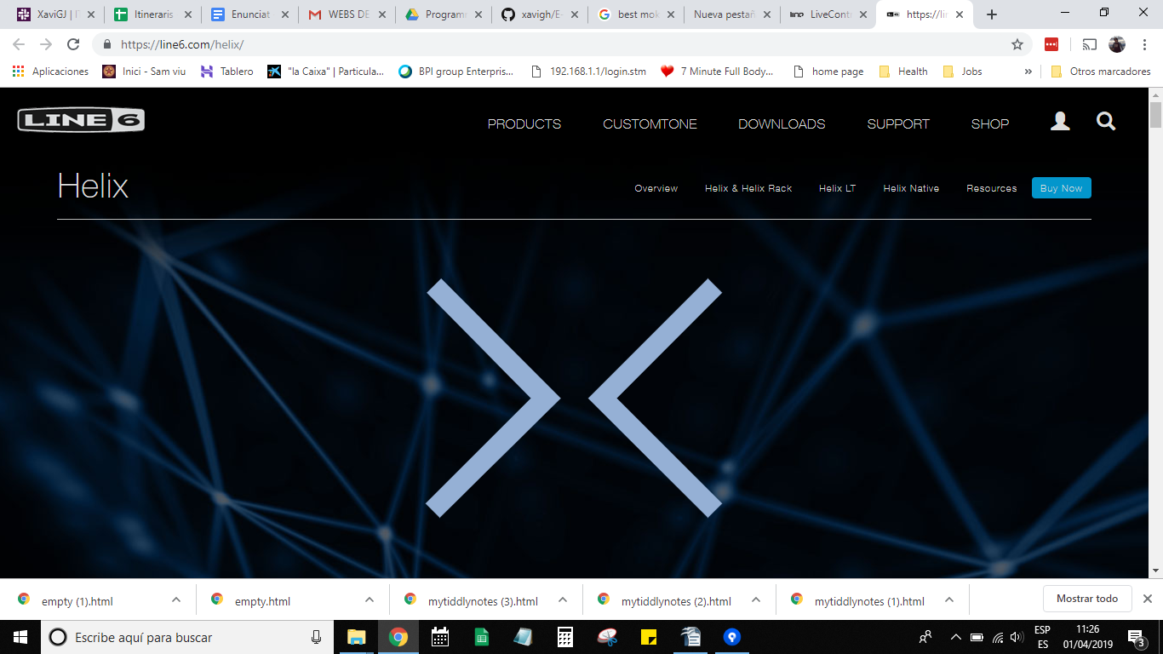

- https://www.sketch.com/

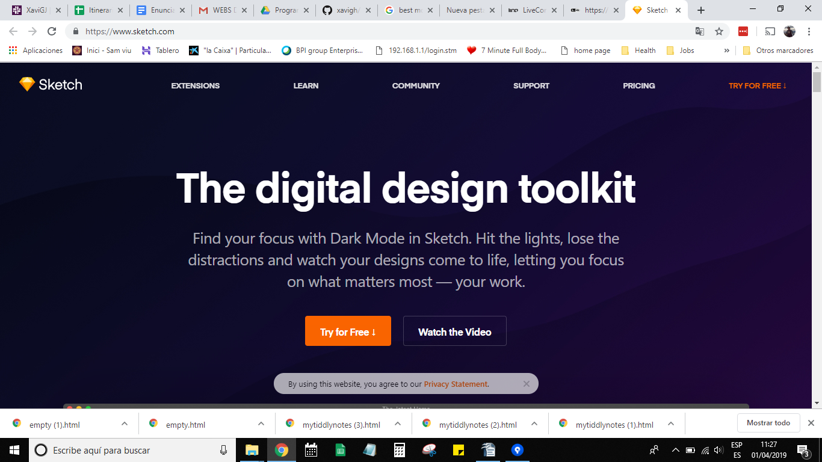

Paper Prototype
Make audience confortable in your site.
The site will have a standard navigation elements so the users are not lost when visiting the site.
The site should be integrated with accessibility for disable users, we are taking into account this group of people with a handfull of different dissabilities such as vision, earing....etc.
Useability and accessibility is not the same, Usability

