1. We shall run the server driver.
2. Run client driver and upload properties files, specified by file type.
3. 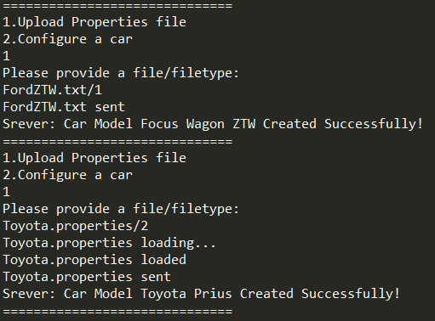
4. Add client project to Tomcat Server and run this server.
5. Open a web browser and do as follows:
6. 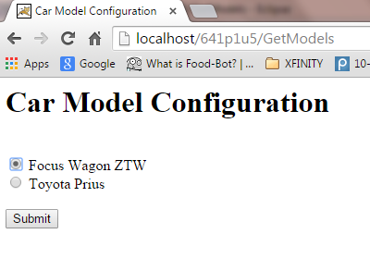
7. 