Project Proposal

CSCI 3300 – Software Engineering, Spring 2024

Registry Website

Team Number and Name: Team 6

Team Members: Brianna Bumpus, Lane Meadows, Xavier Woods

1. **Introduction**
   1. Opening Paragraph
      1. The CSCI 3300 Spring 2024 Team Project topic is to build a registry website that could directly compete with the preexisting website *www.myregistry.com*.
   2. Challenges
      1. The challenges for creating this team project are determining what technology stack is known by all team members and preferred to build the software, determining the scope of what is required to achieve an A on the project, and coordinating with all team members to work synchronously and asynchronously on project tasks.
      2. These challenges will be addressed by utilizing project planning methods to organize and distribute tasks, ensuring all planned specifications are accomplished in an incremental process.
      3. While all the team members are familiar with the HTML/CSS/JavaScript web development stack and databases, most members have limited knowledge of project tools like GitHub and Jira.
2. **Customer Need**
   1. The primary customer is Dr. Salimi and anybody who wishes to make a registry.
3. **Project Goals**
   1. The customer has expressed a need for a competitor to *myregistery.com*, our system aims to remedy this problem.
   2. Measures of Success
      1. We will know the if customer got their desired benefits from customer feedback over the course of the project/semester, and based on the grade we receive after submitting the finished product.
4. **System Description**
   1. 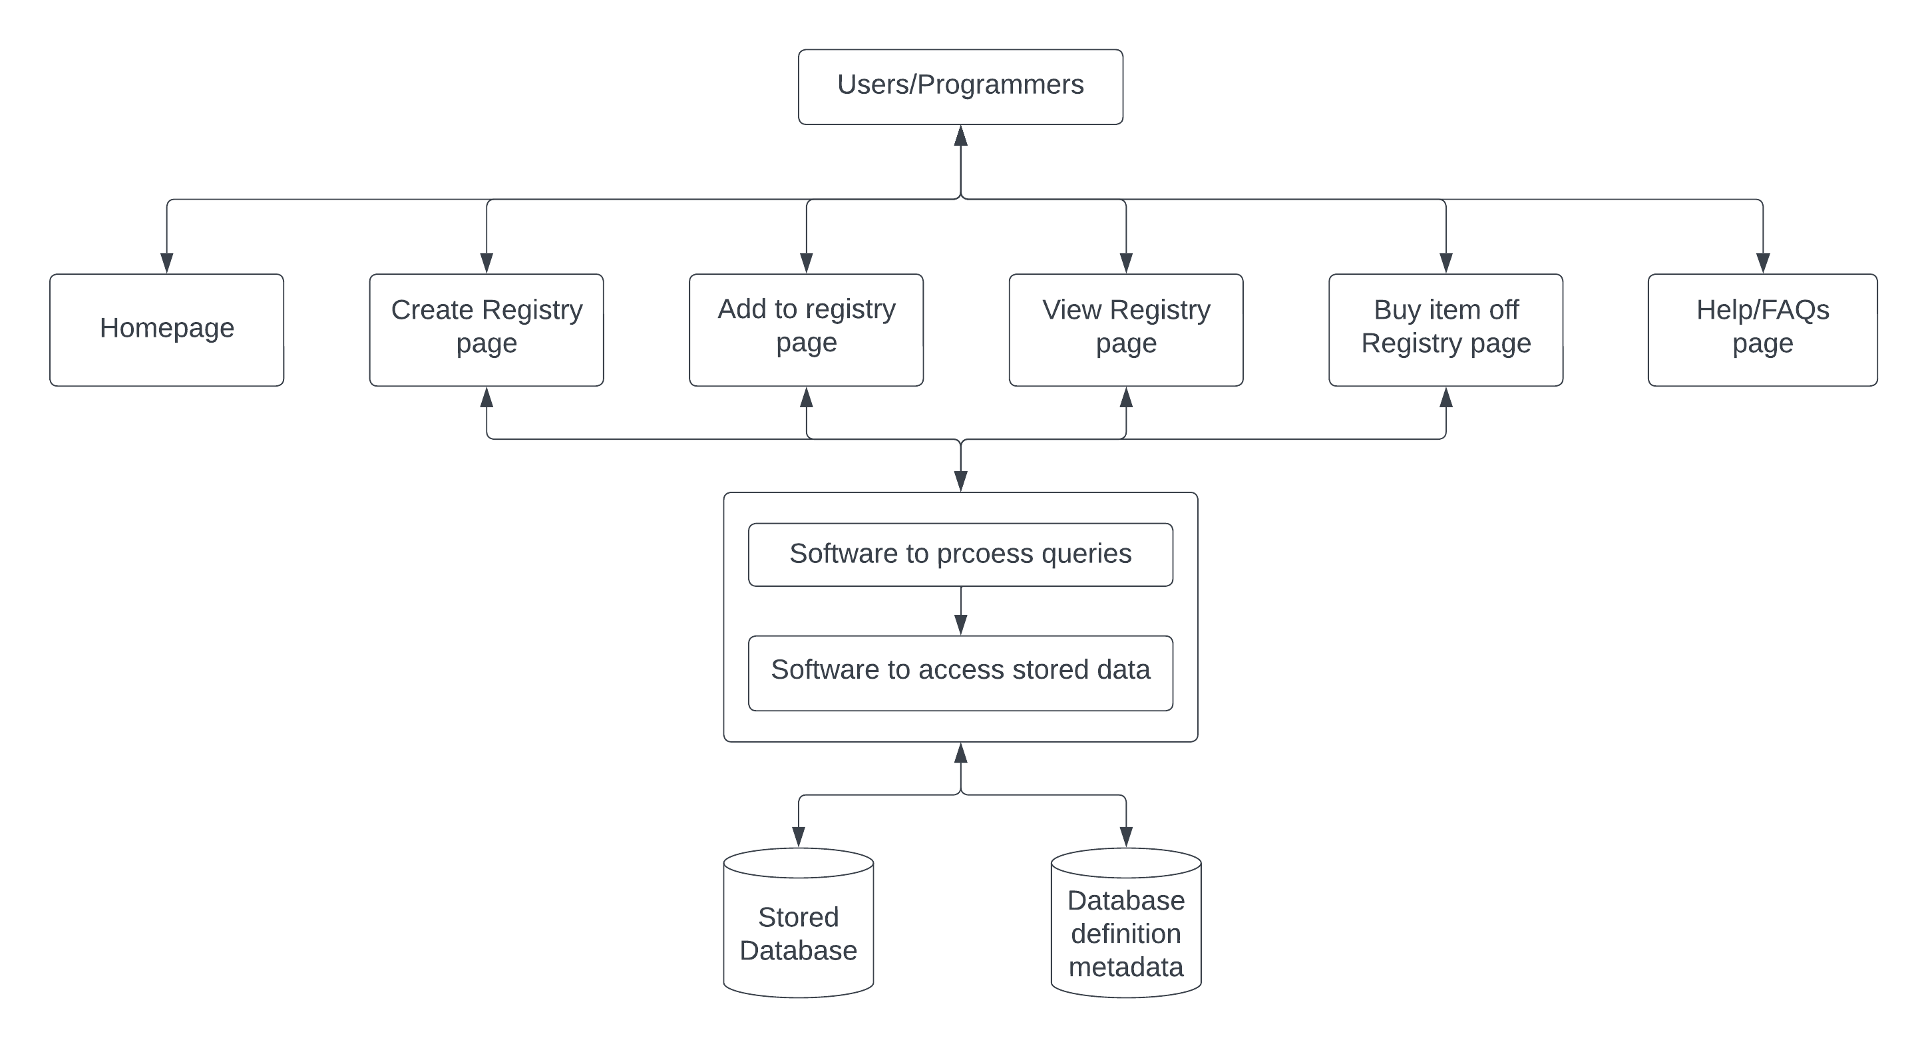
   2. Based on block diagram users will be able to interact with various pages such as the Homepage, a create registry page, an add to a registry page, a view a registry page, and a help/FAQs page. The pages then utilize DBMS to process queries and access data stored in a database.
   3. The main elements of the proposed system are an HTML-based front-end connected to a MySQL based back-end. Additionally, the system will provide the ability for a customer to create a registry, add items to the registry, and share the registry with friends and family.
5. **Solution Approach**
   1. The system will utilize a HTML, CSS, and JavaScript front-end connected to a MySQL backend to create a visually appealing customer-facing design that efficiently allows for the creation and modification of registries.
   2. Our system will be composed of HTML, CSS, JavaScript, NodeJS, MySQL, and SQL
   3. To test our system, we will utilize a test-driven development approach to test as we develop, this enables us to have better documentation and simpler debugging. In addition to this approach, we will also conduct unit testing, integration/component testing, and system testing. Unit testing will be used to positively and negatively test specific components of our code, such as methods/functions or classes. Integration/Component testing will be used to ensure interfaces and components of our system are behaving according to our desired specifications. Finally, system testing will be used to verify the components within our system are interacting with each other as desired.
6. **Project Management**
   1. Our team will utilize the Agile software development process.
   2. Given we don’t know the time constraints of the upcoming iteration, we can’t determine what stage the working system will be at, at the current date.
   3. The main features we will implement are, the ability to create a registry/wish list, add item links to the list, and the list will be stored in a database to allow for saving of data and future retrieval/viewing.
   4. Team Coordination
      1. We will distribute and coordinate the work by meeting frequently and planning ahead of time what needs completed.
      2. We will prioritize meeting in-person once a week, with the ability to for a team member to meet virtually should they be unable to meet in-person on campus.
      3. During the meeting we will begin by taking turns describing what we have completed and any problems we are experiencing, afterwards we will transition into planning for the future. We will determine what needs to be changed and/or completed before our next meeting and split the tasks evenly among all team members.
7. **Team**
   1. Backgrounds:
      1. Brianna Bumpus has experience with Java, Python, SQL, HTML, JavaScript, CSS, PHP, AWS, Git, JetBrains IDEs, VS Code, and various databases. Lane Meadows has experience with Java, HTML, SQL, CSS, JavaScript, Eclipse IDE, VS Code, and MySQL. Xavier Woods has experience with Java, SQL, HTML, CSS, Eclipse IDE, and MySQL.
      2. Brianna has gained experience working as an Intern Software Developer.
      3. None of the team members have built a project of this size and scope.
      4. Most members have little or no experience with GitHub and Jira, but all team members are familiar with the intended programming languages.
   2. Roles:
      1. Project Manager: Xavier Woods
      2. Scrum Master: Brianna Bumpus
      3. Developer: Lane Meadows
      4. Upon completion of project manager and scrum master duties, Xavier and Brianna will also participate in the development work.
8. **Constraints and Risks**
   1. A possible security constraint would be the protection of consumer data/registries. Most customers would likely prefer it if their registry was kept private from unwanted parties, and that their personal data was protected.
   2. Our team has access to all needed data, services, and resources.
9. **Updating the Footer**
   1. Filename is “CSCI3300_Team6_ProjectProposal_ver2.0.docx”