ARCHITECTURE & IMPLEMENTATION GUIDE

Process Intelligence
Knowledge Store
  - A governed knowledge graph and vector RAG architecture for SOPs, policies, BPMN models, journeys, and variants

REFERENCE IMPLEMENTATION
Version 2.0 | July 2026
Neo4j + Qdrant + FastAPI | Locally deployed and verified

Executive summary
The Process Intelligence Knowledge Store combines a governed Neo4j knowledge graph with Qdrant vector retrieval. Process is the central business object. Immutable document versions contain thin Chunk nodes that share their chunk_id with Qdrant. Governed Assertions connect exact evidence to approved facts, while one clean semantic edge is materialized per process/entity pair.
Core decision: The LLM is an extractor—not an ontology designer and not a Cypher author. It may propose only approved entities and relationships, and every proposal is validated by application code before persistence.

What the store answers
- Which policies and SOPs describe a process?
- Which controls govern it, and which documents provide evidence?
- Which systems, business units, and markets are connected to it?
- What does the approved BPMN model say should happen?
- Which journeys and variants are happening in production?
- Where do documented expectations and live execution diverge?

Design principles
Principle | Implementation
Process-centered | Process is the aggregate root and stable retrieval anchor.
Closed ontology | Labels and relationship triples are versioned and allow-listed.
Evidence-aware | Chunks support version-specific, governed assertions.
Hybrid retrieval | Graph facts provide precision; document vectors provide context.
Operationally connected | Journeys and variants use the same process identity.
Secure by construction | Document clearance filters apply to graph and vector results.

1. Architecture
The architecture separates stable business meaning from vector infrastructure without disconnecting them. Neo4j stores entities, immutable versions, thin chunks, assertions, and materialized facts. Qdrant stores chunk text and embeddings under the identical chunk_id. The API joins them through graph-scoped, fixed-intent retrieval.

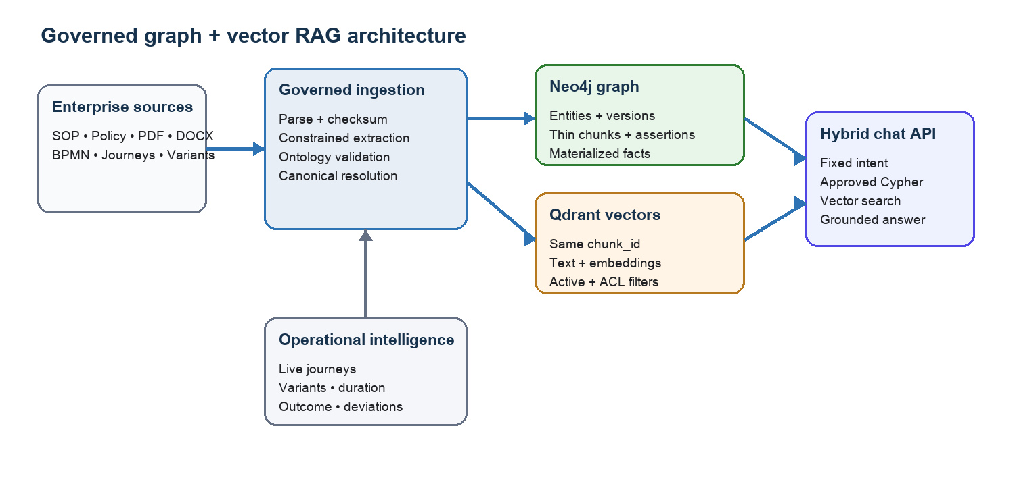
Figure 1. Governed knowledge graph and vector RAG architecture

Store responsibilities
Store | What it contains | Why
Neo4j | Process, versions, thin chunks, assertions, entities, BPMN, journeys | Meaning, provenance, lifecycle, authorization scope, and traversal
Qdrant | Chunk text, embeddings, and replicated filter metadata | Fast semantic retrieval using the same chunk_id as Neo4j
Object storage (production) | Immutable source binaries | Retention, legal hold, integrity, and reprocessing

Chunk-storage trade-offs
Approach | Advantages | Disadvantages
Vector-only chunks | Simple ingestion and a smaller graph | Application-side joins, weaker lineage, and harder lifecycle audits
Text and vectors in Neo4j | One physical store and direct traversal | Graph bloat, mixed workloads, and expensive re-embedding
Direct MENTIONS edges | Easy mention exploration | Dense, noisy edges; a mention does not prove a business fact
Thin Chunk + Assertion | Precise provenance, clean semantics, scalable vector search | Requires cross-store activation, compensation, and reconciliation

Recommended pattern: Use thin Chunk nodes and governed Assertions in Neo4j, keep text and embeddings in Qdrant, and join them with the same deterministic chunk_id.

2. Governed ontology
The ontology is intentionally small. Artifact and operational nodes come from deterministic parsers and APIs. Document LLM extraction may create only Market, BusinessUnit, Control, and System entities.
Source | Approved relationship | Target
Process | HAS_DOCUMENT | Document
Document | HAS_VERSION | DocumentVersion
DocumentVersion | HAS_CHUNK | Chunk
DocumentVersion | HAS_ASSERTION | Assertion
Chunk | SUPPORTS | Assertion
Assertion | SUBJECT | Process
Assertion | OBJECT | Market / BU / Control / System
DocumentVersion | REPRESENTED_BY | BPMNModel
Process | MODELED_BY | BPMNModel
BPMNModel | DEFINES_ACTIVITY | Activity
Activity | NEXT_ACTIVITY | Activity
Process | HAS_JOURNEY | Journey
Process | HAS_VARIANT | Variant
Journey | FOLLOWS_VARIANT | Variant
Process | OPERATES_IN | Market
Process | OWNED_BY | BusinessUnit
Process | GOVERNED_BY | Control
Process | USES_SYSTEM | System
Activity | PERFORMED_BY | BusinessUnit
Activity | USES_SYSTEM | System
Activity | ENFORCES_CONTROL | Control

Governance boundary: A relationship is accepted only when its source label, relationship type, and target label match an ontology v2.0 triple. Prompting is not the enforcement layer; application validation is.

Assertion evidence and semantic cardinality
Every accepted fact becomes a version-specific Assertion supported by exact Chunk nodes. If multiple documents say that Procure-to-Pay uses SAP, the graph keeps their separate assertions but materializes one USES_SYSTEM relationship for business retrieval.
(DocumentVersion)-[:HAS_CHUNK]->(Chunk)-[:SUPPORTS]->(Assertion)
(Assertion)-[:SUBJECT]->(Process)
(Assertion)-[:OBJECT]->(System)
(Process)-[:USES_SYSTEM {assertion_count: 2}]->(System)
- one immutable assertion per source version and governed fact
- one materialized semantic edge per process, predicate, and target
- exact evidence chunk IDs, confidence, and approval lifecycle
- automatic removal of unsupported semantic facts after version supersession

3. Document and diagram ingestion
The ingestion API supports TXT, Markdown, PDF, DOCX, BPMN, and XML. Every artifact must include metadata so process identity, classification, version, and ownership are not guessed from prose.
Metadata group | Required business meaning
Document identity | Document ID, title, type, version, effective date, source URI
Security | Public, internal, confidential, or restricted classification
Process | Process ID, name, description, owner, status, and criticality
Known entities | Markets, business units, controls, and systems

Ingestion sequence
- Validate the file type, size, and metadata contract.
- Calculate a SHA-256 checksum for idempotency and integrity.
- Extract and normalize document text.
- Derive an immutable version ID from document ID, declared version, and checksum.
- Run constrained entity and relationship extraction.
- Validate confidence, ontology triples, and entity resolution.
- Create a metadata-evidence chunk plus deterministic content chunks.
- Stage inactive DocumentVersion and Chunk nodes in Neo4j.
- Upsert Qdrant points using the identical chunk IDs.
- Create assertions and connect them to supporting chunks.
- Activate the version and rematerialize clean semantic edges.
- For BPMN, parse activities and sequence flows deterministically.
Update safety: An unchanged document ID and checksum is skipped. A changed revision creates a new immutable version, supersedes old evidence, switches active vector flags, and restores the previous version through compensation if activation fails.

4. Constrained LLM extraction
The production prompt permits four document-derived entity types: Market, BusinessUnit, Control, and System. Output is structured JSON containing canonical names, optional external IDs, confidence, evidence, and process relationships.

Validation after the model
- Reject unknown entity types.
- Reject unknown relationship types.
- Reject invalid source–relationship–target combinations.
- Drop facts below the configured confidence threshold.
- Drop relationships whose target entity cannot be resolved.
- Normalize names and collapse duplicates before persistence.
Current demonstration mode: The running stack uses LLM_PROVIDER=metadata and EMBEDDING_PROVIDER=hash so no enterprise document is sent externally. Production semantic extraction is enabled by configuring an OpenAI-compatible model endpoint and API key.

5. BPMN and operational intelligence

Deterministic BPMN structure
BPMN XML is parsed directly. The loader reads process IDs, tasks, events, gateways, activity names and types, sequence flows, and optional conditions. The BPMN model links to activities through DEFINES_ACTIVITY; ordered flow uses NEXT_ACTIVITY.
(Process)-[:MODELED_BY]->(BPMNModel)
(BPMNModel)-[:DEFINES_ACTIVITY]->(Activity)
(Activity)-[:NEXT_ACTIVITY]->(Activity)

Live journeys and variants
Observed cases are loaded independently from documents. Each Journey retains timestamps, outcome, attributes, and ordered event details. Journeys connect to stable Variants, allowing frequency and duration analysis without expanding every event into a graph node.
- Journey frequency and recent outcomes
- Average and longest variant duration
- Exceptional paths and rework
- Documented BPMN versus live-execution deviations

6. Vector knowledge store and hybrid RAG
Every document version has one explicit metadata-evidence chunk plus stable content chunks. Neo4j stores thin chunk metadata and provenance; Qdrant stores text and vectors. Both use the same chunk_id, document_version_id, process_id, classification, and active state. Embeddings and full text do not bloat the semantic graph.

Question-answering flow
- Map the question to one of eleven governed intents.
- Ask Neo4j for authorized active document-version scope.
- Run Qdrant search inside version, process, active-state, and classification filters.
- Run the corresponding reviewed, parameterized Cypher query.
- Combine exact graph facts with relevant document evidence.
- Generate a grounded answer with document and chunk citations.

Intent | Primary graph focus
process_overview | Process and accessible related nodes
controls | GOVERNED_BY
systems | USES_SYSTEM
ownership | OWNED_BY
markets | OPERATES_IN
documents | HAS_DOCUMENT
evidence_lineage | HAS_VERSION, HAS_CHUNK, SUPPORTS, Assertion
bpmn_flow | MODELED_BY, DEFINES_ACTIVITY, NEXT_ACTIVITY
variants | HAS_VARIANT and journey aggregates
journeys | HAS_JOURNEY and FOLLOWS_VARIANT
generic_evidence | Accessible governed process neighborhood

Safety property: Chat never executes Cypher supplied by a user or generated by an LLM. The intent router selects only from the application-owned query catalog.

Evidence resolution and reconciliation
Every citation uses [document_id@document_version_id#chunk_id]. The evidence endpoint resolves the exact Qdrant text together with Neo4j document, version, locator, and assertion lineage. A governance endpoint compares active chunk IDs in both stores and reports graph-only or vector-only drift.

7. Security and evidence controls
Documents are classified as public, internal, confidential, or restricted. Clearance filters apply to both vector chunks and graph evidence. An internal user cannot retrieve a confidential document or a source-derived graph fact supported only by that document.
Requested clearance | Accessible classifications
public | public
internal | public, internal
confidential | public, internal, confidential
restricted | public, internal, confidential, restricted

Production requirement: Clearance must be derived from authenticated SSO/OIDC claims. The current request field exists to demonstrate retrieval behavior, not to replace authorization.

8. Advantages of the constrained model
Advantage | Business value
Predictable retrieval | Known intent-to-query mappings make graph retrieval deterministic and testable.
Lower noise | Canonical entity types prevent the same concept from fragmenting across arbitrary labels.
Stable query plans | Reviewed labels, relationships, constraints, and indexes remain valid over time.
Bounded graph growth | Chunk nodes stay sparse; repeated sources create assertions, not duplicate semantic edges.
Auditability | Every fact resolves to versioned chunk evidence, confidence, and assertion status.
Security consistency | Classification filters can be implemented systematically across both retrieval stores.
Better LLM grounding | The answer model receives a small set of meaningful facts and source passages.
Measurable quality | Extraction precision, relationship accuracy, graph coverage, and answer faithfulness can be evaluated.

Why an open ontology becomes noisy
An unrestricted extractor can express one system relationship as USES, SUPPORTED_BY, RUNS_ON, APPLICATION_FOR, or RELATED_TO. The same entity may appear as SAP, SAP ERP, S/4HANA, ERP Platform, or SAP System. Query authors and answer models no longer know which dimensions are authoritative.
Demonstration endpoint: POST /v1/demo/compare-open-ontology runs governed and intentionally open extraction side by side. The open result is never persisted. On the sample SOP it produced eight arbitrary labels versus four governed entity types.

9. Verified reference implementation
The local reference stack has been deployed with Podman and exercised through the live FastAPI endpoints, Neo4j, and Qdrant.
Component | Verified result
Evidence graph | 3 documents, 3 active immutable versions, 6 active chunks
Assertions | 24 active governed assertions; zero unsupported assertions
BPMN | 8 activities and 7 sequence flows
Operational intelligence | 2 journeys, 2 variants, and 9 events
Vector store | 6 active Qdrant points sharing Neo4j chunk IDs
Reconciliation | Graph and vector active chunk sets are consistent
Quality gates | 13 tests passed; lint and all fixed Cypher EXPLAIN checks passed
Idempotency | Repeated unchanged ingestion returns a skip
Version lifecycle | Changed content creates and activates an immutable revision

Useful Neo4j visualization queries
MATCH path=(p:Process {process_id: "P2P-001"})-[:HAS_DOCUMENT]->(:Document)
-[:HAS_VERSION]->(:DocumentVersion {active: true})
-[:HAS_CHUNK]->(:Chunk {active: true})
RETURN path
LIMIT 200;
MATCH (p:Process {process_id: "P2P-001"})-[:USES_SYSTEM]->(s:System)
MATCH (c:Chunk)-[:SUPPORTS]->(a:Assertion)-[:SUBJECT]->(p)
MATCH (a)-[:OBJECT]->(s)
RETURN p, c, a, s;

10. Production hardening roadmap
The reference implementation establishes the data and retrieval architecture. A production platform should add the following controls.
- SSO/OIDC authentication and claim-derived clearance.
- Tenant IDs in every graph key, vector payload, and query filter.
- Secrets management plus TLS or mTLS for databases and model endpoints.
- Immutable object storage for source binaries, checksums, and legal hold.
- Malware scanning, OCR, parser sandboxing, and file/page limits.
- Master-data mappings for canonical systems, controls, markets, and business units.
- Human review queues for low confidence and entity-resolution conflicts.
- Durable outbox, retry worker, dead-letter queue, and scheduled reconciliation.
- Versioned prompts, ontology migrations, embeddings, chunks, and ingestion runs.
- Deletion, tombstone, retention, and reprocessing workflows across every store.
- Asynchronous workers, retry queues, tracing, backups, high availability, and rate limits.
- Labeled-corpus evaluation for extraction accuracy, retrieval relevance, and answer faithfulness.
Recommended operating model: Keep ontology discovery separate from production persistence. New candidate entity or relationship types should be measured across a corpus, mapped to a business question, reviewed by owners, versioned, and introduced only through a controlled migration.

Conclusion
The constrained knowledge store provides a reliable foundation for enterprise process intelligence. It connects formal documentation, BPMN design, governed business entities, and live operational behavior without allowing the graph schema to grow uncontrollably. The result is more queryable, explainable, secure, and useful to both analytical applications and LLM-based assistants.

