Process Intelligence Assistant
Phase 1: Journey and Variant Queries
Initial scope, required information, open decisions, supported prompts, knowledge-base design, and controlled tool contracts.
Field | Value
Initial capability | Natural-language discovery and detail questions about variants, journey membership, individual journeys and journey paths
Explicit exclusion | No aggregate KPIs, counts, top-by-volume, averages, trends, distributions, bottleneck scores or cross-population analytics
Data stores in scope | Variant catalogue index, journey-to-variant mapping index and journey index
Supporting store | Structured knowledge base for process, hierarchy, activity, variant, alias, data and tool metadata
Status | Phase 1 scope and discovery baseline
Date | July 13, 2026

Core Phase 1 principle: The assistant retrieves and explains bounded journey and variant records. It does not analyze an entire population or calculate aggregate findings. If a question requires aggregation, it is clearly marked unsupported for Phase 1.

1. What we are building
Phase 1 is a controlled natural-language interface for finding variants, understanding variant details, finding journeys that belong to a selected variant, viewing individual journeys, and identifying a journey’s variant at a selected process level. Business words are resolved through configuration before any tool is called.
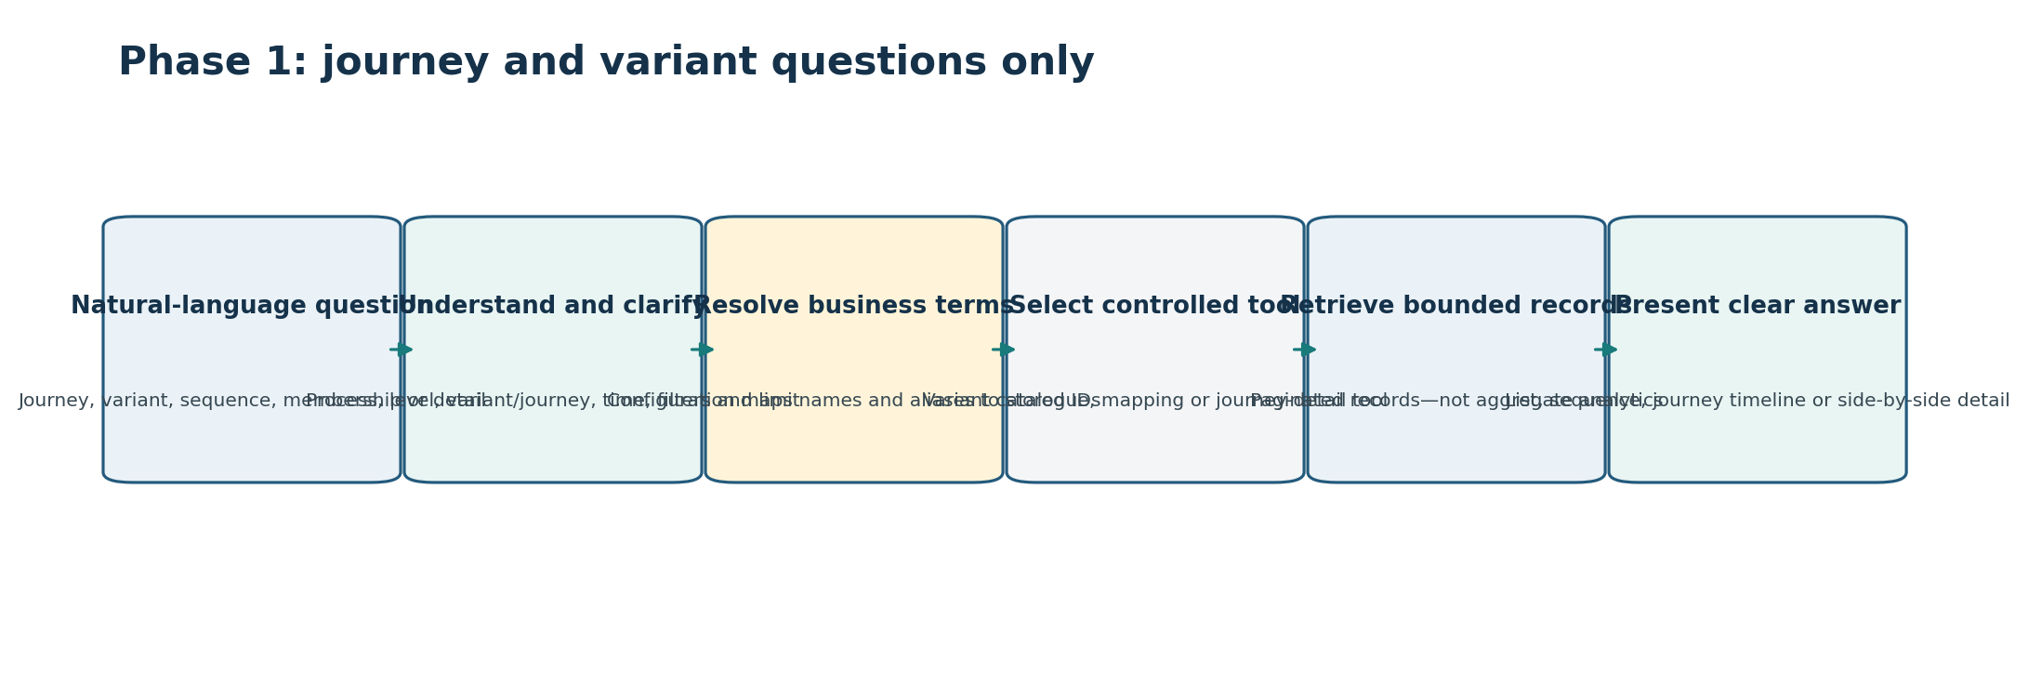
Figure 1. Phase 1 understands and clarifies a journey/variant question, resolves configured terms, calls bounded tools, and presents records without aggregate analysis.

1.1 Business outcome
- A user can find the correct variant without knowing its technical ID.
- A user can see a variant’s configured name, process level and sequence/signature information.
- A user can retrieve a bounded, paginated set of journeys assigned to a variant.
- A user can open one journey and understand its ordered activities/events.
- A user can determine which variant a journey belongs to at a selected level.
- A user can search bounded journeys using approved fields such as time, status, activity or configured attributes—only where the journey index supports it.
- The assistant asks for missing process, level, time, status, filter or limit details instead of searching all data.

1.2 Why this is a good first phase
Journey and variant questions establish the hardest identity and relationship foundations: process scope, hierarchy level, variant definition, journey membership, event ordering, business-label mapping, pagination, versioning and controlled multi-tool calls. These foundations are reusable when aggregate tools are added later.

2. Scope boundaries

2.1 Included in Phase 1
Capability | Examples
Variant catalogue discovery | List variants for a configured process and level; search a variant by name or alias.
Variant detail | Show variant ID, display name, process/node/level, sequence/signature metadata, status and version.
Variant sequence display | Translate stored activity IDs in a variant sequence to configured business labels.
Variant-to-journey lookup | Find a bounded page of journey IDs belonging to a selected variant at a selected level.
Journey detail | Show one journey’s ordered events, activities, timestamps, status and approved attributes.
Journey-to-variant lookup | Find the variant membership of one journey at a selected process level.
Bounded journey search | Search journeys by approved exact filters, date range, status, activity or attributes, with limits and pagination.
Journey comparison | Display two selected journeys side by side; no population statistics.
Conversation follow-up | Continue from a selected variant or journey using stable result references.
Explanation | Explain applied process, level, filters, data timestamp, status and limitations.

2.2 Explicitly excluded from Phase 1
Excluded question | Why excluded / future requirement
“What are the top 10 variants by volume?” | Requires counts or precomputed aggregate data and a ranking tool.
“How many journeys belong to each variant?” | Requires grouped counts.
“What is the average journey duration?” | Requires aggregation over many journeys.
“Show journey volume over time.” | Requires time-series aggregation.
“Which variant is slowest?” | Requires metric computation and comparison.
“What is the most common path?” | Requires population-level path aggregation.
“Where is the bottleneck?” | Requires approved analytical methodology and aggregate tools.
“Why did performance change?” | Requires baseline, metrics, dimensions and diagnostic analysis.
Arbitrary Elasticsearch queries | LLM may call only registered tools with prepared query templates.
Unbounded journey exports | Requires separate export, access and workload design.

User behavior for exclusions: The assistant should explain that Phase 1 supports record discovery and detail, not aggregate analysis, and suggest a supported alternative—for example, “I can list variants or show journeys for a selected variant, but I cannot rank variants by journey count yet.”

2.3 Key scope decisions to approve
ID | Decision or question | Required answer / evidence | Owner
S-01 | Which pilot processes are included? | Named processes with different levels and data patterns. | Product
S-02 | Is bounded journey search included, or only navigation from known variants/journey IDs? | Approved query boundary. | Product + data
S-03 | Is journey side-by-side comparison included? | Required fields and maximum two/few journeys. | Product
S-04 | Are in-progress journeys supported? | Status behavior and membership reliability. | Business + data
S-05 | What maximum date range, page size and pages are allowed? | Limits per tool. | SRE + product
S-06 | Which journey attributes may be searched or shown? | Allowed-field and sensitivity list. | Business + governance
S-07 | Which hierarchy levels are supported? | Main/root and subprocess level list per pilot. | Process owner
S-08 | What future aggregate prompts must be recognized as unsupported? | Negative prompt catalogue. | Product + QA

3. Actors and responsibilities
Actor | Phase 1 responsibility
Business user / analyst | Ask journey and variant questions, answer clarification, inspect results and give feedback.
Process owner / SME | Approve process hierarchy, variant meaning, activity labels, aliases, allowed questions and response wording.
Process-mining SME | Define variant signatures, process levels, journey membership, in-progress/complete behavior and late-event handling.
Configuration / knowledge owner | Store processes, nodes, activities, aliases, variants, index mappings and tool eligibility.
Variant data owner | Own variant catalogue schema, IDs, lifecycle, level and sequence/signature information.
Journey–variant mapping owner | Own membership keys, level/version behavior, freshness and reverse lookup.
Journey data owner | Own journey/event schema, ordering, status, attributes, corrections, retention and pagination.
Tool engineer | Build bounded tools and prepared queries for each index group.
AI/application engineer | Build intent, term matching, clarification, planning, context and grounded response.
QA/evaluator | Create supported, ambiguous, missing-detail, unsupported, failure and regression tests.
Platform/SRE | Define workload limits, latency, caching, retries, monitoring and incidents.
Governance/security owner | Approve allowed journey attributes, logging and access boundaries; detailed security design remains separate.

4. Phase 1 data and knowledge architecture
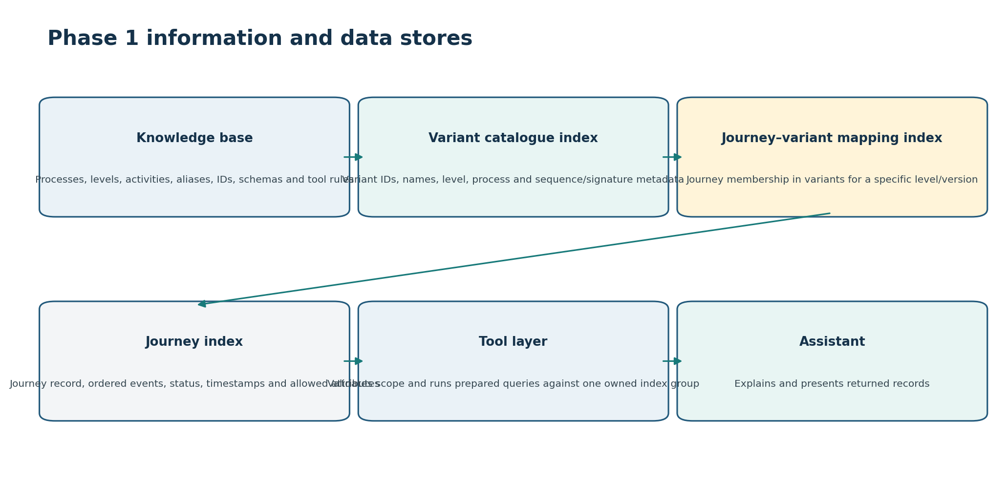
Figure 2. The knowledge base provides meaning and routing; specialized tools query the variant, membership and journey indexes they own.

4.1 Data ownership rule
Store | Owns | Does not own
Knowledge base | Business names, aliases, process hierarchy, activity mappings, variant references, schema/tool metadata and presentation rules. | Journey event data or analytics results.
Variant catalogue index | Unique variant records, process/node/level, sequence/signature metadata and lifecycle fields. | Journey membership unless explicitly part of the source design.
Journey–variant mapping index | The relationship between journey ID and variant ID for a specific process/node/level/version. | Full journey event detail.
Journey index | One journey record or retrievable event sequence, status, timestamps and approved attributes. | Variant catalogue meaning or grouped analytics.
Tool registry | What each tool can answer, inputs, limits, data ownership, result and errors. | Process/event data itself.

4.2 Key entity relationships
Relationship | Rule to establish
Use case → process/hierarchy | Every query is scoped to a configured use case/process and applicable node/level.
Hierarchy node → activity | Activities are resolved in process/node context; one name may appear in several contexts.
Process level → variant | A variant is meaningful only with its process/node/level and compatible version.
Variant → journey membership | Membership lookup must include the complete key, not variant ID alone unless globally unique and proven.
Journey → ordered events | Ordering uses an agreed event timestamp and tie-break rule.
Event activity ID → business label | Labels are read from the configuration version compatible with the journey/variant data.
Conversation result → follow-up | Selected result items use stable references that include item ID, process, level and version.

5. Information the knowledge base must store
Purpose: The knowledge base allows the assistant to understand what a user means and to create valid tool parameters. It should not copy all journey events or perform the journey search itself.

5.1 Required use-case and process information
Group | Required fields
Use-case identity | use_case_id, official/display name, descriptions, aliases, domain/tenant, owners, status, timezone and versions.
Process catalogue | process_id, name, aliases, application/context, start/end rules, journey-process mapping and status.
Hierarchy | node_id/type/name/aliases, level ID/number/label, parent_id, path, root/main indicator, parent activity and validity.
Activities | activity_id, official/display names, aliases, application, process/node memberships, activity type, start/end flags and event-log mapping.
Variant reference | variant_id or lookup key, name/aliases if managed, process/node/level, sequence/signature availability, lifecycle and index routing.
Journey semantics | journey_id field, process field, event structure, status values, ordering fields, time fields, allowed attributes and index routing.
Membership semantics | journey_id, variant_id, process/node/level, configuration/signature version, status and mapping timestamp fields.
Index mappings | Logical index group, physical alias/pattern, schema version, routing keys, timestamps, freshness, retention and owner.
Tool eligibility | Enabled tools/versions, supported processes/levels/filters, required inputs, limits and result types.
Presentation | Business labels, journey columns, event timeline fields, variant-sequence fields, truncation/pagination and warning rules.
Examples/tests | Supported questions, expected intent, matched IDs, clarification, tool calls, parameters, result and unsupported examples.
Governance | Business/data/tool owners, approval, effective dates, source trail, validation state and review date.

5.2 Alias and term-matching requirements
ID | Decision or question | Required answer / evidence | Owner
K-01 | Which process, node, activity, variant and application names may users say? | Approved names, aliases, abbreviations and common misspellings. | Process owner
K-02 | Are variant names stable business labels or generated labels? | Naming and search strategy. | Process-mining SME
K-03 | How are identical variant/activity names disambiguated? | Process, node, level, application and version differentiators. | Knowledge owner
K-04 | Can users search by partial sequence or activity name? | Include/defer decision and tool needs. | Product + data
K-05 | Which exact fields are searched by keyword and meaning? | Search document template. | Knowledge + AI
K-06 | What confidence accepts a match versus asks for clarification? | Threshold and top-candidate gap. | AI + QA
K-07 | How are deprecated variants/activities shown? | Historical and replacement behavior. | Governance
K-08 | How are configuration and search versions kept compatible? | Release/invalidation policy. | Architecture

5.3 Knowledge validation rules
- No duplicate official IDs within the agreed uniqueness scope.
- Every hierarchy node has a valid parent or approved root status.
- Every activity membership points to an existing process/node.
- Every variant reference includes process/node/level and compatible version fields.
- Journey and membership field mappings exist for every enabled tool.
- Allowed filter fields and status values match the actual journey schema.
- Aliases identify a target type and scope; collisions are flagged.
- Tool eligibility does not reference unsupported schemas or missing mappings.
- Example prompts resolve to expected items and tool parameters before release.

6. Data contracts and unresolved questions

6.1 Variant catalogue index
ID | Decision or question | Required answer / evidence | Owner
D-01 | What uniquely identifies a variant? | Complete key: variant ID plus process/node/level/version if needed. | Variant owner
D-02 | How is the variant sequence or signature stored? | Ordered activity IDs, hash, reference or other format. | Variant owner
D-03 | Are activity IDs in the sequence resolvable to the correct configuration version? | Version linkage. | Data + knowledge
D-04 | What variant name/display label exists? | Name source, alias support and fallback label. | Process owner
D-05 | What lifecycle/status fields exist? | Active, historical, merged, replaced or invalid definitions. | Variant owner
D-06 | Can variants be searched by process, node, level, ID, name and activities? | Supported query fields and prepared queries. | Tool owner
D-07 | What pagination and stable sorting are supported? | Cursor/sort key and page limits. | Tool owner
D-08 | How frequently is the catalogue updated? | Freshness and change semantics. | Data owner
D-09 | Can variant identity change after late events or algorithm changes? | Version/migration behavior. | Process-mining SME
D-10 | What Phase 1 variant fields are safe and useful to display? | Response field list. | Product + business

6.2 Journey–variant mapping index
ID | Decision or question | Required answer / evidence | Owner
D-11 | What is the complete membership key? | Journey ID, variant ID, process/node/level and version fields. | Mapping owner
D-12 | Can one journey have several memberships? | Rules across levels, versions or in-progress states. | Process-mining SME
D-13 | How is reverse lookup by journey ID performed? | Prepared query and routing. | Tool owner
D-14 | How is lookup by variant ID performed? | Prepared query, stable sort and pagination. | Tool owner
D-15 | What status/timestamp shows membership freshness? | Mapping update/completion fields. | Mapping owner
D-16 | Can membership change? | History, overwrite and stale-reference policy. | Data owner
D-17 | How are deleted/reprocessed journeys handled? | Deletion/tombstone rule. | Data owner
D-18 | What maximum mapping page and total traversal are allowed? | Bounded pagination policy. | SRE + product
D-19 | Is membership available for in-progress journeys? | Scope and confidence/status. | Process-mining SME
D-20 | How is configuration/signature compatibility checked? | Version rule. | Architecture

6.3 Journey index
ID | Decision or question | Required answer / evidence | Owner
D-21 | Is one journey stored as one document or reconstructed from events? | Retrieval model and cost. | Journey owner
D-22 | What uniquely identifies a journey? | ID scope, routing and version. | Data architecture
D-23 | How are events ordered? | Timestamp and tie-breaker. | Journey owner
D-24 | What fields represent start, end, status and completeness? | Status contract. | Journey owner
D-25 | How are late, duplicate or corrected events handled? | Quality and update policy. | Data engineering
D-26 | Which time field filters journey search? | Start, end, event, ingestion or update time by prompt. | Analytics + product
D-27 | Which attributes may be filtered? | Whitelist, types, operators and value mapping. | Business + data
D-28 | Which attributes/events may be displayed? | Allowed fields and sensitivity. | Governance
D-29 | What maximum events per journey and response size are allowed? | Truncation/detail policy. | SRE + UX
D-30 | How is pagination performed for journey lists? | Cursor and stable sort. | Tool owner
D-31 | How is a journey’s direct duration handled? | May show start-to-end for one journey if defined; no averages. | Business + analytics
D-32 | What retention limits affect date-range prompts? | Supported range and message. | Data owner

6.4 Cross-index and version rules
ID | Decision or question | Required answer / evidence | Owner
D-33 | Which join keys connect variant, membership and journey records? | Field mapping and type compatibility. | Data architecture
D-34 | Who owns the two approved tool chains? | Variant→journeys and journey→variant coordinator. | Architecture
D-35 | What happens if mapping points to a missing journey or variant? | Partial result and data-quality error. | Product + data
D-36 | How are configuration, variant algorithm and index schema versions combined? | Compatibility matrix. | Architecture
D-37 | What data timestamp/freshness is shown for each result? | Standard metadata. | Product + data
D-38 | Can Phase 1 use eventual consistency? | Expected delay and user wording. | Business + architecture
D-39 | What cache keys are safe? | Process, level, version, filters and cursor. | Architecture
D-40 | What changes invalidate conversation result references? | Expiry/invalidation rule. | Architecture

7. Supported natural-language question catalogue

7.1 Variant discovery and detail prompts
Supported prompt example | Required details | Expected tool
“List variants for [process] at level 2.” | Process, level, optional page/limit. | variant_catalog_search
“Find the variant named [name].” | Process and level when the name is not globally unique. | variant_catalog_search
“Show details for variant [name or ID].” | Resolved variant plus process/level/version. | variant_get
“Show the activity sequence for this variant.” | Selected variant and compatible activity mappings. | variant_get + knowledge labels
“Does this variant contain [activity]?” | Selected variant and resolved activity. | variant_get; application checks returned sequence
“Find variants containing [activity].” | Process, level and resolved activity; only if catalogue supports activity search. | variant_catalog_search
“Show the next page of variants.” | Stable cursor from prior result. | variant_catalog_search

7.2 Variant-to-journey prompts
Supported prompt example | Required details | Expected tools
“Show journeys for variant [name].” | Process, level, variant, time/status if required, page size. | variant search/get → journey_membership_by_variant
“Show the latest 5 completed journeys for this variant.” | Selected variant/level, completed status, definition of latest, limit=5. | journey_membership_by_variant → journey_get_batch
“Show journeys for this variant between [date] and [date].” | Variant/level, time field/range and page size. | membership lookup, optionally journey search/details
“Open the first journey.” | Stable selected item from prior result. | journey_get
“Show the next page of journeys.” | Stable membership/journey cursor. | membership lookup or journey search

7.3 Journey detail and reverse-lookup prompts
Supported prompt example | Required details | Expected tools
“Show journey [journey ID].” | Journey ID plus process when ID is not global. | journey_get
“Show the activities in this journey.” | Selected journey and label version. | journey_get + knowledge labels
“Which variant does journey [ID] belong to at level 2?” | Journey, process and level. | variant_membership_by_journey → variant_get
“Show this journey’s variant for the main process.” | Selected journey and configured main/root node. | reverse membership → variant_get
“Compare journey [A] and journey [B].” | Two resolved journeys and fields to compare. | two journey_get calls; application-side display only
“Show completed journeys containing [activity] in the last 24 hours.” | Process, activity, status, time, limit; only if indexed/supported. | journey_search

7.4 Unsupported prompts the assistant must recognize
Prompt | Phase 1 response behavior
“Give me the most common variant.” | Explain that ranking/count aggregation is not available; offer to list or search variants.
“How many journeys are in each variant?” | Explain grouped counts are not supported.
“Show average duration by variant.” | Explain aggregate duration analysis is not supported; offer an individual journey view.
“Show the trend for this variant.” | Explain time-series aggregation is not supported.
“Find the bottleneck.” | Explain diagnostic analytics is outside Phase 1.
“Compare performance of two variants.” | Clarify that Phase 1 can compare configured sequences/details, not population performance.
“Search all processes for unusual journeys.” | Require a process scope and explain that anomaly analysis is unsupported.

8. Intent and clarification design

8.1 Phase 1 intent set
Intent ID | Meaning | Required details
VARIANT_LIST | List/search variant catalogue records. | Use case/process, node/level, search filters, page size/cursor.
VARIANT_GET | Get one variant’s details/sequence. | Resolved variant ID/key, process/node/level/version.
JOURNEYS_FOR_VARIANT | Find journeys assigned to a variant. | Resolved variant, level, optional time/status/filter, page/cursor.
JOURNEY_GET | Get one journey’s ordered detail. | Journey ID, process/routing and detail level.
VARIANT_FOR_JOURNEY | Find variant membership for one journey. | Journey ID, process/node/level/version.
JOURNEY_SEARCH | Find bounded journeys using allowed filters. | Process, filters, time/status, limit/cursor.
JOURNEY_COMPARE | Display selected journey details side by side. | Two/few journey IDs and comparison fields.
FOLLOW_UP | Continue from a stable prior result. | Prior result reference and requested action.
UNSUPPORTED_AGGREGATION | Recognize aggregate/diagnostic request. | Reason and closest supported alternative.

8.2 Structured request fields
Field | Purpose
intent | One of the approved Phase 1 intent IDs.
use_case_id / process_id | Limits search and routes data.
hierarchy_node / level | Required for variant identity and membership when applicable.
variant_ref | Original phrase plus resolved official ID/key/version.
journey_ref(s) | Journey ID(s) or stable prior result references.
activity_refs | Resolved activity IDs for sequence/journey filters.
time_scope | Optional/required date range with timezone and time-field meaning.
status | Completed/in-progress/other approved values.
filters | Whitelisted typed field/operator/value records.
sort / limit / cursor | Bounded retrieval controls.
detail_level | Summary fields, full permitted events or selected attributes.
output_preference | List, detail card, sequence, timeline or comparison table.
resolution_evidence | Matched names/aliases, confidence, alternatives and knowledge version.
parameter_source | User, conversation, configuration, approved default or prior tool result.

8.3 Clarification matrix
Unclear or missing detail | When clarification is required | Example follow-up
Process/use case | No valid UI/conversation scope or same term exists across processes. | “Which process do you want to search?”
Hierarchy level | Variant identity/membership differs by level. | “Use the main process, level 2, or another subprocess?”
Variant | Name/alias matches several variants. | “Which variant do you mean?” with process, level and sequence preview.
Journey | ID is incomplete/non-global or “this journey” has no stable reference. | “Please select the journey or provide its full ID.”
Time range | Journey search would otherwise be too broad or the user asked “latest/recent” without a rule. | “What time range should I use?”
Status | In-progress and completed journeys behave differently. | “Show completed, in-progress, or both?”
Activity | Business label matches multiple activity IDs/applications. | Show labels with parent/application choices.
Limit | Query could return too many records. | “How many journeys should I return? The Phase 1 maximum is N.”
Unsupported aggregation | Question asks for count/ranking/average/trend. | Explain exclusion and offer record-level alternative.

8.4 Approved defaults to decide
ID | Decision or question | Required answer / evidence | Owner
I-01 | May the selected UI process become conversation scope? | Priority and expiry. | Product
I-02 | Is main/root level a default for variant questions? | Use-case-specific approval or mandatory clarification. | Process owner
I-03 | What default time applies to journey search? | None, last N hours, or latest available; disclose in answer. | Business + product
I-04 | What default status applies? | Completed only, all, or mandatory clarification. | Business
I-05 | What default page size and sort apply? | Stable values per tool. | Product + SRE
I-06 | What “latest” means? | Journey start/end/update timestamp and descending sort. | Business + data
I-07 | What detail level is returned by default? | Summary versus full allowed events. | UX + governance
I-08 | How long do selected variants/journeys remain in context? | Expiry and invalidation. | Architecture

9. Phase 1 tool architecture
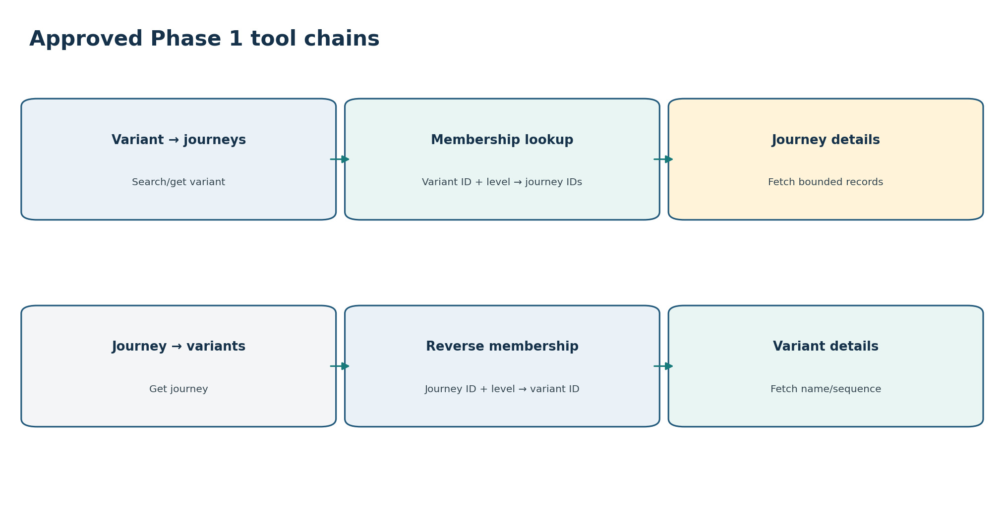
Figure 3. Only two controlled multi-tool patterns are needed initially: variant-to-journey detail and journey-to-variant detail.

9.1 Tool design principles
- Each tool owns one index group and uses prepared, parameterized queries.
- Tool inputs use resolved IDs and typed filters—not raw user text or arbitrary Elasticsearch query code.
- Every list tool uses a strict maximum page size and stable cursor-based pagination.
- Every tool returns applied scope, schema version, data timestamp/freshness, warnings and typed errors.
- Cross-index retrieval is performed through an approved tool chain with explicit keys and bounded fan-out.
- The LLM proposes an intent and selects from eligible tools; deterministic validation confirms every parameter before execution.
- Record detail may be formatted or compared in the application; population calculations are not allowed in Phase 1.

9.2 Proposed Phase 1 tool list
Tool ID | Purpose | Owned store
variant_catalog_search | List/search variants within a process/node/level using approved fields and pagination. | Variant catalogue
variant_get | Retrieve one variant’s metadata and sequence/signature fields. | Variant catalogue
journey_membership_by_variant | Return a page of journey memberships/IDs for one resolved variant at one level. | Journey–variant mapping
variant_membership_by_journey | Return variant membership for one journey at a selected level. | Journey–variant mapping
journey_get | Retrieve one journey and permitted ordered events/attributes. | Journey index
journey_get_batch | Retrieve a small bounded set of known journey IDs; optional if single-get calls are sufficient. | Journey index
journey_search | Search bounded journey records with whitelisted filters/time/status; optional Phase 1 capability. | Journey index
knowledge_resolve | Resolve process, hierarchy, activity and variant business terms to official references. | Knowledge base
knowledge_labels | Translate technical IDs in returned sequences/events to business labels. | Knowledge base

10. Proposed tool contracts

10.1 variant_catalog_search
Contract area | Phase 1 proposal
Purpose | List or search variants without calculating counts or rankings.
Required inputs | use_case_id, process_id or hierarchy_node_id, level_id/number, limit.
Optional inputs | variant_id, name/alias query, activity_id filter if supported, status, cursor, sort.
Validation | Scope exists; level valid; filters supported; limit within maximum.
Prepared query | Filter exact scope/level/status; optional keyword/exact variant search; stable sort; search_after/cursor.
Returns | Variant reference, display/official name, node/level, status, version, optional sequence preview, next cursor, freshness.
Errors | SCOPE_NOT_FOUND, LEVEL_REQUIRED, FILTER_UNSUPPORTED, INVALID_CURSOR, NO_MATCH, LIMIT_EXCEEDED, INDEX_UNAVAILABLE.
Must not do | Count journeys, rank by frequency, calculate performance or query mapping/journey indexes.

{
"tool": "variant_catalog_search",
"use_case_id": "configured-use-case",
"hierarchy_node_id": "configured-node",
"level_id": "level-2",
"name_query": "approval path",
"limit": 20,
"cursor": null
}

10.2 variant_get
Contract area | Phase 1 proposal
Purpose | Retrieve one resolved variant and its available sequence/signature metadata.
Required inputs | use_case_id, variant_id/key, hierarchy_node/level and compatible version where required.
Optional inputs | include_sequence, include_activity_labels hint.
Returns | Variant identity, process/node/level, name, status, signature/sequence activity IDs, version and freshness.
Application action | Resolve activity IDs through knowledge_labels and render a sequence view.
Errors | VARIANT_NOT_FOUND, LEVEL_MISMATCH, VERSION_MISMATCH, SEQUENCE_UNAVAILABLE, INDEX_UNAVAILABLE.

10.3 journey_membership_by_variant
Contract area | Phase 1 proposal
Purpose | Return bounded membership records/journey IDs for one variant at one level.
Required inputs | use_case_id/process, variant_id, hierarchy_node/level, limit.
Optional inputs | status if stored, membership time range if supported, cursor, stable sort.
Returns | Journey ID, membership status/version/timestamp, applied scope, next cursor, freshness and warnings.
Errors | VARIANT_NOT_FOUND, LEVEL_REQUIRED, MEMBERSHIP_NOT_READY, INVALID_CURSOR, NO_MATCH, LIMIT_EXCEEDED.
Must not do | Return grouped counts or rank membership results.

{
"tool": "journey_membership_by_variant",
"use_case_id": "configured-use-case",
"variant_id": "variant-123",
"level_id": "level-2",
"status": "COMPLETED",
"limit": 10,
"cursor": null
}

10.4 variant_membership_by_journey
Contract area | Phase 1 proposal
Purpose | Identify a journey’s variant at a selected process level.
Required inputs | use_case_id/process, journey_id, hierarchy_node/level.
Optional inputs | mapping/configuration version if historical lookup is supported.
Returns | Variant ID/key, process/node/level, membership status/version/timestamp and freshness.
Errors | JOURNEY_NOT_FOUND, LEVEL_REQUIRED, MEMBERSHIP_NOT_FOUND, MULTIPLE_MEMBERSHIPS, VERSION_MISMATCH.

10.5 journey_get and journey_get_batch
Contract area | Phase 1 proposal
Purpose | Retrieve one or a very small known set of journey records.
Required inputs | use_case_id/process and journey_id(s).
Optional inputs | detail_level, allowed attribute list, include_events, maximum events.
Validation | ID count and event/detail limits; fields allowed; process routing valid.
Returns | Journey identity, status, start/end/update time, ordered permitted events, allowed attributes, completeness, data version/freshness and warnings.
Errors | JOURNEY_NOT_FOUND, TOO_MANY_IDS, FIELD_NOT_ALLOWED, EVENTS_TRUNCATED, VERSION_MISMATCH, INDEX_UNAVAILABLE.
Must not do | Scan populations, compute averages, counts or trends.

10.6 journey_search — optional
Contract area | Phase 1 proposal
Purpose | Retrieve a bounded page of journeys matching whitelisted exact/range filters.
Required inputs | use_case/process, at least one selective condition or approved default scope, limit.
Optional inputs | time range, status, resolved activity, allowed attributes, cursor and stable sort.
Safety rules | Maximum date range; filter whitelist; no scripts; no aggregations; no unbounded match-all; strict page limits.
Returns | Journey summary records plus cursor/freshness/coverage; user opens individual detail through journey_get.
Errors | SELECTIVE_FILTER_REQUIRED, TIME_RANGE_REQUIRED, FILTER_UNSUPPORTED, LIMIT_EXCEEDED, INVALID_CURSOR.
Decision | Include only if journey schema and index mapping support predictable, performant filters.

11. Tool selection and orchestration
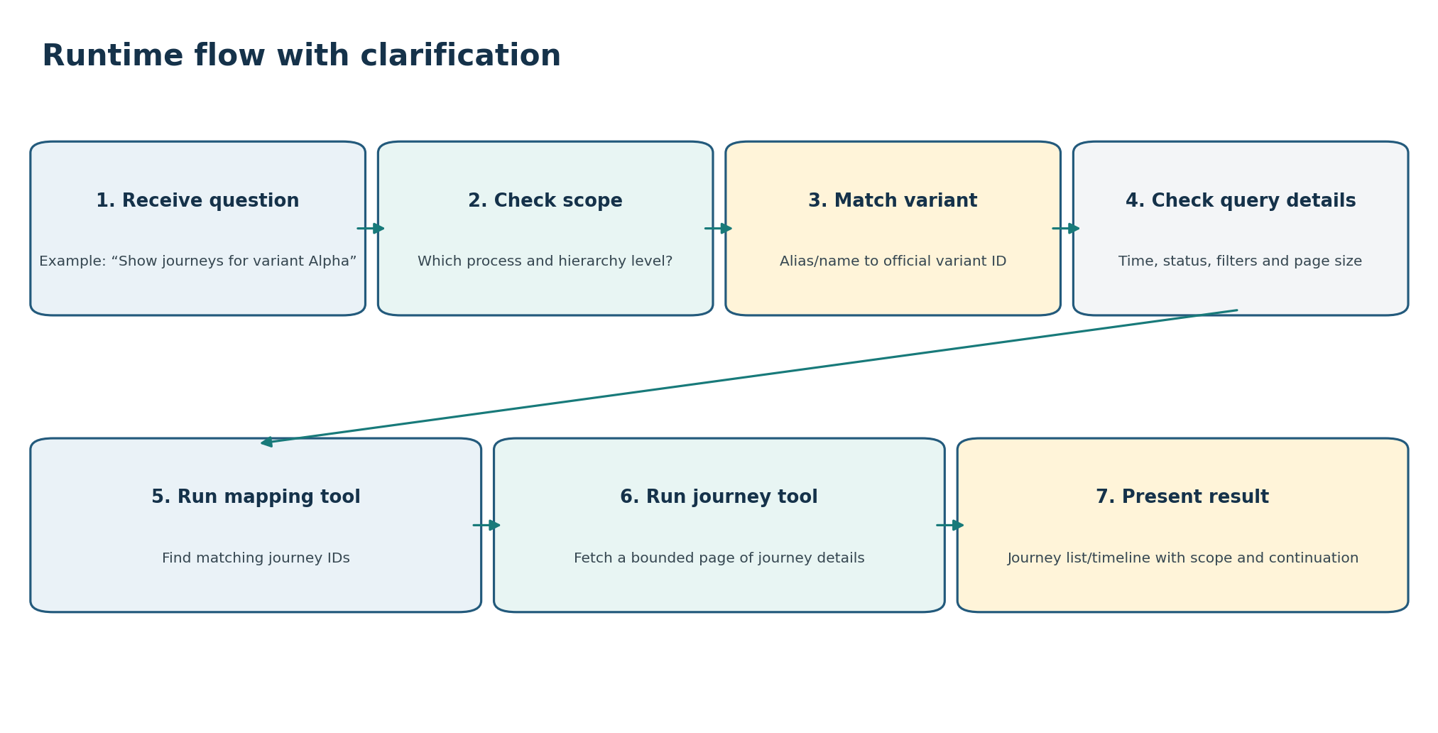
Figure 4. “Show journeys for variant Alpha” requires process/level resolution, variant matching, bounded membership lookup and optionally bounded journey detail retrieval.

11.1 Tool-selection matrix
Resolved intent | First tool | Optional next tool | Clarify when
VARIANT_LIST | variant_catalog_search | None | Process or level missing; unsupported search field.
VARIANT_GET | variant_get | knowledge_labels | Variant ambiguous; level/version unclear.
JOURNEYS_FOR_VARIANT | variant search/get if needed, then membership lookup | journey_get or small batch | Process, level, variant, time/status/limit required.
JOURNEY_GET | journey_get | knowledge_labels; reverse membership if user asks | Journey reference incomplete or detail field prohibited.
VARIANT_FOR_JOURNEY | variant_membership_by_journey | variant_get | Process/level missing or multiple memberships.
JOURNEY_SEARCH | journey_search | journey_get after selection | No selective scope/time/filter or unsupported field.
JOURNEY_COMPARE | journey_get for each bounded ID | Application-side side-by-side view | More than allowed journeys or comparison meaning unclear.
UNSUPPORTED_AGGREGATION | No data tool | Offer supported alternative | No clarification can make an aggregate request record-level.

11.2 Approved orchestration flow: variant to journey
Step | Action | Validation
1 | Resolve process/use case and hierarchy level. | One active compatible scope.
2 | Resolve variant phrase/ID. | Official variant reference with level/version.
3 | Ask for time/status/limit only when required by scope or workload. | Values typed and within tool limits.
4 | Call journey_membership_by_variant. | Mapping result scope/version matches request.
5 | Return journey-ID list or fetch only a bounded first page through journey_get_batch. | No fan-out beyond configured maximum.
6 | Translate activity IDs using compatible knowledge version. | Unknown labels clearly marked.
7 | Present list/timeline with level, filters, freshness, cursor and partial/truncation warnings. | Narrative uses returned facts only.

11.3 Approved orchestration flow: journey to variant
Step | Action
1 | Resolve journey ID and process scope.
2 | Resolve requested level or configured main/root node; clarify if missing and material.
3 | Call variant_membership_by_journey.
4 | Validate one compatible membership; handle missing/multiple memberships explicitly.
5 | Call variant_get to retrieve business-facing name and sequence metadata.
6 | Translate activity IDs and present variant details with process, level and version.

11.4 Planner rules
- Never select a snapshot or aggregate analytics tool in Phase 1.
- Never change an aggregate question into a record query without telling the user.
- Prefer knowledge-only answers for definitions and tool calls only for stored records.
- Require process/node/level when necessary to make variant identity and membership correct.
- Do not call journey details for every membership record; use bounded batch limits and fetch more only on user request.
- Do not merge incompatible versions silently.
- Stop or disclose when a mapping references missing records.
- Record the source of every parameter and every tool/version used.

12. Response and presentation design
Result type | Presentation | Required visible context
Variant list | Paginated table/list with name, ID (optional details), level, status and sequence preview. | Process/node/level, filters, sort, page and freshness.
Variant detail | Detail card plus ordered activity sequence. | Process/node/level, variant version and unknown labels.
Journey list for variant | Paginated journey summaries; open action per journey. | Variant, level, time/status filters, returned limit/cursor and mapping freshness.
Journey detail | Timeline/event table with status, timestamps and permitted attributes. | Process, journey completeness, event truncation and data freshness.
Journey variant membership | Variant detail/sequence plus membership metadata. | Journey, process/node/level and membership version.
Journey comparison | Side-by-side event sequences/selected fields. | Journey IDs, no aggregate conclusion, missing events/fields.
No match | Plain explanation and refinement choices. | Applied process, level, filters and time.
Unsupported aggregation | Explanation plus supported alternatives. | Phase 1 boundary.

12.1 Response rules
- Lead with what was found, not with internal tool details.
- Use configured business names; show technical IDs only when useful or requested.
- Always show the process and hierarchy level for variant/membership answers.
- Show time/status/filter scope for journey lists.
- Show data or mapping freshness and completeness when relevant.
- State page limits, truncation, missing mappings or unavailable sequence data.
- Never say “most common,” “top,” “average,” “trend” or “bottleneck” without an aggregate tool.
- Provide a supported next action: open a journey, next page, view variant sequence, change level or refine filters.

12.2 Example supported answer
Example: I found variant “Approval Path A” at Level 2. Here are the first 10 completed journeys assigned to it for July 10–12. Select a journey to open its event timeline, or ask for the next page. Membership data was last updated at [timestamp].

12.3 Example unsupported answer
Example: Phase 1 cannot rank variants by journey count or calculate the most common variant. I can list the configured variants for this process, search for a variant by name, or show journeys for a selected variant.

13. Functional requirements

A. Scope and understanding
ID | Requirement
FR-001 | The assistant shall support only approved journey and variant intents in Phase 1.
FR-002 | The assistant shall identify and clearly label aggregate, ranking, trend, average and diagnostic requests as unsupported.
FR-003 | Every record query shall resolve or require a use-case/process scope.
FR-004 | Variant and membership queries shall resolve or require hierarchy node/level where identity may change by level.
FR-005 | The assistant shall extract variant, journey, activity, time, status, filters, limit, cursor and requested detail as applicable.
FR-006 | The assistant shall ask a focused clarification when a missing detail changes identity, tool selection, query cost or answer meaning.
FR-007 | Approved defaults shall be stored in configuration and disclosed in the response.
FR-008 | Follow-ups shall use stable prior item references containing process, level and compatible version.

B. Knowledge and resolution
ID | Requirement
FR-009 | The knowledge base shall store use case, process, hierarchy, activity, alias, variant-reference, index and tool metadata required by Phase 1.
FR-010 | The system shall match exact names, approved aliases, abbreviations, misspellings and meaning-based paraphrases.
FR-011 | Meaning-based search shall produce candidates; final IDs and relationships shall be checked against official records.
FR-012 | Every resolved variant shall include process/node/level and compatible version context.
FR-013 | Every important match shall store evidence, confidence, alternatives and knowledge version.
FR-014 | The system shall clarify ambiguous names that could produce different records.
FR-015 | Technical activity IDs in variant/journey results shall be translated through compatible configured labels.
FR-016 | Knowledge publication shall validate IDs, hierarchy, aliases, field mappings, tool eligibility and versions.

C. Tools and data
ID | Requirement
FR-017 | Each Phase 1 tool shall own one declared index group and prepared query templates.
FR-018 | Tools shall accept typed resolved inputs and shall not accept arbitrary Elasticsearch query code.
FR-019 | All list/search tools shall enforce page size, date-range, filter and cursor limits.
FR-020 | variant_catalog_search shall list/search variant records without counts or ranking.
FR-021 | variant_get shall retrieve one variant and available sequence/signature metadata.
FR-022 | journey_membership_by_variant shall return bounded membership/journey IDs for one variant and level.
FR-023 | variant_membership_by_journey shall return a journey’s variant for a requested level.
FR-024 | journey_get shall return one permitted journey detail with ordered events and completeness metadata.
FR-025 | journey_get_batch, if implemented, shall enforce a small maximum known-ID count.
FR-026 | journey_search, if implemented, shall require selective whitelisted filters or an approved bounded scope.
FR-027 | Tools shall return applied scope, schema/version, freshness, pagination, warnings and typed errors.
FR-028 | Tools shall distinguish no match, missing mapping, version mismatch, partial/missing records, invalid cursor, limit exceeded and unavailable index.
FR-029 | The only initial multi-tool chains shall be explicitly approved variant→journey and journey→variant flows.
FR-030 | The orchestrator shall bound fan-out and shall not fetch all journey details automatically.

D. Results and experience
ID | Requirement
FR-031 | Variant lists shall show process/node/level and pagination context.
FR-032 | Variant details shall show available name, status, version and sequence/signature with translated activity labels.
FR-033 | Journey lists shall show the selected variant/level, applied filters/time/status, page limit/cursor and mapping freshness.
FR-034 | Journey detail shall show status, ordered permitted events, timestamps, completeness and truncation warnings.
FR-035 | Journey-to-variant answers shall show journey, process/node/level and membership version.
FR-036 | Side-by-side journey comparison shall not produce population-level performance conclusions.
FR-037 | No-data and unsupported messages shall state the applied scope and offer supported refinements.
FR-038 | Responses shall not invent variant names, activity labels, events, memberships or missing fields.
FR-039 | Responses shall not present aggregate language or claims without a future approved aggregate tool.
FR-040 | Every presented record shall be traceable to knowledge and tool result versions.

E. Lifecycle and quality
ID | Requirement
FR-041 | Each pilot process shall pass a Phase 1 onboarding checklist before release.
FR-042 | Variant, mapping and journey schemas shall have named owners, freshness expectations and sample data fixtures.
FR-043 | Every tool shall pass contract, pagination, limit, no-match, version, partial-record and unavailable-index tests.
FR-044 | Golden prompts shall cover supported, ambiguous, missing-detail, follow-up and unsupported aggregate questions.
FR-045 | Release tests shall verify expected intent, term match, clarification, tool chain, parameters and presentation.
FR-046 | Production traces shall capture question, context, matches, clarification, plan, tool inputs/outputs, versions and response.
FR-047 | The platform shall monitor latency, errors, missing mappings, unresolved terms, invalid cursors, data freshness and unsupported-request rate.
FR-048 | Configuration, knowledge, search records and tool compatibility shall support staged release and rollback.
FR-049 | User feedback shall be attached to the answer trace and reviewed before changing aliases or rules.
FR-050 | Access to journey attributes and details shall be enforced outside the LLM; detailed security design is a separate workstream.

14. Decisions required before implementation
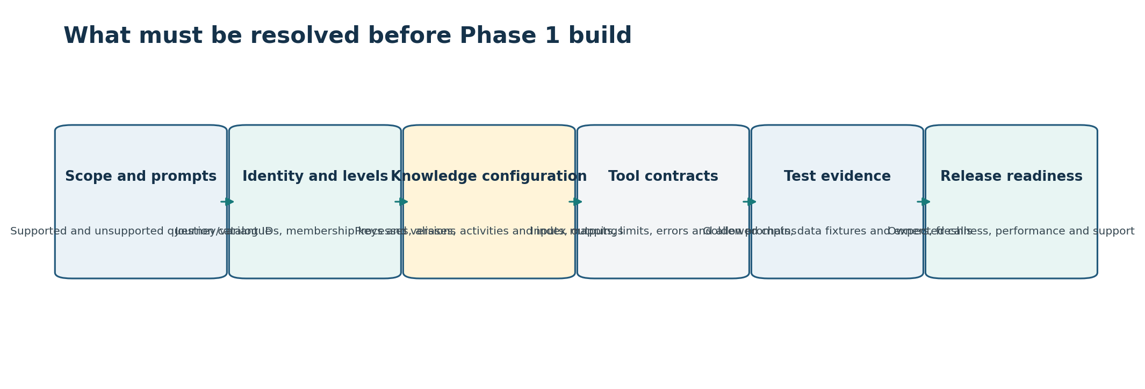
Figure 5. Phase 1 development depends on approved scope, identity/version rules, knowledge configuration, tool contracts, tests and operational ownership.

14.1 Blocking decisions
ID | Decision or question | Required answer / evidence | Owner
B-01 | Which supported prompt families and pilot processes are approved? | Phase 1 prompt/process catalogue. | Product
B-02 | What is explicitly out of scope? | Approved aggregate/diagnostic exclusion list. | Product + business
B-03 | What uniquely identifies variants, journeys and memberships? | Complete keys and version rules. | Data architecture
B-04 | What does hierarchy level mean for every pilot? | Root/main and level mapping. | Process owner
B-05 | How are variant signatures/sequences stored and labeled? | Variant schema and knowledge linkage. | Variant owner
B-06 | How are journey events ordered and completeness/status defined? | Journey contract. | Journey owner
B-07 | How can memberships change and how is freshness represented? | Mapping lifecycle contract. | Mapping owner
B-08 | Which journey filters/attributes are allowed? | Whitelist and data classification. | Business + governance
B-09 | What are time, page, event, batch and fan-out limits? | Measured safe values. | SRE + product
B-10 | Is optional journey_search feasible and in scope? | Schema/index performance evidence. | Data + product
B-11 | What exact request/result/error schema does each tool use? | Approved contracts. | Architecture + tools
B-12 | What defaults require clarification? | Process/level/time/status/limit policy. | Product + business
B-13 | What version combinations are compatible? | Knowledge/variant/mapping/journey/tool matrix. | Architecture
B-14 | What quality targets and golden prompts block release? | Evaluation plan and thresholds. | QA + product
B-15 | Who owns incidents, missing mappings and incorrect labels? | RACI/support workflow. | Program leadership

14.2 Workload and operational decisions
ID | Decision or question | Required answer / evidence | Owner
B-16 | Expected concurrent users and queries per second? | Phase 1 workload model. | Product + SRE
B-17 | Expected list page size and maximum page traversal? | UX and cost limits. | Product + SRE
B-18 | Expected events per journey and journey response size? | Detail/truncation limit. | Data + UX
B-19 | P50/P95 targets for single-tool and two-tool chains? | Latency SLO. | SRE
B-20 | Freshness expectations for catalogue, membership and journey stores? | SLA and user wording. | Data owners
B-21 | Caching allowed for variant details/membership pages/journey details? | Cache and invalidation policy. | Architecture
B-22 | How long are result cursors and conversation references valid? | Expiry policy. | Architecture + UX
B-23 | What monitoring and alerts are mandatory? | Dashboard/runbook. | SRE
B-24 | What trace fields are retained and redacted? | Observability policy. | Governance
B-25 | What release/rollback process applies? | Staging, compatibility checks and rollback target. | Operations

15. Phase 1 onboarding checklist per process
Gate | Required evidence
Business scope | Use-case/process identity, owner, purpose, root/main definition, supported levels and supported prompts.
Hierarchy | Validated process/node/level relationships and activity memberships.
Business language | Approved process, node, activity, application and variant names/aliases with collision review.
Variant data | Schema, keys, level/version semantics, sequence/signature, sample records, freshness and owner.
Membership data | Complete keys, reverse lookup, status/version/freshness, pagination, sample records and owner.
Journey data | ID/routing, ordered-event schema, status/completeness, allowed filters/fields, retention, sample records and owner.
Knowledge mappings | Index fields, routing, labels, versions and enabled-tool configuration.
Tool readiness | Contracts, templates, limits, errors and positive/negative/failure tests.
Prompt readiness | Supported, ambiguous, missing-detail, follow-up and unsupported aggregate golden prompts.
Presentation readiness | Variant list/detail, journey list/detail, membership and comparison views with limits/warnings.
Operations | Freshness/latency targets, dashboards, alerts, support owners, staged release and rollback.
Approval | Process, data, tool, product and QA owners approve readiness report.

16. Evaluation and acceptance plan

16.1 Golden prompt groups
Test group | Examples
Exact resolution | Exact process, variant, journey and activity names/IDs.
Business language | Aliases, abbreviations, partial names, spelling errors and paraphrases.
Ambiguity | Same name across process/level/application; multiple memberships.
Missing details | No process, level, variant, journey, time, status or limit.
Supported chains | Variant→membership→journey and journey→membership→variant.
Pagination | Next page, invalid/expired cursor and maximum traversal.
Data problems | Missing variant/journey, stale membership, version mismatch, partial/missing records.
Follow-up | “Open the first journey,” “show its variant,” “next page,” “use level 2.”
Unsupported aggregate | Top/common/count/average/trend/bottleneck/why prompts.
Presentation | Correct labels, level, filters, freshness, truncation and no aggregate claims.

16.2 Acceptance measures to set
ID | Decision or question | Required answer / evidence | Owner
E-01 | Variant/activity/process term-match target? | Precision/top-k/clarification metrics. | QA + AI
E-02 | Intent and unsupported-aggregation classification target? | Accuracy by intent. | QA + product
E-03 | Tool and parameter selection target? | Expected call exact-match rate. | QA + architecture
E-04 | Clarification quality target? | Necessary/complete/effective rates. | Product + UX
E-05 | Record/result grounding target? | No invented IDs/events/memberships and narrative consistency. | QA
E-06 | Pagination/version/error behavior target? | Contract conformance. | Tool QA
E-07 | Latency/freshness target? | SLOs by tool chain. | SRE
E-08 | What regression blocks a release? | Critical and overall thresholds. | Product + QA

16.3 Minimum end-to-end acceptance scenarios
Scenario | Expected result
List variants at a known level | Correct scoped variants, stable page, no counts/ranking.
Ambiguous variant name | Assistant asks with process/level/sequence context; no tool call before selection.
Variant to journeys | Correct level-aware membership and bounded journey page.
Journey to variant | Correct reverse membership at selected level and variant detail.
Open selected journey | Correct ordered events and business labels with completeness warning.
Unsupported “top variant” | No aggregate tool/query; clear boundary and supported alternatives.
Version mismatch | No silent merge; typed error or safe clarification.
Missing mapping target | Partial/data-quality message with no invented record.
Expired cursor/reference | User asked to rerun/refine; no stale continuation.
Tool unavailable | Transparent error/retry policy; no fabricated answer.

17. Suggested implementation plan
Stage | Build outcome | Exit criteria
1. Finalize scope and contracts | Approved prompts, exclusions, identity/version rules, tool list and response rules. | Blocking decisions B-01–B-15 approved.
2. Build reference knowledge package | One pilot process with hierarchy, activities, aliases, index mappings, tool eligibility and test examples. | Knowledge validation and term-resolution tests pass.
3. Build variant tools | variant_catalog_search and variant_get with pagination/version behavior. | Contract and golden variant prompts pass.
4. Build membership tools | Forward and reverse membership lookup. | Level/version/missing-mapping tests pass.
5. Build journey detail tools | journey_get and optional bounded batch. | Ordering, fields, truncation and performance tests pass.
6. Decide/build journey_search | Only if filters and index performance are proven. | Selective-filter and workload tests pass.
7. Implement planner and clarification | Intent, unsupported classification, required details, eligible tools and two approved chains. | Expected tool/parameter/clarification tests pass.
8. Implement presentation and context | Lists, sequence, timeline, side-by-side, cursors and stable follow-ups. | End-to-end conversation and accessibility tests pass.
9. Operationalize | Tracing, dashboards, freshness, alerts, staged release and rollback. | Readiness checklist approved by all owners.

17.1 Phase 1 definition of done
- Supported prompt catalogue and aggregate exclusions are approved and tested.
- At least one representative pilot process has complete knowledge configuration.
- Variant, membership and journey identity/version semantics are agreed.
- Required tools pass contract, limit, error, pagination and version tests.
- The assistant clarifies missing process/level/time/status/limit details correctly.
- The two approved tool chains are bounded, traceable and correct.
- Variant and journey results use configured labels and disclose scope/freshness/limitations.
- Unsupported aggregation prompts never produce direct database queries or aggregate claims.
- Quality, latency, freshness, monitoring, support and rollback gates pass.

Appendix A. Phase 1 prompt reference
Supported now | Not supported now
List/search configured variants. | Rank variants by count, duration or performance.
Show one variant and its sequence/signature. | Count journeys by variant.
Show a bounded page of journeys for a variant. | Average or distribution across journeys.
Open one journey and its ordered events. | Journey volume trends.
Find a journey’s variant at a selected level. | Most common paths or bottlenecks.
Search bounded journeys using approved filters, if enabled. | Root-cause or driver analysis.
Compare two selected journey records side by side. | Population-level performance comparison.
Continue through pages and selected records. | Unbounded search/export or arbitrary query generation.

Baseline: Phase 1 succeeds when users can reliably discover variants and inspect journey relationships/details using business language, while the system remains bounded, level-aware, version-aware, traceable and honest about the absence of aggregate analytics.

