Process Intelligence Assistant
Detailed Use Cases, Actors, Entities, and Functional Requirements
A companion specification for business, product, process-mining, data, AI, engineering, QA and operations teams.
Field | Value
Applies to | All configured decision processes and process-mining use cases
Purpose | Define who uses the system, what they need to do, what information the system manages, and what functions must be built
Relationship to architecture blueprint | Expands the actors, use cases, entities and functional requirements into a testable use-case model
Status | Working baseline for stakeholder review
Version | 0.1
Date | July 13, 2026

Scope principle: The assistant is reusable across many processes. Process names, subprocesses, activities, aliases, metrics, storage locations and enabled tools come from configuration; they are not hard-coded for one use case.

1. Purpose and reading guide
This document describes the system from a use-case point of view. A use case explains an outcome an actor needs from the system. The actor may be a business user asking a question, a process owner defining business meaning, an engineer adding an analytics tool, or an operator monitoring production quality.

1.1 What this document contains
- System boundary and actor diagrams.
- Runtime use cases for business questions and follow-up conversations.
- Design-time use cases for configuration, knowledge, tools, testing and release.
- Detailed use-case specifications with triggers, required information, main flow, alternate flow and result.
- Core entities and their relationships.
- Functional requirements traced back to use cases.
- Examples and acceptance scenarios that can become test cases.

1.2 Simple definitions
Term | Meaning
Actor | A person or system that interacts with the assistant.
Use case | A goal an actor completes with the system.
Entity | A business or technical item the system identifies, such as a process, activity, variant, journey or metric.
Configuration | Approved information describing one process use case: labels, IDs, relationships, metrics, data mappings and enabled tools.
Tool | A controlled function that answers a specific type of question from the correct data store.
Precondition | Something that must already be true before a use case can run.
Postcondition | What must be true after the use case succeeds.
Alternate flow | What happens when information is missing, unclear, unsupported or unavailable.

2. Actors and responsibilities
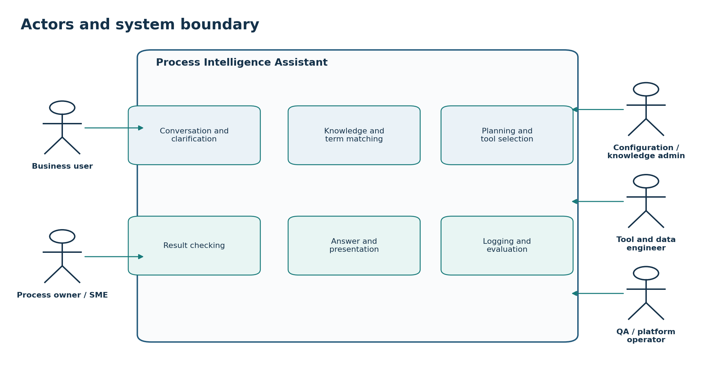
Figure 1. Human actors interact with a controlled assistant boundary. Internal components understand the question, match terms, choose tools, check results and present answers.

2.1 Primary human actors
Actor | Goal | Main responsibilities
Business user / analyst | Get a correct and understandable process answer. | Ask questions, answer follow-ups, refine results, inspect supporting scope and give feedback.
Process owner | Ensure the assistant reflects the real business process. | Approve process boundaries, main/subprocess structure, activity meaning, metrics, aliases, defaults and supported questions.
Business SME / operations lead | Provide day-to-day language and exceptions. | Supply common terms, abbreviations, unusual paths, expected questions and operational interpretation.
Configuration / knowledge administrator | Maintain the stored process information. | Load configuration, manage labels and aliases, validate relationships, version records and publish approved changes.
Tool and data engineer | Add correct analytical capabilities. | Define tool inputs/outputs, query templates, index ownership, limits, errors, freshness and contract tests.
AI / application engineer | Build understanding, planning and response behavior. | Implement structured intent extraction, term matching, clarification, planning and grounded answer generation.
QA / evaluator | Prove expected behavior before release. | Create golden questions, expected matches, expected tool calls, negative cases and regression tests.
Platform operator / SRE | Keep the service reliable. | Monitor latency, failures, cost, versions, data freshness and incidents; perform rollback when required.
Governance / security owner | Set policy boundaries. | Approve access, logging, retention, data classification and audit rules; detailed security design remains a separate workstream.

2.2 Runtime system actors
System actor | Responsibility
Conversation service | Receives questions, manages conversation state and sends follow-up questions or results.
Understanding service / LLM | Proposes the user goal and required details in a structured format.
Knowledge and term-matching service | Matches business words to approved process, subprocess, activity, variant, metric and dimension records.
Tool registry | Lists available tools, supported questions, required inputs, limits and result types.
Planner | Chooses clarification, a knowledge answer, one tool or an approved chain of tools.
Tool gateway | Validates tool calls, limits and policy before execution.
Analytics tools | Run prepared queries against the data stores they own.
Result checker | Confirms scope, time, units, freshness, coverage and result structure.
Presentation service | Selects a summary, table, KPI, chart, tree, flow or journey timeline.
Evaluation and monitoring service | Records traces, errors, quality results and user feedback.

3. Use-case catalogue
ID | Use case | Primary actor | Outcome
UC-01 | Ask a natural-language process question | Business user | A structured request is created.
UC-02 | Select or identify the process scope | Business user / system | One configured use case/process is selected.
UC-03 | Understand goal and required details | Understanding service | Intent and needed information are identified.
UC-04 | Match business terms to stored process items | Term-matching service | Words are linked to approved internal IDs.
UC-05 | Clarify missing or unclear information | Business user / assistant | A focused follow-up resolves the uncertainty.
UC-06 | Find and select the correct tool | Planner / tool registry | An eligible tool or approved tool chain is selected.
UC-07 | Get process structure or definitions | Business user | Process, subprocess, activity or hierarchy information is returned.
UC-08 | Get metrics, trends or comparisons | Business user | A validated metric result is returned.
UC-09 | Analyze variants | Business user | Variants are listed, ranked, compared or summarized.
UC-10 | Inspect journeys or paths | Business user | Journeys, events or transitions are returned with pagination.
UC-11 | Validate and present the answer | Assistant | A clear answer with scope, time and limitations is displayed.
UC-12 | Continue, refine or drill down | Business user | A follow-up reuses valid prior context.
UC-13 | Submit feedback | Business user | Feedback is stored against the answer trace.
UC-14 | Onboard or update a process use case | Process owner / config admin | Approved process knowledge becomes available.
UC-15 | Manage labels, aliases and hierarchy | Knowledge admin / process owner | Business language is accurately mapped.
UC-16 | Register or update an analytics tool | Tool engineer | A tested capability becomes eligible for selection.
UC-17 | Validate and release a use case | QA / product / owners | The use case passes readiness gates and is published.
UC-18 | Monitor, evaluate and improve | Operator / evaluator | Quality and operational issues are detected and corrected.

4. Runtime use-case diagrams
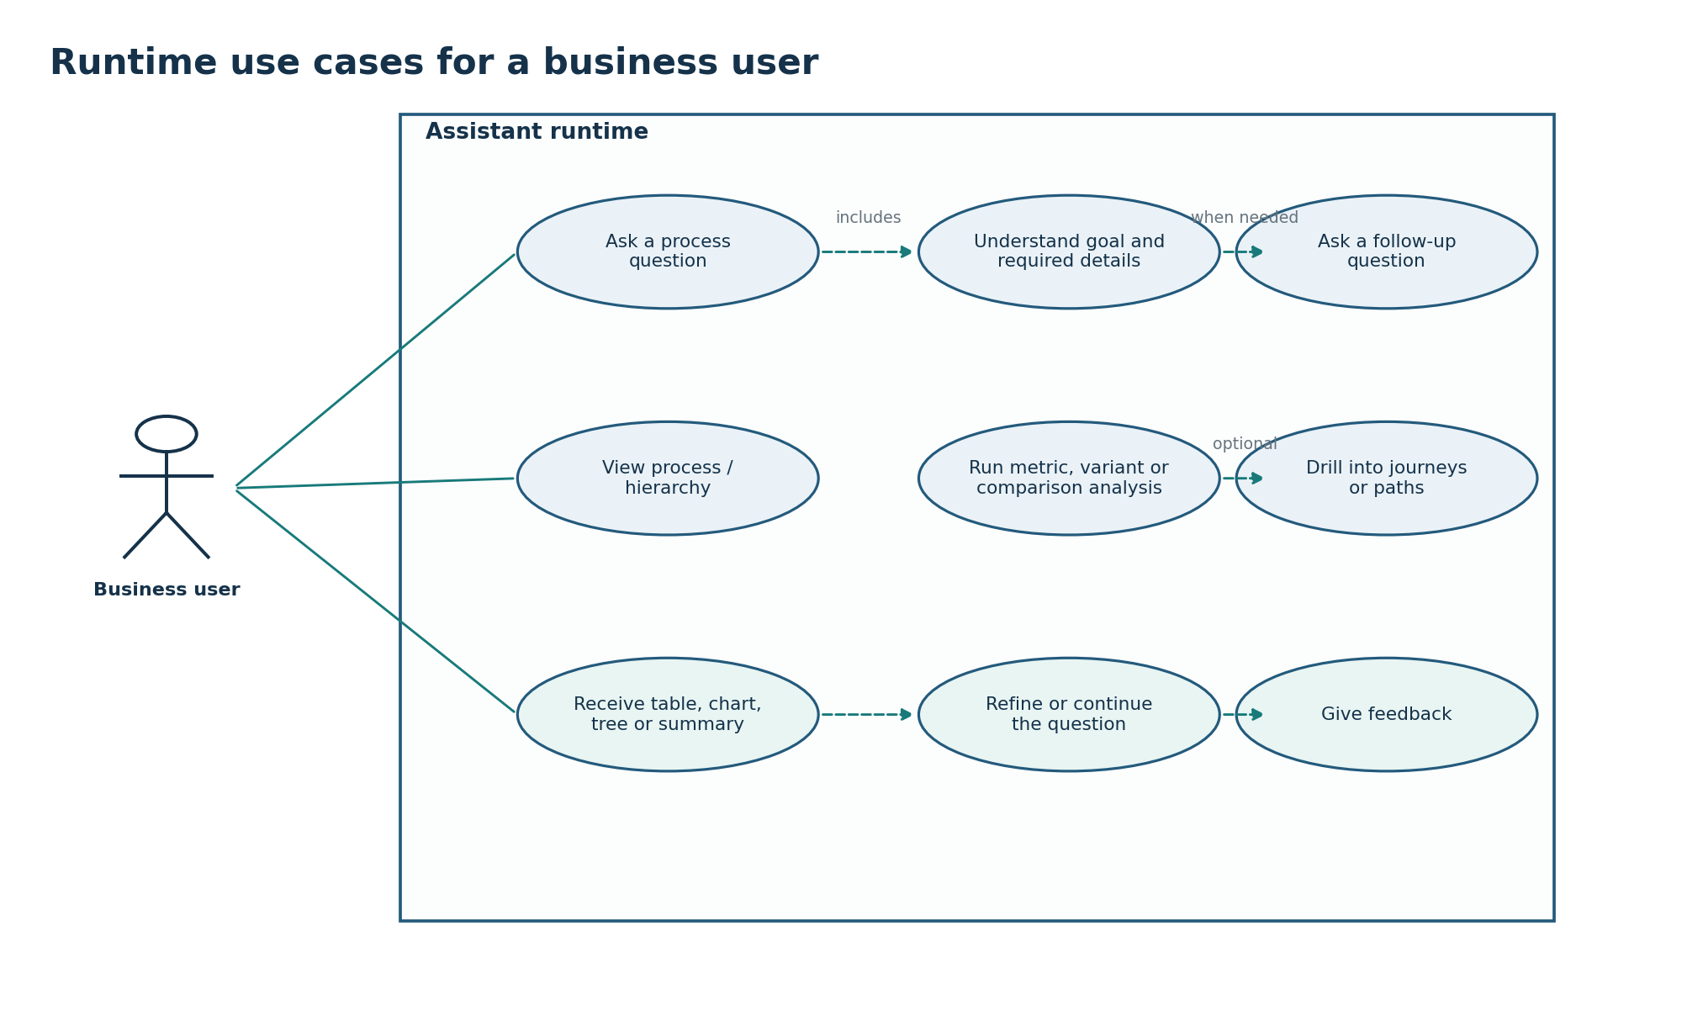
Figure 2. The business user can ask, explore, analyze, drill down, refine and provide feedback. Understanding and clarification are included in the question flow.

4.1 Key runtime rule
Do not query first: The assistant must understand enough of the question before it calls an analytics tool. If a missing process, level, time range, metric or business label would change the answer, it asks a focused follow-up question.

4.2 Example interaction patterns
Question | Missing information the assistant checks | Likely outcome
“Give me the top 10 variants.” | Process, process level, time range and meaning of “top.” | Follow-up if missing; then variant-ranking tool and ranked table/chart.
“Show the main process.” | Selected use case and configured root/main designation. | Process/hierarchy tool and tree or process view.
“Compare verification and approval.” | Which configured activities, comparison metric and time range. | Term matching, possible clarification, activity-comparison tool.
“Show journeys for the second variant.” | Stable reference to prior result, variant level, time and page size. | Journey-to-variant lookup followed by journey-detail tool.
“Why did cycle time increase?” | Process, cycle-time metric, current period, baseline and supported diagnostic capability. | Clarification or approved diagnostic tool with careful non-causal wording.

5. Detailed runtime use-case specifications

UC-01 — Ask a natural-language process question
Field | Details
Primary actor(s) | Business user
Trigger | User opens the assistant and enters a question.
Preconditions | User identity and conversation are available.
Required information | Question text, locale, channel, optional selected process and prior conversation context.
Main flow | 1. Create request and conversation identifiers.  2. Validate the request format.  3. Load allowed conversation context.  4. Send the question for structured understanding.
Alternate / failure flow | If input is empty, too large or unsupported, return a clear correction message.
Successful result | A structured request is created and traceable.

UC-02 — Select or identify the process scope
Field | Details
Primary actor(s) | Business user and term-matching service
Trigger | A question needs a process or use-case scope.
Preconditions | At least one process use case is available to the user.
Required information | Explicit process name, UI selection, current conversation scope or search phrase.
Main flow | 1. Use an explicit UI/process selection first when available.  2. Otherwise check a valid active process from conversation.  3. Otherwise search approved process names and aliases.  4. Accept one high-confidence result or show meaningful choices.
Alternate / failure flow | If multiple processes remain possible, ask the user to choose. Do not search every process data store.
Successful result | One approved use-case/process ID and configuration version are selected.

UC-03 — Understand the goal and required details
Field | Details
Primary actor(s) | Understanding service / LLM
Trigger | A validated question enters the understanding stage.
Preconditions | Supported intent catalogue and structured request format are available.
Required information | Question, process context and supported operations.
Main flow | 1. Identify whether the user wants to list, explain, compare, rank, trend, inspect, diagnose or continue.  2. Extract subjects, metric, time, level, filters, grouping, limit and presentation preference.  3. Mark missing or conflicting required details.  4. Return a schema-valid structured interpretation.
Alternate / failure flow | If the interpretation is invalid, retry within a limit or ask the user to rephrase.
Successful result | A validated intent and required-detail record is produced.

UC-04 — Match business terms to stored process items
Field | Details
Primary actor(s) | Knowledge and term-matching service
Trigger | The interpretation contains business labels.
Preconditions | Process scope and approved knowledge are available.
Required information | Business phrases and expected item types.
Main flow | 1. Try exact official names and approved aliases.  2. Use keyword and meaning-based search only to find candidates.  3. Retrieve official records for candidates.  4. Check item type, process, parent, level, application, status and tool compatibility.  5. Accept, clarify or leave unresolved based on confidence and impact.
Alternate / failure flow | If two candidates could produce different answers, show choices and request clarification.
Successful result | Each important phrase is linked to an official ID with evidence and confidence.

UC-05 — Clarify missing or unclear information
Field | Details
Primary actor(s) | Business user and assistant
Trigger | A required detail is missing or more than one meaning is possible.
Preconditions | The system knows the exact uncertainty and valid choices.
Required information | Missing field, candidate choices and safe context.
Main flow | 1. Ask one short question that separates the meaningful options.  2. Show business labels and helpful context, not raw IDs.  3. Receive the user choice.  4. Update the structured request and conversation state.  5. Resume at understanding, matching or planning.
Alternate / failure flow | If the user does not answer, keep the request pending or explain that analysis cannot continue.
Successful result | The required detail is resolved without silently guessing.

UC-06 — Find and select the correct tool
Field | Details
Primary actor(s) | Planner and tool registry
Trigger | The request and important terms are resolved.
Preconditions | Tool registry is available and current.
Required information | Intent, process, entities, metric, level, time, filters and requested result.
Main flow | 1. Filter tools by active status and process eligibility.  2. Filter by supported operation, item type, level, metric, filters and result type.  3. Remove tools with missing inputs or unavailable data.  4. Prefer one complete purpose-built tool.  5. Use multiple tools only when an approved sequence and join rule exist.  6. Validate all parameters before execution.
Alternate / failure flow | If no tool supports the request, explain the limitation and offer the closest supported question.
Successful result | A validated execution plan or unsupported result is produced.

UC-07 — Get process structure or definitions
Field | Details
Primary actor(s) | Business user and process/hierarchy tool
Trigger | The user asks what a process item is or how the process is organized.
Preconditions | Process scope and hierarchy configuration are valid.
Required information | Process, node, activity, level or parent selection.
Main flow | 1. Retrieve approved names, descriptions and parent-child relationships.  2. Apply level/parent filters.  3. Return only active or requested historical version.  4. Choose a definition, list, tree or process view.
Alternate / failure flow | If hierarchy is incomplete or conflicting, stop the affected view and report a configuration issue.
Successful result | The user receives an understandable process definition or structure.

UC-08 — Get metrics, trends or comparisons
Field | Details
Primary actor(s) | Business user and metric tool
Trigger | The user asks for performance, trend or comparison.
Preconditions | Metric definition and eligible tool exist.
Required information | Process/items, metric, aggregation, time, grain, filters and comparison.
Main flow | 1. Confirm metric meaning and unit.  2. Resolve time and comparison period.  3. Execute the eligible metric tool.  4. Validate units, groups, coverage and freshness.  5. Present KPI, table or chart with scope and caveats.
Alternate / failure flow | Ask for missing metric/time; reject incomparable items; label partial or stale data.
Successful result | A validated metric answer is displayed.

UC-09 — Analyze variants
Field | Details
Primary actor(s) | Business user and variant/snapshot tool
Trigger | The user asks to list, rank, compare or summarize variants.
Preconditions | Variant data exists for the selected process level.
Required information | Process, hierarchy level, time, ranking metric, filters and limit.
Main flow | 1. Confirm level because variants may differ by level.  2. Confirm time range and ranking metric.  3. Choose snapshot/variant tool based on requested detail.  4. Apply bounded top-N or pagination.  5. Return variant ID, display name/signature, metric, time and coverage.
Alternate / failure flow | If level/time/metric is missing, clarify. If results exceed limits, return top-N/pagination and disclose it.
Successful result | Variant results are displayed in a ranked table, chart or sequence view.

UC-10 — Inspect journeys or paths
Field | Details
Primary actor(s) | Business user and journey/path tools
Trigger | The user drills into a variant, journey or activity transition.
Preconditions | Requested item is resolved and user is allowed to view details.
Required information | Variant/journey/activity, level, time, direction/depth, filters and pagination.
Main flow | 1. Use journey-to-variant mapping when starting from a variant.  2. Retrieve journey details in bounded pages.  3. For transitions, use the registered path tool.  4. Translate activity IDs to business labels.  5. Return timestamps, ordering, scope and coverage.
Alternate / failure flow | If detail volume is too large, require tighter filters or pagination. If a tool chain fails, disclose partial results.
Successful result | Journey timeline, event table or path flow is displayed.

UC-11 — Validate and present the answer
Field | Details
Primary actor(s) | Assistant
Trigger | A knowledge or analytics result is returned.
Preconditions | Result schema and presentation rules are available.
Required information | Structured result, intent and channel capability.
Main flow | 1. Check requested scope, time, units, freshness, coverage and warnings.  2. Choose the clearest supported format.  3. Generate a short answer only from returned facts.  4. Show process, level, time, filters, defaults and important limits.  5. Store the result reference for follow-up.
Alternate / failure flow | If validation fails, do not present the result as successful. Return a safe error or partial-data message.
Successful result | A grounded, understandable and traceable answer is delivered.

UC-12 — Continue, refine or drill down
Field | Details
Primary actor(s) | Business user
Trigger | The user refers to the prior answer.
Preconditions | Prior result reference and resolved context are still valid.
Required information | Follow-up phrase, selected row/chart item or requested refinement.
Main flow | 1. Resolve references such as “this,” “second one,” or “same period” to stable prior items.  2. Inherit only valid scope and clearly retain or change filters/time.  3. Return to the required matching/planning/tool step.
Alternate / failure flow | If the reference is unclear, expired or no longer visible, ask the user to select the item again.
Successful result | The follow-up is answered without re-entering all context.

UC-13 — Submit feedback
Field | Details
Primary actor(s) | Business user
Trigger | The user marks an answer helpful/incorrect or adds a comment.
Preconditions | Answer trace exists.
Required information | Rating, issue type and optional comment/correction.
Main flow | 1. Attach feedback to request, matches, plan, tool result and presentation versions.  2. Route the issue to the correct owner category.  3. Do not automatically turn one user correction into a global alias.  4. Add reviewed issues to evaluation or knowledge backlog.
Alternate / failure flow | If sensitive text is entered, apply logging/redaction policy.
Successful result | Feedback is available for controlled improvement.

6. Design-time and operational use cases
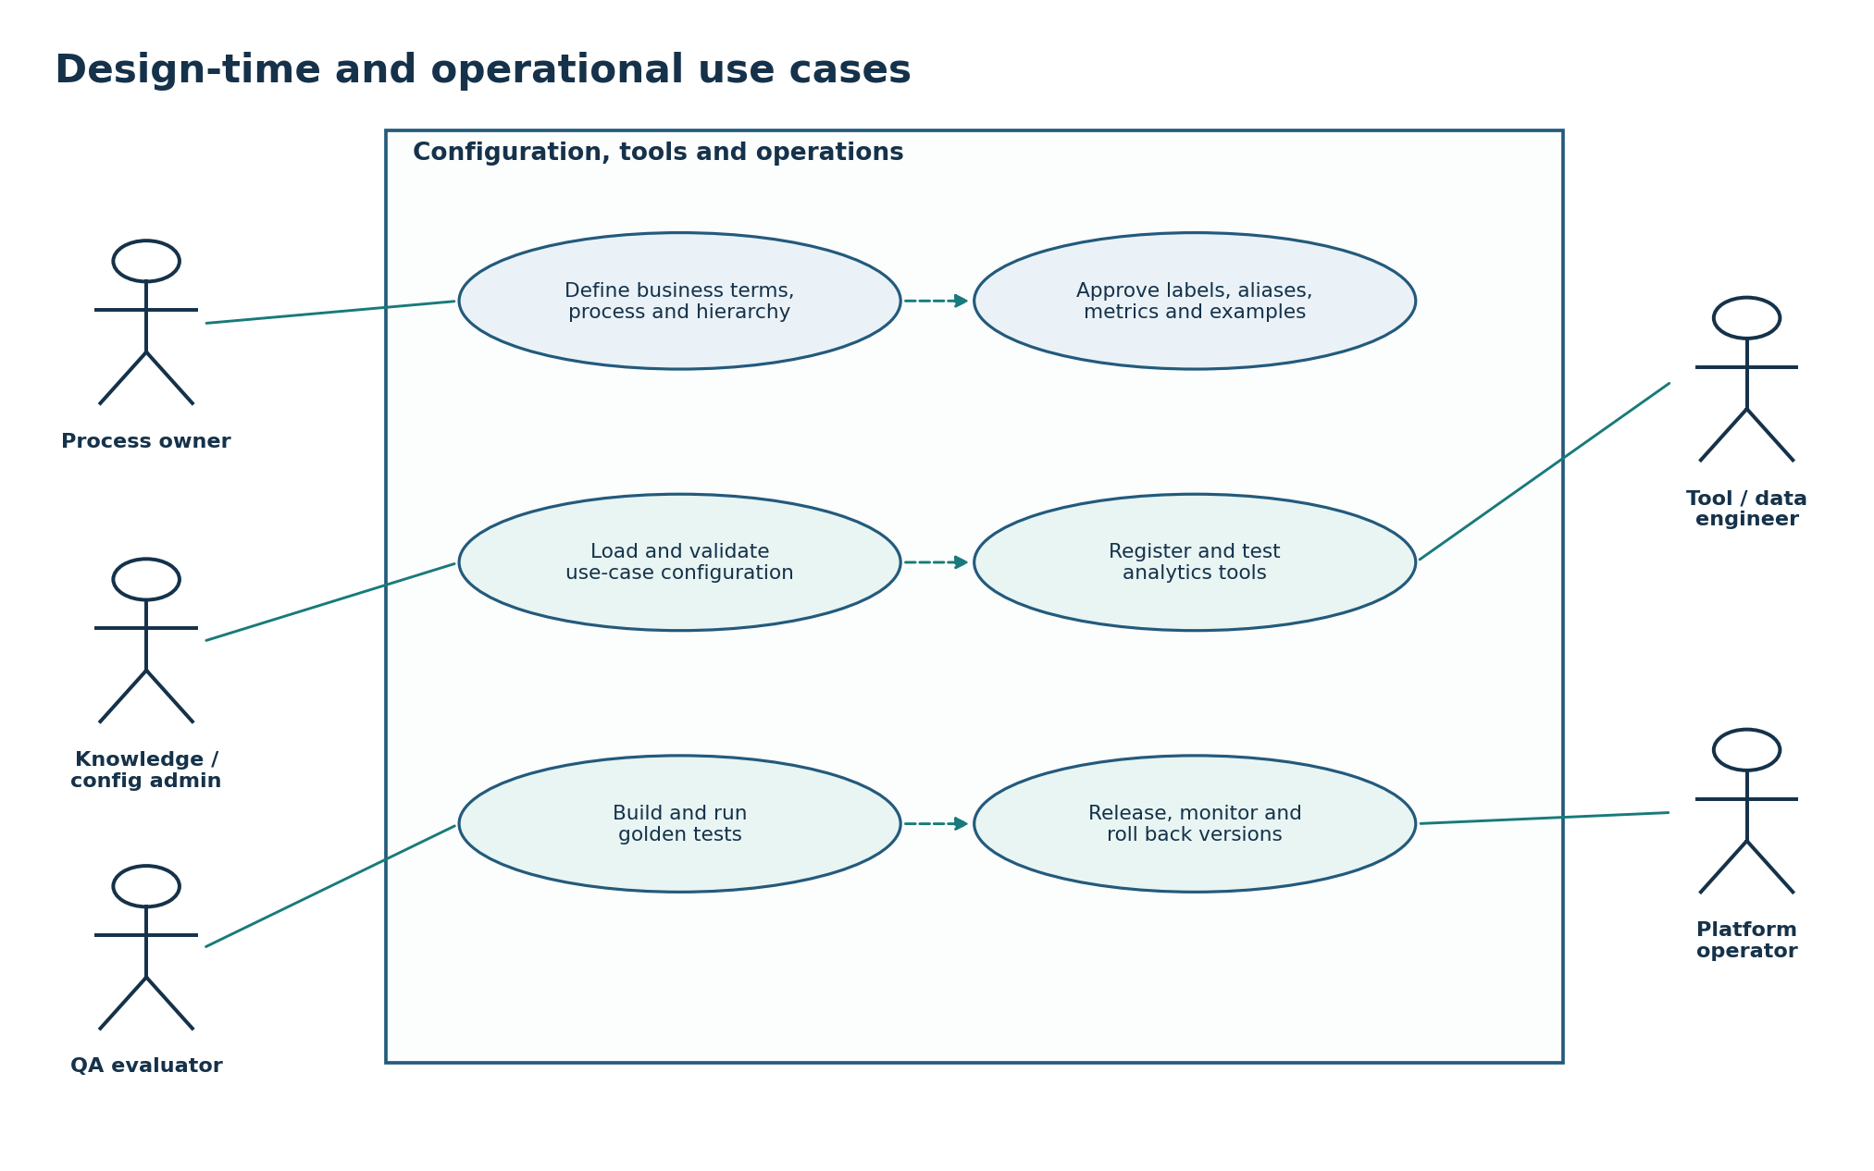
Figure 3. Process owners and administrators define business meaning; engineers register tools; evaluators test behavior; operators release and monitor versions.

UC-14 — Onboard or update a process use case
Field | Details
Primary actor(s) | Process owner, configuration administrator and data owner
Trigger / precondition | Approved source configuration and business definitions are available.
Main flow | 1. Collect process identity, owners, scope, timezone and status.  2. Load processes, subprocesses, activities, parent-child relationships and technical IDs.  3. Load metrics, dimensions, time rules, index mappings and enabled tools.  4. Load labels, aliases, examples and presentation preferences.  5. Run completeness, duplicate-ID, hierarchy, collision and compatibility checks.  6. Publish only after readiness approval.
Successful result | A versioned, validated process use case becomes available to the assistant.

UC-15 — Manage labels, aliases and hierarchy
Field | Details
Primary actor(s) | Process owner, SME and knowledge administrator
Trigger / precondition | A business term, process relationship or label needs creation or correction.
Main flow | 1. Record the official label and alternate terms with scope and source.  2. Check collisions across processes, applications, levels and item types.  3. Update parent-child paths and effective dates when needed.  4. Review and approve changes.  5. Regenerate meaning-search records and tests.  6. Publish a compatible version and invalidate affected caches/context.
Successful result | Users can use approved business language to identify the correct stored process items.

UC-16 — Register or update an analytics tool
Field | Details
Primary actor(s) | Tool engineer, analytics SME and QA
Trigger / precondition | A new analytical capability is ready for controlled integration.
Main flow | 1. Define tool ID, owner, purpose, version and status.  2. Define supported intents, processes, items, levels, metrics, filters and time ranges.  3. Define required/optional inputs, defaults, limits and validation rules.  4. Declare owned data-index groups and prepared query template.  5. Define result structure, units, freshness, coverage and errors.  6. Add positive, negative, limit and failure tests.  7. Release only after contract and business validation.
Successful result | The planner can select the tool only for supported, validated requests.

UC-17 — Validate and release a use case
Field | Details
Primary actor(s) | QA, product owner, process owner, tool owners
Trigger / precondition | Configuration, tools and test questions are ready.
Main flow | 1. Run knowledge completeness and hierarchy checks.  2. Run term-matching tests including aliases, typos and ambiguity.  3. Run intent, clarification, tool-selection and parameter tests.  4. Run result and presentation checks on representative data.  5. Review performance, freshness and operational readiness.  6. Approve, stage, release and record all versions; retain rollback target.
Successful result | A certified use case and compatible components are published.

UC-18 — Monitor, evaluate and improve
Field | Details
Primary actor(s) | Platform operator, evaluator and component owners
Trigger / precondition | The assistant is running or a release candidate is being evaluated.
Main flow | 1. Monitor latency, availability, tool errors, data freshness, cost and user outcomes.  2. Measure intent, term matching, clarification, tool selection and grounded-answer quality.  3. Find unresolved terms, repeated reformulations and incorrect-tool patterns.  4. Route issues to knowledge, tool, data, prompt, UX or platform owners.  5. Create regression tests before applying reviewed changes.  6. Roll back incompatible releases when required.
Successful result | Quality and operational problems lead to traceable, tested improvements.

7. Detailed example sequence
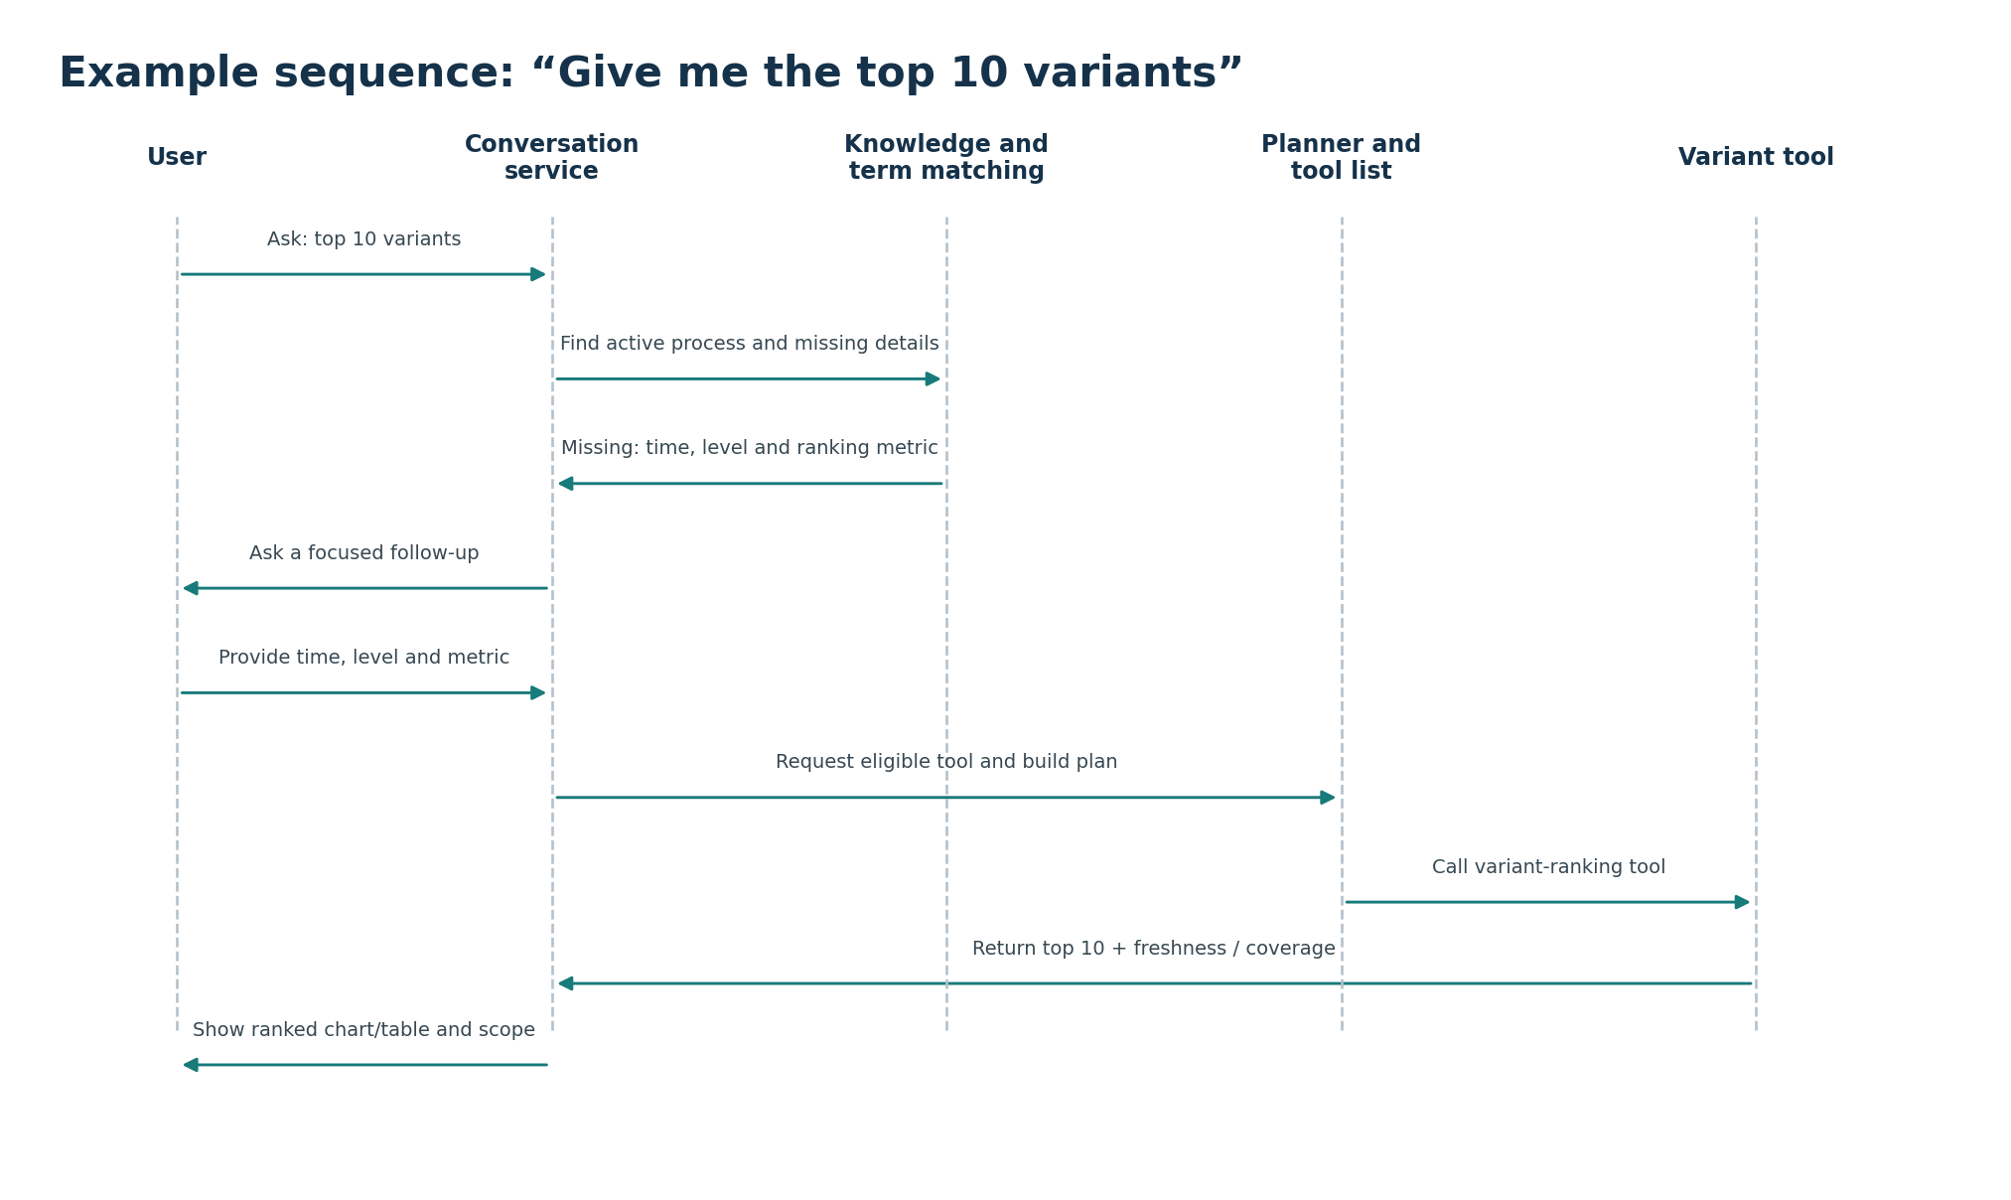
Figure 4. The “top 10 variants” question requires clarification when process, time, level or ranking metric is missing. Only then is the variant-ranking tool called.

7.1 Example conversation
Turn | Speaker | Message | System state
1 | User | “Give me the top 10 variants.” | Goal=rank variants; process/time/level/metric may be missing.
2 | Assistant | “Which process do you want to analyze?” | Process scope required before data search.
3 | User | Selects or names a configured process. | Official process ID and configuration version resolved.
4 | Assistant | “Use the main process or a subprocess level?” | Level required because variant membership changes by level.
5 | User | “Main process.” | Root/main node resolved from configuration.
6 | Assistant | “What time range, and rank by journey count, average duration or exception rate?” | Time and metric required.
7 | User | “Last 7 days, by journey count.” | All required inputs resolved.
8 | System | Selects variant-ranking tool, validates parameters and executes approved query. | Tool result includes top 10, coverage and freshness.
9 | Assistant | Shows ranked chart/table and states process, level, last 7 days, journey count and data timestamp. | Answer trace stored for follow-up.

7.2 Why each clarification is required
Detail | Risk if guessed
Process | The same variant labels or activity sequences can exist in many process use cases.
Process level | One journey may belong to different variants at the root and subprocess levels.
Time range | Top variants can change from hour to hour or day to day.
Ranking metric | “Top” may mean most common, slowest, highest exception rate or another approved measure.

8. Core entities and relationships
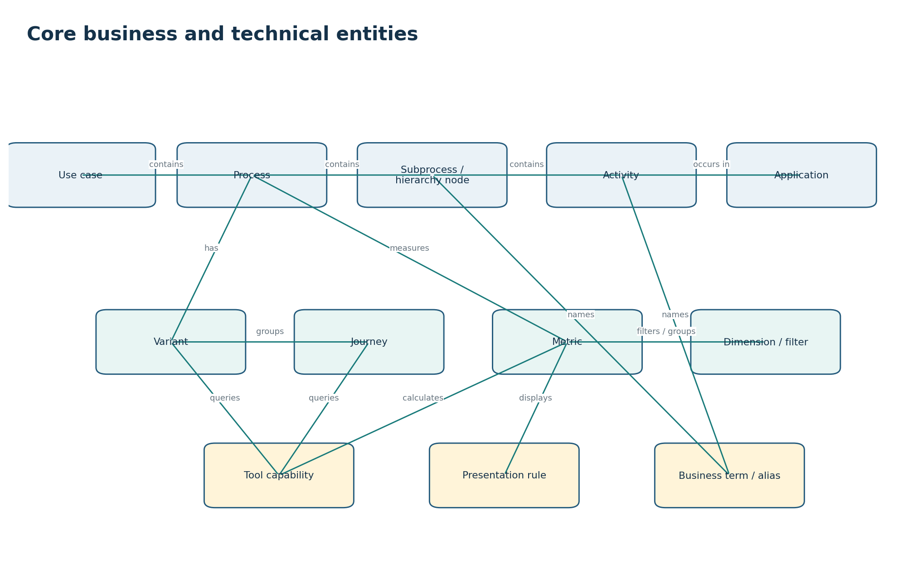
Figure 5. The official knowledge model connects use cases, process hierarchy, activities, applications, variants, journeys, metrics, tools, presentation rules and business terms.

8.1 Entity definitions
Entity | Business meaning | Minimum information
UseCase | One configured decision process available to the assistant. | use_case_id, name, description, owners, status, timezone, version, defaults, enabled tools.
Process | A process definition within a use case. | process_id, name, aliases, application/context, main/root indicator, start/end rules.
HierarchyNode / Subprocess | A node showing process levels and parent-child structure. | node_id, name, type, level, parent_id, path, process_id, active dates.
Activity | A process step mapped to event-log data. | activity_id, official/display names, aliases, application, parent node/process, source mapping.
Application | A source or business application associated with activities. | application_id/name, aliases, owners, process/activity relationships.
Variant | A unique journey pattern at a specific process level. | variant_id, level/node, signature/sequence, label, first/last seen, status/version.
Journey | One process instance with ordered events. | journey_id, process, timestamps, status, attributes, variant membership by level.
Metric | A defined measure used in analytics. | metric_id, name, definition, formula, unit, aggregation, direction, allowed items/levels.
Dimension / Filter | A field used to narrow or group results. | dimension_id, label, type, operators, values/source mapping, applicability.
BusinessTerm / Alias | Another business phrase for an official item. | term, normalized term, locale, target_id/type, source, approval, effective dates, collision scope.
ToolCapability | A registered analytical function. | tool_id/version, supported operations/items/metrics, inputs, limits, data ownership, result/errors.
PresentationRule | A rule for selecting and configuring an output. | conditions, component type, fields, labels, units, limits, fallback and accessibility.
ConversationContext | Temporary state for a conversation. | conversation_id, active process, resolved items, prior result references, time/filters, expiry.
ExecutionTrace | Record of how one answer was produced. | request, interpretation, matches, clarification, plan, tools, versions, result, presentation, feedback.

8.2 Relationship rules that must be decided
- Whether IDs are globally unique, use-case unique or version-specific.
- Whether one activity may belong to several processes or hierarchy nodes.
- How “main process” is marked when levels differ by use case.
- How variant identity and journey membership change by hierarchy level.
- How process, event, snapshot and configuration versions are connected.
- Which source owns the final meaning when business configuration and analytics implementation disagree.

9. Functional requirements
Each requirement is linked to one or more use cases. Priorities and release phases should be agreed after stakeholder review.

A. Question, conversation and clarification
ID | Use case(s) | Functional requirement
FR-001 | UC-01 | The system shall accept natural-language process questions and create a request and conversation ID.
FR-002 | UC-01, UC-12 | The system shall maintain valid conversation context and expire or invalidate stale references.
FR-003 | UC-02 | The system shall use an explicit selected process when provided.
FR-004 | UC-02 | The system shall search approved process names and aliases when process scope is not explicit.
FR-005 | UC-02, UC-05 | The system shall ask the user to select when more than one process remains possible.
FR-006 | UC-03 | The system shall create a structured request containing goal, subject, metric, time, level, filters, grouping, comparison, limit and output preference as applicable.
FR-007 | UC-05 | The system shall identify which required details are missing or conflicting.
FR-008 | UC-05 | The system shall ask a focused follow-up when guessing could materially change the answer or selected tool.
FR-009 | UC-05 | Clarification choices shall use business labels and useful parent/application context rather than raw technical IDs.
FR-010 | UC-12 | The system shall support follow-up references only when they map to stable, visible prior result items.

B. Knowledge and term matching
ID | Use case(s) | Functional requirement
FR-011 | UC-04 | The system shall match official names, approved aliases, abbreviations, partial names, common misspellings and meaning-based paraphrases.
FR-012 | UC-04 | Candidate search shall be limited by selected process and expected item type whenever possible.
FR-013 | UC-04 | Meaning-based search results shall be treated as candidates and checked against official records before acceptance.
FR-014 | UC-04 | Every important match shall record selected ID, item type, evidence, confidence, alternatives and knowledge version.
FR-015 | UC-04, UC-05 | The system shall clarify when two candidates could produce materially different answers.
FR-016 | UC-07 | The system shall support process, subprocess, parent, child, main/root and numbered-level language from configuration.
FR-017 | UC-14 | The knowledge store shall keep official records separate from derived search text and vectors.
FR-018 | UC-14, UC-15 | Knowledge records shall support owners, status, approval, source, version, effective dates and validation results.
FR-019 | UC-15 | The system shall detect duplicate IDs, alias collisions, broken hierarchy links and missing required mappings.
FR-020 | UC-15, UC-17 | Knowledge and meaning-search versions shall be released and rolled back together or through tested compatibility rules.

C. Tool discovery, planning and execution
ID | Use case(s) | Functional requirement
FR-021 | UC-06, UC-16 | The platform shall maintain a machine-readable registry of active tools and capabilities.
FR-022 | UC-16 | Every tool shall declare supported goals, item types, levels, metrics, dimensions, filters, time ranges and use-case eligibility.
FR-023 | UC-16 | Every tool shall define required and optional inputs, validation, limits, data ownership, query-template version, result structure and errors.
FR-024 | UC-06 | The planner shall remove tools that do not support the resolved request or whose required inputs are missing.
FR-025 | UC-06 | The planner shall prefer one complete purpose-built tool when available.
FR-026 | UC-06, UC-10 | The planner shall use multiple tools only when an approved sequence, join key, level rule and failure policy exist.
FR-027 | UC-06 | Every tool parameter shall record whether it came from the user, conversation, official configuration, an approved default or a prior tool step.
FR-028 | UC-06 | The tool gateway shall validate IDs, enums, ranges, filters, time, level, limits and policy before execution.
FR-029 | UC-06, UC-16 | Tools shall not accept arbitrary Elasticsearch query code generated by the LLM.
FR-030 | UC-08, UC-09, UC-10 | Tools shall return success, no data, partial data, invalid request, unavailable data, timeout and internal failure as distinct statuses.
FR-031 | UC-08, UC-09, UC-10 | Tools shall enforce timeouts, result limits, pagination, bucket limits, concurrency and query budgets.
FR-032 | UC-16 | Cross-data-store analysis shall be owned by a named tool with documented combination and reconciliation rules.

D. Process, metrics, variants and journeys
ID | Use case(s) | Functional requirement
FR-033 | UC-07 | The system shall retrieve process definitions and hierarchy from approved configuration.
FR-034 | UC-07 | The system shall return a list, tree or process view based on requested scope and result size.
FR-035 | UC-08 | Metric requests shall resolve an approved metric definition, unit, aggregation, entity applicability and time rule.
FR-036 | UC-08 | Comparisons shall use compatible units, populations, hierarchy scope and time periods.
FR-037 | UC-09 | Variant requests shall require or resolve process level, time range, metric and bounded result limit.
FR-038 | UC-09 | Variant results shall include level, variant ID/label, selected metric, time scope, freshness and coverage.
FR-039 | UC-10 | Journey lookup from a variant shall include the variant level as part of the membership key.
FR-040 | UC-10 | Journey results shall use pagination and translate technical activity IDs into approved business labels.
FR-041 | UC-10 | Path questions shall declare direction, depth, process scope, time range and filters.
FR-042 | UC-08, UC-09, UC-10 | The system shall distinguish zero, no match, not applicable, not ingested, stale data and tool failure.

E. Result checking and presentation
ID | Use case(s) | Functional requirement
FR-043 | UC-11 | The system shall check result structure, requested scope, time, units, freshness, coverage, warnings and limits before presentation.
FR-044 | UC-11 | The system shall select only presentation types supported by the result and client channel.
FR-045 | UC-11 | The system shall support concise text, tables, KPI cards, charts, hierarchy trees, process flows, variant views and journey timelines where applicable.
FR-046 | UC-11 | Every answer shall show or make available the process scope, level, time, filters, approved defaults, freshness and important limitations.
FR-047 | UC-11 | Narrative statements and computed highlights shall use only validated returned data or approved process information.
FR-048 | UC-11 | The system shall not state causal conclusions unless an approved diagnostic capability supports them.
FR-049 | UC-11 | Large category, node or series counts shall use top-N, pagination, aggregation or a simpler fallback and disclose the limit.
FR-050 | UC-11 | Every visual result shall provide a readable text alternative and color-independent meaning.

F. Onboarding, lifecycle, evaluation and operations
ID | Use case(s) | Functional requirement
FR-051 | UC-14 | The platform shall provide a standard onboarding package for identity, ownership, process structure, activities, metrics, data mappings, tools, language and examples.
FR-052 | UC-14 | The onboarding pipeline shall generate a readiness report and block release on critical failures.
FR-053 | UC-15 | Alias and hierarchy changes shall require an owner, source, review status and effective date.
FR-054 | UC-16 | Tool registration shall require contract tests, representative data tests, negative tests and limit tests.
FR-055 | UC-17 | A release shall pin or record compatible configuration, knowledge, search, model/prompt, tool and presentation versions.
FR-056 | UC-17 | The platform shall support staged release, rollback, replacement and deprecation.
FR-057 | UC-18 | Every production answer shall create a trace across question, context, interpretation, matches, clarification, plan, tools, result and presentation.
FR-058 | UC-18 | The platform shall measure intent accuracy, term-match accuracy, clarification quality, tool-selection accuracy, parameter accuracy and grounded-answer quality.
FR-059 | UC-13, UC-18 | User feedback shall be attached to the complete answer trace and routed to the relevant owner.
FR-060 | UC-13, UC-15 | One user correction shall not automatically become a global alias or production rule.
FR-061 | UC-18 | The platform shall monitor latency, availability, tool failures, data freshness, cost, unresolved terms and reformulation rate.
FR-062 | UC-18 | Reviewed production failures shall become regression tests before the related fix is released.
FR-063 | UC-01–UC-18 | The system shall validate authorization context before returning process knowledge or analytics data; detailed authorization design is handled separately.
FR-064 | UC-18 | User-safe errors and operator-actionable diagnostic codes shall be provided for all major failure classes.

10. Requirement traceability and acceptance

10.1 Use-case-to-component trace
Use cases | Main components | Primary evidence
UC-01–UC-03 | Conversation, context and understanding | Structured request tests and conversation examples.
UC-04–UC-05 | Knowledge search, term matching and clarification | Golden labels/aliases, ambiguity cases and confidence evaluation.
UC-06 | Tool registry, planner and gateway | Expected tool/parameter tests and unsupported cases.
UC-07–UC-10 | Process, metric, variant, journey and path tools | Contract tests, representative data and result reconciliation.
UC-11–UC-13 | Result checker, presentation, context and feedback | Narrative/data consistency, visual rules, follow-up and feedback tests.
UC-14–UC-17 | Ingestion, knowledge lifecycle, tool lifecycle and release | Readiness reports, approval records, compatibility and rollback tests.
UC-18 | Monitoring, trace and evaluation | Dashboards, trace samples, alerts, golden-set results and regression reports.

10.2 Minimum end-to-end acceptance scenarios
Scenario | Expected behavior
Top variants with missing details | Assistant asks for process, level, time and ranking metric before calling the variant tool.
Ambiguous activity label | Assistant shows approved candidates with parent/application context and waits for user selection.
Process hierarchy question | Assistant uses configured root/level/parent relationships and returns a tree or clear list.
Metric comparison | Assistant validates metric, unit, time and comparable subjects before presenting the comparison.
Journey drill-down | Assistant uses stable prior variant selection, includes variant level, paginates journeys and labels activities.
Unsupported analysis | Assistant states the missing capability and suggests the closest supported question; it does not generate a direct database query.
Stale or partial data | Assistant labels freshness and coverage and follows the configured stop/partial-result policy.
Configuration update | New aliases/hierarchy/tool versions are validated, released compatibly and traceable; affected caches/context are invalidated.
Incorrect answer feedback | Feedback is linked to the answer trace and routed without automatically changing production knowledge.

10.3 Open decisions that block detailed implementation
- ID uniqueness and version rules for use cases, processes, hierarchy nodes, activities, variants and journeys.
- Exact meaning of main/root process and numbered levels for each configuration style.
- Metric definitions, units, time fields, approved defaults and no-data rules.
- Index ownership and approved combinations among snapshot, variant, journey-to-variant and journey data.
- Confidence thresholds and clarification policy by item type and business risk.
- Tool contracts, limits, error catalogue and result envelope.
- Conversation context expiry and invalidation after configuration change.
- Workload, latency, availability, freshness, cost and evaluation targets.

Appendix A. Use-case specification template
Field | What to document
Use-case ID and name | Stable ID and plain outcome-oriented name.
Goal | Business result the actor needs.
Primary and supporting actors | People and systems involved.
Trigger | Event that starts the use case.
Preconditions | Required state, configuration, data and access.
Required information | Fields needed to complete the use case.
Main flow | Normal actor/system steps in order.
Alternate flows | Missing, ambiguous, no-data, partial, stale, unsupported and failure behavior.
Postconditions | Successful system state and returned result.
Business rules | Defaults, limits, approval and interpretation rules.
Related entities | Use case, process, activity, variant, journey, metric, tool and trace records.
Functional requirements | Requirement IDs implemented by the use case.
Acceptance tests | Inputs and observable expected results.

Appendix B. Baseline statement
Baseline: The assistant converts a natural-language process question into a structured and validated request. It uses configuration to understand business terms, asks follow-up questions when required, selects only registered tools, checks returned data and presents an answer that is understandable, traceable and appropriate for the result. The capability grows safely as new tools and process configurations are onboarded.

