Process Intelligence Assistant
Essential Knowledge Base Metadata Guide
The important information required for accurate entity understanding, journey and variant retrieval, tool selection, and clear presentation
Item | Definition
Audience | Business process owners, process-mining teams, product managers, AI/application engineers, data owners, UX and QA.
Phase 1 scope | Journey and variant discovery and detail questions. No counts, rankings, averages, trends or other aggregate analysis.
Purpose | Define a practical set of metadata that is complete enough for reliable answers without collecting unnecessary detail.
Example used | A fictional Customer Order Fulfillment process is used only to make the metadata easy to understand.

Architectural principle: Store business meaning and canonical identity as structured metadata. Use semantic matching to find candidates, but validate the final process, node, activity, variant and tool inputs using approved structured records.

1. What the knowledge base must do
A business user should not need to know an internal process ID, hierarchy node, activity ID, variant ID, index name or field name. The knowledge base translates familiar business language into these technical references and tells the assistant what it can safely retrieve.
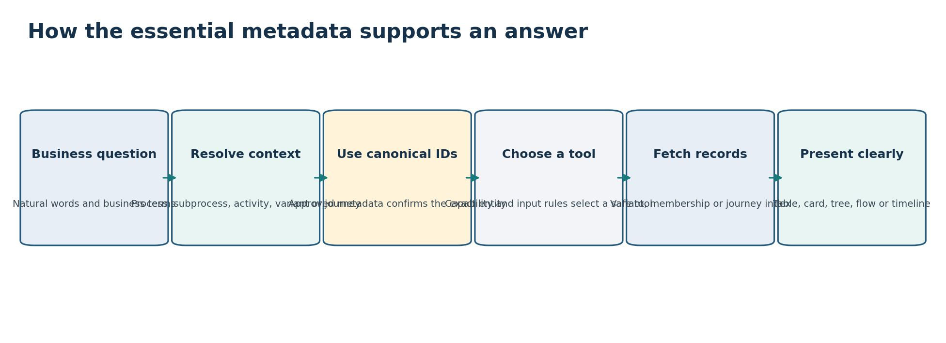
Figure 1. Essential metadata connects natural language to a canonical entity, controlled tool, operational data and suitable presentation.

1.1 The six questions the metadata must answer
Question | What the knowledge base must provide
Which process is the user talking about? | Process name, description, aliases and business scope.
Which part of the process? | Main/root node, subprocess hierarchy, level meaning and node aliases.
Which business step or system? | Activity labels/aliases, event IDs and system relationships.
Which path or journey? | Variant identity, business classification, activity sequence and journey membership.
How should the information be retrieved? | Tool purpose, required inputs, supported questions, limits and returned fields.
How should the answer be shown? | Presentation rule based on question type, result shape and size.

1.2 Information we deliberately do not need in the initial knowledge base
- Full journey and event records; they remain in the journey index.
- Calculated counts, averages, rankings or performance measures; they are outside Phase 1.
- Every technical implementation detail of a system when it does not help entity resolution or tool execution.
- Large free-form documents without structured IDs, scope and approval.
- Unreviewed model-generated aliases or variant labels treated as business truth.

2. Essential entity model
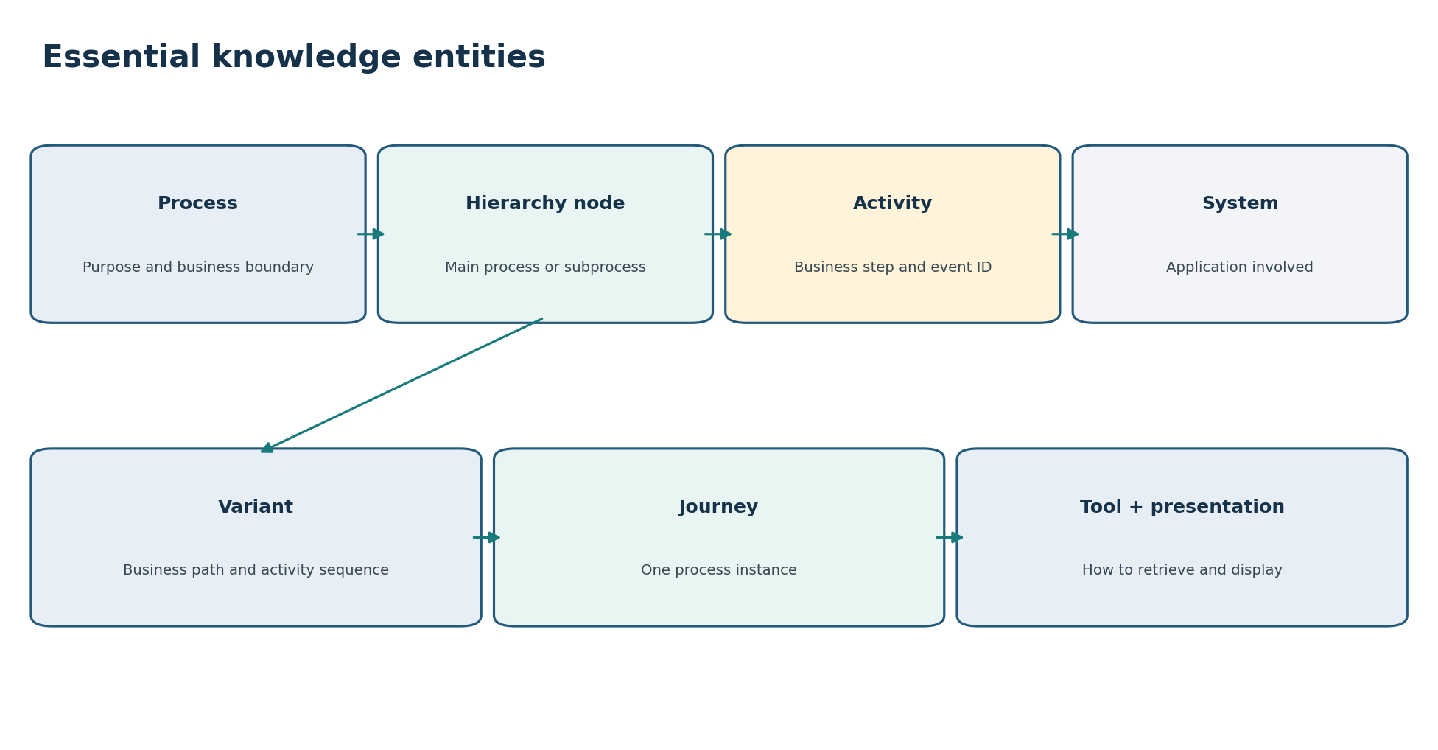
Figure 2. The process is the main scope; hierarchy nodes organize activities and variants; systems add context; journeys link to variants; tool and presentation metadata control retrieval and display.

2.1 Entities included
Entity | Plain-language meaning | Why it matters
Process / use case | The business process being analyzed. | Creates the main boundary for all searches.
Hierarchy node / level | The main process or a subprocess within it. | Tells the assistant where an activity or variant belongs.
Activity | A business step represented by an event. | Connects business wording to event-log values.
System / application | An application that performs or records process work. | Helps distinguish similar activities and explain handoffs.
Variant | A distinct ordered path through one process node. | Supports path discovery, explanation and journey membership.
Journey | One process instance and its ordered events. | Supports record lookup and timeline display.
Alias / business term | An alternate word users may say. | Bridges natural language to a canonical entity.
Data binding | The index family, keys and important fields used by tools. | Connects knowledge to the correct data store.
Intent / capability | A supported type of user request. | Limits the tools the assistant may choose.
Tool | A controlled retrieval operation. | Prevents direct LLM-generated queries.
Presentation rule | The rule for showing returned information. | Produces consistent and useful answers.
Example question | A prompt with expected meaning and behavior. | Supports evaluation and continuous improvement.

Minimum rule: Every production entity needs a canonical ID, approved name, short description, valid scope, status/version, source and owner. Entity-specific fields are added only where they help understanding or execution.

3. Process or use-case metadata
This is the root record. It gives the assistant enough business context to distinguish the process, explain it and constrain all later matching and retrieval.
Information to store | Why the assistant needs it | Importance | Simple example
Canonical process ID | Supplies the exact scope used by hierarchy, entity resolution and tools. | Required | proc-order-fulfillment
Official name and short name | Provides the label shown to users and a compact conversational name. | Required | Customer Order Fulfillment / Order Fulfillment
Plain-language description | Lets the assistant explain what the process covers and compare it with similar processes. | Required | From accepted order through shipment confirmation or cancellation.
Business purpose | Helps understand why the process exists and interpret user questions. | Required | Fulfill valid customer orders.
Included and excluded scope | Prevents the assistant from using the process for the wrong cases. | Required | Includes domestic orders; excludes returns.
Journey meaning | Explains what one process instance represents. | Required | One accepted customer order.
Start and end definitions | Explains journey boundaries and labels journey timelines correctly. | Required | Starts at Order Accepted; ends at Shipped or Cancelled.
Business domain | Helps narrow searches when processes have similar names. | Important | Sales Operations
Process aliases | Matches abbreviations, former names and common business terms. | Important | OF; order-to-ship
Main/root hierarchy node | Provides the answer to “main process” without guessing a level. | Required | node-order-main
Participating systems | Adds useful context and connects activity/system phrases. | Important | OMS, payment service, WMS
Supported capabilities | Stops the assistant from offering unavailable journey/variant functions. | Required | Variant list/detail; journey membership/detail
Known data limitation | Allows honest answers about freshness, missing data or retention. | Important | Events can be delayed up to 10 minutes.
Owner, status and version | Ensures only approved and current metadata is used. | Required | Order Process Owner; approved; v3

3.1 Example business explanation
Assistant explanation: Customer Order Fulfillment covers the work from accepting an order until it is shipped or cancelled. It includes validation, payment and warehouse subprocesses. Returns are handled by a separate process.

4. Hierarchy node and level metadata
A hierarchy should be stored as named nodes with parent-child links. A level number alone is not enough because ‘level 2’ can mean different subprocesses in different processes.
Information to store | Why the assistant needs it | Importance | Simple example
Canonical node ID | Provides the exact subprocess scope for activities, variants and tools. | Required | node-payment
Node name | Provides the approved business label. | Required | Payment Processing
Node description or purpose | Helps the assistant explain what happens in the subprocess. | Required | Authorizes and records customer payment.
Parent node ID | Builds the hierarchy and supports main-process/subprocess navigation. | Required except root | node-order-main
Root/main indicator | Identifies the main process deterministically. | Required | false
Display level and level name | Supports user phrases such as ‘level 2’ and explains what that level means. | Important | 2 / Operational subprocess
Node aliases | Matches business names and abbreviations for the subprocess. | Important | payment; pay flow
Entry and exit activities | Makes subprocess boundaries understandable. | Important | Start Payment / Payment Completed
Variant support and definition | Tells the assistant whether variant questions are valid at this node. | Required | Variants calculated from node-level activity sequence.
Allowed tools | Prevents a tool from running at an unsupported level. | Required | variant_catalog_search, variant_get
Status and version | Keeps relationships consistent when hierarchy changes. | Required | approved; hierarchy v2

4.1 Easy hierarchy example
Level | Node | Parent | What a user may say
1 | Order Fulfillment | — | main process; order flow
2 | Order Validation | Order Fulfillment | validation subprocess
2 | Payment Processing | Order Fulfillment | payment; pay flow
2 | Warehouse Fulfillment | Order Fulfillment | warehouse; pick-pack

Important: When a user says “show level 2,” the assistant still needs the process and the requested action. If level 2 contains several subprocesses, it should show or ask the user to select the relevant node.

5. Activity metadata
Activity metadata is the key translation layer between business language and event-log values.
Information to store | Why the assistant needs it | Importance | Simple example
Canonical activity ID | Supplies the exact value used in variant sequences and journey events. | Required | act-payment-authorized
Business display name | Provides the understandable label shown in answers. | Required | Authorize Payment
Plain-language description | Distinguishes activities with similar or technical names. | Required for ambiguous activities | Requests and records payment authorization.
Activity aliases | Matches abbreviations and alternate business wording. | Important | payment auth; authorize card
Process and valid node IDs | Prevents the same phrase from resolving to an activity in the wrong process/subprocess. | Required | Order Fulfillment / Payment Processing
Source event name or code | Maps the business activity to the actual event-log value. | Required | PAY_AUTH_OK
System ID | Helps distinguish similar activities and explain which application performs them. | Important | sys-payment-gateway
Activity type | Improves explanation and presentation. | Important | automated; manual; decision; start; end
Start/end or terminal meaning | Supports process boundaries and journey status interpretation. | Required when applicable | is_terminal: false
Repeat behavior | Helps explain repeated events in a journey. | Useful | May repeat after retry.
Status and version | Prevents retired or remapped activity values from being used as current truth. | Required | approved; mapping v2

5.1 Example resolution
User phrase | Context | Resolved entity | Why
payment auth | Order Fulfillment → Payment Processing | act-payment-authorized | Approved alias in the selected node.
review | No process/node selected | Clarification required | Could mean an activity, variant class or user action.
review | Payment Processing selected | act-manual-payment-review | Only if it is the approved scoped alias; otherwise show candidates.

6. System or application metadata
System metadata adds business context. We only need enough information to recognize system names, connect activities and explain important handoffs.
Information to store | Why the assistant needs it | Importance | Simple example
Canonical system ID | Provides a stable reference from activities and data mappings. | Required | sys-wms
Official and short name | Lets the assistant recognize and display the system. | Required | Warehouse Management System / WMS
Aliases or former names | Matches terms used by business and technical teams. | Important | warehouse app
Simple purpose | Explains the system’s role without unnecessary technical detail. | Required | Controls picking, packing and shipment handoff.
Role in this process | Provides process-specific context. | Required | Produces warehouse fulfillment activities.
Related activity IDs | Lets a system phrase find the correct activities within scope. | Important | Pick Item, Pack Order
Important system handoffs | Helps explain transitions between subprocesses or applications. | Useful | Receives released order from OMS.
Source system value | Maps the registered system to values found in event data. | Required if displayed/filtered | application_id=WMS01
Owner, status and version | Supports correction and lifecycle changes. | Required | Warehouse Technology; active

Do not over-collect: The knowledge base does not need server names, deployment topology or internal APIs unless a Phase 1 tool needs them. Store business purpose, aliases, activity relationships and the data identifier used in events.

7. Variant metadata
A variant is a distinct ordered path at a specific process node. The metadata must identify the variant, explain the sequence and record any approved business meaning such as happy path or manual-review path.
Information to store | Why the assistant needs it | Importance | Simple example
Canonical variant ID | Supplies the exact key for variant detail and journey membership tools. | Required | var-payment-manual-01
Process and node ID | Defines where the path is valid. | Required | Order Fulfillment / Payment Processing
Variant name | Provides an understandable label; may be curated or generated. | Required | Manual Review Then Approval
Activity sequence | Allows the assistant to show and explain the path in order. | Required | Start Payment → Manual Review → Authorize
Technical signature | Connects the business record to the unique path stored by the platform. | Required | sequence hash/signature
Variant definition version | Prevents variants calculated with different rules from being mixed. | Required | variant algorithm v3
Variant aliases | Matches business names for a known path. | Important | manual approval flow
Business classification | Supports terms such as happy path, straight-through, manual-review, exception or cancellation. | Important when promised | manual_review_path
Classification definition | Explains why the business label applies. | Required with classification | Contains Manual Review before authorization.
Classification approval/source | Prevents the model from inventing business meaning. | Required with classification | Approved by Payment Process Owner
Lifecycle status | Prevents retired variants from appearing as current without warning. | Required | active; retired; merged
Membership version | Keeps journey-to-variant lookup compatible with the catalogue. | Required | membership v12

7.1 How to model business paths
Business term | What must be defined | Assistant behavior
Happy path | Approved rule or exact variant IDs for one process node and version. | Resolve one or list several; do not assume universal meaning.
Straight-through path | Which manual/exception activities are excluded and which successful end is required. | Do not treat it as automatically equal to happy path.
Manual-review path | The activity IDs or approved variant IDs that make the classification true. | Explain the classification and list matching variants if more than one.
Exception/cancellation path | Approved exception or terminal activity rule. | State the configured meaning; do not invent a cause.

Example: ‘Happy path’ may refer to three approved variants in the Order Fulfillment main process. The assistant should say it is a business category and show the three variants, not silently select one.

8. Journey and membership metadata
The knowledge base does not store all journeys. It stores the minimum schema knowledge required to find one journey, display it correctly and connect it to a variant.

8.1 Journey schema metadata
Information to store | Why the assistant needs it | Importance | Simple example
Journey ID field and meaning | Allows exact lookup and explains what the identifier represents. | Required | journey_id; one accepted order
Process scope field | Prevents cross-process lookup. | Required | process_id
Status field and meanings | Supports completed/in-progress/cancelled questions and labels. | Required | COMPLETE → Completed
Start, end and update times | Supports journey display, date filters and the meaning of ‘latest.’ | Required | journey_start_utc
Event/activity field | Maps journey events to canonical activities. | Required | events.activity_id
Event timestamp and ordering rule | Ensures the timeline is shown in the correct order. | Required | event_time then ingestion_sequence
Allowed fields to show | Prevents accidental display of unsupported or sensitive attributes. | Required | status, channel, event labels/times
Allowed search fields | Limits journey_search to safe indexed filters. | Required if search enabled | time, status, activity_id
Freshness and retention | Helps explain currentness and impossible date searches. | Important | Updated within 5 minutes; 13 months online
In-progress/late-event behavior | Warns users that an active journey can change. | Important | Path recalculated when late events arrive.

8.2 Journey-to-variant membership metadata
Information to store | Why the assistant needs it | Importance | Simple example
Journey ID + variant ID | Defines the relationship the lookup tool returns. | Required | J-100 → var-payment-manual-01
Process and node ID | Specifies the level at which the membership is valid. | Required | Payment Processing
Membership/algorithm version | Keeps the relationship compatible with variant definitions. | Required | membership v12 / algorithm v3
Assignment status | Distinguishes final, provisional or pending membership. | Important | provisional for in-progress journey
Calculated time/freshness | Explains when the assignment was produced. | Important | calculated_at
One/many rule | Tells the assistant whether a journey can have more than one active variant at the same node/version. | Required | One active membership
Missing-membership meaning | Supports an accurate message instead of ‘not found.’ | Important | Pending calculation; unsupported node; no data

9. Alias and business-term metadata
Aliases should be stored as scoped mappings, not as a global list of words. The same phrase can mean different things in different processes or subprocesses.
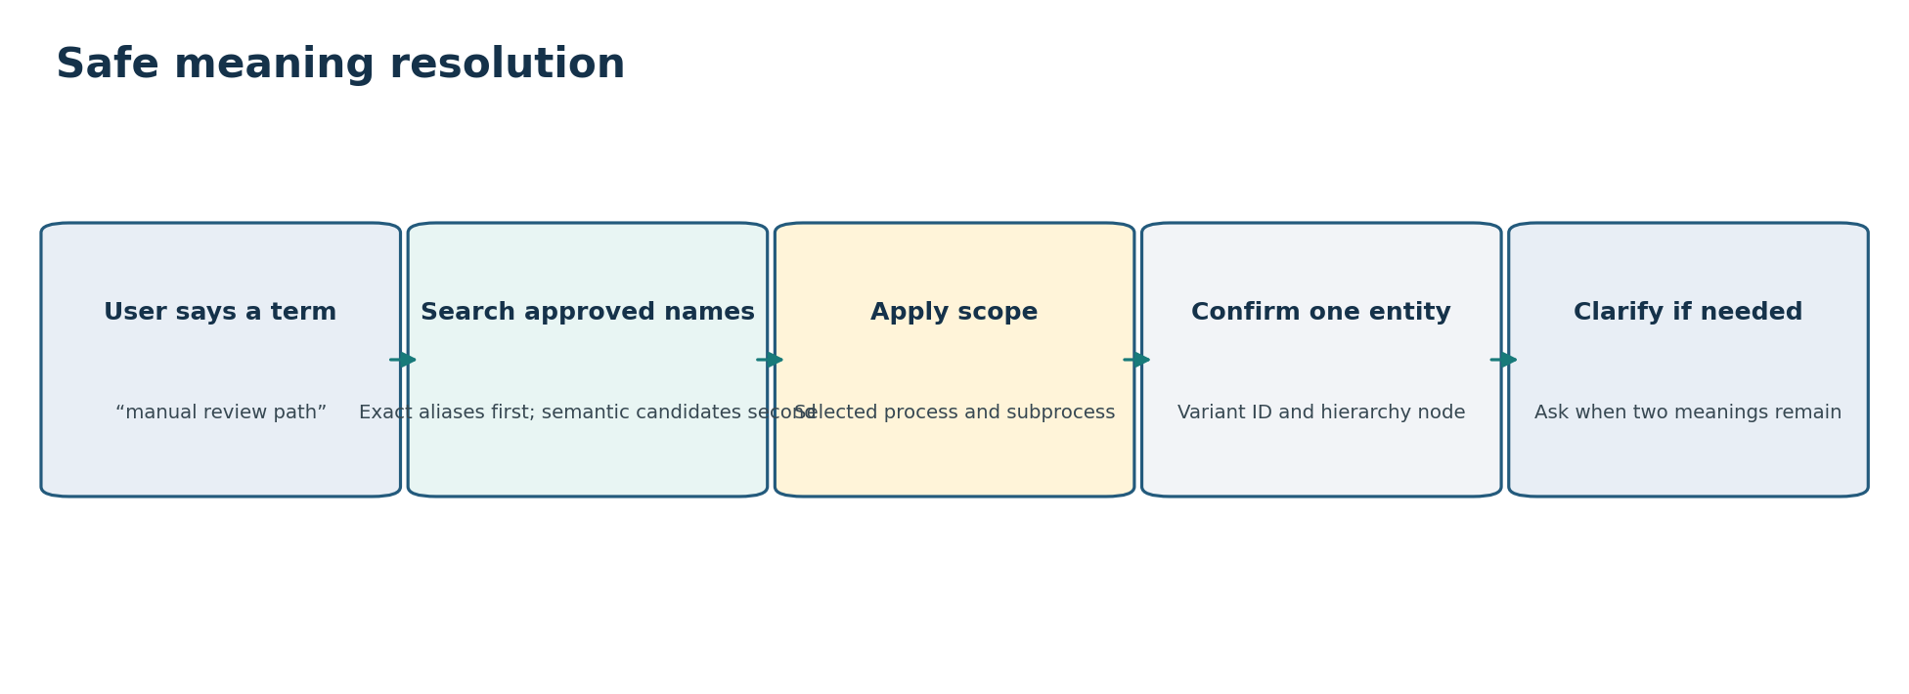
Figure 3. Exact approved names and aliases are preferred. Semantic retrieval suggests candidates; scope and structured metadata confirm or reject them.
Information to store | Why the assistant needs it | Importance | Simple example
Alias text | The word or phrase the user may say. | Required | manual approval flow
Target entity type and ID | Identifies exactly what the alias means. | Required | variant / var-payment-manual-01
Process and node scope | Prevents the same phrase from resolving incorrectly elsewhere. | Required for local terms | Order Fulfillment / Payment Processing
Alias type | Helps understand whether it is an abbreviation, synonym, former name or common misspelling. | Useful | business synonym
Priority | Ranks approved aliases when several candidates are available. | Useful | 90
Positive example | Shows how users use the term in a question. | Important | Show the manual approval flow.
Confusing or negative context | Prevents false matches. | Important for ambiguous terms | ‘Review this answer’ is an action, not the activity.
Source and approval | Prevents unverified language from becoming production truth. | Required | SME workshop; approved
Status/valid dates | Supports renamed entities and former terminology. | Required | active from 2026-07-01

9.1 Matching order
Order | Method | What happens
1 | Canonical ID or exact official name | Use the structured entity if scope and status are valid.
2 | Exact approved alias | Resolve inside the selected process/node.
3 | Fuzzy or semantic candidate search | Retrieve likely approved entity records inside scope.
4 | Structured validation | Check entity type, process, node, version and status.
5 | Clarification | Ask the user when two different valid meanings remain.

10. Data-binding metadata
Data-binding metadata connects canonical entities to the correct index family and fields. It belongs in the knowledge/configuration layer so the LLM never invents field names or Elasticsearch queries.
Information to store | Why the assistant needs it | Importance | Simple example
Logical index family | Tells the orchestrator which specialized tool owns the data. | Required | variant catalogue; journey-variant mapping; journey
Process/index binding | Shows that the process is available in that store. | Required | proc-order → journey_index_alias
Canonical key fields | Maps process, node, activity, variant and journey IDs to stored fields. | Required | variant_id: keyword
Important filter fields | Defines which time, status, activity or attribute filters tools may use. | Required where supported | status; start_time; activity_id
Field types and allowed values | Allows deterministic validation before a tool call. | Required | status enum; UTC date
Schema version | Prevents tools from using incompatible fields. | Required | journey schema v4
Cross-index join keys | Defines safe tool chains using canonical IDs. | Required | variant_id + node_id + membership_version
Freshness information | Lets the assistant state how current the result is. | Important | data_as_of
Supported query limits | Prevents broad or expensive retrieval. | Required | max page 25; max date range 30 days
Restricted fields | Prevents tools or presentations from exposing fields that are not allowed. | Required | payment token excluded

Important: Store logical data bindings, not raw query DSL in the LLM prompt. Each tool owns a prepared query template and accepts typed values such as process_id, node_id, variant_id, journey_id, time range and page size.

11. Intent and capability metadata
Intent metadata describes the supported kinds of questions. Capability metadata states whether a specific process/node can answer that intent.
Information to store | Why the assistant needs it | Importance | Simple example
Intent ID and plain description | Provides a stable name and explains the user goal. | Required | VARIANT_GET: show one variant’s details
Typical question patterns | Helps the model recognize the intent across different wording. | Important | Show variant X; explain this path
Required entities/inputs | Tells the assistant what must be resolved before a tool call. | Required | process_id, node_id, variant_id
Optional filters | Defines extra details the intent may accept. | Useful | include sequence
Clarification conditions | Tells the assistant when it must ask rather than guess. | Required | Ask when node or unique variant is missing.
Eligible tools | Limits tool selection. | Required | variant_get
Supported process/node conditions | Prevents unavailable capabilities from being offered. | Required | Only variant-enabled nodes
Presentation choices | Connects the intent to suitable formats. | Important | variant card + sequence
Unsupported/nearby intents | Prevents record tools from being used for aggregation. | Required | No top variants or count by variant
Examples | Supports prompt evaluation. | Important | positive, ambiguous and unsupported example

11.1 Essential Phase 1 intents
Intent | Meaning | Minimum inputs
VARIANT_LIST | List/search variants in one process node. | process_id, node_id, page size
VARIANT_GET | Show one variant and its sequence. | process_id, node_id, variant_id
JOURNEYS_FOR_VARIANT | Find bounded journey memberships for a variant. | process_id, node_id, variant_id, version, limit
JOURNEY_GET | Show one journey and ordered events. | process_id, journey_id
VARIANT_FOR_JOURNEY | Find a journey’s variant at a node. | process_id, node_id, journey_id, version
JOURNEY_SEARCH | Optional bounded search using approved fields. | process_id, time/filter/limit as configured
UNSUPPORTED_AGGREGATION | Counts, top, average, trend or ranking request. | No execution; explain Phase 1 boundary

12. Tool metadata
Each tool must be described clearly enough that the assistant understands what it does, why it exists, the information it needs and when it must not be used.
Information to store | Why the assistant needs it | Importance | Simple example
Tool ID and version | Provides the exact registered operation. | Required | variant_get:v1
Plain-language purpose | Tells the assistant what answer the tool returns. | Required | Retrieves one variant’s details and sequence.
Why the tool is needed | Clarifies data ownership and avoids selecting a similar tool. | Important | Variant catalogue owns variant identity and sequence.
Supported intents | Limits selection to appropriate questions. | Required | VARIANT_GET
Must-not-use cases | Blocks incorrect use such as aggregation or broad search. | Required | No journey counts or rankings.
Owned index family | Prevents arbitrary cross-index queries. | Required | variant catalogue
Required inputs | Defines what must be resolved before execution. | Required | process_id, node_id, variant_id
Optional inputs/defaults | Defines approved behavior when details are omitted. | Important | include_sequence=true
Input validation | Prevents node/version mismatch and oversized requests. | Required | Variant must belong to node; page <= 25.
Returned fields | Lets the LLM and presentation layer understand the result. | Required | variant ID/name/sequence/version/status
Limits and pagination | Keeps retrieval bounded and supports continuation. | Required for list tools | page_size, next_cursor
Errors and recovery | Allows useful clarification rather than a generic failure. | Required | UNKNOWN_VARIANT; NODE_MISMATCH
Allowed tool chain | Controls safe multi-index retrieval. | Important | variant_get → journey_membership_by_variant
Compatible presentations | Ensures the result can be shown correctly. | Required | variant card; sequence flow
Owner and status | Ensures the contract is current and supported. | Required | Variant Data Team; active

12.1 Phase 1 tools in plain language
Tool | What it does | Why separate
knowledge_resolve | Finds approved candidate processes, nodes, activities, systems or variants from a phrase. | Resolves language before operational retrieval.
variant_catalog_search | Lists or searches variants within one process node. | Variant catalogue owns path identity.
variant_get | Retrieves one variant’s details and activity sequence. | One-record detail is different from list search.
journey_membership_by_variant | Returns a bounded page of journey IDs assigned to one variant. | Membership index owns the relationship.
variant_membership_by_journey | Returns a journey’s variant at one selected node/version. | Supports the reverse relationship safely.
journey_get | Returns one journey and ordered approved events. | Journey index owns the full record.
journey_get_batch | Fetches a small known list of journeys after membership lookup. | Avoids unbounded per-record calls.
journey_search (optional) | Finds bounded journeys using only approved filters. | Included only if safe indexed search is available.

13. Presentation metadata
Presentation selection should be configured, not improvised. The rule should consider what the user asked, the result shape and the result size.
Information to store | Why the assistant needs it | Importance | Simple example
Presentation ID and name | Provides a stable renderer and understandable format name. | Required | journey_timeline:v1
Best use | Tells the assistant when the format is useful. | Required | One journey with ordered timestamped events.
Eligible intents/results | Prevents the format from being used for incompatible data. | Required | JOURNEY_GET / JourneyDetail
Required fields | Ensures the renderer has enough information. | Required | activity label and event time
Selection priority | Chooses among several valid formats. | Important | Timeline before table for journey detail.
Size threshold | Avoids unreadable diagrams and oversized responses. | Required | timeline up to 50 events
Important displayed fields | Keeps answers focused on what users need. | Important | journey ID, status, event labels/times
Sort/group rule | Keeps display deterministic. | Required | Use tool-provided event order.
Fallback | Provides a readable alternative when a visual cannot render. | Required | event table
Process-specific preference | Allows a process to add a useful column or label. | Useful | Show system name in event timeline.

13.1 Which presentation to choose
Presentation | Choose when | Example | Fallback
Entity card | One process, activity, system, variant or journey is the focus. | Show details for variant X. | Short label-value list
Table | Several comparable variants or journeys are returned. | List variants for Payment Processing. | Numbered list
Hierarchy tree | Parent-child process structure is the main information. | Show the main process and subprocesses. | Indented table
Variant sequence flow | One variant’s ordered activities are the focus. | Show the manual-review path. | Ordered activity list
Journey timeline | One journey’s ordered timestamped events are the focus. | Open journey J-100. | Event table
Side-by-side comparison | Two selected journeys or variants are compared as records. | Compare journey J-100 and J-101. | Comparison table
Short summary | The user asks for a definition or a very small result. | What is Payment Authorization? | Plain text

Phase 1 rule: Do not use KPI cards for calculated counts, averages or rankings. Those are aggregate results and require future analytics tools. A card is appropriate only as an entity-detail layout for one process, variant or journey.

14. Example-question metadata
Example questions are structured test cases. They show the assistant how business terms, missing details, tool plans and presentations should behave.
Information to store | Why the assistant needs it | Importance | Simple example
Question and paraphrases | Provides realistic natural-language wording. | Required | Show variants for Payment; list payment paths
Conversation context | Shows selected process/node or prior result references. | Important | Order Fulfillment already selected
Expected intent | Defines the supported user goal. | Required | VARIANT_LIST
Expected entities | Defines the correct canonical IDs. | Required | proc-order; node-payment
Missing information/clarification | Defines whether the assistant must ask a question. | Required | Ask for process if not selected.
Expected tool plan | Defines the correct tool and important parameters. | Required | variant_catalog_search(process,node,limit)
Forbidden behavior | Defines unsafe or incorrect actions. | Important | Do not search all processes.
Expected presentation | Defines primary format and fallback. | Required | Variant table / numbered list
Expected answer facts | Defines what must appear in the answer. | Important | Process/node scope and next-page option
Status and owner | Ensures the example is reviewed and current. | Required | Approved by QA and SME

14.1 End-to-end examples
User question | What must be resolved | Tool plan | Presentation
List variants for Payment Processing. | Process + node-payment | variant_catalog_search | Variant table
Show the manual-review path. | Process/node + approved alias/classification; clarify if multiple | knowledge_resolve → variant search/get | Choice list or sequence flow
Show journeys for this variant. | Selected variant/node/version + limit | journey_membership_by_variant | Journey table
Open the first journey. | Stable journey reference from prior table | journey_get | Journey card + timeline
Which variant contains journey J-100 at Payment Processing? | Process + node + journey + membership version | variant_membership_by_journey → variant_get | Variant card + sequence
Which variant is most common? | Aggregation intent | No Phase 1 tool | Explain scope and offer supported alternatives

15. Minimal governance metadata
Governance metadata should be simple but mandatory. It tells the system which records are trustworthy and who can correct them.
Information to store | Why the assistant needs it | Importance | Simple example
Owner/steward | Identifies the accountable team for meaning and corrections. | Required | Payment Process Owner
Source | Shows where the ID, mapping, alias or classification came from. | Required | Process configuration / SME workshop
Status | Prevents draft or retired knowledge from being used as current truth. | Required | draft; approved; deprecated; retired
Version | Keeps related metadata and tool bindings consistent. | Required | knowledge package v3
Effective date | Supports renamed or changed entities over time. | Important | Valid from 2026-07-01
Approval information | Confirms business review for important descriptions, aliases and path classifications. | Required | approved_by + approved_at
Last reviewed date | Identifies knowledge that may be stale. | Important | 2026-07-10
Known limitation | Ensures the assistant communicates important gaps. | Important | In-progress membership is provisional.

15.1 What must be approved by business owners
- Process purpose, scope, journey meaning and boundaries.
- Hierarchy labels, main/root designation and business meaning of levels.
- Activity display names, important aliases and plain-language descriptions.
- System names and their roles in the process.
- Business-path classifications such as happy path, manual-review path and exception path.
- Supported question types, required clarification behavior and important presentation fields.

15.2 What must be approved by technical/data owners
- Canonical IDs and relationships.
- Event/activity mappings, index families, keys, fields and schema versions.
- Variant algorithm and membership compatibility.
- Journey status/time semantics, event ordering and allowed fields.
- Tool contracts, filters, limits, errors and allowed tool chains.

16. Minimum knowledge package per process
A process should be enabled only when the following essential information is complete. This is the practical onboarding checklist.
Area | Minimum information required | Ready when
Process | ID, name, description, purpose, scope, journey meaning, start/end, aliases, root node. | Business owner approves.
Hierarchy | Node IDs/names, parent links, level meanings, aliases, variant-enabled nodes. | Tree has no missing links; root is clear.
Activities | IDs, labels, aliases, valid nodes, source event mapping, important system links. | Sample journey and variant sequences label correctly.
Systems | IDs, names, purpose, role and source data values. | Important system terms resolve correctly.
Variants | IDs, node, name, sequence, signature/version, lifecycle and promised business classifications. | Catalogue matches membership version.
Journey/membership | Key fields, status/time/event order, allowed fields, membership rule/version and freshness. | Known fixture journeys join correctly.
Aliases | Scoped approved aliases plus collision/clarification cases. | Pilot prompts resolve accurately.
Data bindings | Index families, keys, fields, types, schema versions, limits and restricted fields. | Tools validate against real sample data.
Intents/tools | Supported intents, required inputs, clarification, tool contracts, errors and allowed chains. | All supported prompt families execute; aggregates are blocked.
Presentation | Primary format, important fields, thresholds and fallback for each result type. | Every result has a readable display.
Examples/governance | Positive, ambiguous and unsupported prompts; owners, source, status, version and approval. | Business, data and QA sign off.

16.1 Recommended build order
Step | Deliverable
1 | Select pilot processes and approve supported journey/variant question families.
2 | Create process and hierarchy metadata.
3 | Create activity, system and scoped alias metadata.
4 | Define variant identity, sequence rules and approved business-path classifications.
5 | Define journey/membership schemas and data bindings.
6 | Register intent and tool metadata with required inputs, limits and errors.
7 | Register presentation rules and fallbacks.
8 | Create golden example questions and validate complete end-to-end flows.
9 | Publish one approved versioned knowledge package and monitor unknown terms and wrong matches.

Definition of ready: A business user can ask an approved journey or variant question using normal business terms; the assistant can resolve or clarify the entities, call the correct bounded tool using canonical IDs, and show the result in an approved format with process/node scope and freshness visible.

Appendix. Simple metadata collection form
Use this one-page form as the starting point for every process, node, activity, system, variant, tool or presentation record.
Question | Response
What type of entity is this?
What is its canonical ID?
What official name should users see?
What does it mean in simple business language?
Which process and subprocess does it belong to?
What other names or abbreviations do users say?
Which canonical entities is it related to?
Which stored ID/field/version connects it to data?
Which questions, tools or presentations can use it?
What could it be confused with, and when should the assistant ask?
Who owns and approves it?
What is its status, version and effective date?
What important limitation should the assistant explain?

Final review checklist
- The entity can be understood by a business reader.
- Its canonical ID and scope are unambiguous.
- Aliases are scoped and approved.
- Relationships and versions are consistent.
- The assistant knows when to use it and when to clarify.
- The correct tool can receive typed IDs and fields.
- The result has an appropriate presentation and fallback.
- Owner, source, status and approval are present.

