**What’s new MOL Content**

User manual of MOL Version 1 is at (Link for download)

1. **Inventory Report**

Under the header search, all the filters applied to all product categories

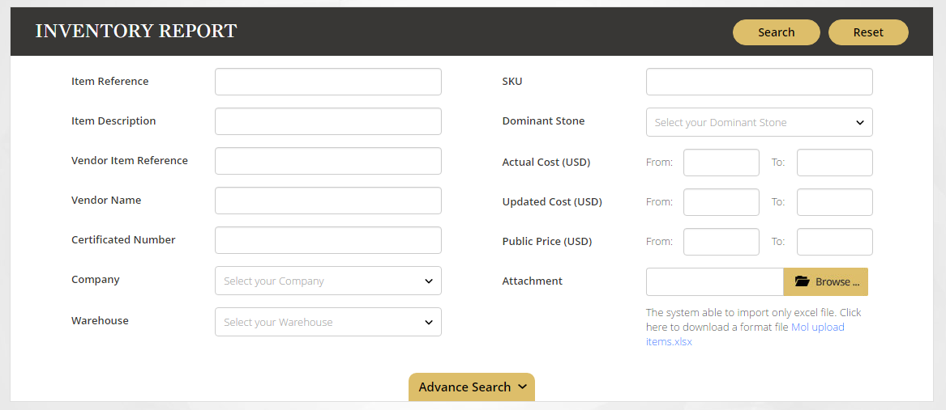

Or filtering any criteria in each category under the Advance Search

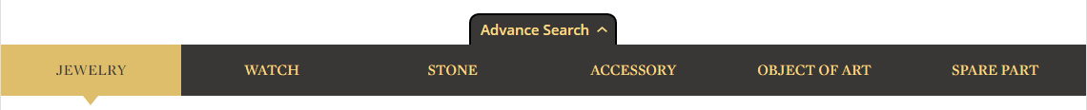

1. **6 Product Categories**

There are 6 product categories such Jewelry, Watch, Stone, Accessory, Object of Art and Spare Part. Filtering in each category by selected the category and fill the criteria.

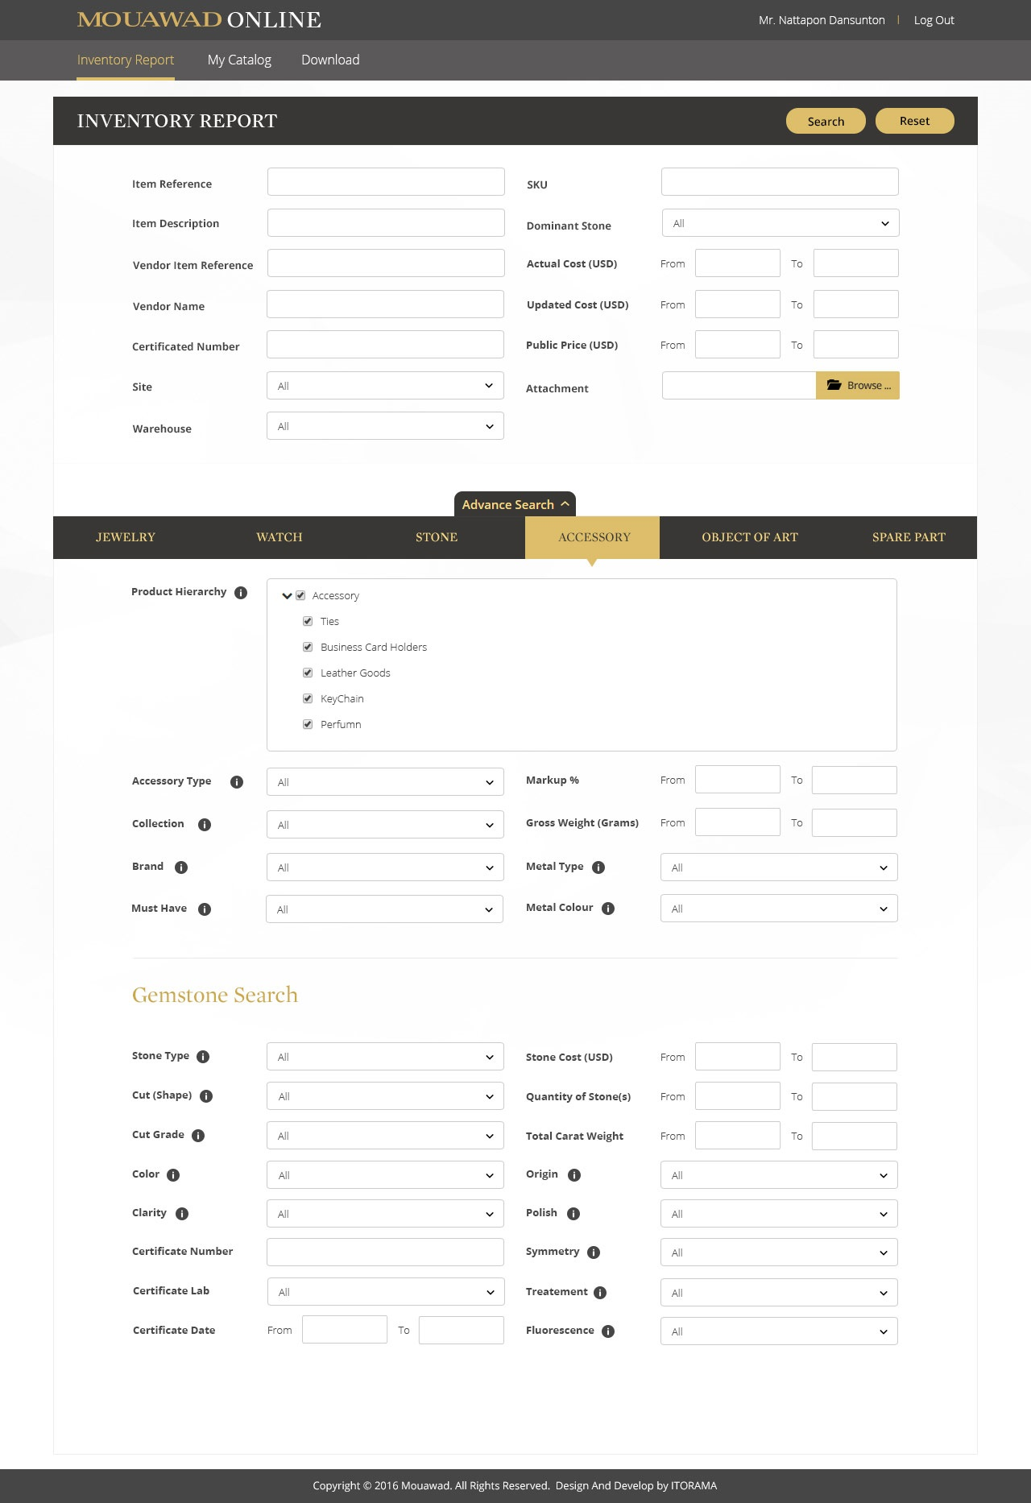

1. **Search any items from Excel file**

The simple steps to search any items from your Excel file:

1. Download Excel template
2. Fill the item reference in the Excel file
3. Upload the file in MOL by clicking “Browse” button and select the file

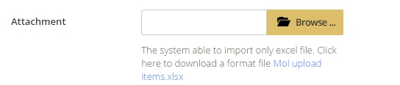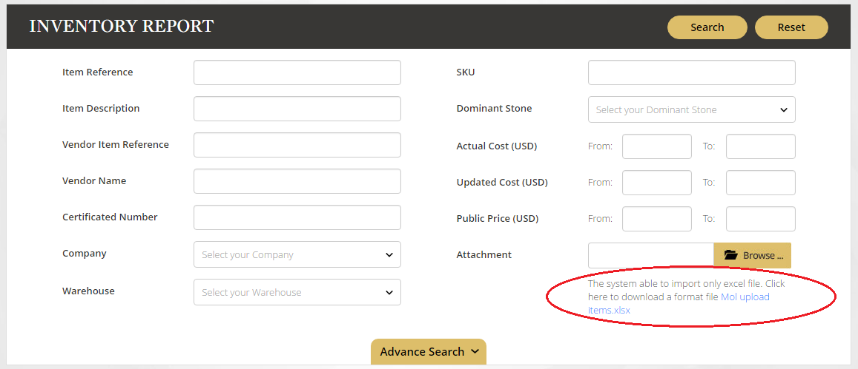

1. **Search Result**

There are the friendly functions under the Search Result page:

* List and Grid style
* Quick View and Product detail
* Number of items in a page
* My catalog
* Sorting and Export the data

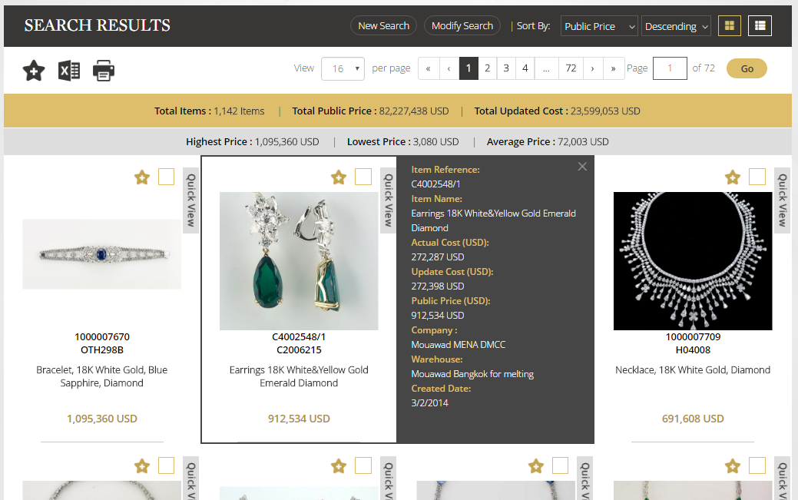

1. **Export data to Excel file, and send to your e-mail**

Click at “Excel” icon  to export data to Excel file, that the system will send the download link to your e-mail.

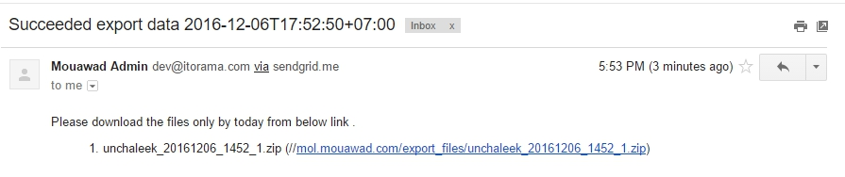

1. **Export data to PDF file**

Click at “Print” icon  to print to PDF file, that the system will send the download link to your e-mail.

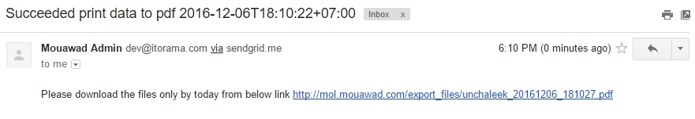

1. **Change Password**

Changing your password, by clicking at your username and click Change Password menu.



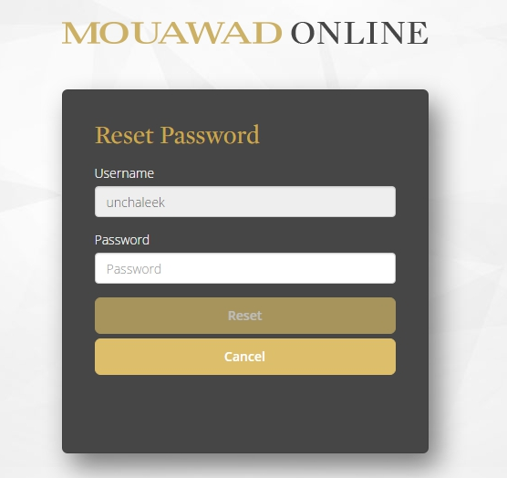

1. **My catalog**

Manage and view your catalog My Catalog menu.

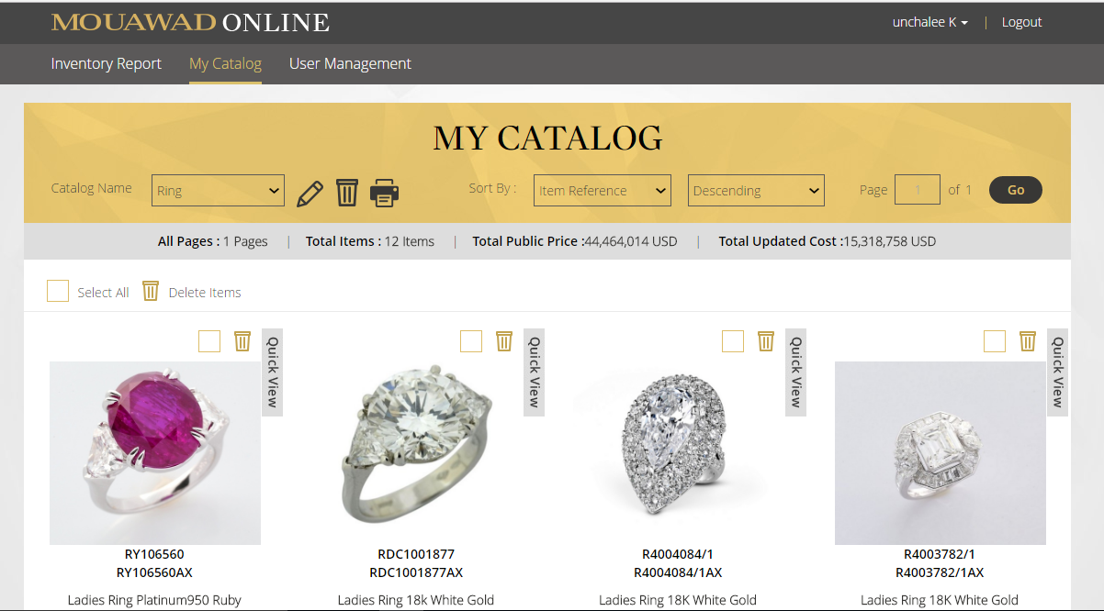

**Management tools**

Export pdf file

Edit Catalog name

Catalog name

Delete Catalog

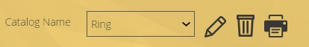

**How to add items to catalog**

1. User adds item to My Catalog at Search Result page and Product Detail page
2. Add an item to catalog: click “Catalog” icon at the selected items, and go to step 4
3. Add multiple items to catalog: click “Square” icon  at the selected items, and click “Catalog” icon on bar , and go to step 4

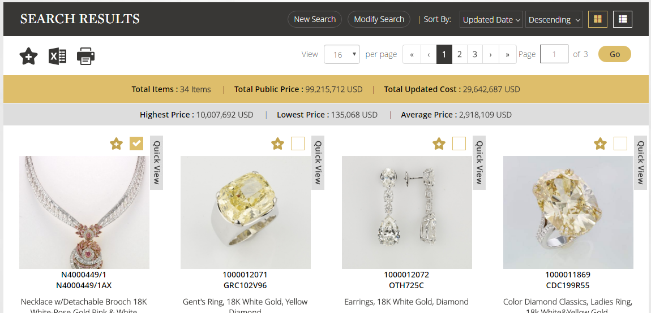

1. Select the existing catalog or create the new catalog

