**[Coffee time] Test Analysis**

**Participant Profiles:**

|  |  |  |
| --- | --- | --- |
|  | **Age** | **Frequency of drinking coffee** |
| Participant 1 | 22 | 2-3 times a week |
| Participant 2 | 21 | 4 times a week |
| Participant 3 | 22 | More than 3 times a week |
| Participant 4 | 24 | Twice in a weekday |
| Participant 5 | 26 | Nearly every day, VIP of many coffee shops |

**Testing Setup, Moderation & Post-Test Questions**

*1) Introduction*  
This website is designed to help regular coffee drinkers find the right coffee shop and get a discounted order path. On this site, users can choose to "买一杯! " : by searching for a coffee shop in different ways, browsing through the shop's basic information, buying a voucher to spend, or "做一杯！" to search for coffee-making guides, coffee beans, coffee machines, coffee cups, etc. Of course, you can get exclusive offers if you register as a member.

*2) Tasks set*  
Suppose you want to search for a perfect coffee shop to grab a coffee and buy some coffee beans for a weekend brewing experience:  
1. Where would you click for list of coffee shops?

2. Add one coffee shop to your favourites and check all your favourite coffee shops

3. Where would you view the details of specific products?

4. Register and log in

5. How would you upgrade your VIP package?

*3) Post-Test Questions*  
1. Please rate the overall process: 5 as very satisfied, 1 as very dissatisfied

2. Which part do you think is confusing?

3. How do you think the page can be improved?

**Results:(by task)**

* **Qualitative:**

**Task 1: Find a list of coffee shop**

|  |  |
| --- | --- |
|  | **User access routes** |
| Participant 1 | Homepage:“买一杯”➜“咖啡店筛选” |
| Participant 2 | Homepage:“买一杯”➜“每日臻选” |  |
| Participant 3 | Homepage:“买一杯”➜“咖啡店筛选” |  |
| Participant 4 | Homepage: click the coffee icon on the lower side |  |
| Participant 5 | Homepage:“买一杯”➜“咖啡店筛选” |  |

**Task 2: Add one shop to your favourites and check your all favourite shops**

|  |  |
| --- | --- |
|  | **User access routes** |
| Participant 1 | “买一杯”➜“咖啡店筛选”➜“按咖啡豆筛选”➜ bookmark➜“查看我的所有收藏” |
| Participant 2 | “买一杯”➜“咖啡店筛选”➜“按咖啡豆筛选”➜ bookmark➜“买一杯”➜“我的心选” |  |
| Participant 3 | “买一杯”➜“离我最近”➜ bookmark➜“查看我的所有收藏” |  |
| Participant 4 | “我的心选”➜ “买一杯”➜ “咖啡店筛选”➜“按咖啡豆筛选”➜ bookmark➜“查看我的所有收藏” |  |
| Participant 5 | “我的”➜“买一杯”➜“咖啡店筛选”➜“按咖啡豆筛选”➜ bookmark➜“查看我的所有收藏” |  |

**Task 3: upgrade your membership to VIP**

|  |  |
| --- | --- |
|  | **User access routes** |
| Participant 1 | “我的”➜“我的账户”➜“登陆注册”➜ “关于”➜“会员体系”➜“立刻升级” |
| Participant 2 | “我的”➜“登陆注册”➜ “关于”➜“会员体系”➜“立刻升级” |  |
| Participant 3 | “我的”➜“我的账户”➜ “关于”➜“会员体系”➜“立刻升级” |  |
| Participant 4 | “关于”➜“会员体系”➜“立刻升级” |  |
| Participant 5 | “我的”➜“我的账户”➜ “关于”➜“会员体系”➜“立刻升级” |  |

***Problems encountered:***

When asked to find their favourites and upgrade their membership, participants would prefer to go to the "我的" portal and try to find a similar portal such as "我的心选" or "我的会员", only to find that it was not there. but find that it is not there. "我的心选" is set to "买一杯！" headset navigation at the bottom of the page, and most users do not view new shops as soon as they are added to their favourites, so the box set to indicate success in favourites is not frequently clicked.

In addition, when users want to upgrade their membership, they hesitate for a long time before choosing which level of navigation to use to access the membership information, and it is clear that the level one navigation is not particularly straightforward for membership-related entries.

***Analysis:***

1. The first level of navigation is not clear enough, the navigation bar is set up from the designer's point of view, but does not particularly fit the user's logic and habits.
2. Users of different ages use different user paths, which also correlate with their profession. For example, the last participant, a product manager in the internet industry, was more curious about the web, paying attention to every web element and clicking on every clickable content.
3. The "关于" tab is much less frequently clicked than the other level navigation, and most users do not focus on this tab first unless they cannot find the entrance and then try to click on it one by one.

* **Quantitative:**

**Task success rate**

|  |  |  |  |  |  |
| --- | --- | --- | --- | --- | --- |
| participant | **Task 1** | **Task 2** | **Task 3** | **Task 4** | **Task 5** |
| Participant 1 | ✓ | ✓ | ✓ | ✓ | ✓ |
| Participant 2 | ✓ | ✓ | ✓ | ✓ | - |
| Participant 3 | ✓ | - | ✓ | ✓ | ✓ |
| Participant 4 | ✓ | ✓ | ✓ | ✓ | ✓ |
| Participant 5 | ✓ | ✓ | ✓ | ✓ | - |
| Total | 5 | 4 | 5 | 5 | 3 |
| Completion rates | 100% | 80% | 100% | 100% | 60% |

All participants successfully completed Task 1&3&4. Three of the five (60%) completed Task 5. Four of the five (80%) were able to finish Task 2.

**Time on Task (seconds)**

|  |  |  |  |  |  |
| --- | --- | --- | --- | --- | --- |
| participant | **Task 1** | **Task 2** | **Task 3** | **Task 4** | **Task 5** |
| Participant 1 | 15 | 27 | 21 | 8 | 52 |
| Participant 2 | 13 | 24 | 18 | 6 | 75 |
| Participant 3 | 11 | 43 | 23 | 8 | 41 |
| Participant 4 | 10 | 20 | 18 | 9 | 55 |
| Participant 5 | 19 | 24 | 19 | 10 | 83 |
| Average | 13.6 | 27.6 | 19.8 | 8.2 | 61.2 |

Both Task 1 and Task 3 were set up in a way that was operationally similar to the operation of other current competing software. Considering that most of the participants had used competing software, they were more proficient in participating in the testing process and the testing time was shorter.

In comparison, task 4 is the simplest, as the instructions involved are displayed at the first level of navigation, and the user can easily see and click on them to jump to the login and registration screen.

Task 5 required the user to upgrade their membership level, which involved a number of steps, firstly the user needed to know their current membership level, many participants spent the most time navigating through the pages as they were unable to correctly locate which level of navigation the membership tab was a sub-tab of through the existing level one navigation.

**Satisfaction of the process:**

|  |  |  |
| --- | --- | --- |
| participant | **Rate(1-5)** | **Comments** |
| Participant 1 | 5 | Good design and UI, I think it match coffee style perfectly, and simple to use |
| Participant 2 | 4 | Love the layout, pay more attention to the navigation bar |
| Participant 3 | 3.5 | Little confused about the navigation bar, but it’s ok as different websites have their own style. |
| Participant 4 | 4.5 | I love the content of the “每日臻选”, it helps a lot for me as a Decidophobia. |
| Participant 5 | 3 | As a product manager, I would suggest that the content distribution of the navigation bar be modified. The navigation bar needs to start from the user's point of need and consider the user's thinking logic and habits. The content of the site is practical and meets the needs of the product, the interface is simple and the navigation would be better if it were clearer. |
| Average | 4 | 27.6 |

**Bugs & Issues:**

1. All secondary navigation, once triggered, must be clicked to jump before it disappears, otherwise, it will always be there.
2. Some users are unsure of how to add coffee shops to their favorites. The icon for the collection is set too mini.
3. The “会员体系” section is difficult to be found on the “关于” page.
4. Users cannot change their profile
5. Some fixed background layers, navigation bars and logos may also shift in position when switching between pages.

**Further improvements:**

1. Adjust the overall layout of the home page so that more of the content with high user click-through rates in the primary navigation bar is placed on the home page to attract the attention of users.
2. Adjust '收藏' tab to a sub-tab under the '我的' tab.
3. Adjust '会员' tab to a sub-tab under the '我的' tab.
4. Show more information about purchased tickets and create a responsive page after clicking '去使用'.
5. Make the pop-up of the hint window more natural.
6. Make maps clickable and easy to drag and drop positions.
7. Change the position of the same elements on different pages to achieve constant same content when jumping.
8. Find out more information about products and make it clickable to browse.

Supporting materials:

Figma design file:

<https://www.figma.com/file/M9lbMaGsiKX49APECjDhVD/coffee-time?node-id=0%3A1&t=o0kr7tHUezq5jbG8-1>

Figma prototype:

<https://www.figma.com/proto/M9lbMaGsiKX49APECjDhVD/coffee-time?node-id=2%3A2&scaling=scale-down&page-id=0%3A1&starting-point-node-id=2%3A2>

Sitemap:

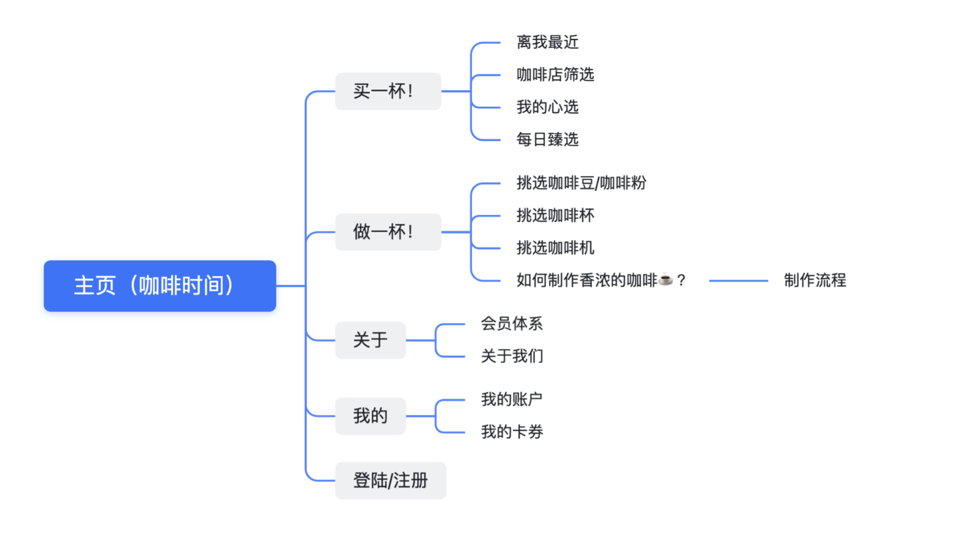

Usability Planning Dashboard:

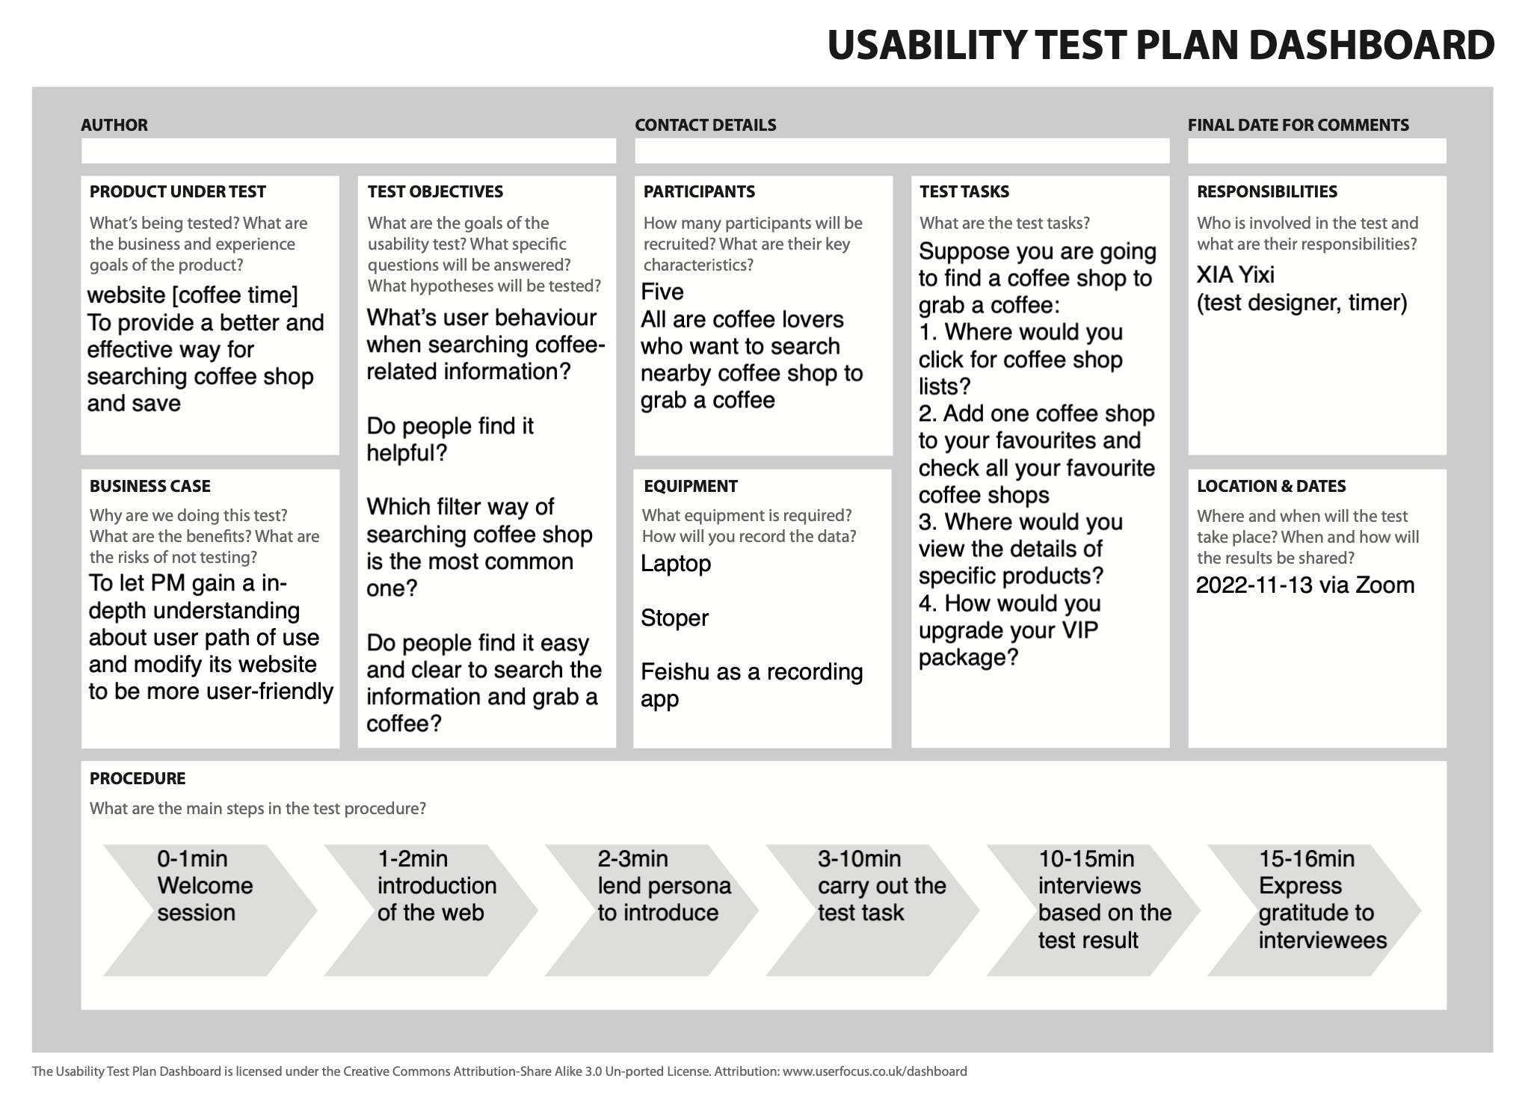

Revised customer journey map:

Revised story map:

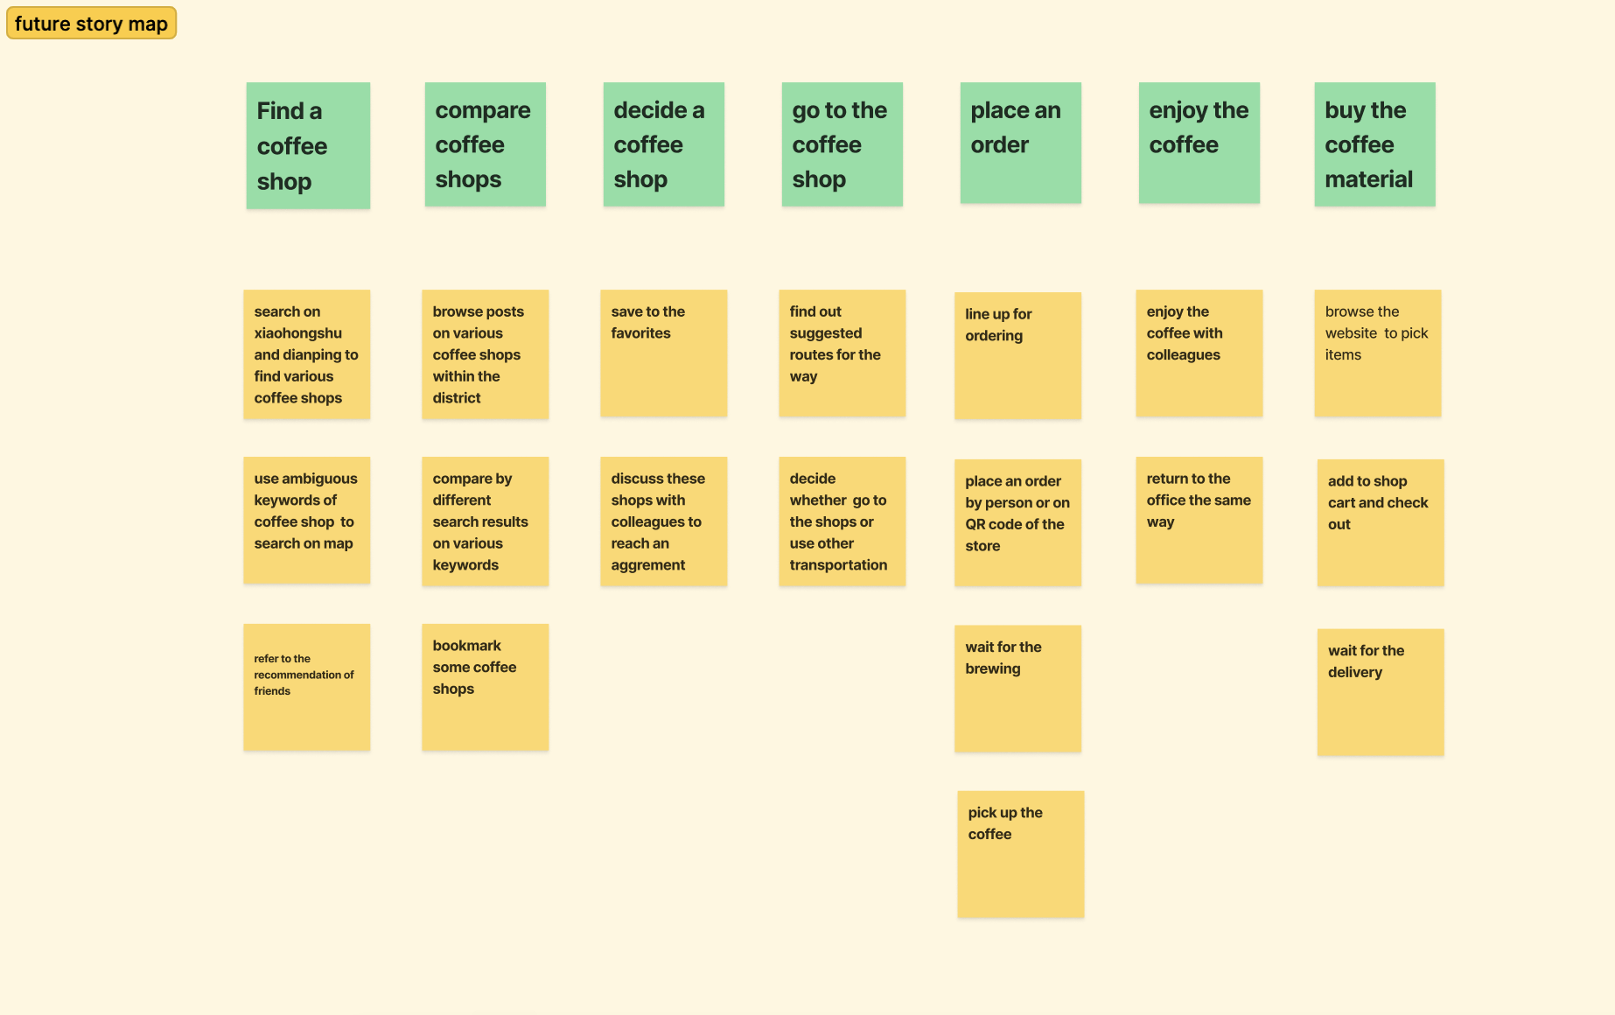

Card sorting result:

