CS 499 Module One Assignment Template

Complete this template by replacing the bracketed text with the relevant information.

- Self-Introduction: Address all of the following questions to introduce yourself.

  - How long have you been in the Computer Science program?
I’ve been in the Computer Science program for 3 years now.

  - What have you learned while in the program? List three of the most important concepts or skills you have learned.

  - Writing clear, commented code to make projects easier for others to follow and collaborate on.
  - Understanding different programming languages and how to apply them in the right type of application.
  - Learning software development methodologies and the lifecycle of building, testing, and maintaining applications.

  - Discuss the specific skills you aim to demonstrate through your enhancements to reach each of the course outcomes.

Through my enhancements, I plan to demonstrate skills in full-stack development, data structures and algorithms, and database design with MongoDB. I will also show my ability to improve efficiency with algorithms, build scalable systems with modern tools, and ensure data persistence and security. These skills connect directly to the course outcomes, such as designing computing solutions, applying tools and techniques, and addressing security.

  - How do the specific skills you will demonstrate align with your career plans related to your degree?

The skills align with my career plans because I want to move into a cybersecurity and software engineering role within the aerospace/defense industry. Full-stack knowledge helps me understand system design, algorithms give me problem-solving tools, and database skills are important for working with secure data.

  - How does this contribute to the specialization you are targeting for your career?

This contributes to my specialization by showing I can take a simple program and expand it into a secure, efficient, and scalable application. For cybersecurity, it’s important to understand how systems are built so I can better protect them. For software engineering, it shows I can design and implement solutions that add value. Overall, I think this highlights the mix of development and security skills that I plan to use in my career.

- ePortfolio Set Up:

  - Submit a screen capture of your ePortfolio GitHub Pages home page that clearly shows your URL.
    - You already have a repository in GitHub where you uploaded projects in previous courses. Your ePortfolio will reside in GitHub but can link to work at other sites, such as Bitbucket.

  - Use the GitHub Pages link in the Resource section for directions on:
    - How to create your GitHub website and publish code to GitHub Pages
    - Issues, such as adding links to other sites

  - Paste a screenshot of your GitHub Pages home page with your URL clearly showing in the space below.

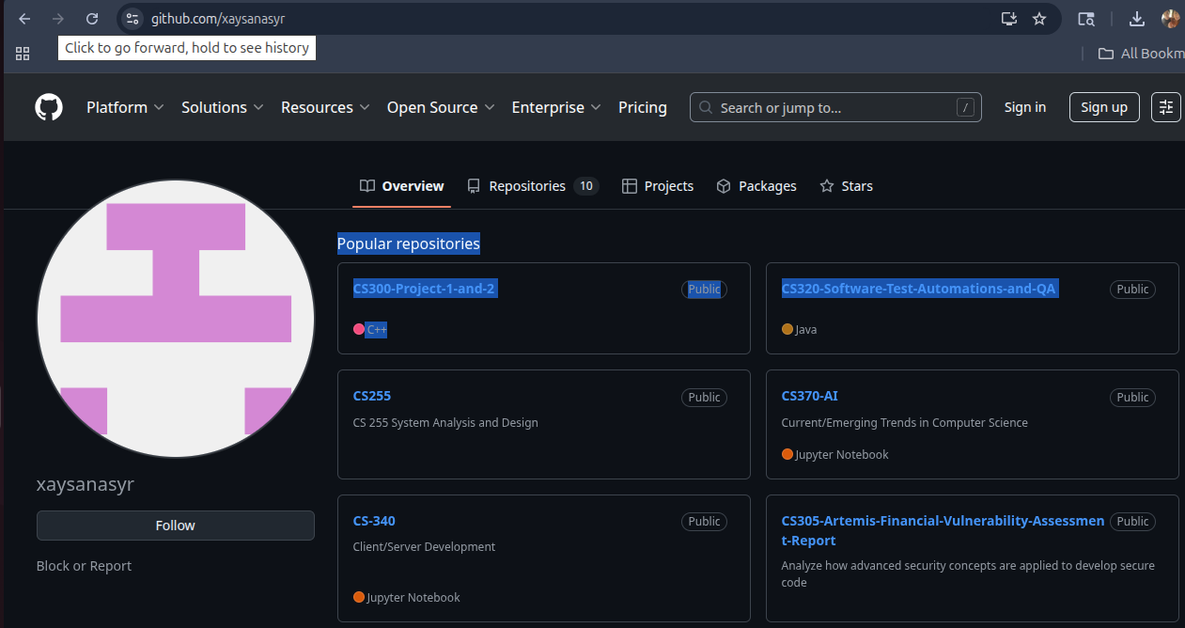

- Enhancement Plan:

  - Category One: Software Engineering and Design
    - Select an artifact that is aligned with the software engineering and design category and explain its origin. Submit a file containing the code for the artifact you choose with your enhancement plan.

The artifact I chose is PetCheckIn.java from IT-145: Foundations in Application Development. It is a simple console program that lets a user check in a pet by entering name, type, and age. It also tracks spaces for dogs and cats. I chose this because it has a clear process flow and can be expanded into a bigger project.

Note: Your artifact may be work from the following courses:

- IT 145: Foundation in Application Development
- CS 250: Software Development Lifecycle
- CS 260: Data Structures and Algorithms
- IT 315: Object Oriented Analysis and Design
- CS 320: Software Testing, Automation, and Quality Assurance
- CS 330: Computational Graphics and Visualization
- CS 340: Advanced Programming Concepts
- CS 350: Emerging Systems Architectures and Technologies
- CS 360: Mobile Architecture and Programming
- IT 365: Operating Environments
- IT 380: Cybersecurity and Information Assurance
- CS 405: Secure Coding
- CS 410: Reverse Software engineering
- IT 340: Network and Telecommunication Management
- IT 380: Cybersecurity and Information Assurance

    - Describe a practical, well-illustrated plan for enhancement in alignment with the category, including a pseudocode or flowchart that illustrates the planned enhancement.

I will turn this console program into a full stack web application. Instead of Java only, I will use the MEAN stack. This means rewriting the code in JavaScript. Using MongoDB to store customers, pets, bookings, and availability. Creating REST API endpoints with Express. Building a small frontend site with Angular or React to check pets in through forms. Then finally deployed using localhost port. ( Maybe do cloud hosting)

Pseudocode:
- Start
- Enter or find customer
- Enter or find pet
- Check availability (dog or cat spaces)
- If no space,
  - Print “Sorry, we have no more spots availability.”
- If space
  - proceed to pick days + grooming option
- Assign space,
  - update MongoDB
- Show confirmation
- End

For this category of enhancement, consider improving a piece of software, transferring a project into a different language, reverse engineering a piece of software for a different operating system, or expanding a project’s complexity. These are just recommendations. Consider being creative and proposing an alternative enhancement to your instructor.

Think about what additions to include to complete the enhancement criteria in this category. Since one example option is to port to a new language, that is the kind of scale that is expected. This does not mean you need to port to a new language but instead have an equivalent scale of enhancement. Underlying expectations of any enhancement include fixing errors, debugging, and cleaning up comments, but these are not enhancements themselves.

    - Explain how the planned enhancement will demonstrate specific skills and align with course outcomes.

      - Identify and describe the specific skills you will demonstrate that align with the course outcome.

      - Full stack development (frontend + backend + database).
      - JavaScript and MongoDB proficiency.
      - Expanding the project’s complexity from console to web.
      - API design and basic validation.

      - Select one or more of the course outcomes below that your enhancement will align with.

Demonstrate an ability to use well-founded and innovative techniques, skills, and tools in computing practices for the purpose of implementing computer solutions that deliver value and accomplish industry-specific goals.

Course Outcomes:

- Employ strategies for building collaborative environments that enable diverse audiences to support organizational decision-making in the field of computer science.
- Design, develop, and deliver professional-quality oral, written, and visual communications that are coherent, technically sound, and appropriately adapted to specific audiences and contexts.
- Design and evaluate computing solutions that solve a given problem using algorithmic principles and computer science practices and standards appropriate to its solution while managing the trade-offs involved in design choices.
- Demonstrate an ability to use well-founded and innovative techniques, skills, and tools in computing practices for the purpose of implementing computer solutions that deliver value and accomplish industry-specific goals.
- Develop a security mindset that anticipates adversarial exploits in software architecture and designs to expose potential vulnerabilities, mitigate design flaws, and ensure privacy and enhanced security of data and resources.

  - Category Two: Algorithms and Data Structures

- Select an artifact that is aligned with the algorithms and data structures category and explain its origin. Submit a file containing the code for the artifact you choose with your enhancement plan. You may choose work from the courses listed under Category One.

I will again use PetCheckIn.java from IT-145. The original program only stores pet information in variables and doesn’t use strong algorithms or data structures.

- Describe a practical, well-illustrated plan for enhancement in alignment with the category, including a pseudocode or flowchart that illustrates the planned enhancement.

I will add data structures and search algorithms to make the program more efficient. I will use an ArrayList or HashMap to store pets and customers, and a binary search to quickly find pets by name or customers by ID. I will also add a queue to manage the order of check-ins and check-outs, and a stack to track recent transactions or allow undo actions.

Psuedocode:
- Start
- Store customers and pets in HashMaps
- When adding a pet, also place pet into a check-in queue
- To find a pet, use binary search on pet names
- To undo a recent check-in, pop from the stack
- Continue processing until all customers are checked in
- End

For this category of enhancement, consider improving the efficiency of a project or expanding the complexity of the use of data structures and algorithms for your artifact. These are just recommendations. Consider being creative and proposing an alternative enhancement to your instructor. Note: You only need to choose one type of enhancement per category.

Think about what additions to include to complete the enhancement criteria in this category. Since one example option is to port to a new language, that is the kind of scale that is expected. Perhaps you might increase the efficiency and time complexity of an algorithm in an application and detail the logic of the increased time complexity. Remember, you do not need to port to a new language but instead have an equivalent scale of enhancement. Underlying expectations of any enhancement include fixing errors, debugging, and cleaning up comments, but these are not enhancements themselves.

- Explain how the planned enhancement will demonstrate specific skills and align with course outcomes.

  - Identify and describe the specific skills you will demonstrate to align with the course outcome.

- Use a HashMap to store customers and pets for faster lookups.
- Use a binary search to find pets by name.
- Use a queue to manage the order of check-ins.
- Use a stack to handle undo for recent actions.

  - Select one or more of the course outcomes listed under Category One that your enhancement will align with.

Design and evaluate computing solutions that solve a given problem using algorithmic principles and computer science practices and standards appropriate to its solution while managing the trade-offs involved in design choices.

  - Category Three: Databases

    - Select an artifact that is aligned with the databases category and explain its origin. Submit a file containing the code for the artifact you choose with your enhancement plan. You may choose work from the courses listed under Category One.

I will also use PetCheckIn.java from IT-145. The original version does not store data permanently, so all information is lost when the program ends.

    - Describe a practical, well-illustrated plan for enhancement in alignment with the category, including a pseudocode or flowchart that illustrates the planned enhancement.

I will enhance the program by adding a MongoDB database layer to store customers, pets, bookings, and inventory so data will persist between runs. This includes creating collections for each type of information, adding CRUD operations to manage records, linking pets to their owners and bookings, and using queries to check availability or generate reports for better functionality.

Pseudocode:
    - Start
    - Connect to MongoDB
    - Enter or find customer in the database
    - Enter or find pet in the database
    - Check availability in the Inventory collection
    - If no space, print “No space available”
    - If space, create booking and update inventory count
    - Save booking in database
    - Show confirmation
    - End

For this category of enhancement, consider adding more advanced concepts of MySQL, incorporating data mining, creating a MongoDB interface with HTML/JavaScript, or building a full stack with a different programming language for your artifact. These are just recommendations; consider being creative and proposing an alternative enhancement to your instructor. Note: You only need to choose one type of enhancement per category.

Think about what additions to include to complete the enhancement criteria in this category. Since one example option is to port to a new language, that is the kind of scale that is expected. Perhaps you might increase the efficiency and time complexity of an algorithm in an application and detail the logic of the increased time complexity. Remember, you do not need to port to a new language but instead have an equivalent scale of enhancement. Underlying expectations of any enhancement include fixing errors, debugging, and cleaning up comments, but these are not enhancements themselves.
    - Explain how the planned enhancement will demonstrate specific skills and align with course outcomes.

    - Database design and modeling by creating collections for customers, pets, bookings, and inventory.
    - CRUD operations with MongoDB to add, read, update, and delete records.
    - Connect backend code to a database so that the application can store and retrieve information.
    - Link pets to owners and bookings to pets.
    - Run queries to check availability and generate reports.

      - Select one or more of the course outcomes listed under Category One that your enhancement will align with.

Develop a security mindset that anticipates adversarial exploits in software architecture and designs to expose potential vulnerabilities, mitigate design flaws, and ensure privacy and enhanced security of data and resources.

- ePortfolio Overall Skill Set

  - Accurately describe the skill set to be illustrated by the ePortfolio overall.
    - Skills and outcomes planned to be illustrated in the code review

The full-stack design (MEAN), clean API endpoints, and modular code. The use of data structures and algorithms and how they improve efficiency. Explaining the MongoDB schemas and CRUD functions. Explaining basic security practices utilized in code.

    - Skills and outcomes planned to be illustrated in the narratives

Clear explanation of design choices, explaining how the full stack, tools, and methods deliver execute and function, reflection on improvements from the original IT-145 file.

    - Skills and outcomes planned to be illustrated in the professional self-assessment

Growth from improvements done to a console app to a deployed web app that will be displaying strengths in problem-solving, testing, and documentation.

Questions and answers

1. Would this be easier deploying this app with its enhancements into a mobile application instead?

2. Deploying into cloud hosting instead? Pros and cons?

