# Problem.

Human signature is presented as an array of points. The goal is to change points locations so that the resulting “distorted” signature could still be recognized as one produced by the same person’s handwriting.

The ultimate solution would be to ask the person to produce as many copies of the signature manually and then train a neural network of some kind to produce similar variations.

Here we are making an attempt to apply a specific algorithm to the original array of points in the hope that even though the signature variations are going to be somewhat predetermined they would still resemble the ones that normally occur when an actual person tries to repeat his/her own handwriting.

# Method 1. Randomizing points coordinates.

Random values are added to both X and Y (within about 10% of the original value). It expectedly causes the “shaken hand” effect:

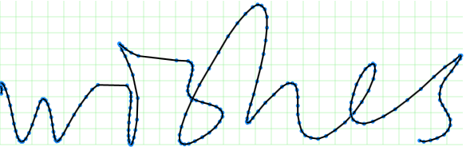

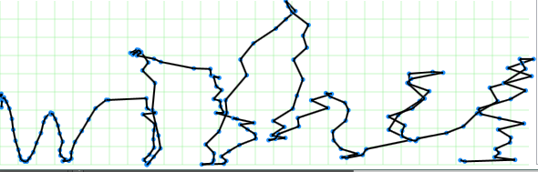

This present a challenge. In real life signature variations are indeed random but not as random as the above. The different parts of signature may slightly change their shape or size or be shifted towards or from each other but there is a certain amount of dependency between the points. If Nth point moves 1 cm to the left there is a great chance that (N-1)th and (N+1)th points will also move roughly to the same direction but maybe not exactly the same distance.

# Method 2. Gravity distortion

In order to meet the challenge we need to find a principle that would affect different points of the signature array in different ways while still preserving the basic humanly-recognizable shape of the curve.

One physical principle that satisfies this requirement is gravity. A center of gravity (e.g. Sun) attracts different masses (e.g. planets) to itself with different forces depending on how far they are from the center:

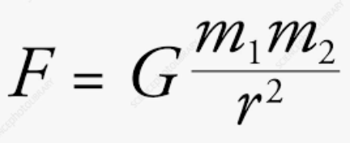

So, we introduce a gravity center into our “signature space”. It will draw signature points to itself. The more a point is attracted the more it shifts towards the center. Since all signature points have the same mass the attraction force (and the shift distance) will depend only on center’s mass and it’s distance to a given point:

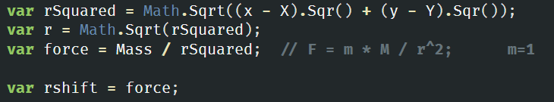

Another way to look at this is to imagine that the surface on which signatures are drawn is made of rubber. Putting a metal ball on the surface will cause it to stretch in a similar way. (Google “rubber sheet gravity”)

The result is much more “natural” than method 1:

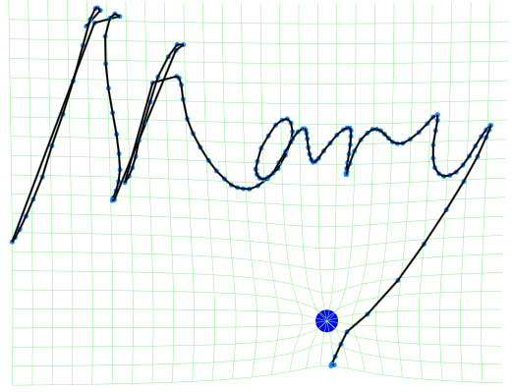

To make it even more realistic we introduce multiple gravity centers and compute the resulting shift as vector sum of individual shifts caused by each center.

We also allow both positive (attracting) masses and negative (repelling).

Masses are random, their number is random and controlled by DefaultMassdensity param, they are placed randomly.

A typical result:

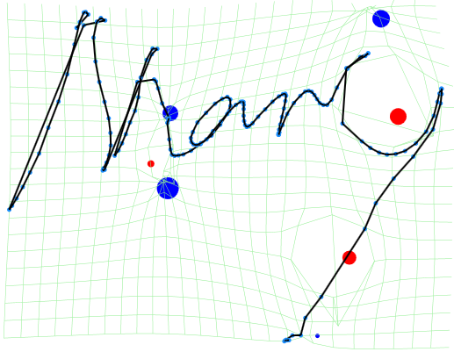

Blue circles are positive masses, red are negative.

Having completed the task of changing points locations we still have the “invisible” parameters left to modify (pressure, azimuth etc). There is likely a connection between the coordinates and “invisible” parameters: If a certain loop on a signature is larger than usual than it was probably drawn by applying more (or less) pressure to the pen. Without knowing the nature of this connection the least we can do is apply the same law to invisible parameters as we did to coordinates:

