

RelaxBot

Project proposal

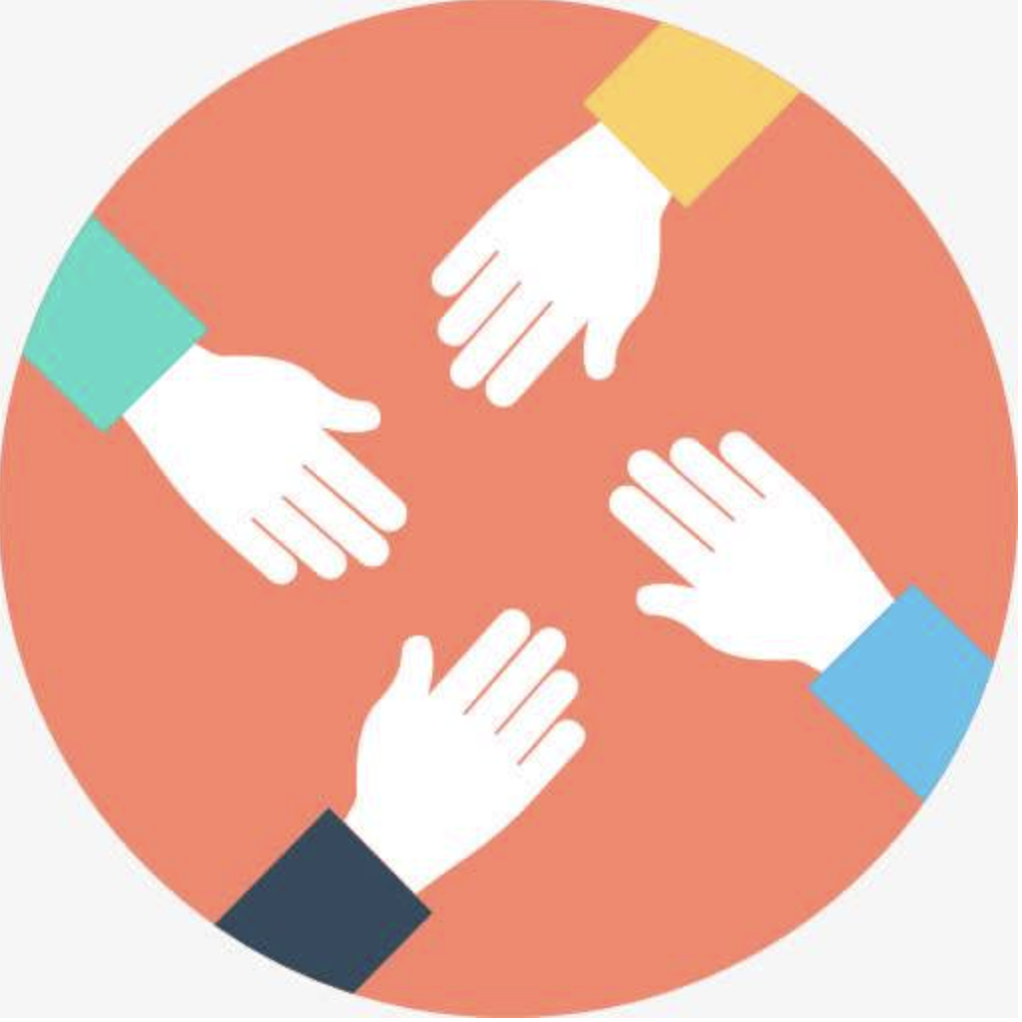

**Group: yangchaoyue**

**Members:**

|  |  |  |  |  |
| --- | --- | --- | --- | --- |
| Name: | Biao Xiong | Xijia Xin | Nanfei Ye | Xinyi lu |
| ID: | z5124362 | z5128960 | z5186110 | z5128245 |
| Email: | xiongbiao147@gmail.com | z5128960@ad.unsw.edu.au | z5186110@ad.unsw.edu.au | z5128245@ad.unsw.edu.au |
| Role: | Scrum Master | Developer | Developer | Developer |

1. **Background**

Recently, new tools designed to simplify the interaction between humans and computers have hit the market: Chatbots or Virtual Assistants. A chatbot is an artificial intelligence (AI) software that can simulate a conversation (or a chat) with a user in natural language through messaging applications, websites, mobile apps or through the telephone.

Why are chatbots important? A chatbot is often described as one of the most advanced and promising expressions of interaction between humans and machines.

Chatbot applications streamline interactions between people and services, enhancing customer experience. At the same time, they offer companies new opportunities to improve the customers engagement process and operational efficiency by reducing the typical cost of customer service.

To be successful, a chatbot solution should be able to effectively perform both of these tasks. Human support plays a key role here: Regardless of the kind of approach and the platform, human intervention is crucial in configuring, training and optimizing the chatbot system.

1. **Aim**

The aim of this project is to design and build an application based on cell phones, which provides users some relax function. With the development of computer technique and data processing technique, chatting with chatbot is turned out to be a easier approach for relaxing and releasing themselves. Thus, we decided to build a household butler called RelaxBot that is able to coordinate devices like wearable devices, intelligent lights and provide entertainment services, like music service, movie service and video service by texting or talking with it.

The main functions of RelaxBot include:

* 1. Multimedia player services

User can chat with RelaxBot about specific music, movie information and video name and related the resource can be played. If user cannot provide a specific information for refine search, the recommend results will be displayed according to the content.

1. Music player part provides function includes play back, pause, stop, next, previous and the way of playing the list like play track, loop track, loop playlist, randomize.
2. Movie part provides function includes movie details like title, actors, directors, runtime and so on.
3. Users will play Youtube videos by inputing content that they hope to see. The videos can be played in this app.
   1. Health monitor

Users can extract their personal health status information from their wearable devices, such as daily steps, peak heart rate, sleep status and so on.

* 1. Light control

Users can use voice and text to control the colors and brightness of a bulb.Meanwhile, open and close function also provided in the app.

2.4 Chat (Optional)  
Users can talk with this app when they feel boring, sad, or happy. The bot should can talk like a friend and response sentences like a real person.

**3.Architectural Graph**

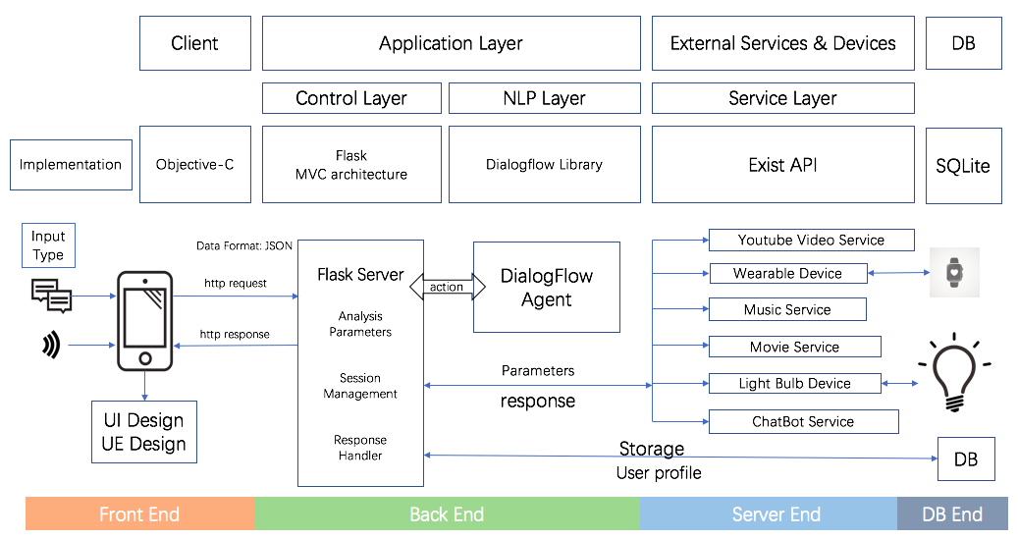

**4.Technical Details**

Due to the mobility and convenience. We have decided to build a mobile app on the iPhone. At the same time, we will adapt all kind of version iPhones that can be bought in the market. Web is another design choice, and we will also complete a web version if we have enough time.

We seperates the app into two parts, the user interface and server. The UI end only collect voice or text, send requests and display the response. The server end Is to receive requests, deal with actions and send and receive the responses from services and devices. We hope that our application can be built in different platforms, and divides the application increases the expansibility and maintainability.

We have decided to support iOS 11+ to fit more users. Because some iPhone users didn’t update their phone os yet. Apple app have their own programming languages which are swift and Objective-C. The former is more light and newer, the latter is more stable and mature. So we choose Objective-C as the programming language due to the stable and various libraries and APIs.

At the back end, we will use flask written in Python to build our server. For the chat part, we will use natural language processing and machine learning technique for chatting, extracting intents and entities then selecting action and responding to user throught Dialogflow. We will use 4 service APIs and 2 devices to support this application.

For both front end and back end, We will use MVC or MVVM design pattern. This pattern has the low coupling that allow us modify the view layer without recompling the model and controller code, high reuseability that helps us build one server end but fits various platforms, low life cycle which is easily develop and maintain interface, and fast deployment that developers only need to focus on their own jobs.

**5.Epics**

Our app have 3 main pages, Login Page, Setting Page, and Chat Page. In the Chat page, There are 6 functions

1.Login Page:  
This page provides 2 textbox for user to input username and password. It also has two buttons for sign up and forget password is an optional function.

2.Setting page:  
This page can modify the UI of whole app, set personal profile, introduce about us and login out button to exit to login page. It also have some optional functions which is reset password and change user profile.

3.Chat Page:  
This page has 6 functions, music shows in audio, video shows in video stream, the other three functions which are including health information, movie details, light control and chat function represent in text and voice. User can input in voice or text.  
Feature:  
 Input: default input mode is Voice button. There is a keyboard button for users to switch input mode from voice to text.  
 Display: user questions show on the right side and bot responses show on the left side. Video and music have independent show modules.

**6.Plan**

**Project Methodology**

The project team is a group of four. There are 3 Software Developer and 1 Scrum Master, everyone will be in charge of Scrum Master for 2 or 3 week.

IDE: Xcode, Pycharm

Code management: Github

Programming language: Python3, Javascript, Sqlite3, Objective-C/Swift

**Project Scrum**

Scrum team:

z5128960@ad.unsw.edu.au

z5186110@ad.unsw.edu.au

[z5128245@ad.unsw.edu.au](mailto:z5128245@ad.unsw.edu.au)

z5124362@ad.unsw.edu.au

Scrum master: Biao Xiong(z5124362)

Developer: ALL scrum team

Sprint Review Meeting: 14:00-16:00 Saturday

Sprint Retrospective Meeting: 14:00-16:00 Sunday

Project deliverables include project progression demos every 2 weeks and the final project demonstration and report submission will be on the Friday of week10.

**Project Time-frame/Schedule**

|  |  |  |
| --- | --- | --- |
| DATE | WORK | WEEK |
| Wednesday 20th February | Project Proposal Released | Week 2 |
| Friday 8th March | Proposal Deadline | Week 3 |
| Wednesday 13th March | Progress Report | Week 4 |
| Wednesday 27th March | Progress Demo | Week 6 |
| Wednesday 10th April | Progress Demo | Week 8 |
| Wednesday 24th April | Final Demo | Week 10 |