# Progress Report of WP2

Automation Technology Center

Hong Kong University of Science and Technology

# Review

However, nowadays the parts in a 3C product are much smaller. Subsequently, the assembly processes require much finer actions, which almost go beyond the limit of even skilled human worker. Also the labor costs are growing each day. As a result, automatic assembly systems are urgent if 3C manufactory is to survive in the future.

The ultimate goal of this project is to comprehensively classify and evaluate robot configuration for a given type or class of assembly operations, and to develop an efficient algorithm for robot configuration selection. Simulation or experiment shall be conducted for verification of effectiveness as well.

Towards the final goal, the project is divided into five work packages. The first task is to conduct a survey on typical operations of 3C assembly. Typical operations shall then be summarized based on their frequency, maturity and urgency. Moreover, a mathematical description of these typical operations shall be established as well.

# 2. Survey

In order to get firsthand information about typical 3C assembly operations, quite a few surveys are conducted by site visiting factories including Rapoo, DJI, Yaskawa and Flextronics. Besides, a robotized 3C work cell prototype is also constructed in the lab. Other resources we have access to are video clips of ABB smart mouse and camera assembly, Epson watch assembly and so forth.

Rapoo is the world leading mouse and keyboard manufacturer in Shenzhen. After re-construction, they have realized a human-robot collaborative product line for their mouse and keyboard assembly. The most common operation is pick-and-place in which scenario the robot picks a part, usually from a vibrating bowl feeder or a transit position, then moves to the destination and finally places it. Only pure position loop control is adopted. The precision and robustness relies highly on the fixture that is designed specifically and smartly. Circumstances where Robots conducting pressing and snap fit actions in position loop are also common. Simple screw driving tasks are also encountered and gantry type robots are utilized in such scenarios.

DJI Innovation is the global leader in UAV field. They are transforming their production lines from pure manual operations to robotized automation step by step. Currently, their IMU calibration process and small motor assembly process have been successfully automated. Pick-and-place is the most common operation seen in their assembly line. Perhaps the most apparent difference from Rapoo is that some of their operations use vision to help locate the parts. There are also many plugging and pressing operations that can be further divided into sub-classes. Some are typical plug-in-a-hole action such as robot putting a motor rim or shaft into fixtures and then executing pre-press where orientation does not matter. In other cases the roll angle matters, for example, placing the IMU block into a square slot. Explicit force control is utilized in the prismatic joint of SCARA robot in order to enhance robustness and to protect the system. Other operations such as gluing of the magnetic steel and testing are also seen. Aside from the robot work cells, there are lots of operators performing screw driving and packaging tasks along the assembly line, where we see really high potential to be automated.

Yaskawa owns the most advanced automatic production line for their Sigma series motors. Although servo motor is not a typical 3C product, it’s worthy of visiting and studying. In the assembly line, robots are connected by various part transfer systems. Coil winding, soldering, insertion, gluing and pressing are orderly conducted with many testing operations in between. Different work stations have different own core tasks, but pick-and-place is still the most prevalent operation performed by almost all robots.

Flextronics is the second largest global EMS company by revenue. In our visit to Flextronics, it is found that their production lines rely highly on manual labors except the hard automation of SMT. Common tasks of the operators include screw driving, labeling, snap fitting, wire soldering and gluing. Among all these operations, they confess that they would to automate screw-driving as a first step.

For other resources like the ABB smart mouse assembly ([YouTube link](http://www.youtube.com/watch?v=uCgBmY34sDw)), camera assembly and Epson watch assembly demo, a lot of pick and place, snap fit and plugging are observed.

Operations are summarized in the following table and evaluated in three aspects: frequency that how frequently the operation would be encountered in assembly processes among all operations; maturity that how mature the operation could be automated by robots; urgency that how urgent the employers desire such operation to be automated.

|  |  |  |  |
| --- | --- | --- | --- |
| Operations | Frequency  1 for the least frequent  5 for the most frequent | Maturity  1 for the least mature  5 for the most mature | Urgency  1 for the least urgent  5 for the most urgent |
| Pick and place | 5 | 5 | 5 |
| Plugging | 3 | 3 | 4 |
| Pressing | 3 | 3 | 3 |
| Screw-driving | 4 | 3 | 5 |
| Dispensing | 2 | 4 | 2 |
| Wire-soldering | 2 | 3 | 3 |
| Cable/FPC-handling | 2 | 1 | 2 |

From the above table, we may conclude that pick and place, plugging, pressing and screw-driving are the most ubiquitous operations in typical 3C assembly line. The next section will provide a mathematically perspective of these typical operations.

# 3. Analysis

This section consists of two parts: the operations classification and mathematical modeling. According to the survey we have conducted in these factories, we make a conclusion that the most frequent operations can be divided into three types: Pick and Place, Plug and Press, Screw driving. The reason why we combine plug and press into one shall be clear after our analysis.

Before getting too much into the math, a brief introduction to the theory that will be applied in our analysis shall be given here.

Every rigid body motion can be realized by a rotation about an axis combined with a translation parallel to that axis and every collection of wrenches applied to a rigid body is equivalent to a force applied along a fixed axis plus a torque about the same axis. The former pair  and the latter pair  are called twist and wrench, respectively. Twist lies in while wrench lies in. Our theory allows us to describe rigid body motion in an exponential way. For operations in pure position loop, the corresponding rigid body motion can be described using twist, and for those requires force control, the rigid body motion can be described using both twist and wrench. From above we conclude that these assembly operations can be described using concept of twist and wrench.

For more information, one may refer to *A Mathematical Introduction to Robotic Manipulation* by Richard Murray, Zexiang Li and Shankar Sastry, which is available online.

## 3.1 Pick and Place

Robots are asked to pick a part up from one location and place it to another one, along which process only its position is needed to be taken care of. Different parts may require different types of end-effects to manipulate. Actually in Rapoo assembly factory, most of the end-effects are a simple gripper with a sucker connected to a vacuum source. Without considering too much about the end-effect of various types, we can describe this operation in the space of $se\left(3\right)$ without any requirements in $se{\left(3\right)}^{*}$ space.

In most cases, roll and pitch angle of the part is kept unchanged, that is, there is no rotation about axis in x-y plane (Figure 1, the robot pick up a component of a keyboard from a feed table on a plane , then place it into a groove of the keyboard on a plane). Hence $ξ_{p\&p}={\left(x,y,z,0,0,yaw\right)}^{T}∈se(3)$ and Schoenflies or even $T^{3}$ motion is enough to perform pick-and-place tasks according to the part symmetry about the z-axis: for non-symmetric part we need Stoneflies motion type if the rotation about z-axis does matter; for symmetric part such as a cylinder or the cases where we don’t care about its orientation about z-axis, $T^{3}$ is good enough.

There are situations where we also need to rotate the part about x and y axis, although with a low percentage (Figure 2, the robot pick up a battery from a battery feed table on a plane, the place it into a battery slot on a bevel). In such scenario all 6 dimension should be moveable and we ask for $ξ_{p\&p}={\left(x,y,z,roll,pitch,yaw\right)}^{T}∈se(3)$.

Most of the Pick and Place operations in Rapoo factory only require 4-dimensional control in the $se(3)$ space which are  and yaw which means 4 DOF SCARA is sufficient for most of the assembly operations.

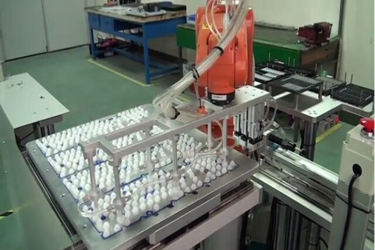 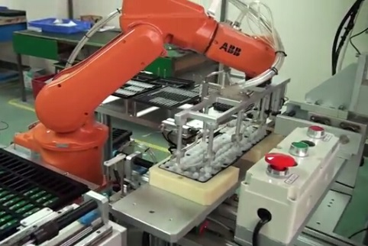

Figure 1. Pick and Place in 4 Dimension

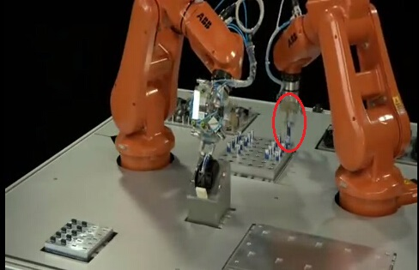 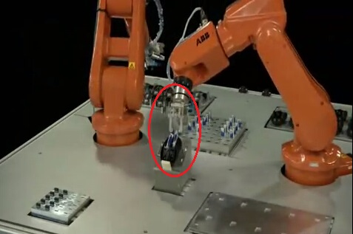

Figure 2. Pick and Place in 6 Dimension

## 3.2 Plug and Press

To snap fit two parts together or to press a part tight against another, a proper amount of force should be exerted along the normal direction. Sometimes how much force we could apply is even specified with lower and upper bounds. As we can see, pressing emphasizes more on the force side. Without loss of generality, we assume that the local normal direction is along the z-axis and the required force is $F_{press}=f_{z}∈Τ^{*}⊂se{\left(3\right)}^{*}$, where $T^{*}$ is the one dimensional wrench subspace where the desired force lies. In x and y direction, usually the robot has no motion, $ξ_{press}={\left(x,y,roll,pitch\right)}^{T}={\left(0,0,0,0\right)}^{T}∈T_{xy}⊂se(3)$ (Figure 3, the robot press the battery into a battery slot tightly). As for the rotation about z-axis, again it depends on the part symmetry. Pressing is a hybrid operation that requires force and velocity/position at the same time in different components.

Although pressing actually require force control along the normal direction, most automation solutions using pure position control to perform such tasks. The trick here is some elastic materials are on the end-effector and the pressing force, which is the elastic force here, is controlled by the position. This kind of solution is feasible, however, we cannot control the force precisely and need a case-by-case discussion since environment stiffness and force requirements are different for various tasks.

To plug a component into a specified hole, the process is quite the same with press process if described on mathematics. $ξ_{plug}={\left(x,y,roll,pitch\right)}^{T}={\left(0,0,0,0\right)}^{T}∈T_{xy}⊂se(3)$ and $F_{plug}=f_{z}∈Τ^{*}⊂se{\left(3\right)}^{*}$.

According to the above analysis, it becomes clear that plug and press are actually the same since:

1. they both require position control in 3-dimensional twist space
2. they both require force control in one dimensional wrench space
3. necessity of rotation about z-axis depends on the part symmetry

This gives us enough reason to treat them as one typical motion type.

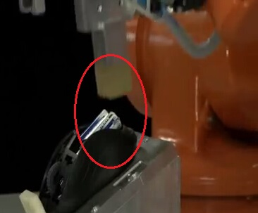 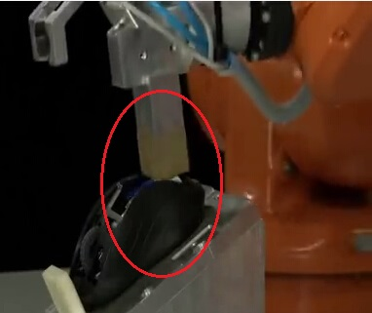

Figure 3. Press

## 3.3 Screw driving

Screw driving has always been an important part of assembly, the task of screw driving is still time-consuming for workers in spite of the fact that electric hand-held screw drivers are widely used in factories. Actually, the most difficult part of automatic screw driving is the screw feed system. Here, we just want to describe the screw driving operation in mathematic instead of consider too much about the screw feed system.

A typical screw driving example as shown in figure 4 might be decomposed into following steps:

1. move the screw driver to the position right above the screw hole
2. move down along z axis until screwed up

It’s obvious the first step only requires position control in . Assuming we are using a 6-DOF robot, such as the ABB IRB 120, then we have to ensure that the screw driver is in the desired position in all axises with the right orientation about x and y axis, which means we have to control in a 5-dimensional twist space. However, if we are using a 4-DOF robot, like the SCARA robot, we will only have to control in a 3-dimensional subspace of , since rotation about x and y axis are now guaranteed intrinsically.

As to the second step, it involves prismatic and revolute motion about z axis. During the screw driving process, force and torque control should be taken into account. Force control along z axis is needed in that

1. the screw driver must stick to the screw for a successful screw driving,
2. the screw driver must not press the screw too hard so as to jeopardize the screw thread.

Torque control about z axis is also a must since:

1. different screw have different criteria for being screwed up;
2. too large torque can actually damage the screw.

Generally speaking, assuming that local direction is along the z-axis, during the second step, control in a 2-dimentsional wrench space is necessary, namely

$$F_{screw}={\left(f_{z},τ_{z}\right)}^{T}∈ se{\left(3\right)}^{*}$$

In the same time, control in 4-dimensional twist space is required:

$ξ_{screw}={\left(x,y,roll,pitch\right)}^{T}={\left(0,0,0,0\right)}^{T}$

However, in practice, there is hardly any force control in z-axis, since precise force control in z-axis is not required. As a matter of fact, there is a spring inside most hand-held screw drivers, which offers a buffer distance for screw driving. The trick here is very similar to the trick used in the above press process which uses pure position control instead of using force control with the help of some elastic materials.

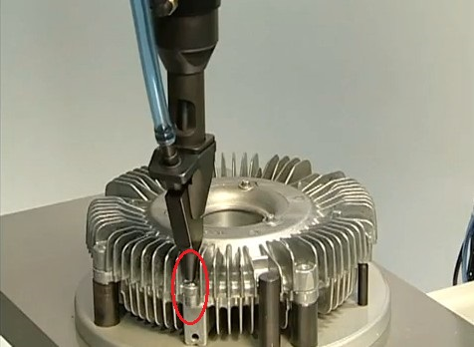

Figure 4. Screw driving

# 4. Conclusion

After conduction of quite some surveys of typical assembly process, we conclude that pick and place, plug and press and screw driving are the most typical operations in 3C assembly process, despite that a considerable proportion are done by hands.

Based on our survey and theory from Richard Murray, Zexiang Li and Shankar Sastry’s book, a simple yet effective mathematical analysis is provided, where we describe different operations using twist and wrench.

|  |  |  |
| --- | --- | --- |
| Operations | Control Requirement | |
| $$se(3)$$ | $$se{\left(3\right)}^{*}$$ |
| Pick and place | $ξ_{pick\&place}={\left(x,y,z,roll,pitch,yaw\right)}^{T}$ (most of time $roll=0, pitch=0$) | no requirement on $se{\left(3\right)}^{*}$ |
| Plug and Press | $ξ_{plug \& press}={\left(x,y,roll,pitch\right)}^{T}={\left(0,0,0,0\right)}^{T}$ (*yaw* depends on symmetry) | $$F_{plug \& press}=f_{z}∈Τ^{*}$$ |
| Screw driving | $$ξ_{screw}={\left(x,y,roll,pitch\right)}^{T}={\left(0,0,0,0\right)}^{T}$$ | $$F_{screw}={\left(f_{z},τ_{z}\right)}^{T}$$ |