# MPC-MAP Assignment No. 1 - Report

## **Author:** Josef Bartoněk

## **Date:** 26.2.2025

## Task 2

Calculated standard deviation for gnss is: 0.5002, 0.4969, and for lidar: 0.0504, 0.0491, 0.0522, 0.0507, 0.0501, 0.0514, 0.0522, 0.0513. It can be said that the std is consistent across individual LiDAR channels and both GNSS axes.

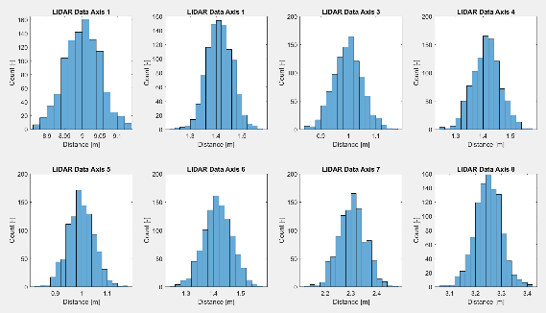

Figure 2 – LIDAR Histograms

Figure 1 – GNSS Histograms

## Task 3

From Figures 3 and 4 can be seen that the values on the main diagonal are equal to sigma^2, i.e., variance=std^2`.

Figure 4 - LIDAR Covariance matrix

Figure 3 – GNSS Covariance matrix

## A graph of a graph AI-generated content may be incorrect.Task 4

Figure 1 –  Noise characteristics of the robot's sensors

## Task 5

Potential sources of uncertainty in the robot's motion include wheel diameter differences, wheel slip, ...

Figure 3 – GG