# MPC-MAP Assignment No. 3 - Report

## **Author:** Josef Bartoněk

## **Date:** 12.3.2025

## Task 1

I implemented the predict_pose function to update the particle pose based on the given control input. I applied a probabilistic motion model using *randn()/20* to slightly enhance particles variance.

## Task 2

For the correction part, i implemented weight_particles funtion using euclidean distance.

## Task 3&4

For resampling, I implemented Thruns algorithm. I also implemented function to make 1/40 resampled particles random. Most important parameters are number of particles and number of randomly regenerated particles. Biggest obstacles was me making mistakes while implementing algorithms, another big obstacle is map  containing similar corridors, as shown in Figure 1. In Figure 2 is shown adjusted map, where it is easier for particle filter to correctly “guess” robots position. That is not necessary, as shown in Figure 3, but in this case it obviously works correctly less often.

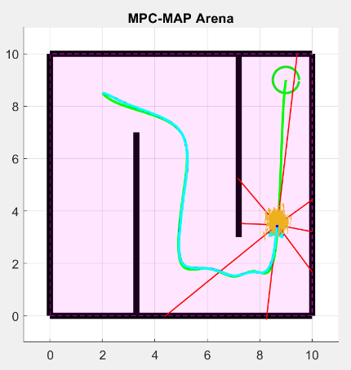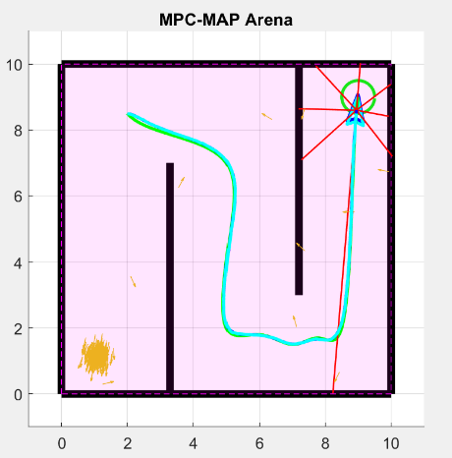

Figure 3 – PF working correctly

Figure 2 – PF working correctly adjusted map

Figure 1 – PF not working