Distortion: Error + 0.5

PL: Error + 0.9

VAE: Error + [3, 4]

For our current approach, the low accuracy ones are mostly due to relatively small training samples.

The performance of the model predicting T Cells is not good, but it is not due to the size of training dataset. I am planning to look into the T Cell individual dataset.

The confusion matrix and corresponding model & loss are listed as follows.

Only Neural Networks + Cross Entropy loss

Epoch 30 ||Train ER 7.64, time 0.4s ||

Neural Network Encoding + Cross Entropy loss & Distortion loss

Epoch 30 || Train ER 8.75, time 0.5s || Test ER 9.71, time 0.1s

Neural Network Encoding + Cross Entropy loss & Distortion loss & PL loss

Epoch 50 || Train ER 10.38, time 0.6s ||

VAE encoding + Cross Entropy loss & VAE loss

Epoch 50 || Train ER 13.40, time 0.8s ||

VAE + Cross Entropy loss & Distortion loss

Epoch 50 || Train ER 13.75, time 0.9s ||

VAE + Cross Entropy & PL

Epoch 50 || Train ER 13.36, time 0.9s ||

VAE + Cross entropy & Distortion & PL

Epoch 50 || Train ER 13.19, time 1.0s || Test ER 13.54, time 0.1s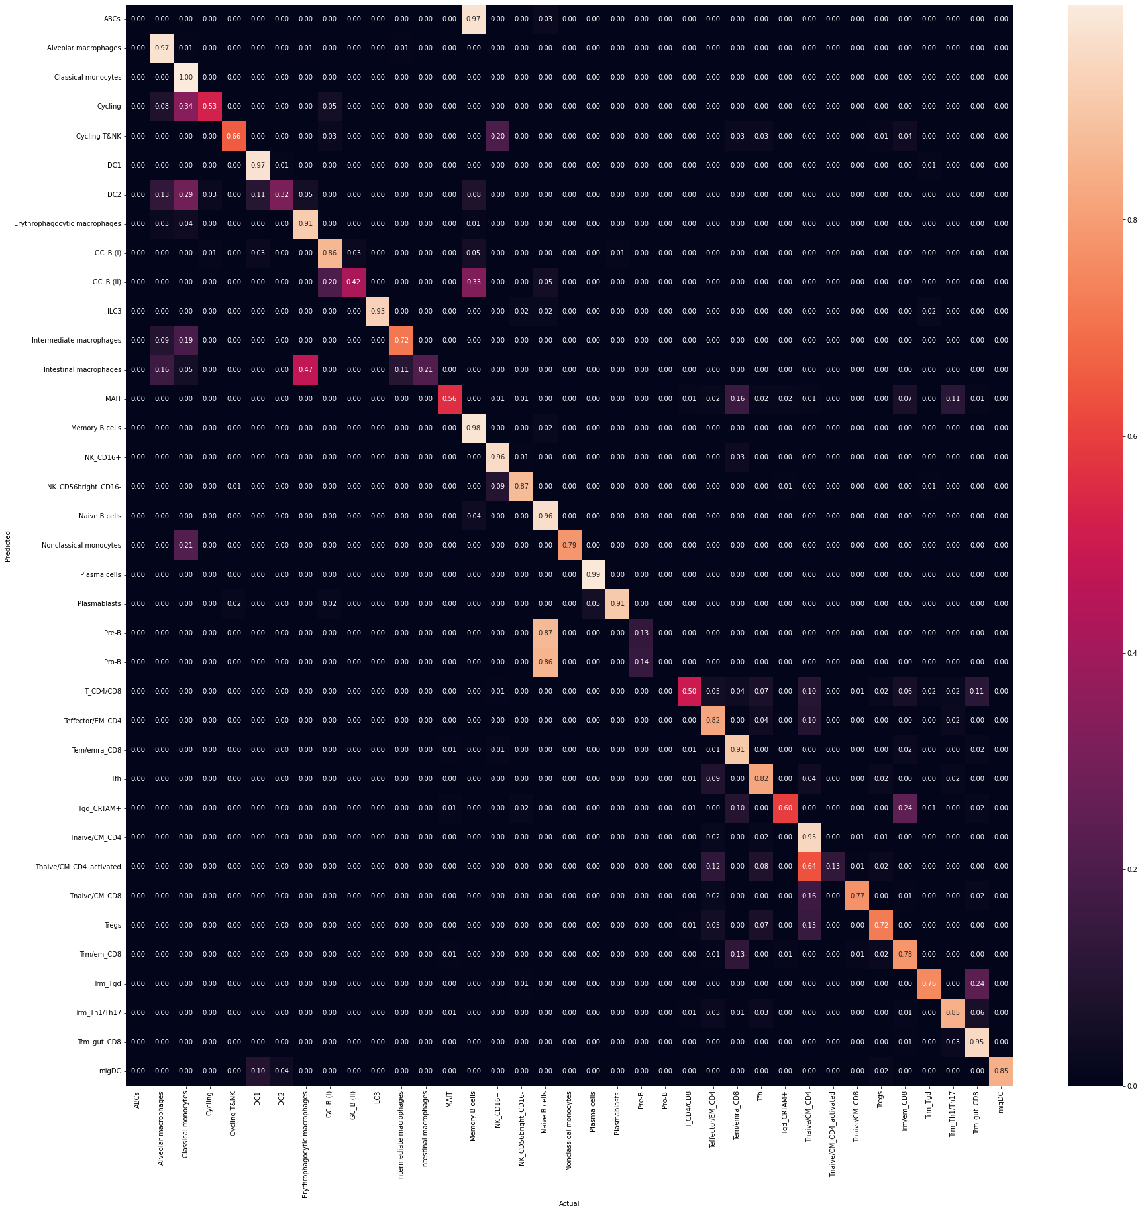

Count by cell type (red line: y = 500)

