======================================================================
Scene Description: The ego vehicle proceeded straight ahead after making a right turn at the traffic light intersection and entering the right lane.
Number of Frames: 8
======================================================================

======================================================================
Frame 1/8 token: 2ce93aa700164aacbc001a2c81e25b3c
======================================================================

--- Path to Camera Image ---

CAM_FRONT: n008-2018-08-28-16-16-48-0400__CAM_FRONT__1535488208262404.jpg
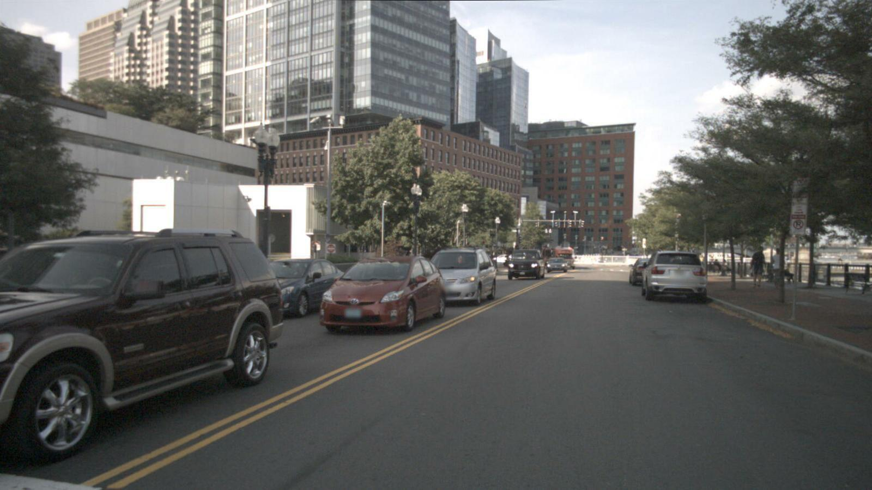

CAM_FRONT_LEFT: n008-2018-08-28-16-16-48-0400__CAM_FRONT_LEFT__1535488208254799.jpg
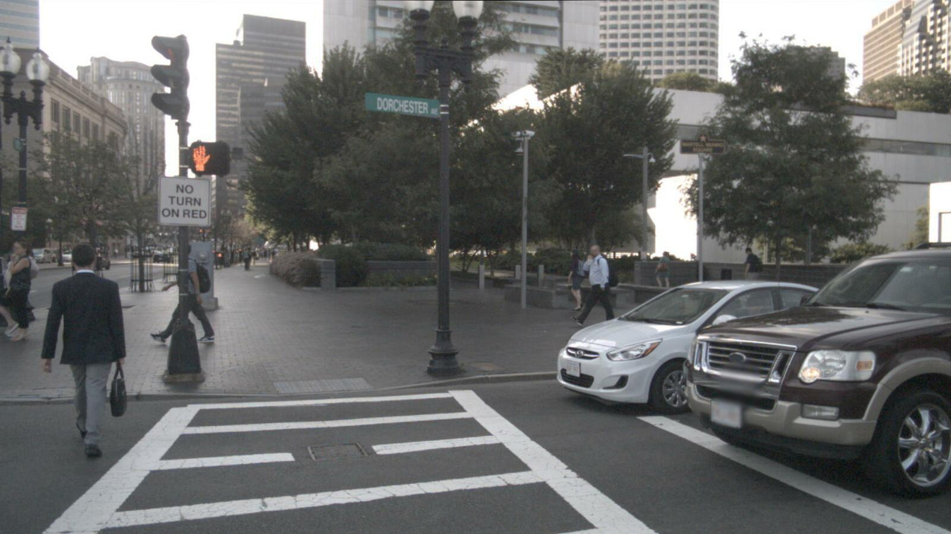

CAM_FRONT_RIGHT: n008-2018-08-28-16-16-48-0400__CAM_FRONT_RIGHT__1535488208270482.jpg
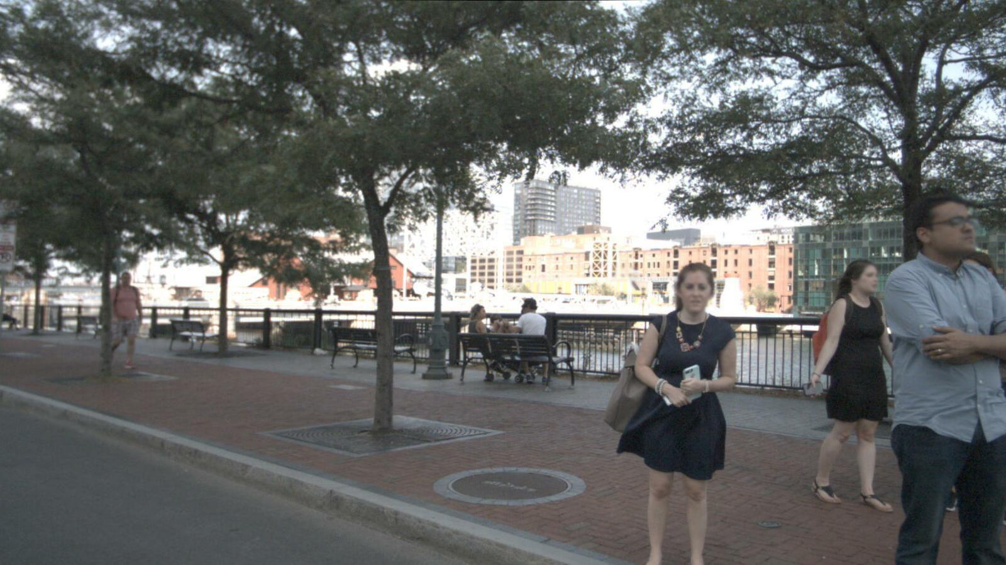

CAM_BACK: n008-2018-08-28-16-16-48-0400__CAM_BACK__1535488208287558.jpg
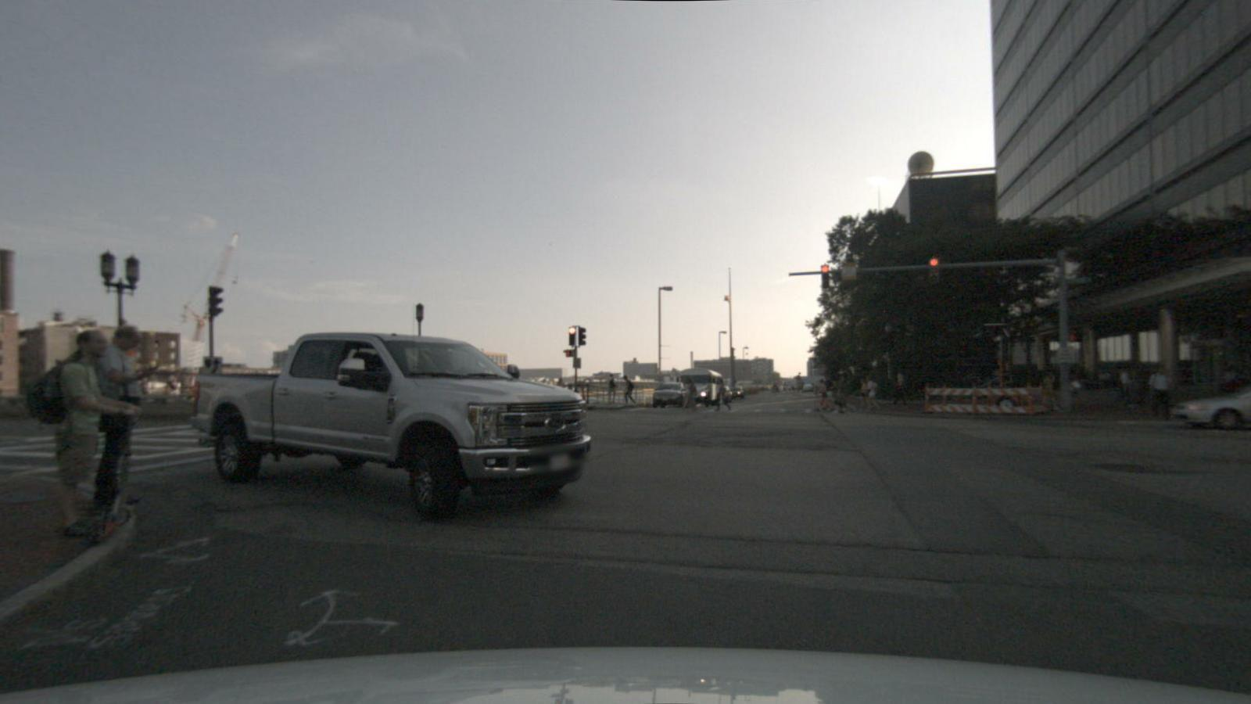

CAM_BACK_LEFT: n008-2018-08-28-16-16-48-0400__CAM_BACK_LEFT__1535488208297405.jpg
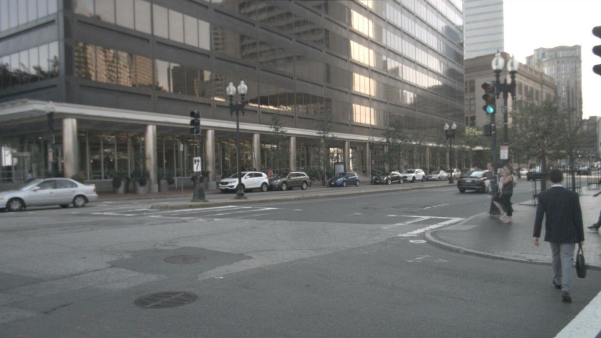

CAM_BACK_RIGHT : n008-2018-08-28-16-16-48-0400__CAM_BACK_RIGHT__1535488208278113.jpg
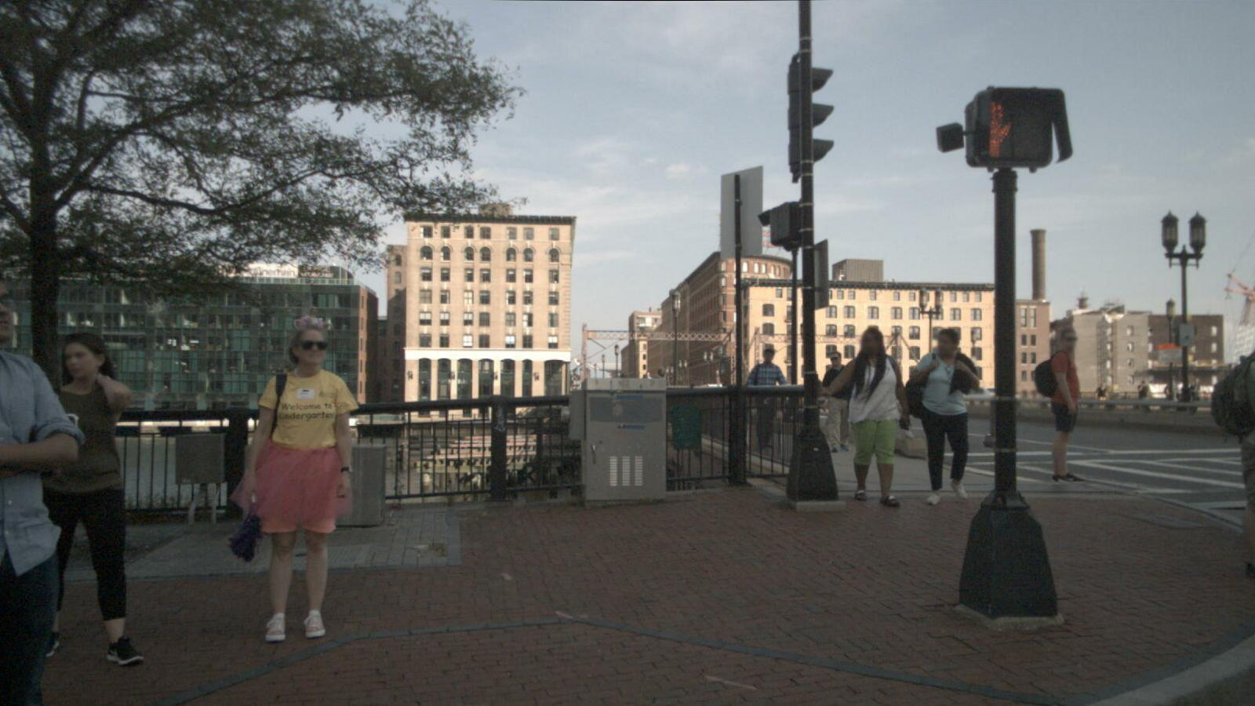

--- PERCEPTION (62 records) ---
Q1: What are objects to the front right of the ego car?
A1: There are many pedestrians to the front right of the ego car.

Q2: What is the status of the pedestrians that are to the front right of the ego car?
A2: Many pedestrians are standing, and many are moving.

Q3: What are objects to the back of the ego car?
A3: There are many pedestrians, many traffic cones, one truck, many cars, one bus, and one trailer behind the ego car.

Q4: What is the status of the pedestrians that are to the back of the ego car?
A4: Many pedestrians are moving, and one is standing.

Q5: What are objects to the back left of the ego car?
A5: There are many pedestrians, one traffic cone, and many cars to the back left of the ego car.

Q6: What is the status of the pedestrians that are to the back left of the ego car?
A6: One of the pedestrians is standing, and three are moving.

Q7: What are objects to the front left of the ego car?
A7: There are many pedestrians and three cars to the front left of the ego car.

Q8: What is the status of the pedestrians that are to the front left of the ego car?
A8: Three of the pedestrians are standing, and many are moving.

Q9: What are objects to the back right of the ego car?
A9: There are many pedestrians to the back right of the ego car.

Q10: What is the status of the pedestrians that are to the back right of the ego car?
A10: Many pedestrians are standing, and many are moving.

Q11: What are objects to the front of the ego car?
A11: There are many pedestrians, many cars, and one truck in front of the ego car.

Q12: What is the status of the pedestrians that are to the front of the ego car?
A12: Many pedestrians are moving.

Q13: What is the status of the truck that is to the back of the ego car?
A13: One truck is moving.

Q14: What is the status of the cars that are to the back left of the ego car?
A14: Many cars are moving, and three are parked.

Q15: What is the status of the cars that are to the back of the ego car?
A15: One of the cars is moving, and three are parked.

Q16: What is the status of the cars that are to the front of the ego car?
A16: Many cars are moving, and many are parked.

Q17: What is the status of the cars that are to the front left of the ego car?
A17: Two of the cars are moving, and one is parked.

Q18: What is the status of the bus that is to the back of the ego car?
A18: One bus is stopped.

Q19: What is the status of the truck that is to the front of the ego car?
A19: One truck is moving.

Q20: What is the status of the trailer that is to the back of the ego car?
A20: The trailer at the back of the ego car is parked.

Q21: Are there parked cars to the front right of the ego car?
A21: No.

Q22: Are there barriers to the front left of the ego car?
A22: No.

Q23: Are there moving cars to the back left of the ego car?
A23: Yes.

Q24: Are there moving pedestrians to the back right of the ego car?
A24: Yes.

Q25: Are there standing pedestrians to the front left of the ego car?
A25: Yes.

Q26: Are there standing pedestrians to the back of the ego car?
A26: Yes.

Q27: Are there traffic cones to the back of the ego car?
A27: Yes.

Q28: Are there moving pedestrians to the back left of the ego car?
A28: Yes.

Q29: Are there moving pedestrians to the front right of the ego car?
A29: Yes.

Q30: Are there moving pedestrians to the front of the ego car?
A30: Yes.

Q31: Are there stopped buses to the back of the ego car?
A31: Yes.

Q32: Are there parked cars to the front left of the ego car?
A32: Yes.

Q33: Are there standing pedestrians to the back right of the ego car?
A33: Yes.

Q34: Are there parked trailers to the back of the ego car?
A34: Yes.

Q35: Are there moving pedestrians to the front left of the ego car?
A35: Yes.

Q36: Are there moving pedestrians to the back of the ego car?
A36: Yes.

Q37: Are there parked cars to the back left of the ego car?
A37: Yes.

Q38: Are there traffic cones to the back left of the ego car?
A38: Yes.

Q39: Are there parked cars to the back of the ego car?
A39: Yes.

Q40: Are there parked cars to the front of the ego car?
A40: Yes.

Q41: Are there standing pedestrians to the front right of the ego car?
A41: Yes.

Q42: Are there moving cars to the front of the ego car?
A42: Yes.

Q43: Please describe the current scene.
A43: There are three moving cars in front of the ego car, two parked cars in front of the ego car, one parked car to the front left of the ego car, two parked cars behind the ego car, one moving truck behind the ego car, one stopped bus behind the ego car, three standing pedestrians to the front right of the ego car, three standing pedestrians to the back right of the ego car, one standing pedestrian behind the ego car, one moving pedestrian in front of the ego car, one moving pedestrian to the front right of the ego car, and many moving pedestrians behind the ego car.

Q44: What is the relative positioning of the important objects in the current scene?
A44: <c4,CAM_FRONT,1238.3,498.3> is in front of <c1,CAM_FRONT_RIGHT,1087.1,666.4>, <c5,CAM_FRONT_RIGHT,187.5,508.3> is in front of <c1,CAM_FRONT_RIGHT,1087.1,666.4>, <c3,CAM_FRONT,20.8,620.8> is on the front left of <c1,CAM_FRONT_RIGHT,1087.1,666.4>, <c2,CAM_BACK,508.0,547.4> is behind <c1,CAM_FRONT_RIGHT,1087.1,666.4>, <c6,CAM_BACK_LEFT,1507.5,619.2> is on the back left of <c1,CAM_FRONT_RIGHT,1087.1,666.4>, <c3,CAM_FRONT,20.8,620.8> is in front of <c2,CAM_BACK,508.0,547.4>, <c4,CAM_FRONT,1238.3,498.3> is in front of <c2,CAM_BACK,508.0,547.4>, <c5,CAM_FRONT_RIGHT,187.5,508.3> is in front of <c2,CAM_BACK,508.0,547.4>, <c6,CAM_BACK_LEFT,1507.5,619.2> is on the front left of <c2,CAM_BACK,508.0,547.4>, <c4,CAM_FRONT,1238.3,498.3> is on the front right of <c3,CAM_FRONT,20.8,620.8>, <c5,CAM_FRONT_RIGHT,187.5,508.3> is on the front right of <c3,CAM_FRONT,20.8,620.8>, <c6,CAM_BACK_LEFT,1507.5,619.2> is on the back left of <c3,CAM_FRONT,20.8,620.8>, <c5,CAM_FRONT_RIGHT,187.5,508.3> is behind <c4,CAM_FRONT,1238.3,498.3>, <c6,CAM_BACK_LEFT,1507.5,619.2> is on the back left of <c4,CAM_FRONT,1238.3,498.3> and <c6,CAM_BACK_LEFT,1507.5,619.2> is on the back left of <c5,CAM_FRONT_RIGHT,187.5,508.3>.

Q45: Is there any traffic element in the front view?
A45: Yes, there are traffic elements in the front view.

Q46: Identify all the traffic elements in the front view, categorize them, determine their status, and predict the bounding box around each one. The output should be a list formatted as (c, s, x1, y1, x2, y2), where c represents the category, s denotes the status, and x1, y1, x2, y2 are the offsets of the top-left and bottom-right corners of the box relative to the center point.
A46: There are many traffic elements in the front view. The information of these traffic elements is [(traffic light, unknown, 1061.0, 402.75, 1071.81, 417.8), (traffic light, unknown, 1042.11, 403.07, 1048.82, 417.67), (traffic light, unknown, 1018.53, 401.55, 1027.85, 418.12), (traffic light, unknown, 982.55, 402.1, 990.37, 417.92), (traffic light, unknown, 952.01, 431.03, 957.32, 447.08)].

Q47: What are the important objects in the current scene? Those objects will be considered for the future reasoning and driving decision.
A47: There is a person wearing a black dress to the front right of the ego vehicle, a white truck to the back of the ego vehicle, a brown SUV to the front of the ego vehicle, a white sedan to the front of the ego vehicle, a person wearing an orange shirt to the front right of the ego vehicle, and a person wearing a black top to the back left of the ego vehicle. The IDs of these objects are <c1,CAM_FRONT_RIGHT,1087.1,666.4>, <c2,CAM_BACK,508.0,547.4>, <c3,CAM_FRONT,20.8,620.8>, <c4,CAM_FRONT,1238.3,498.3>, <c5,CAM_FRONT_RIGHT,187.5,508.3>, and <c6,CAM_BACK_LEFT,1507.5,619.2>.

Q48: What is the observed status of object <c1,CAM_FRONT_RIGHT,1087.1,666.4>?
A48: Stationary.

Q49: What is the observed status of object <c2,CAM_BACK,508.0,547.4>?
A49: Moving.

Q50: What is the moving status of object <c2,CAM_BACK,508.0,547.4>?
A50: Going ahead.

Q51: What is the observed status of object <c3,CAM_FRONT,20.8,620.8>?
A51: Stationary.

Q52: What is the observed status of object <c4,CAM_FRONT,1238.3,498.3>?
A52: Stationary.

Q53: What is the observed status of object <c5,CAM_FRONT_RIGHT,187.5,508.3>?
A53: Moving.

Q54: What is the moving status of object <c5,CAM_FRONT_RIGHT,187.5,508.3>?
A54: Going ahead.

Q55: What is the observed status of object <c6,CAM_BACK_LEFT,1507.5,619.2>?
A55: Moving.

Q56: What is the moving status of object <c6,CAM_BACK_LEFT,1507.5,619.2>?
A56: Going ahead.

Q57: What is the visual description of <c1,CAM_FRONT_RIGHT,1087.1,666.4>?
A57: The visual description of <c1,CAM_FRONT_RIGHT,1087.1,666.4> is a person wearing a black dress.

Q58: What is the visual description of <c2,CAM_BACK,508.0,547.4>?
A58: White truck.

Q59: What is the visual description of <c3,CAM_FRONT,20.8,620.8>?
A59: Brown SUV.

Q60: What is the visual description of <c4,CAM_FRONT,1238.3,498.3>?
A60: White sedan.

Q61: What is the visual description of <c5,CAM_FRONT_RIGHT,187.5,508.3>?
A61: The visual description of <c5,CAM_FRONT_RIGHT,187.5,508.3> is a person wearing an orange shirt.

Q62: What is the visual description of <c6,CAM_BACK_LEFT,1507.5,619.2>?
A62: A person wearing a black top is the visual description of <c6,CAM_BACK_LEFT,1507.5,619.2>.

--- PREDICTION (37 Records) ---
Q1: Is <c1,CAM_FRONT_RIGHT,1087.1,666.4> a traffic sign or a road barrier?
A1: No.

Q2: Would <c1,CAM_FRONT_RIGHT,1087.1,666.4> be in the moving direction of the ego vehicle?
A2: No.

Q3: What is the future state of <c1,CAM_FRONT_RIGHT,1087.1,666.4>?
A3: Stationary.

Q4: Is <c2,CAM_BACK,508.0,547.4> a traffic sign or a road barrier?
A4: No.

Q5: Which object is most likely to be occluded by <c2,CAM_BACK,508.0,547.4>? Would this object affect the ego vehicle? Based on this object, what action of the ego vehicle is dangerous?
A5: None, no, none.

Q6: Would <c2,CAM_BACK,508.0,547.4> be in the moving direction of the ego vehicle?
A6: No.

Q7: What is the future state of <c2,CAM_BACK,508.0,547.4>?
A7: Turn right.

Q8: Is <c3,CAM_FRONT,20.8,620.8> a traffic sign or a road barrier?
A8: No.

Q9: Would <c3,CAM_FRONT,20.8,620.8> be in the moving direction of the ego vehicle?
A9: No.

Q10: What is the future state of <c3,CAM_FRONT,20.8,620.8>?
A10: Keep going straight.

Q11: Is <c4,CAM_FRONT,1238.3,498.3> a traffic sign or a road barrier?
A11: No.

Q12: Would <c4,CAM_FRONT,1238.3,498.3> be in the moving direction of the ego vehicle?
A12: Yes.

Q13: What is the future state of <c4,CAM_FRONT,1238.3,498.3>?
A13: Stationary.

Q14: Is <c5,CAM_FRONT_RIGHT,187.5,508.3> a traffic sign or a road barrier?
A14: No.

Q15: Which object is most likely to be occluded by <c5,CAM_FRONT_RIGHT,187.5,508.3>? Would this object affect the ego vehicle? Based on this object, what action of the ego vehicle is dangerous?
A15: None, no, none.

Q16: Would <c5,CAM_FRONT_RIGHT,187.5,508.3> be in the moving direction of the ego vehicle?
A16: No.

Q17: What is the future state of <c5,CAM_FRONT_RIGHT,187.5,508.3>?
A17: Keep going straight.

Q18: Is <c6,CAM_BACK_LEFT,1507.5,619.2> a traffic sign or a road barrier?
A18: No.

Q19: Which object is most likely to be occluded by <c6,CAM_BACK_LEFT,1507.5,619.2>? Would this object affect the ego vehicle? Based on this object, what action of the ego vehicle is dangerous?
A19: None, no, none.

Q20: Would <c6,CAM_BACK_LEFT,1507.5,619.2> be in the moving direction of the ego vehicle?
A20: No.

Q21: What is the future state of <c6,CAM_BACK_LEFT,1507.5,619.2>?
A21: Keep going straight.

Q22: What object should the ego vehicle notice first when the ego vehicle is getting to the next possible location? What is the state of the object that is first noticed by the ego vehicle and what action should the ego vehicle take? What object should the ego vehicle notice second when the ego vehicle is getting to the next possible location? What is the state of the object perceived by the ego vehicle as second and what action should the ego vehicle take? What object should the ego vehicle notice third? What is the state of the object perceived by the ego vehicle as third and what action should the ego vehicle take?
A22: Firstly, notice that <c1,CAM_FRONT_RIGHT,1087.1,666.4>. The object is stationary, so the ego vehicle should turn right. Secondly, notice that <c3,CAM_FRONT,20.8,620.8>. The object is stationary, so the ego vehicle should turn right. Thirdly, notice that <c5,CAM_FRONT_RIGHT,187.5,508.3>. The object is going ahead, so the ego vehicle should turn right.

Q23: Are <c2,CAM_BACK,508.0,547.4> and <c6,CAM_BACK_LEFT,1507.5,619.2> traffic signs?
A23: Neither is a traffic sign.

Q24: Will <c2,CAM_BACK,508.0,547.4> be in the moving direction of <c6,CAM_BACK_LEFT,1507.5,619.2>?
A24: No.

Q25: Will <c2,CAM_BACK,508.0,547.4> change its motion state based on <c6,CAM_BACK_LEFT,1507.5,619.2>?
A25: Yes.

Q26: Based on the observations of <c6,CAM_BACK_LEFT,1507.5,619.2>, what are possible actions to be taken by <c2,CAM_BACK,508.0,547.4>? What is the reason?
A26: The action is to decelerate and go ahead; the reason is to yield to pedestrians.

Q27: What object would consider <c2,CAM_BACK,508.0,547.4> to be most relevant to its decision?
A27: None.

Q28: What object would consider <c6,CAM_BACK_LEFT,1507.5,619.2> to be most relevant to its decision?
A28: The ego vehicle.

Q29: Except for the ego vehicle, what object would consider <c6,CAM_BACK_LEFT,1507.5,619.2> to be most relevant to its decision?
A29: <c2,CAM_BACK,508.0,547.4>.

Q30: Are <c5,CAM_FRONT_RIGHT,187.5,508.3> and <c3,CAM_FRONT,20.8,620.8> traffic signs?
A30: Neither is a traffic sign.

Q31: Will <c5,CAM_FRONT_RIGHT,187.5,508.3> be in the moving direction of <c3,CAM_FRONT,20.8,620.8>?
A31: No.

Q32: Will <c5,CAM_FRONT_RIGHT,187.5,508.3> change its motion state based on <c3,CAM_FRONT,20.8,620.8>?
A32: No.

Q33: Based on the observations of <c3,CAM_FRONT,20.8,620.8>, what are possible actions to be taken by <c5,CAM_FRONT_RIGHT,187.5,508.3>? What is the reason?
A33: The action is to keep going at the same speed, the reason is there is no safety issue.

Q34: What object would consider <c5,CAM_FRONT_RIGHT,187.5,508.3> to be most relevant to its decision?
A34: The ego vehicle.

Q35: Except for the ego vehicle, what object would consider <c5,CAM_FRONT_RIGHT,187.5,508.3> to be most relevant to its decision?
A35: <c2,CAM_BACK,508.0,547.4>.

Q36: What object would consider <c3,CAM_FRONT,20.8,620.8> to be most relevant to its decision?
A36: The ego vehicle.

Q37: Except for the ego vehicle, what object would consider <c3,CAM_FRONT,20.8,620.8> to be most relevant to its decision?
A37: <c2,CAM_BACK,508.0,547.4>.

--- PLANNING (30 Records) ---
Q1: Is <c1,CAM_FRONT_RIGHT,1087.1,666.4> an object that the ego vehicle should consider in the current scene?
A1: Yes.

Q2: What actions could the ego vehicle take based on <c1,CAM_FRONT_RIGHT,1087.1,666.4>? Why take this action and what's the probability?
A2: The action is to decelerate gradually without braking. The reason for taking this action is to avoid a collision, which has a high probability.

Q3: What is the probability of colliding with <c1,CAM_FRONT_RIGHT,1087.1,666.4> after the ego vehicle decelerates and goes straight?
A3: Low.

Q4: What actions taken by the ego vehicle can lead to a collision with <c1,CAM_FRONT_RIGHT,1087.1,666.4>?
A4: Sharp right turn.

Q5: Is <c2,CAM_BACK,508.0,547.4> an object that the ego vehicle should consider in the current scene?
A5: No.

Q6: What actions could the ego vehicle take based on <c2,CAM_BACK,508.0,547.4>? Why take this action and what's the probability?
A6: The action is to decelerate gradually without braking. The reason is that there is no safety issue. The probability of this action is high.

Q7: What is the probability of colliding with <c2,CAM_BACK,508.0,547.4> after the ego vehicle decelerates and goes straight?
A7: Low.

Q8: What actions taken by the ego vehicle can lead to a collision with <c2,CAM_BACK,508.0,547.4>?
A8: Brake suddenly.

Q9: Is <c3,CAM_FRONT,20.8,620.8> an object that the ego vehicle should consider in the current scene?
A9: Yes.

Q10: What actions could the ego vehicle take based on <c3,CAM_FRONT,20.8,620.8>? Why take this action and what's the probability?
A10: The action is to decelerate gradually without braking. The reason is that there is no safety issue. The probability is high.

Q11: What is the probability of colliding with <c3,CAM_FRONT,20.8,620.8> after the ego vehicle decelerates and goes straight?
A11: Low.

Q12: What actions taken by the ego vehicle can lead to a collision with <c3,CAM_FRONT,20.8,620.8>?
A12: Sharp left turn.

Q13: Is <c4,CAM_FRONT,1238.3,498.3> an object that the ego vehicle should consider in the current scene?
A13: Yes.

Q14: What actions could the ego vehicle take based on <c4,CAM_FRONT,1238.3,498.3>? Why take this action and what's the probability?
A14: The action is to slightly offset to the left in maneuvering. The reason is that there is no safety issue, with a high probability.

Q15: What is the probability of colliding with <c4,CAM_FRONT,1238.3,498.3> after the ego vehicle decelerates and goes straight?
A15: Low.

Q16: What actions taken by the ego vehicle can lead to a collision with <c4,CAM_FRONT,1238.3,498.3>?
A16: Sharp right turn.

Q17: Is <c5,CAM_FRONT_RIGHT,187.5,508.3> an object that the ego vehicle should consider in the current scene?
A17: Yes.

Q18: What actions could the ego vehicle take based on <c5,CAM_FRONT_RIGHT,187.5,508.3>? Why take this action and what's the probability?
A18: The action is to decelerate gradually without braking. The reason for taking this action is that there is no safety issue. The probability is high.

Q19: What is the probability of colliding with <c5,CAM_FRONT_RIGHT,187.5,508.3> after the ego vehicle decelerates and goes straight?
A19: Low.

Q20: What actions taken by the ego vehicle can lead to a collision with <c5,CAM_FRONT_RIGHT,187.5,508.3>?
A20: Sharp right turn.

Q21: Is <c6,CAM_BACK_LEFT,1507.5,619.2> an object that the ego vehicle should consider in the current scene?
A21: No.

Q22: What actions could the ego vehicle take based on <c6,CAM_BACK_LEFT,1507.5,619.2>? Why take this action and what's the probability?
A22: The action is to decelerate gradually without braking because there is no safety issue. The probability of this action is high.

Q23: What is the probability of colliding with <c6,CAM_BACK_LEFT,1507.5,619.2> after the ego vehicle decelerates and goes straight?
A23: Low.

Q24: What actions taken by the ego vehicle can lead to a collision with <c6,CAM_BACK_LEFT,1507.5,619.2>?
A24: Sharp left turn.

Q25: What is the traffic signal that the ego vehicle should pay attention to?
A25: None.

Q26: What is the target action of the ego vehicle?
A26: Go straight.

Q27: In this scenario, what are safe actions to take for the ego vehicle?
A27: Decelerate gradually without braking and turn right.

Q28: In this scenario, what are dangerous actions to take for the ego vehicle?
A28: Turning left, backing up.

Q29: What is the priority of the objects that the ego vehicle should consider?(in descending order)
A29: The priority of the objects that the ego vehicle should consider (in descending order) is <c1,CAM_FRONT_RIGHT,1087.1,666.4>, <c3,CAM_FRONT,20.8,620.8>, <c5,CAM_FRONT_RIGHT,187.5,508.3>, <c4,CAM_FRONT,1238.3,498.3>, <c2,CAM_BACK,508.0,547.4>, <c6,CAM_BACK_LEFT,1507.5,619.2>.

Q30: What's your comment on this scene?
A30: Pay attention to safety with so many cars.

--- BEHAVIOR (1 Record) ---
Q1: Predict the behavior of the ego vehicle.
A1: The ego vehicle is slightly steering to the right. The ego vehicle is driving slowly.

