**index:**

**monitor.js:**

**products.js:**

**script.js:**

**events.js:**

**O****utput:**

**Toggle search bar**

**Add button**

**Popup show net cart**

**Shopping cart**

**Dynamic source code:**

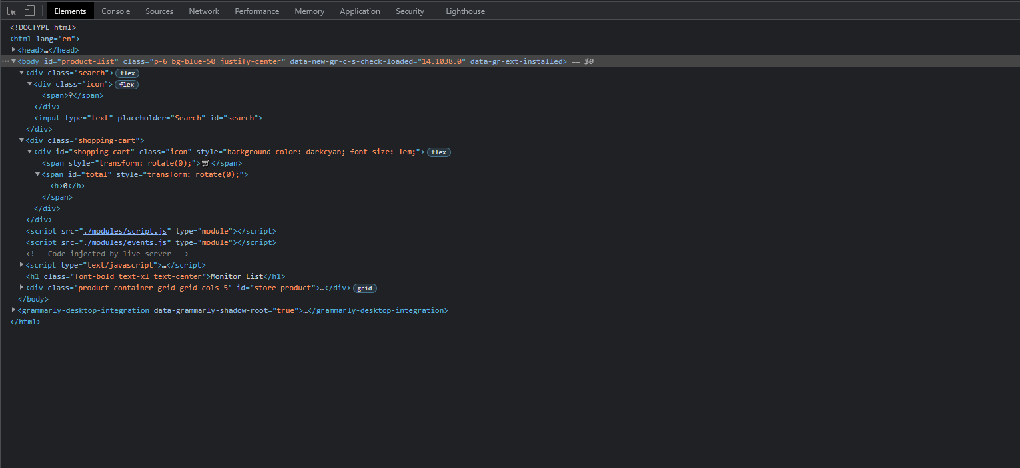

***GIT LINK* (This Assignment => include work ratio):** [***Click here***](https://github.com/xbklyn/INT201-G06-GroupWorks/tree/main/Assignment7)

***GIT LINK* (All Assignment):** [***Click here***](https://github.com/xbklyn/INT201-G06-GroupWorks)