**index:**

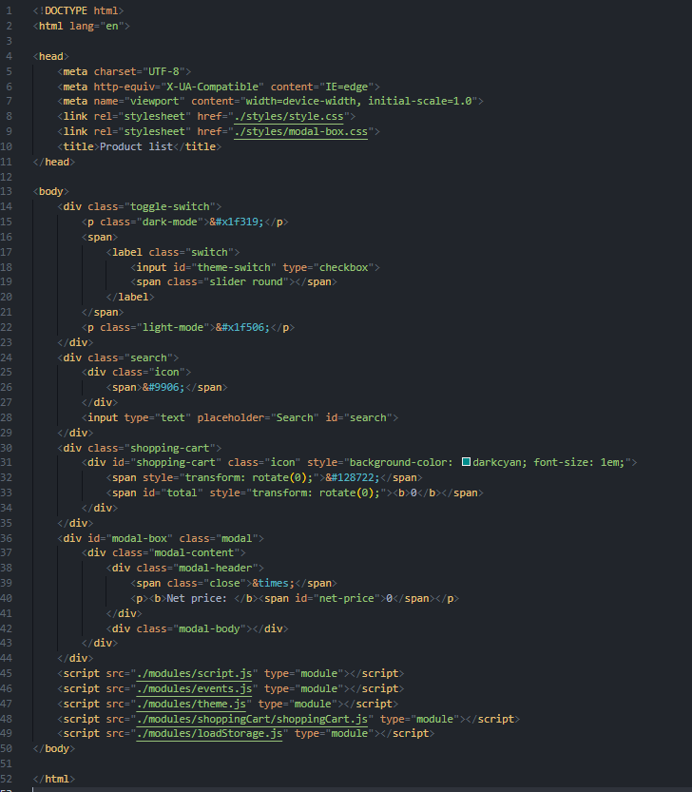

**monitor.js:**

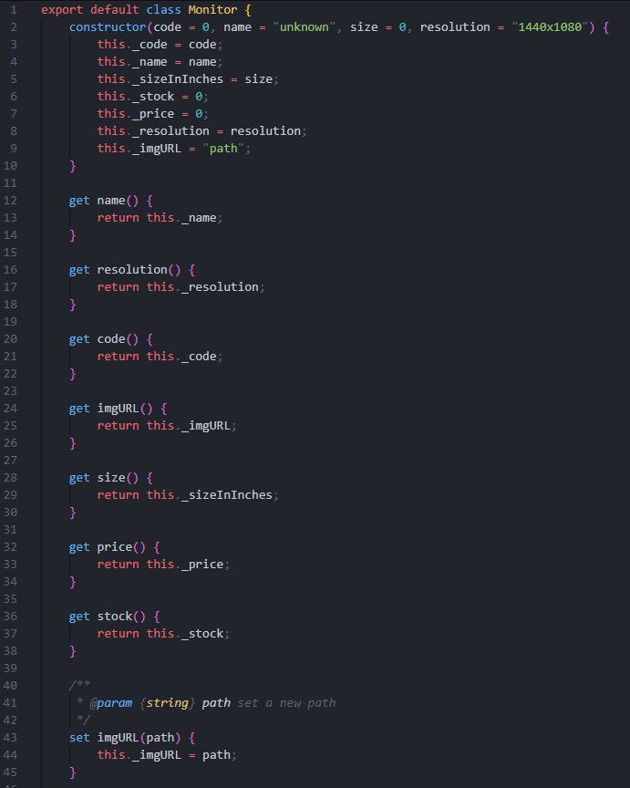

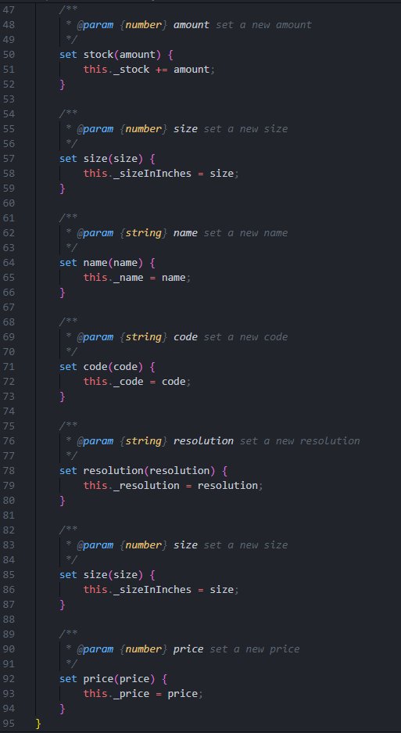

**products.js:**

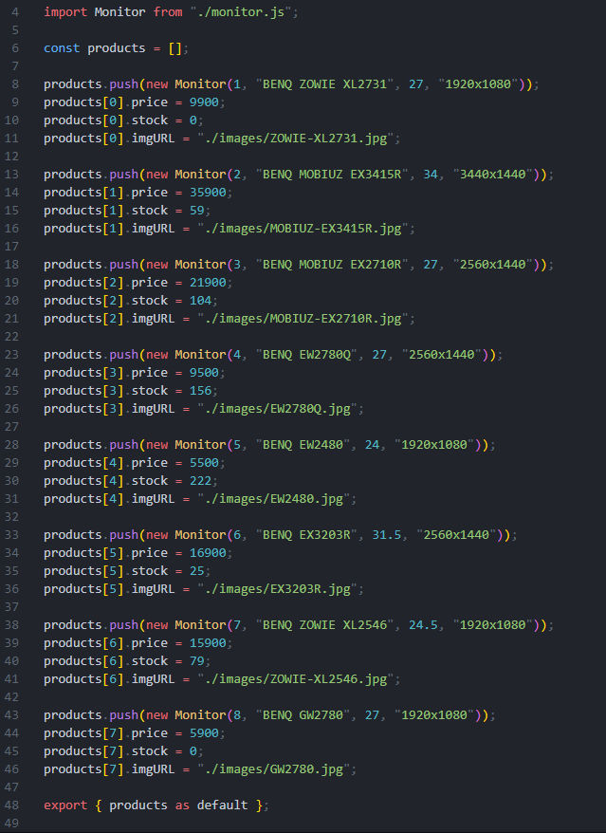

**script.js:**

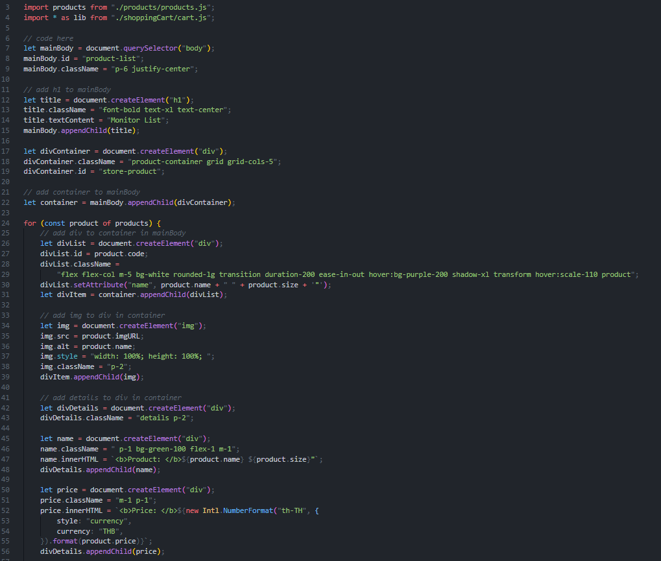

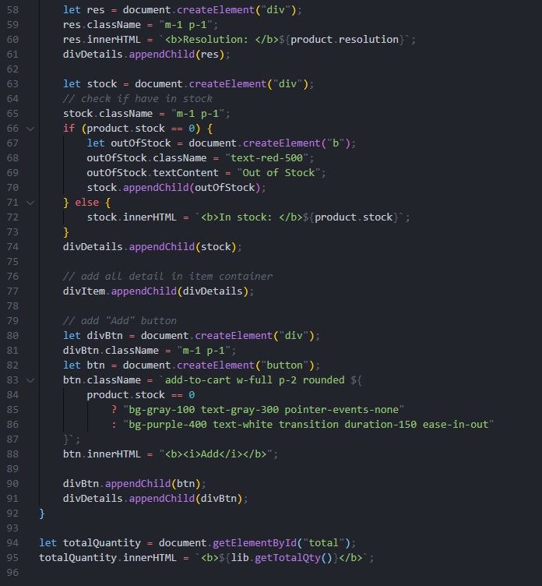

**events.js:**

change toggle search bar to arrow function

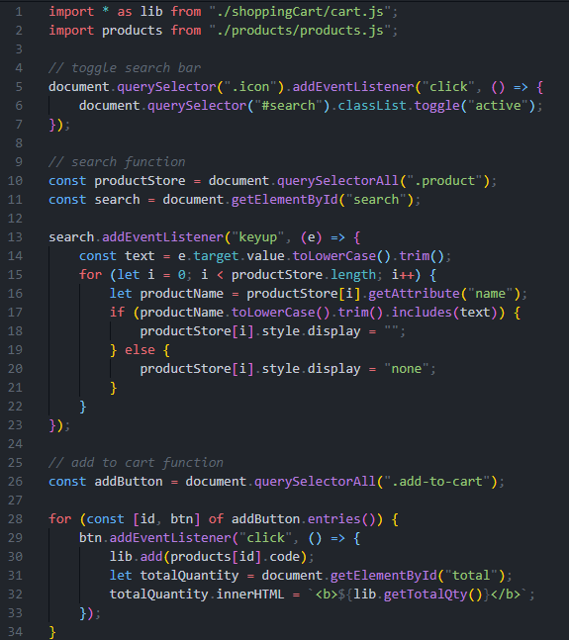

**cart.js:**

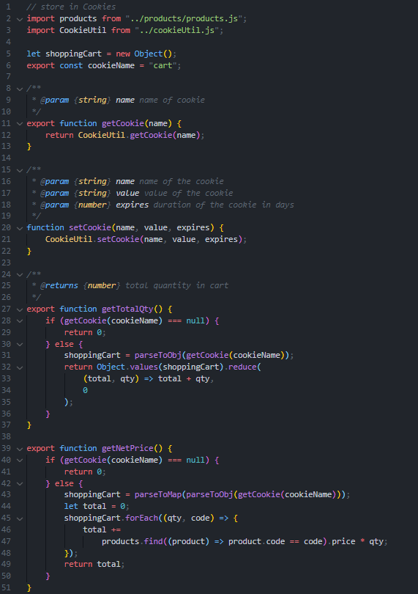

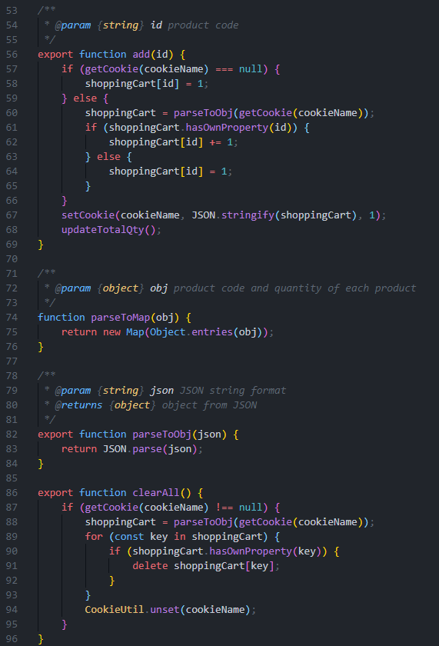

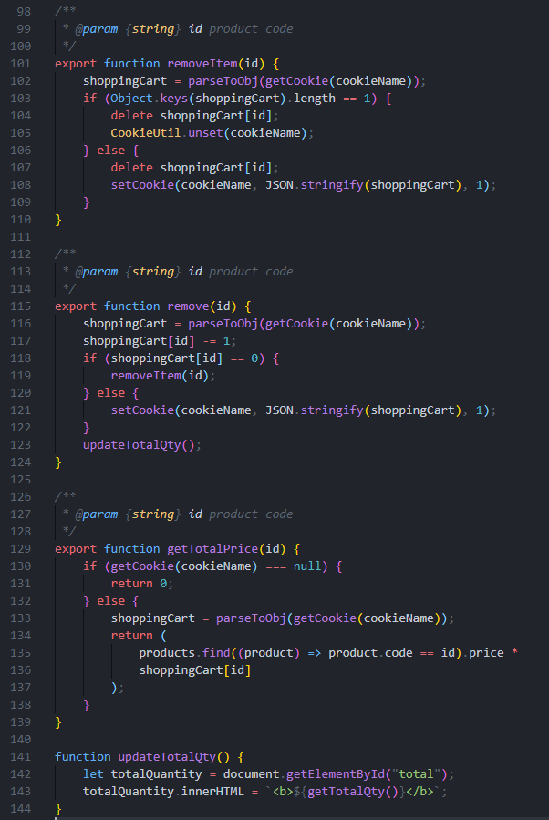

**cookieUtil.js:**

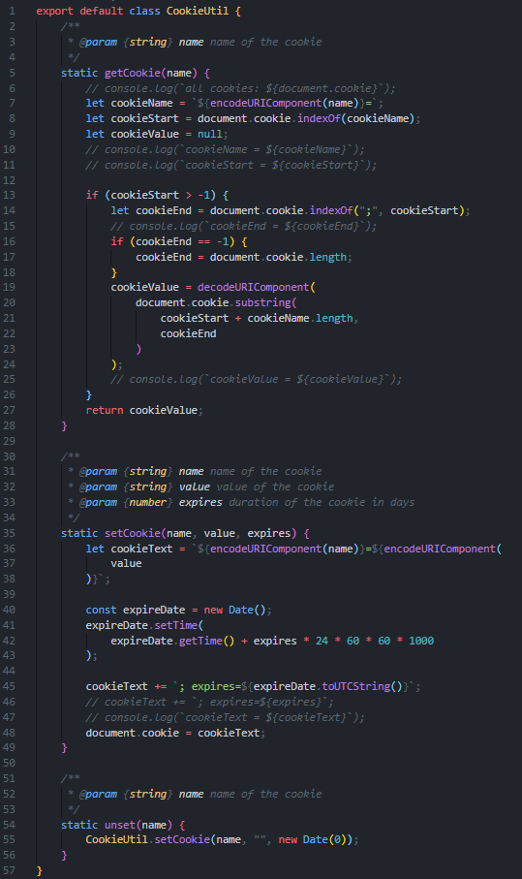

**shoppingCart.js:**

add function showNetPrice & revise code

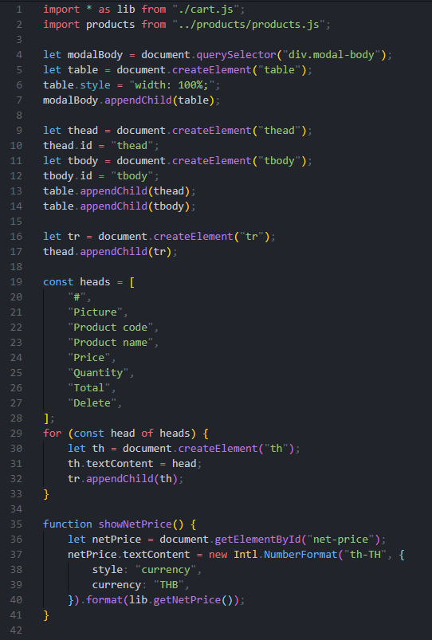

revise clear all and deleteRow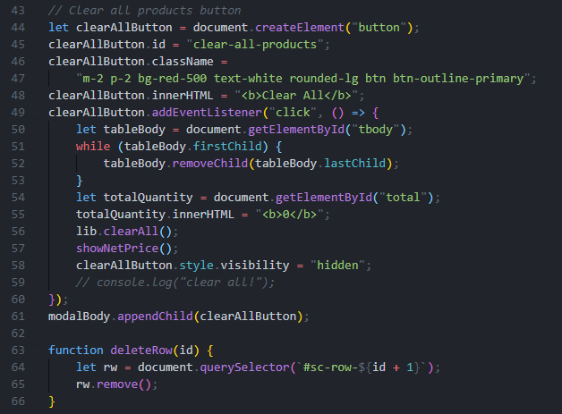

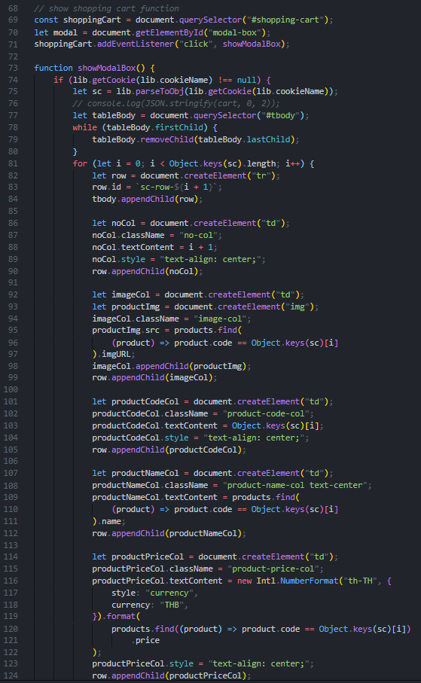

Add plus button and minus button

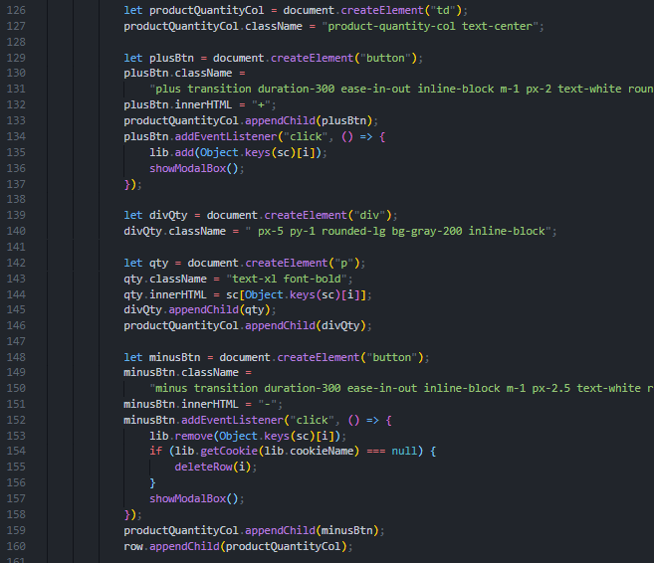

**theme.js:**

revise code

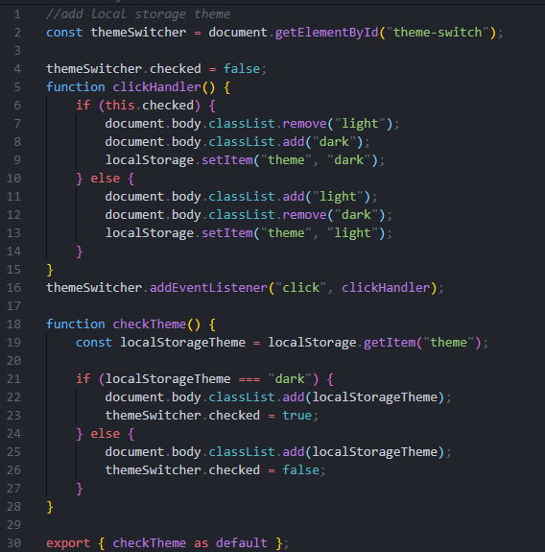

**loadStorage.js:**



**O****utput:**

ถ้าไม่มีสินค้าจะไม่มีปุ่ม clear all

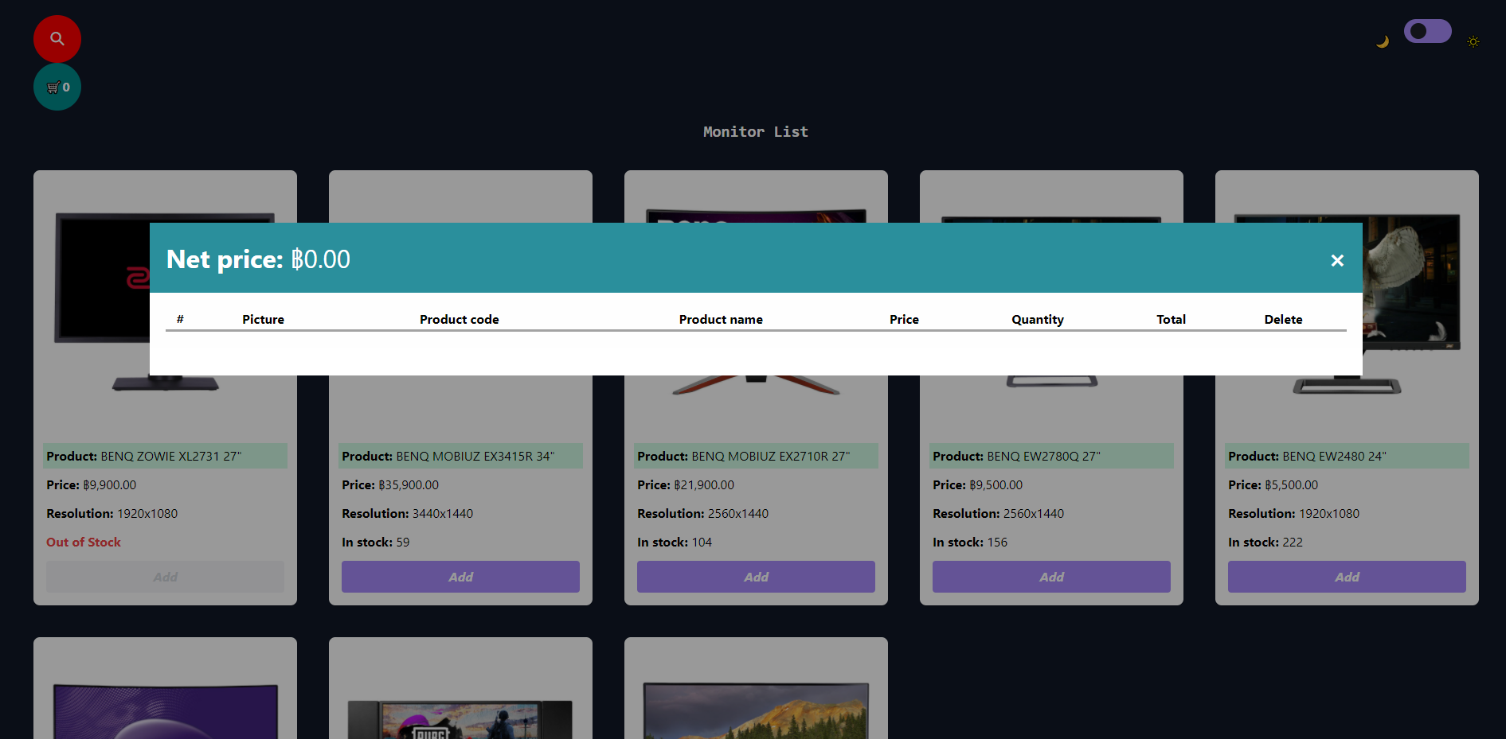

สามารถเพิ่มลดสินค้าได้โดยกดที่ปุ่มบวกและลบ

**before**

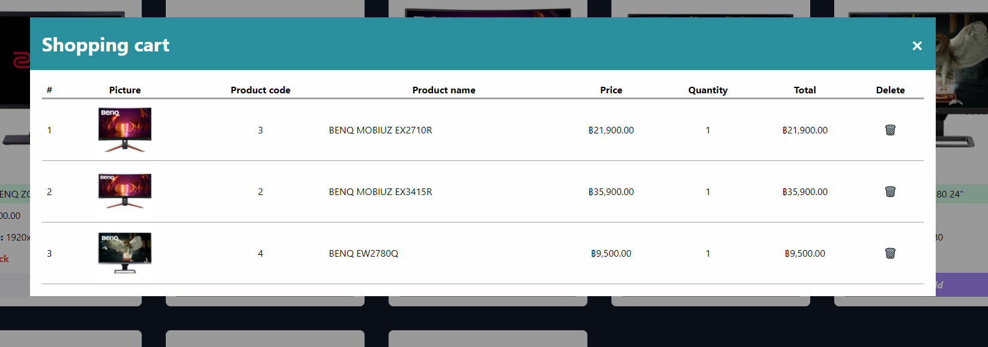

**after**

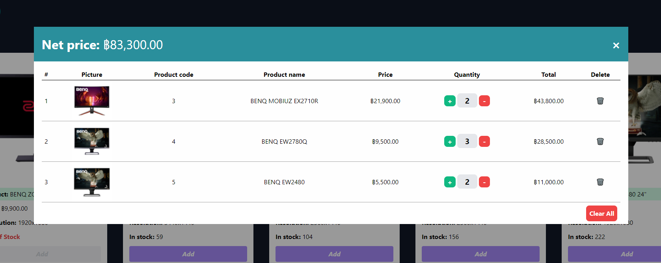

***GIT LINK* (This Assignment):** [***Click here***](https://github.com/xbklyn/INT201-G06-GroupWorks/tree/main/Assignment8)

***GIT LINK* (All Assignment):** [***Click here***](https://github.com/xbklyn/INT201-G06-GroupWorks/tree/main/Assignment9)

