# This is the first Section

This is a simple Word document help us illustrate the capabilities of the DOCXPath package.

## A level 2 heading

Let us include an image first:

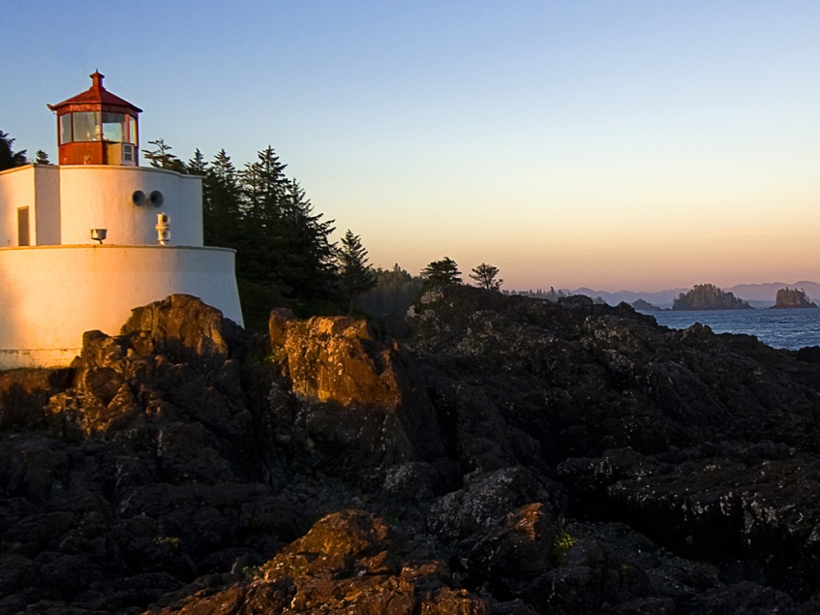

And a table:

|  |  |
| --- | --- |
| Sample Table | Data |
| First row | First data |
| Second row | Second data |

## Another heading to separate content

And a list to finish:

* One
* Two
* Three
  + Subitem

# Second section

Now a chart: