Date: 3/9/19

Time: 3pm-4pm

Venue: SIS GSR 2-6

Attendees: Bao Xian, Xiao Binn, Tricia, Yan Ning, Casper

Agenda:

1. Individual Strength and Weaknesses
   1. **Celine**: in general, i dont spend alot of time on technical stuff despite knowing im quite weak at it. will try to keep up by taking the initiative to share knowledge in this group chat :>

can be on the lookout for small details and helping each other stay on the same page (esp cos i sked i off track from everyone since I q busy outside i hope if i do this we can all work more efficiently and spend less time on updating each other)

* 1. **Casper:** When I have to read a lot of words, i tend miss out some details and misunderstand certain points. So please do correct me. But in terms of technical stuff, i am quite decent and i will be able to contribute in that portion. I like to brainstorm for ideas and act as a devil's advocate.to
  2. **Yan Ning:**

Weakness:

- Weak at programming

- Procrastinate sometimes so need someone to push at times

- Erase irrelevant functions in BOSS currently

Strength:

- Detail oriented

- Quite a perfectionist I guess but not that jialat

- More of a biz and design person

* 1. **Tricia**: I think I am better at front-end compared to back-end stuff, that's also because I like doing front-end more than back-end. Quite meticulous I would say, detail-oriented but can be a weakness as well. Takes time to process my thoughts
  2. **Bao** Xian: I'm quite good at backend logic and I can understand things quite fast like proj requirements and new topics. Quite decisive most of the time also. But I sometimes ignore small details, and I cannot stand front end (TOO TEDIOUS) HAHAHA

1. Organize manpower
   1. Team leader: Bao Xian
   2. Assistant leader: Casper
2. Glossary for future code use
   1. Bao Xian to create doc when we use it
3. End goal of our BOSS
   1. Consider adding caching function for BOSS
   2. Improve on graphics using CSS & HTML
   3. 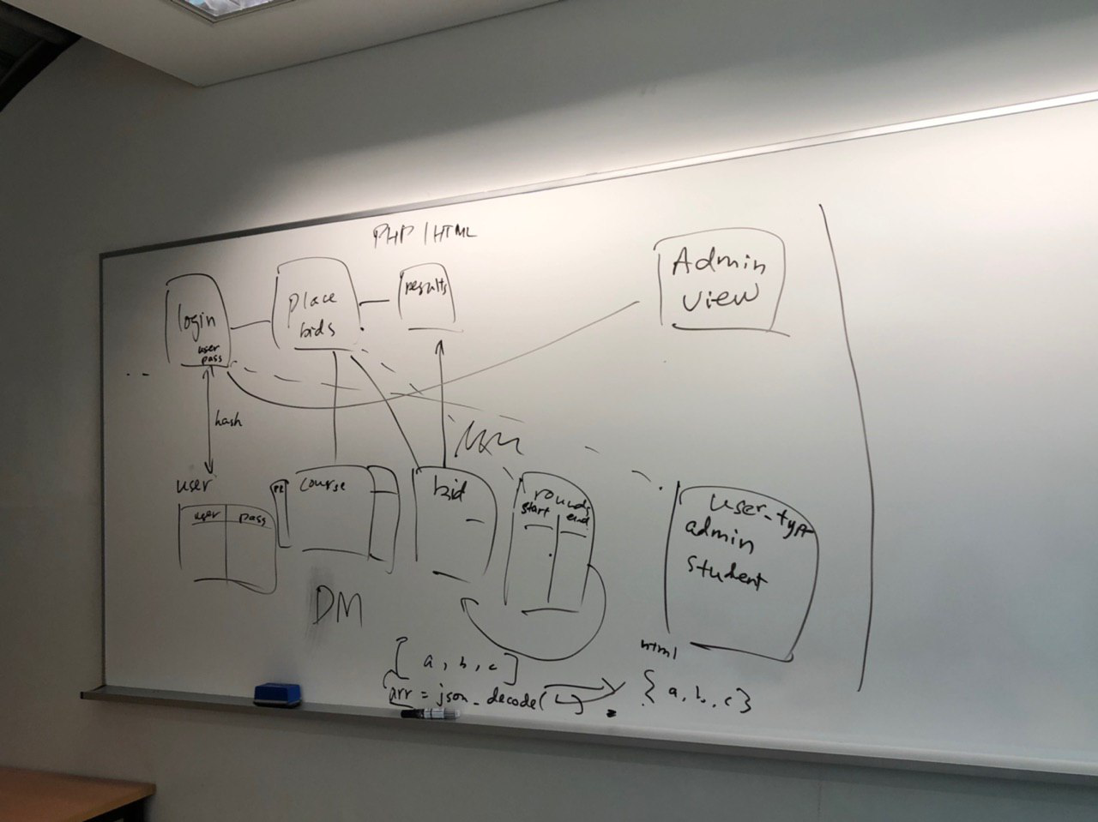
4. Others:
   1. Each iteration focus on one function including front end and back end
      1. This is to aid presentation
      2. Have a soft deadline for each iteration
         1. By tuesday 6pm
         2. Team members review before next class
   2. Appointed roster for reading
      1. To be done every tuesday
      2. Refer to roster
      3. IC: Yan Ning
5. Next Meeting: 5 September 2019 2.15pm-3.15pm
6. Scrum meetings (online/offline)
   1. 30 mins
   2. From the prev meeting, what have we done
   3. Fridays
   4. Callable by any team member in telegram group chat

Actionables:

|  |  |  |  |  |
| --- | --- | --- | --- | --- |
| No. | Task | IC | Soft Deadline | Due Date/Time |
| 0 | More familiarizing of project requirements | Self | Wk 3 Class | Wk 3 Class |
| 1 | List out functional requirements and describe | Casper and BX | Next Meeting | Next meeting |
| 2 | Familiarising of Git  IC : help check everyone is on the same understanding of Git and what we will be using it for as a team | Casper | Next Meeting | Next Meeting |
| 3 | Create glossary for future code reference | Bao Xian | Wk 3 Class | Wk 3 Class |
| 4 | Familiarise on Coding Conventions | Bao Xian (the enforcer) | - | - |
| 5 | Reading of live wiki page for  Wk 3 updates | Yan Ning  (enforcer!!!) | Wk 3 Class | Wk 3 Class |

The meeting was adjourned at 3.10 pm. These minutes will be circulated and adopted if there are no amendments reported in the next three days.

Prepared by,

Celine

Vetted and edited by,

Bao Xian