What is the sprite size of a pouch for ultima 7

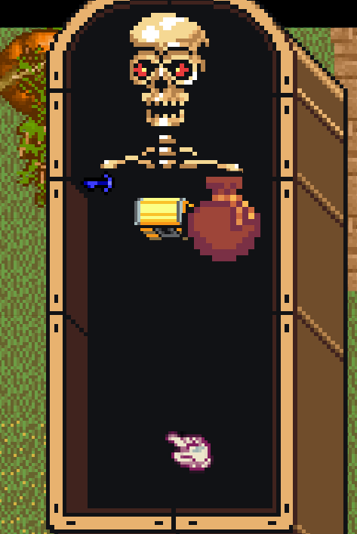

You see the key and chest is perfect but why is the pouch the most right this inflated on the paperdoll of body…..not container….

