Two things we need to do now is the faction editor and the npc editor. We cannot do the npc editor without finishing the faction editor first.
However, there is no such thing as NPC editor. Instead, we are going to take PC Editor and modify it.

Side track: Implement a graphical font from the font sheet like this below.:
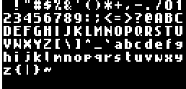

There should be a preview showing like the picture above, by opening not a lockable window, I can move it around and still add frames in the sprite editor, showing the picture above to guide the user each frame what character it should be..
THIS ONLY APPEAR IN SPRITE EDITOR WHEN YOU EDIT THE SPRITE INGAMEFONT OR DIALOGFONT INSIDE THE GROUP FONTS.

Add another locked group in sprite editor called Fonts, just LIKE tilesheet, it is red and cannot be deleted or renamed and then add inside of that...pure internal also locked two empty sprites with their names as follows: InGameFont and DialogFont. InGameFont is used for the main in game font. The same font I use for when I click objects and identify them, that main game font and it needs to apply to everything we have done now…world and inside all paperdolls, etc…all use one standard in game font. When I select the added sprite ingamefont…I can add the graphical fonts in frames, just like the tile editor the location of the font determines which spot it is in the preview window shown up. Update the preview window of the book editor with the new mechanics of the font. DISABLE IN SPRITE EDITOR ONLY FOR THE INGAMEFONT AND DIALOGFONT, the ability to add sound per frame and disable animation FOR JUST THE TWO INGAMEFONT AND DIALOGFONT in the sprite editor..so there is no wasted CPU resource or execution…when they never actually animate.

These are what we are going to do:
- Rename PC Editor in the menu to Character Editor.
- < -- rename that to Is Main Player. If it is Main player disable schedule tab and disable AI
- Rename PC Editor in the window title bar of the PC Editor to Character Editor instead.
- Look at the schedule system in EXULT AND MEMIC THIS IN THE ENGINE and allow us to modify the schedule system in the Character Editor. Add a new tab in the Character Editor called Schedule and allow a person to add custom schedules from the custom events we can add later. FOR THE SCHEDULE EDITOR PLEASE MAKE IT ACTIVE IN THE ENGINE SIDE AS WELL AND UPDATE THE BUILD ENGINE WITH THE NEW CHANGES..AND MAKE IT FUNCTIONING IN BOTH EDITOR AND ENGINE SIDE.
- AI: AI only works in the character that does not have Is Main character checked. PLEASE, MIMIC EXULT AI 100000000000000000% PERCENT in path, and how it interacts in the world. NOW WE ARE GOING TO ADD SOMETHING new, not part of exult, after you add the AI 100000%, THE ENTIRE INTERACTION IN THE WORLD THAT AFFECTS THE MAIN CHARACTER ALSO AFFECTS THE NPC. For example, for example, I climb the stair case, if the npc path means going to second floor it will climb the staircase like me, same with what we did with containers and books, etc…if there is a trap I stepped on and I get hit and damaged by the trap, or alignment, it will affect that npc too. IF THERE IS A TELEPORTER that teleports me and that NPC stepped on that teleporter it will affected too. THE BEST PART BECAUSE ARE NOT MAKING ANY NEW EDITOR LIKE PC OR NPC EDITOR, AND WE ARE RENAMING PC EDITOR TO CHARACTER EDITOR…YOU JUST NEED TO COMPLETE THE MECHANICS ON THIS CHARACTER EDITOR and it will effect all NPCS ANYWAYS, it just instead of been controlled by a human it is controlled by AI.
- Schedule tab is ONLY ENABLED AND ACTIVATED IF THE CHARACTER IHAVE IS MAIN PLAYER CHECK AS OFF..IF IT IS ON..IT CLEARS AND RESETS THE SCHEDULE SETTING AND GET DISABLED.
- Look at EXULT about food level, we need to add food level here.
- In EXULT poison does not kill you, here food starvation and poison kills you. If you don’t cure the poison, or the poison isn’t cured by itself based on time we specify, or if the person is not feed and is starving and is losing hp, they keep losing hp until death. This applies to all characters in the game.
- Give a choice a radio button: Can get hungry.
- Specify the level of hunger, meaning long a person can last before getting hungry and how fast they get hungry and how much damage they get if starving.
- Add ability for alignment effect and if they can be immune to alignment effect
- Move to Faction Editor and finish it first as Character Editor need the faction editor before making the character Edito. Add a faction Editor.
- Activate faction in main engine and make it work.
- IMPLEMENT THE COMBAT AI AND COMBAT SYSTEM 100000% AS IT IS IN EXULT AS WELLA S BELONG TO ITEM AND EMOTION LEVEL MUST BE ACTIVATED. IF I MAKE NPC ANGRY they can attack me, if I attack them they behave like exult and dead mechanics is implemented. Remember the body pose in character editor that will be the body of npc when killed like exult…..we stop here…

Faction Editor:

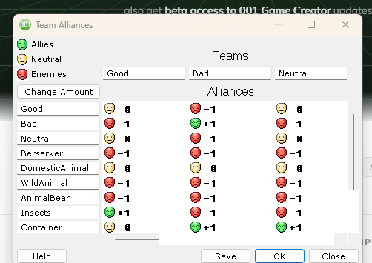

It would look like that. You can add infinite amount..and if you want to delete a faction you don’t want, have a small x checkmark behind them…to delete the faction you want. If this faction is already used in the editor, prompt an error indicating it is used, and give a choice to unlink it from one or multiple characters…and if you say yes, it goes through all the characters in the character editor that uses that faction and remove it, and revert to the one after..and then prompt a list of all the characters affected, in a new window. It gives the person a choice to select the affected character from the list, double click or click edit..and will open that character in the character list to give the person the ability to choose the faction they want and when that happens…the window closes and the character from the list disappears. It gives the person the ability to select multiple characters at once and only edit one of them and then that faction applies to all of them, giving the person a warning if they want to apply this faction to that number of selected characters.

