SOLARPUNK PI
DATASHEET
RK3576 + RP2350 + RK3506J
Triple-Processor Solar-Powered Edge Computer

85×56mm Pi 5 Form Factor • 6-Layer PCB • 8GB LPDDR4X • 32GB eMMC • NVMe
WiFi 5 + BT 5.0 • GbE + PoE • 4G LTE + nano-SIM • LoRa Mesh • 6 TOPS NPU
2× MIPI CSI Camera • Micro-HDMI 4K • 3.5mm Stereo Audio • ES8316 Codec
2× USB-C 3.1 + 2× USB-C 2.0 • 40-Pin GPIO • 10-Pin RP2350 Expansion
30-Pin Industrial: CAN FD×2 • RS485 • PWM×12 • ADC×4 • UART×4 • SPI×2 • I2C×2
Solar MPPT + LiFePO4 • PoE 802.3at • USB-C PD • Auto-OR Switching
Schmitt Trigger Signal Conditioning • Ferrite Bead Power Filtering • ESD Protection
Docker • Ollama • Reticulum • FreeRTOS • AMP Multi-Core

RK3576 — Brain  8-core + 6T NPU  Linux, Docker, Ollama | RP2350 — Nerves  2×M33, 0.1W  Power, LoRa, WiFi | RK3506J — Muscle  3×A7+M0, 0.7W  CAN, RS485, motors
Rev 3.0 • March 2026 • Preliminary

Table of Contents

1. General Description
Solarpunk Pi is a triple-processor single-board computer designed for solar-powered edge computing, AI inference, mesh networking, and industrial automation. It integrates three Rockchip/Raspberry Pi processors on an 85×56mm Pi 5-compatible PCB, each serving a distinct role: high-performance Linux computing (RK3576), ultra-low-power radio and power management (RP2350), and hard real-time industrial control (RK3506J).
The board accepts power from solar panels, PoE Ethernet, or USB-C PD with automatic source switching. All inter-chip communication lines are Schmitt-trigger buffered for noise immunity, and all power domains are ferrite-bead filtered for stability. Industrial I/O channels are galvanically isolated for safe connection to factory equipment.

1.1 Key Features
- Triple-processor architecture: RK3576 (Linux) + RP2350 (power/radio) + RK3506J (RTOS automation)
- 6 TOPS NPU for on-device AI inference (Ollama, RKNN, TensorFlow Lite)
- 8GB LPDDR4X RAM + 32GB eMMC + M.2 NVMe SSD slot
- Five network interfaces: GbE, WiFi 5, 4G LTE, LoRa mesh, backup WiFi 4
- Dual MIPI CSI camera ports (4K + 1080p) + Micro-HDMI 4K + stereo audio
- 4× USB-C ports (2× USB 3.1 + 2× USB 2.0, all native, no hub)
- 30-pin industrial header with CAN FD×2, RS485, PWM×12, ADC×4, isolated
- Triple power input: Solar MPPT + PoE 802.3at + USB-C PD, auto-switching
- Schmitt trigger signal conditioning on all inter-chip and industrial signals
- 6-layer impedance-controlled PCB, ENIG finish, JLCPCB-optimized

2. System Architecture
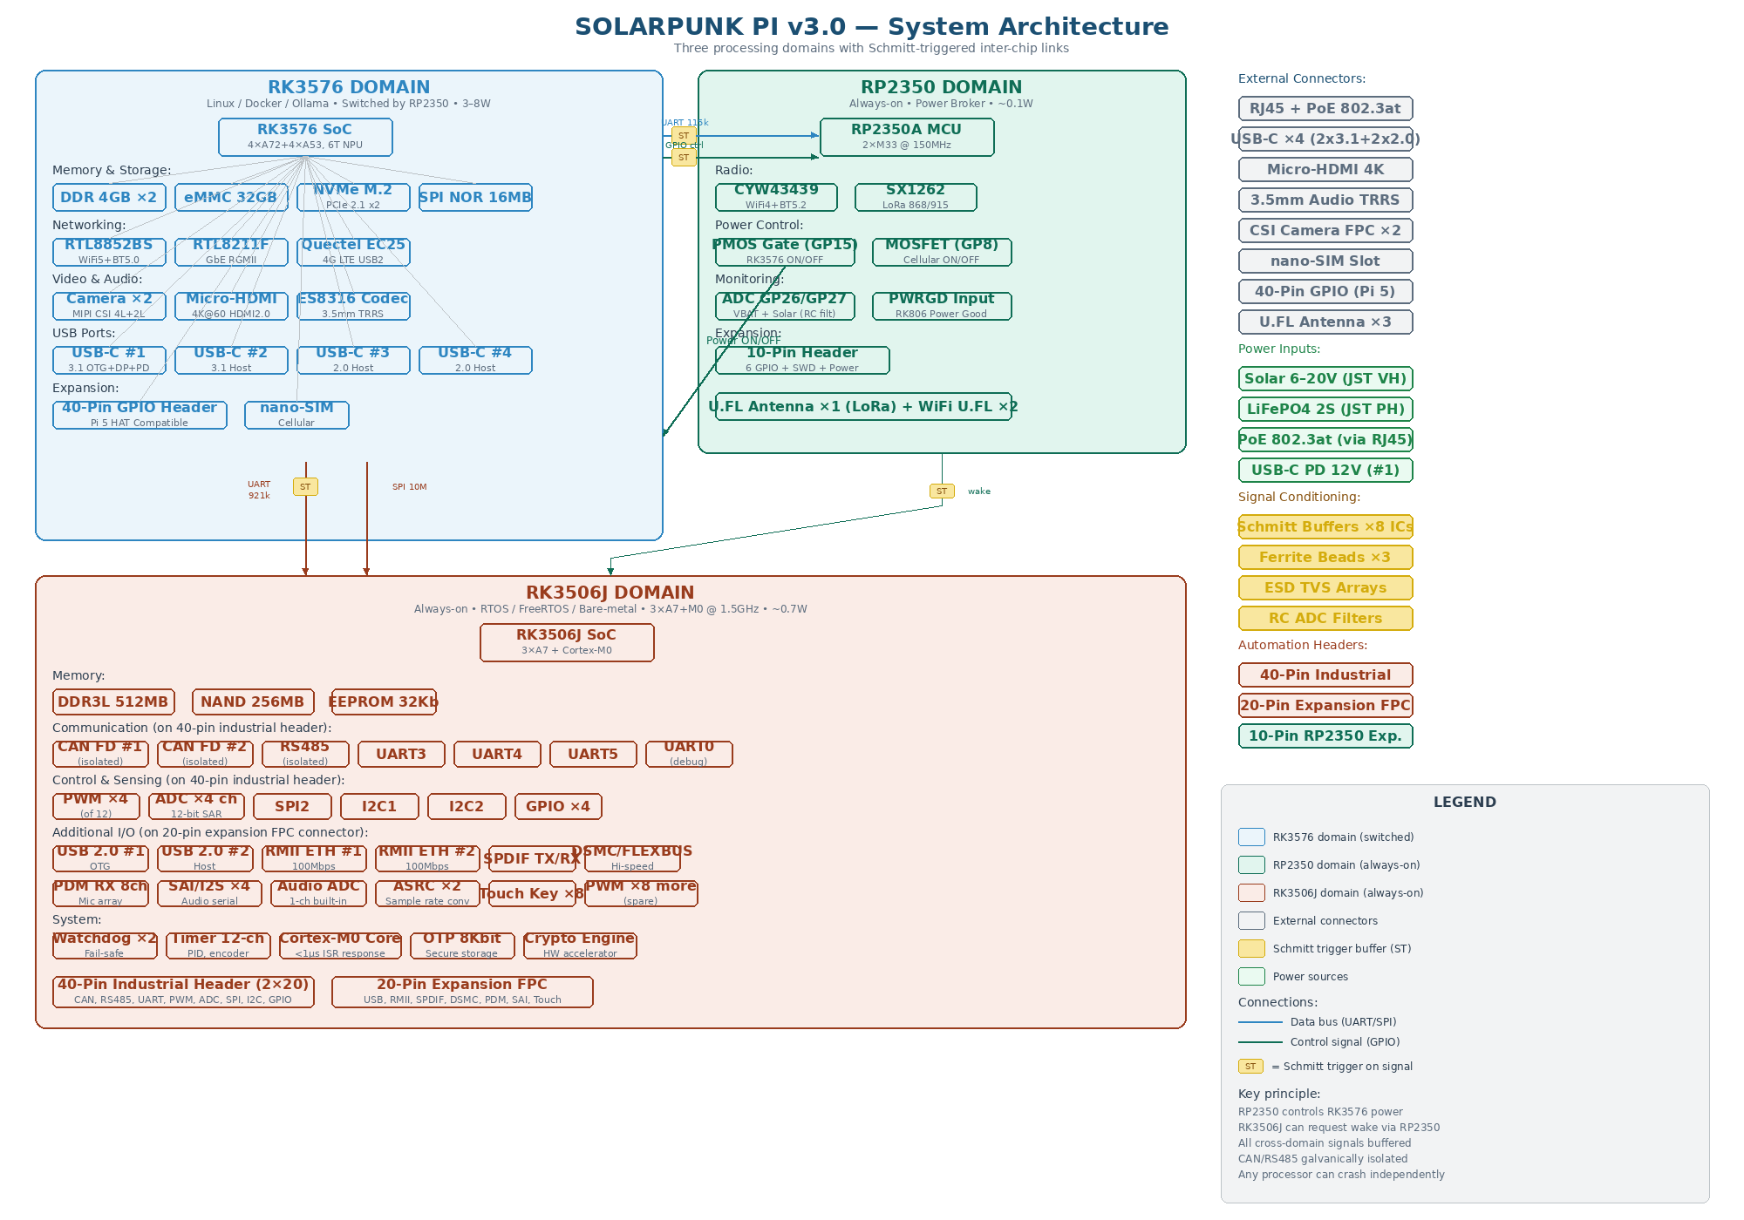
Figure 1-1: System architecture with all three domains and Schmitt-triggered links

2.1 Processing Domains
Domain | Processor | Always On | Key Peripherals | Power
RK3576 | 4×A72@2.2G+4×A53@1.8G, 6T NPU | No (switched) | NVMe, eMMC, GbE, WiFi5, cellular, CSI×2, HDMI, audio, USB×4 | 3–8W
RP2350 | 2×Cortex-M33@150MHz, 520KB SRAM | Yes | CYW43439 WiFi/BT, SX1262 LoRa, ADC, power MOSFET gates | ~0.1W
RK3506J | 3×Cortex-A7@1.5G+Cortex-M0@200M | Yes | CAN×2, UART×6, SPI×3, I2C×3, PWM×12, ADC×4, RMII×2, USB×2 | ~0.7W

2.2 Inter-Chip Communication
All signals crossing power domain boundaries pass through Schmitt trigger buffers (SN74LVC2G17 or SN74LVC1G17) for clean signal transitions, noise rejection, and ESD protection.
Signal | From | To | Type | Speed | Schmitt Buffer
UART1 TX/RX | RK3576 UART4 | RP2350 GP0/GP1 | UART | 115200 | SN74LVC2G17 (dual)
UART2 TX/RX | RK3576 UART5 | RK3506J UART2 | UART | 921600 | SN74LVC2G17 (dual)
SPI bridge | RK3576 SPI2 | RK3506J SPI0 | SPI | 10MHz | Direct (same 3.3V)
Power enable | RP2350 GP15 | PMOS gate | GPIO | — | SN74LVC1G17 (single)
Power good | RK806 PWRGD | RP2350 GP12 | GPIO | — | SN74LVC1G17 (single)
RK3506 reset | RP2350 GP14 | RK3506J RESET | GPIO | — | Direct
Wake request | RK3506J GPIO | RP2350 GP13 | GPIO | — | SN74LVC1G17 (single)
Alarm IRQ | RK3506J GPIO | RK3576 GPIO | GPIO | — | SN74LVC1G17 (single)
Shutdown | RK3576 GPIO | RP2350 GP28 | GPIO | — | SN74LVC1G17 (single)

3. Electrical Specifications

3.1 Absolute Maximum Ratings
Parameter | Min | Max | Unit
Solar input voltage | –0.3 | 22 | V
PoE input voltage (at RJ45) | 36 | 57 | V
USB-C PD input voltage | 4.5 | 20 | V
LiFePO4 battery voltage (2S) | 4.0 | 7.4 | V
RK3576 domain supply (5V_SYS) | 4.75 | 5.25 | V
I/O voltage (RK3576 / RK3506J) | 0 | 3.63 | V
I/O voltage (RP2350) | 0 | 3.63 | V
Operating temperature | –20 | +70 | °C
Storage temperature | –40 | +85 | °C
ESD tolerance (HBM) | — | 2000 | V

3.2 Recommended Operating Conditions
Parameter | Min/Typ/Max | Unit | Notes
Solar panel voltage | 6 / 12–18 / 20 | V | CN3722 MPPT range
Solar panel power | 10 / 50–100 / 120 | W | 100W recommended for 24/7
LiFePO4 capacity | 5 / 20 / 50 | Ah | 20Ah recommended
PoE class | Class 4 (802.3at) | 25.5W | At PD, after cable losses
USB-C PD voltage | 12 | V | HUSB238 negotiates 12V
USB-C PD current | — / 2 / 3 | A | 24W typical available
Ambient temperature | 0 / 25 / 50 | °C | No heatsink needed <40°C

3.3 Power Consumption
System State | Typical | Maximum | Notes
Deep sleep (RP2350 only) | 0.2W | 0.3W | LoRa listening, ADC polling
Automation idle (RP2350+RK3506J) | 0.8W | 1.2W | CAN/RS485 active, no motor load
Linux idle (all three, no load) | 4W | 5W | Linux booted, Docker idle
Full compute (Ollama inference) | 10W | 12W | NPU + CPU active, WiFi+GbE
Peak load (all peripherals) | 14W | 18W | Cameras+cellular+NVMe+compute

4. Connectivity & Pin Descriptions

4.1 External Connectors
Connector | Type | Interface | Specification
USB-C #1 | USB-C female, top edge | USB 3.1 Gen1 OTG + DP Alt | 5Gbps data + 4K display + PD power in (12V)
USB-C #2 | USB-C female, top edge | USB 3.1 Gen1 Host | 5Gbps. Combo PHY (muxed w/ SATA).
USB-C #3 | USB-C female, right edge | USB 2.0 Host | 480Mbps. General peripherals.
USB-C #4 | USB-C female, right edge | USB 2.0 Host | 480Mbps. General peripherals.
RJ45 | 8P8C w/ PoE magnetics | GbE + PoE 802.3at | 1Gbps Ethernet + 25.5W PoE input
Micro-HDMI | Type-D female, left edge | HDMI 2.0 TX | 4K@60fps output
3.5mm TRRS | Audio jack, left edge | Stereo out + mic in | ES8316 I2S codec, line-level
CSI #1 | 22-pin FPC, left edge | 4-lane MIPI CSI (dcphy) | Up to 4K@30fps, 48MP stills
CSI #2 | 15-pin FPC, left edge | 2-lane MIPI CSI (dphy) | Up to 1080p@60fps
Nano-SIM | Push-push, right edge | SIM card | For Quectel EC25 4G LTE cellular
Solar input | JST VH 2-pin, left edge | 6–20V DC | To CN3722 MPPT charger
Battery | JST PH 2-pin, left edge | 6.4V nominal | 2S LiFePO4 connection
U.FL ×3 | SMD, board edges | RF antenna | LoRa (1), WiFi main/aux (2)

4.2 40-Pin GPIO Header (Pi 5 Compatible)
Standard Raspberry Pi 5 pinout. Active RK3576 GPIO bank. Directly compatible with Pi 5 HATs. I2C, SPI, UART, PWM, and general-purpose GPIO available per Pi 5 specification.

4.3 10-Pin RP2350 Expansion Header
Pin | GPIO | Functions | Future Use
1 | GP23 | GPIO / PWM / PIO | NeoPixel, IR, 1-Wire
2 | GP24 | GPIO / PWM / PIO | Encoder, button matrix
3 | GP25 | GPIO / PWM | Status LED, buzzer
4 | GP29 | ADC3 / GPIO | Analog sensor (0–3.3V)
5 | GP9 | GPIO / UART1 RX | Spare serial, interrupt
6 | SWCLK | SWD debug | Programming probe
7 | SWDIO | SWD debug | Programming probe
8 | 3V3_RP | Power | 100mA always-on output
9 | 5V_SYS | Power | 200mA fused output
10 | GND | Ground | Reference

4.4 30-Pin RK3506J Industrial Header
Pin | Signal | Interface | Notes
1–2 | CAN1_H / CAN1_L | CAN FD | Isolated (ADUM1401). 120Ω term jumper. 5Mbps.
3–4 | CAN2_H / CAN2_L | CAN FD | Independent isolated bus. 120Ω term jumper.
5–6 | RS485_A / RS485_B | RS485 | Isolated (ADUM1401). Modbus RTU. 120Ω term.
7–8 | UART3_TX / UART3_RX | UART 3.3V | Spare serial. Schmitt buffered input.
9–10 | UART4_TX / UART4_RX | UART 3.3V | 2nd spare serial. Schmitt buffered input.
11–14 | PWM_CH0–CH3 | PWM out | 4 of 12 PWM channels. Motors, servos, LEDs.
15–18 | ADC_IN0–ADC_IN3 | 12-bit ADC | 4-ch SAR ADC. 0–3.3V. RC filtered inputs.
19–22 | GPIO_0–GPIO_3 | Digital I/O | 3.3V. Schmitt buffered. Limit switches, relays.
23–24 | I2C1_SDA / I2C1_SCL | I2C bus 1 | Sensor bus (temp, pressure, humidity).
25–26 | I2C2_SDA / I2C2_SCL | I2C bus 2 | IMU, magnetometer, barometer.
27 | SPI2 (SCK/MOSI/MISO/CS) | SPI | External ADC/DAC, SPI sensor, OLED display.
28 | +5V_OUT | Power | Fused 500mA for external sensors.
29 | +3V3_OUT | Power | 200mA for low-power sensors.
30 | GND | Ground | Star ground point.

RK3506J Spare Peripherals (Not on Header)
Beyond the 30-pin header, the RK3506J still has available: PWM×8 more channels, UART×2 more, USB 2.0 OTG ×2, RMII Ethernet ×2 (100Mbps), SPDIF TX+RX, PDM RX 8-ch, SAI (I2S) ×2, FLEXBUS/DSMC high-speed bus, GPIO ×20+, Watchdog ×2, Timer 12-ch. These can be accessed via a custom carrier board or by repurposing existing header pins in firmware.

5. Power System
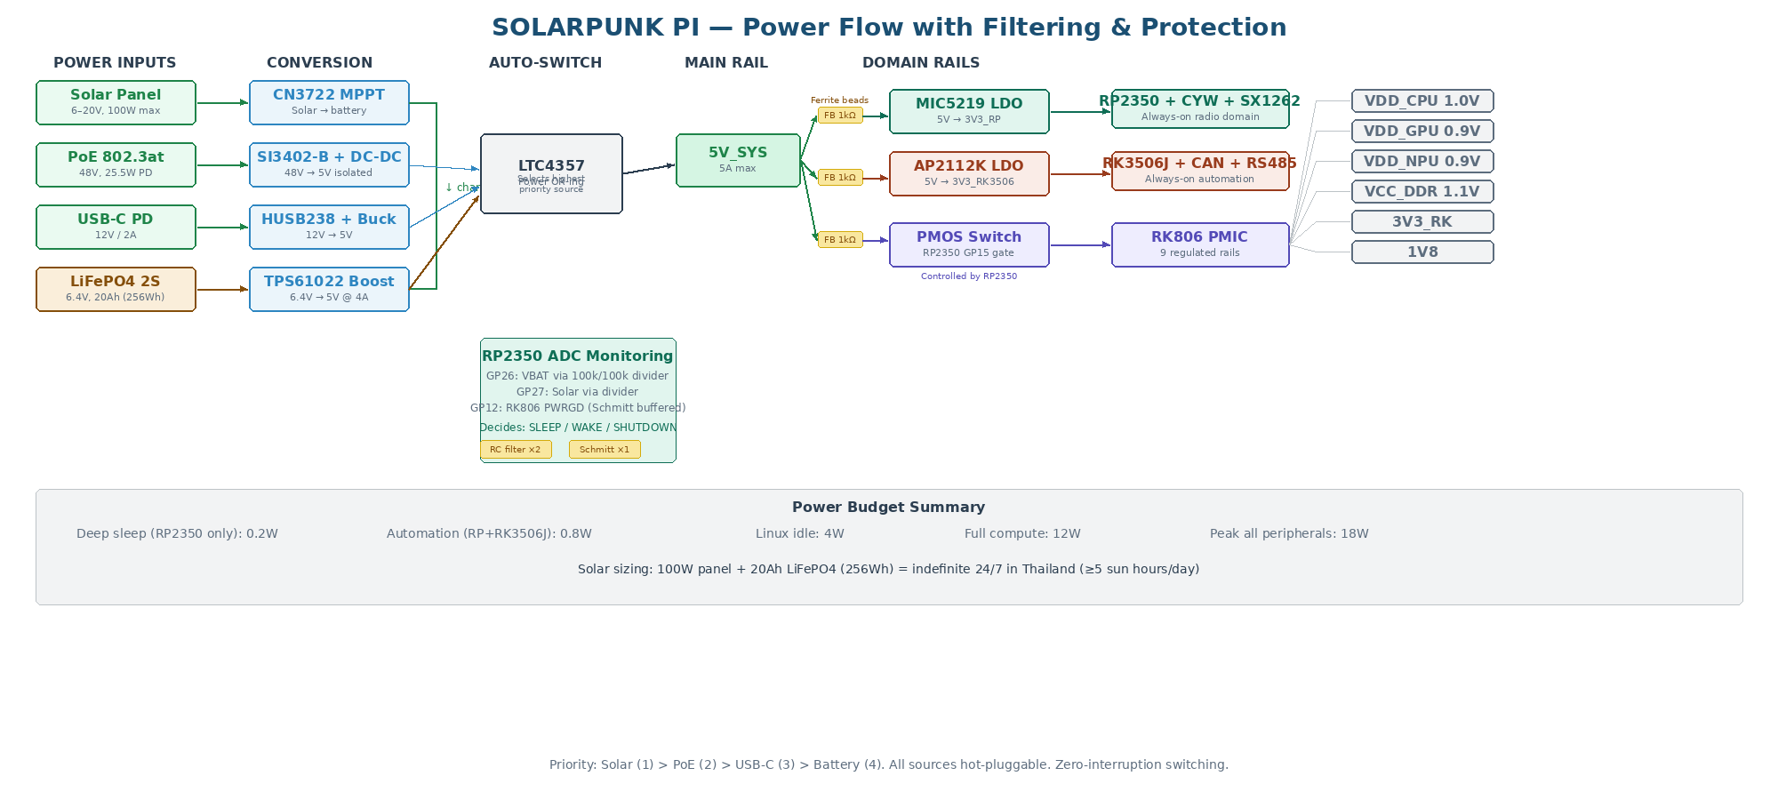
Figure 2-1: Power flow with ferrite bead filtering and RC-filtered ADC monitoring

5.1 Power Sources
Source | Input V | Conversion Path | Priority | Max Power
Solar + LiFePO4 | 6–20V | CN3722 MPPT → 2S LiFePO4 → TPS61022 boost → 5V | 1 (highest) | 100W panel / 4A boost
PoE 802.3at | 48V | SI3402-B PD → isolated DC-DC → 5V | 2 | 25.5W at PD
USB-C PD | 12V | HUSB238 → buck converter → 5V | 3 | 24W (12V/2A)
LiFePO4 alone | 6.4V | TPS61022 boost → 5V | 4 (backup) | 20W (4A boost)

5.2 Power Rails
Rail | Voltage | Source | Powers | Always On
SOLAR_IN | 6–20V | Panel via JST VH | CN3722 MPPT | N/A
VBAT | 6.4V | 2S LiFePO4 via JST PH | TPS61022 input | N/A
48V_POE | 48V | PoE cable via RJ45 | SI3402-B PD | N/A
5V_SYS | 5.0V | TPS61022 / PoE / USB-C (auto) | Entire board | Yes
3V3_RP | 3.3V | MIC5219 LDO from 5V | RP2350, CYW, SX1262 | Yes
3V3_RK3506 | 3.3V | AP2112K LDO from 5V | RK3506J, CAN, RS485 | Yes
VDD_CPU_BIG | 1.0V | RK806 DCDC1 | A72 cores | No
VDD_CPU_LIT | 0.9V | RK806 DCDC2 | A53 cores | No
VDD_GPU | 0.9V | RK806 DCDC3 | Mali-G52 | No
VDD_NPU | 0.9V | RK806 DCDC4 | 6T NPU | No
VDD_LOGIC | 0.75V | RK806 DCDC5 | RK3576 logic | No
VCC_DDR | 1.1V | RK806 DCDC6 | LPDDR4X ×2 | No
3V3_RK | 3.3V | RK806 LDO | GbE, WiFi, eMMC, cell, audio | No
1V8 | 1.8V | RK806 LDO | SDIO, eMMC, CSI, HDMI I/O | No

5.3 Power Filtering & Stability
Location | Component | Purpose
5V entry to each domain (3×) | Ferrite bead BLM18AG102SN1D | Block HF switching noise between domains
RP2350 ADC inputs (GP26/27) | 100Ω + 100nF RC filter per ch | Low-pass filter on VBAT/solar voltage dividers
RK3506J ADC inputs (4-ch) | 100Ω + 100nF RC filter per ch | Low-pass filter on industrial analog inputs
Every RK3576 VDD ball | 100nF 0402 within 0.5mm | Mandatory per-pin decoupling
Every domain entry point | 10µF 0805 ceramic | Bulk energy storage per domain
RK806 outputs | Per datasheet: bulk + MLCC | PMIC output capacitor requirements

6. Signal Conditioning & Protection

6.1 Schmitt Trigger Buffers
All inter-chip communication signals and industrial digital inputs pass through Schmitt trigger buffers. This provides noise immunity (hysteresis), clean signal transitions across power domain boundaries, and basic ESD protection.
Location | IC | Pkg | Qty | Signals Covered
UART1 (RK3576↔RP2350) | SN74LVC2G17 | SOT-23-6 | 1 | TX + RX (2 channels)
UART2 (RK3576↔RK3506J) | SN74LVC2G17 | SOT-23-6 | 1 | TX + RX (2 channels)
GPIO power-good | SN74LVC1G17 | SOT-23-5 | 1 | RK806 PWRGD → RP2350
GPIO wake request | SN74LVC1G17 | SOT-23-5 | 1 | RK3506J → RP2350
GPIO alarm IRQ | SN74LVC1G17 | SOT-23-5 | 1 | RK3506J → RK3576
GPIO shutdown | SN74LVC1G17 | SOT-23-5 | 1 | RK3576 → RP2350
GPIO power gate | SN74LVC1G17 | SOT-23-5 | 1 | RP2350 → PMOS
Industrial header inputs (6ch) | SN74LVC14A | TSSOP-14 | 1 | GPIO×4 + UART3/4 RX inputs
Total |  |  | 8 ICs | 13 conditioned channels

6.2 ESD & Overvoltage Protection
Location | IC | Notes
USB-C ports (×4) | USBLC6-2SC6 (×4) | Bidirectional TVS for USB D+/D− lines
Micro-HDMI | PRTR5V0U2X | HDMI-specific ESD clamp, low capacitance
Nano-SIM | PRTR5V0U2X | ESD on SIM data/clock lines
CAN / RS485 | ADUM1401 isolation | 2.5kV galvanic isolation IS the protection
Industrial GPIO inputs | PESD5V0S4UG | Quad TVS for unprotected digital inputs
RF antenna U.FL | Low-C TVS (<0.5pF) | On LoRa/WiFi paths, minimal capacitive loading

7. PCB Specification

7.1 Board Parameters
Parameter | Value
Board size | 85.0 × 56.0 mm (Pi 5 form factor)
Layer count | 6 layers
Stackup | JLCPCB JLC06161H-3313
Surface finish | ENIG (Electroless Nickel Immersion Gold)
Min trace/space outer | 0.1mm / 0.1mm
Min trace/space inner | 0.09mm / 0.09mm
Via size | 0.4mm pad / 0.2mm drill (standard)
Impedance control | Required — specify stackup in order notes
Copper weight | 1 oz outer, 0.5 oz inner
Thickness | 1.6mm
Mounting holes | 4× 2.7mm at Pi 5 positions
Assembly | JLCPCB PCBA, both sides, X-ray for BGAs

7.2 Layer Stackup
Layer | Function | Impedance | Critical Signals
L1 — Top | RK3576 BGA fanout, DDR CH0 | 50Ω SE ref to L2 | DDR data, SDIO, USB, CSI, RGMII
L2 — GND | Solid ground pour | — | NEVER CUT. Reference for L1.
L3 — Signal | DDR CH1, NVMe, HDMI, USB3 | 85Ω diff | PCIe x2, HDMI TMDS, USB3 SS
L4 — Power | Copper fills: 5V, 3V3, 1V8, VBAT | — | Power planes, not traces
L5 — GND | Solid ground pour | — | NEVER CUT. Reference for L6.
L6 — Bottom | RP2350, RK3506J, LoRa, MPPT, PoE | 50Ω SE ref to L5 | SPI, LoRa RF, CAN/RS485

7.3 Impedance-Controlled Net Classes
Net Class | Target | Trace W | Gap | Via | Use For
Default | 50Ω SE | 0.15mm | 0.15mm | 0.2mm | General routing
DDR_DQ | 50Ω SE | 0.10mm | 0.10mm | 0.2mm | DDR data lines
DDR_CLK | 85Ω diff | 0.09mm | 0.10mm | 0.2mm | DDR clock pairs
USB_HS | 90Ω diff | 0.085mm | 0.12mm | 0.2mm | USB 2.0 D+/D−
PCIE | 85Ω diff | 0.12mm | 0.12mm | 0.2mm | NVMe PCIe x2
HDMI | 100Ω diff | 0.075mm | 0.15mm | 0.2mm | HDMI TMDS pairs
MIPI_CSI | 100Ω diff | 0.10mm | 0.12mm | 0.2mm | Camera MIPI lanes
SDIO | 50Ω SE | 0.15mm | 0.15mm | 0.2mm | WiFi 5 SDIO bus
I2S_AUDIO | 50Ω SE | 0.15mm | 0.15mm | 0.2mm | Audio codec I2S
POWER | — | 0.50mm | 0.25mm | 0.3mm | Power, battery traces

8. Component Placement
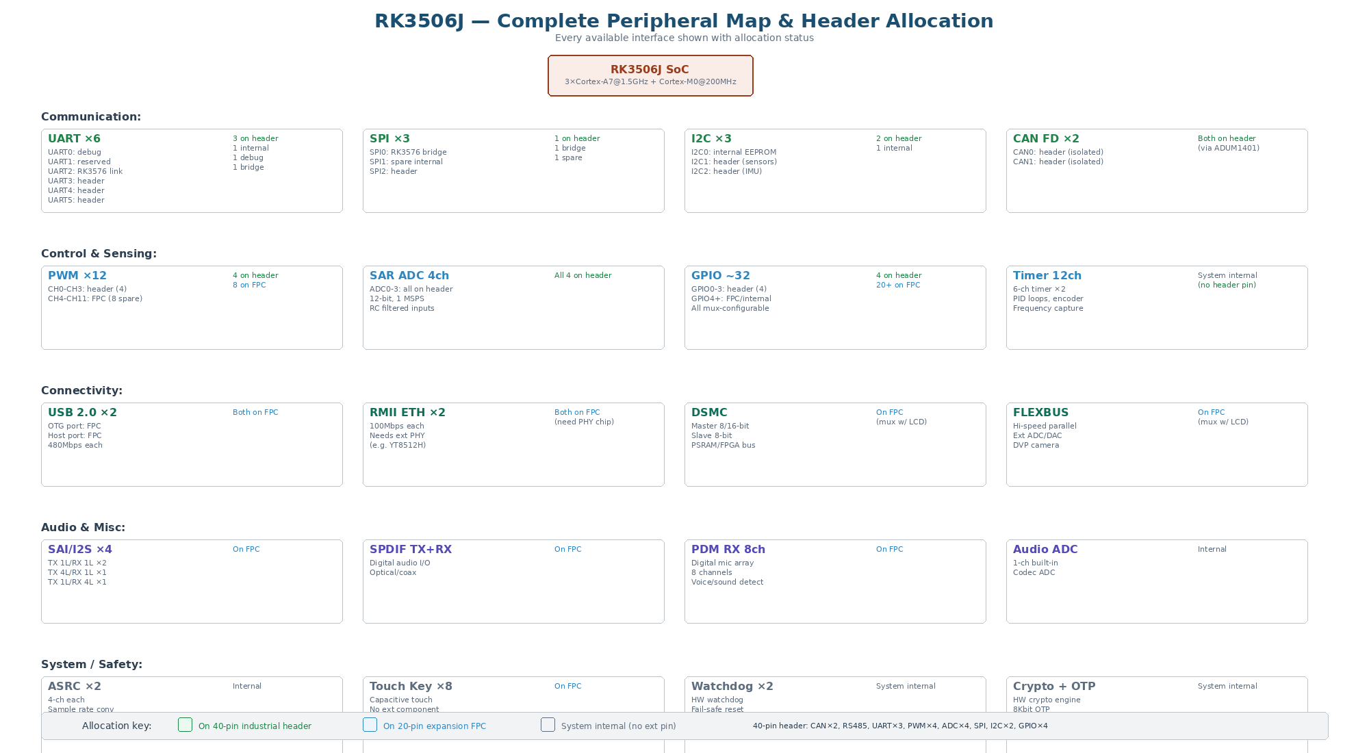
Figure 3-1: RK3506J complete peripheral map

8.1 Placement Order
# | Component | Side | Critical Rule
1 | RK3576 BGA | TOP | ANCHOR — center-left. All others relative.
2 | LPDDR4X ×2 | TOP | Above/below RK3576. Gap ≤3mm. DDR sandwich.
3 | RK806 PMIC | TOP | Within 5mm right of RK3576.
4 | eMMC + SPI NOR | TOP | Near FSPI pins. Short HS400 traces.
5 | RTL8211F + RJ45 | TOP | Right edge. RGMII <40mm.
6 | RTL8852BS WiFi | TOP | Top-right. 3mm antenna keepout ALL layers.
7 | ES8316 + audio jack | TOP | Left edge. Near I2S pins.
8 | Micro-HDMI + CSI ×2 | TOP | Left edge. TMDS/MIPI diff pairs short.
9 | NVMe M.2 | TOP/BOT | Top edge or bottom side. PCIe diff.
10 | Cellular M.2 + SIM | TOP | Near USB-C. USB 2.0.
11 | USB-C ×4 | TOP | #1+#2 top edge, #3+#4 right edge.
12 | 40-pin GPIO | TOP | Bottom edge. Pi 5 exact position.
13 | RK3506J | BOTTOM | Bottom-left quadrant. Own 3V3 domain.
14 | CAN/RS485 + ADUM1401 | BOTTOM | Near RK3506J. Isolation barrier.
15 | SN74LVC14A Schmitt | BOTTOM | Between RK3506J and industrial header.
16 | 30-pin industrial header | BOTTOM | Left edge.
17 | RP2350A | BOTTOM | Bottom-right quadrant. Own 3V3 domain.
18 | CYW43439 + SX1262 | BOTTOM | Near RP2350. 3mm RF keepout.
19 | Inter-chip Schmitt ICs | BOTTOM | At domain boundaries.
20 | CN3722 + TPS61022 | BOTTOM | Bottom-left. Away from RF/DDR.
21 | PoE PD circuit | BOTTOM | Near RJ45 (via through-board).
22 | 10-pin RP2350 header | BOTTOM | Right edge.

9. Bus & Interface Allocation
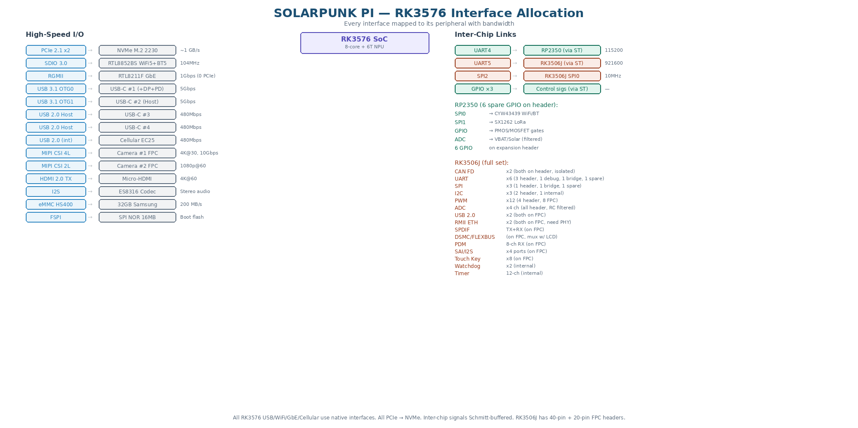
Figure 4-1: RK3576 interface map and full RK3506J peripheral allocation

9.1 RK3576 Interface Map
RK3576 Interface | Type | Connected To | Bandwidth / Notes
PCIe 2.1 x2 | Serial | NVMe M.2 2230 SSD | ~1 GB/s sequential
SDIO 3.0 | Parallel | RTL8852BS WiFi 5 + BT5 | 104MHz. Zero PCIe cost.
RGMII | Parallel | RTL8211F GbE PHY | 1 Gbps. Zero PCIe cost.
USB 3.1 OTG0 | Serial | USB-C #1 (+DP Alt+PD) | 5 Gbps + 4K display
USB 3.1 OTG1 | Serial | USB-C #2 (host) | 5 Gbps. Combo PHY (mux SATA).
USB 2.0 Host ×2 | Serial | USB-C #3 + #4 | 480 Mbps each
USB 2.0 Host (int) | Serial | Quectel EC25 cellular | Internal. 480 Mbps.
MIPI CSI (4L dcphy) | Serial | Camera #1 FPC | Up to 4K@30fps, 10 Gbps
MIPI CSI (2L dphy) | Serial | Camera #2 FPC | Up to 1080p@60fps, 5 Gbps
HDMI 2.0 TX | Serial | Micro-HDMI | 4K@60fps, 14.4 Gbps
I2S | Serial | ES8316 audio codec | Stereo audio
eMMC HS400 | Parallel | 32GB Samsung eMMC | 200 MB/s
FSPI | Serial | W25Q128 SPI NOR | Boot flash
UART4 | Serial | RP2350 (Schmitt) | 115200 baud
UART5 | Serial | RK3506J (Schmitt) | 921600 baud
SPI2 | Serial | RK3506J SPI0 | 10 MHz bulk

9.2 RK3506J Full Peripheral Map
The RK3506J has significantly more peripherals than allocated on the 30-pin header. This table shows the complete set and allocation status:
Peripheral | Total | On Header | Remaining / Notes
UART | 6 | 2 (UART3/4) | UART0=debug, UART2=RK3576 link. 2 spare internal.
SPI | 3 | 1 (SPI2) | SPI0=RK3576 bridge. 1 spare internal.
I2C | 3 | 2 (I2C1/2) | I2C0=internal. Both exposed.
CAN FD | 2 | 2 (both) | Both isolated. Fully exposed.
PWM | 12 | 4 (CH0–CH3) | 8 more available via GPIO mux or custom header.
SAR ADC | 4 ch | 4 (all) | All 4 channels exposed with RC filters.
USB 2.0 OTG | 2 | 0 | Available for USB sensors or serial adapters.
RMII Ethernet | 2 | 0 | 100Mbps each. Industrial Ethernet segments.
SPDIF | TX+RX | 0 | Digital audio. Ultrasonic sensor processing.
PDM | 8-ch RX | 0 | Digital microphone array.
SAI (I2S) | 2 ports | 0 | Audio serial interface.
FLEXBUS/DSMC | 1 | 0 | High-speed bus for FPGA or external ADC/DAC.
GPIO | ~32 | 4 (GPIO0–3) | ~28 more available via pin mux.
Watchdog | 2 | N/A | Hardware watchdog for fail-safe.
Timer | 12 ch | N/A | PID loops, encoder counting.
Cortex-M0 | 1@200MHz | N/A | Hard real-time ISR handler.

10. Bill of Materials

10.1 RK3576 Compute Domain (17 components, top side)
Component | Part Number | Package | Src | Notes
RK3576 SoC | Rockchip RK3576 | FCCSP-698L | LCSC | X-ray required
LPDDR4X ×2 | Samsung K4UBE3D4AB | BGA-200 | Ali | 4GB each = 8GB
RK806 PMIC | RK806-1 | QFN-68 | LCSC | ArmSoM Sige5 rails
eMMC 32GB | Samsung KLMAG2JENB | BGA-153 | LCSC | HS400
SPI NOR 16MB | W25Q128JVSIQ | SOP-8 | JLC | Bootloader
WiFi 5 + BT5 | RTL8852BS | LCC | Ali | SDIO 3.0
GbE PHY | RTL8211F-CG | QFN-40 | LCSC | RGMII
Audio codec | ES8316 | QFN-24 | LCSC | I2S, stereo
Cellular | Quectel EC25-E | M.2 B-key | Ali | 4G LTE, USB 2.0
NVMe slot | M.2 M-key 2230 | SMD | LCSC | PCIe x2
CSI FPC ×2 | 22-pin + 15-pin | SMD | LCSC | MIPI cameras
Micro-HDMI | Type-D female | SMD | LCSC | 4K@60
3.5mm TRRS | Audio jack | THT | LCSC | Stereo + mic
USB-C ×4 | HRO TYPE-C-31-M-12 | SMD | JLC | #1:OTG+DP+PD
RJ45+magnetics | HR911105A w/PoE | THT | LCSC | GbE+PoE
Nano-SIM | Push-push | SMD | LCSC | Cellular SIM
40-pin GPIO | 2×20 2.54mm | THT | LCSC | Pi 5 HAT

10.2 RP2350 Domain (8 components, bottom side)
Component | Part Number | Package | Src | Notes
RP2350A MCU | RP2350A | QFN-60 | LCSC | Always-on
Flash 2MB | W25Q16JVSSIQ | SOP-8 | JLC | QSPI
WiFi/BT | CYW43439 | BGA | Ali | WiFi4+BT5.2
Crystal | ABM8-12.000MHz | 3225 | JLC | Clock ref
LoRa | SX1262IMLTRT | QFN-24 | LCSC | 868/915MHz
U.FL antenna | U.FL-R-SMT-1(10) | SMD | LCSC | LoRa
10-pin header | 1×10 2.54mm | THT | LCSC | Expansion
Modem MOSFET | Si2301 | SOT-23 | JLC | Cellular pwr

10.3 RK3506J Domain (9 components, bottom side)
Component | Part Number | Package | Src | Notes
RK3506J SoC | Rockchip RK3506J | QFN | LCSC | 3×A7+M0
DDR3L | 512MB LPDDR3L | BGA | LCSC | RTOS memory
NAND | 256MB NAND | BGA | LCSC | FW + logs
CAN FD ×2 | MCP2562FD ×2 | SOT-23-8 | JLC | Isolated
RS485 | SP3485 | SOP-8 | JLC | Modbus
Isolation | ADUM1401 | SOIC-16 | LCSC | 2.5kV galvanic
Schmitt (ind.) | SN74LVC14A | TSSOP-14 | JLC | 6-ch input clean
ESD (ind.) | PESD5V0S4UG | SOT-553 | LCSC | Quad TVS
30-pin header | 3×10 2.54mm | THT | LCSC | Industrial I/O

10.4 Signal Conditioning (8 ICs)
Component | Part Number | Package | Qty | Purpose
Dual Schmitt buffer | SN74LVC2G17 | SOT-23-6 | 4 | UART + GPIO boundaries
Single Schmitt buffer | SN74LVC1G17 | SOT-23-5 | 3 | PG, wake, alarm, shutdown, gate
Hex Schmitt inverter | SN74LVC14A | TSSOP-14 | 1 | Industrial header inputs

10.5 Power Section (14 components, bottom side)
Component | Part Number | Package | Src | Notes
MPPT charger | CN3722 | SOP-16 | LCSC | Solar→LiFePO4
Boost 5V | TPS61022DRLR | SOT-23-6 | JLC | Batt→5V@4A
PoE PD | SI3402-B | QFN/SOP | LCSC | 802.3at isol.
USB-C PD | HUSB238 | QFN-16 | JLC | 12V negotiate
OR-ing | LTC4357 | SOT-23-5 | JLC | Auto-switch
LDO (RP) | MIC5219-3.3YM5 | SOT-23-5 | JLC | 3V3 always-on
LDO (3506) | AP2112K-3.3 | SOT-23-5 | JLC | 3V3 always-on
PMOS switch | Si2301 | SOT-23 | JLC | Brain power
Ferrite ×3 | BLM18AG102SN1D | 0603 | JLC | Domain entry
USB ESD ×4 | USBLC6-2SC6 | SOT-23-6 | JLC | USB ports
HDMI ESD | PRTR5V0U2X | SOT-363 | JLC | HDMI port
Boost inductor | SWPA4012S 1µH | 4012 | LCSC | TPS61022
Battery conn | JST PH 2-pin | THT | LCSC | LiFePO4
Solar conn | JST VH 2-pin | THT | LCSC | Panel input

11. PCB Routing Guidelines

11.1 Routing Priority Order
- DDR CH0+CH1 (L1/L3). Length-match ±25mil within byte lanes. ROUTE FIRST.
- NVMe PCIe x2 diff (L3). 85Ω, ±5mil matched, no 90° bends.
- MIPI CSI diff (L1). 100Ω, ≤30mm. Match pairs.
- HDMI TMDS diff (L3). 100Ω, ≤60mm.
- USB 2.0 D+/D− (L1). 90Ω, ≤25mm, no 90° bends.
- RGMII Ethernet (L1). 50Ω, ≤40mm.
- SDIO WiFi 5 (L1). 50Ω, ≤30mm, ±5mm length match to CLK.
- I2S Audio (L1). Match BCLK/LRCK/DATA lengths.
- CYW43439 SPI + LoRa SPI (L6). 50Ω, ≤20mm.
- CAN/RS485 (L6). Not impedance-controlled. Keep short.
- Power planes (L4). Copper fills for 5V, 3V3, 1V8, VBAT.
- Everything else (UARTs, I2C, GPIO, SPI bridges, cellular USB)

11.2 Critical Layout Rules
- Via-in-pad (POFV) on RK3576 BGA — free on JLCPCB 6-layer orders
- 100nF cap within 0.5mm of EVERY RK3576 VDD ball (verify in 3D view)
- WiFi antenna keepout: no copper on ANY of 6 layers within 3mm
- CAN/RS485 isolation barrier: no copper crossing between isolated and non-isolated
- PoE isolation: maintain creepage/clearance per IEC 62368-1
- MPPT switching node: short, direct, no ground copper under inductor
- RP2350 domain: GND island with single connection back to main GND
- Ferrite beads placed at physical domain boundaries on 5V trace
- Schmitt trigger ICs placed directly at domain boundary crossings

12. Reference Documents
Document | Source | Use For
RK3576 Hardware Design Guide V1.1 | Scribd: search “Hardware Design 3576 en” | DDR, PMIC, USB, PCIe — PRIMARY
ArmSoM Sige5 schematic | docs.armsom.org | RK3576+RK806 exact rail voltages
Pico 2W schematic | datasheets.raspberrypi.com | CYW43439 SPI wiring — copy exactly
RP2350 HW design guide | datasheets.raspberrypi.com | RP2350A minimal circuit, SMPS, crystal
RK3506G2 datasheet | opensource.rock-chips.com | Full peripheral map, pin mux, FLEXBUS
Firefly Core3506BY BSP | en.t-firefly.com | RK3506J AMP config, CAN/RS485 drivers
Quectel EC25 HW design guide | quectel.com | 4G LTE integration, USB, antenna
ES8316 datasheet | LCSC / Everest Semiconductor | Audio codec I2S wiring, analog design
SX1262 datasheet | semtech.com | LoRa RF matching, SPI commands
SN74LVC1G17 / 2G17 datasheet | ti.com | Schmitt trigger application circuits
SN74LVC14A datasheet | ti.com | Hex Schmitt trigger specs
CN3722 datasheet | LCSC | MPPT circuit, charge current programming
TPS61022 datasheet | ti.com | Boost converter, inductor selection
SI3402-B datasheet | Silicon Labs | PoE PD circuit, isolated DC-DC
JLCPCB impedance calculator | jlcpcb.com/pcb-impedance-calculator | Trace widths for JLC06161H-3313
JLCPCB stackup files | github.com/gsuberland/jlcpcb_autogenerated_stackups | Pre-built KiCad stackup import
PCBWay RK3576 SBC V1.0 | pcbway.com (CERN-OHL-P license) | KiCad reference design, symbol/footprint

13. Ordering Information
JLCPCB Setting | Value
Layers | 6
Stackup | JLC06161H-3313 (specify in order notes)
Surface finish | ENIG
Impedance control | YES
Via-in-pad (POFV) | YES (free on 6+ layers)
X-Ray inspection | YES (RK3576, LPDDR4X, eMMC BGAs)
Material | FR-4 TG155
Assembly | Standard PCBA — BOTH SIDES
Estimated cost (5 pcs) | USD $350–500 assembled
Order notes | Impedance: 50Ω SE, 85/90/100Ω diff. Stackup: JLC06161H-3313.

14. Revision History
Rev | Date | Changes
1.0 | Jan 2026 | Initial RK3576+RP2350 dual-processor spec (no RK3506J)
2.0 | Feb 2026 | Added RK3506J automation domain, cellular, solar, PoE
3.0 | Mar 2026 | Added Schmitt triggers, ferrite filtering, expanded headers, cameras, audio, all USB-C, full datasheet format

Solarpunk Pi v3.0
Three brains, three power sources, five networks, thirty automation I/O pins, Schmitt-triggered signal conditioning, ferrite-filtered power rails, ESD-protected connectors — in a board the size of a credit card. Solar-powered edge computing with real-time industrial automation.

