Kairos Defense
Product overview
A shared memory of drone behavior across military installations. November 2026. All data in this product is synthetic.
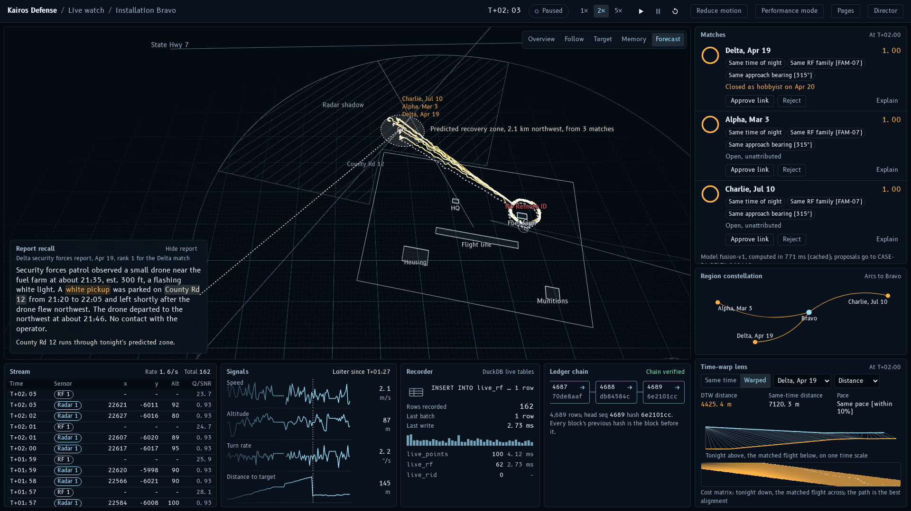
Live watch, two minutes into the demo: tonight's drone orbiting Bravo's fuel farm, amber ghosts of three matched past flights, the dotted recovery forecast and the linked Delta report.

In brief
Kairos Defense gives every installation one shared memory of every drone flight that has crossed a fence line. While a drone is still in the air, it answers one question: have we seen this before, and what happened then?
It recognizes the live flight's pattern among every past flight at every base, pulls up the reports written about those flights, predicts where tonight's drone will be recovered, and keeps a tamper-evident case memory of what was known when. Analysts stay in charge: the system proposes links and exports, and only a person approves them.

The problem
Small drones probe military installations at night. Each base sees only its own nights: its own radar tracks, its own patrol reports, its own assessments. When the same operator flies the same pattern at another base six weeks later, nobody connects the two, and a flight that was closed as "a hobbyist" stays closed.
The information to connect them usually exists. It is spread across bases, stored in different forms (tracks, radio detections, free-text reports), and nobody can search it by the shape of a flight.

What it does
Capability | What it does
Recognize | Compares the shape of the live track with every past track at every base using dynamic time warping, which still matches a flight flown faster or slower. A small trained model weighs the shape against radio family, approach bearing, time of night, launch area, orbit radius and altitude, and explains each match in plain words.
Recall | Retrieves the written reports (security forces, local police, aviation authority) about the matched flights with a search that combines meaning and exact keywords, and highlights shared clues such as a vehicle on a road.
Anticipate | From how the matched flights ended, forecasts where tonight's drone will be recovered and which roads cross that zone.
Remember | Keeps a case memory that never forgets and never rewrites. Every assessment, link, decision and export is an appended, hash-chained event with two times, when it was true and when the system learned it, so any case can be shown exactly as it was known at any moment.
Formations | Matches the choreography of multi-drone swarms against swarm events seen before, including at other installations.
Report | Produces a signed, verifiable evidence package and a "what changed since" brief for the next shift.

A night with Kairos Defense
The built-in demo replays one planted incident at Installation Bravo. Times count from the first radar contact (T+0).
When | What happens
T+0 | A drone comes out of the radar shadow northwest of Bravo and appears at the north fence at 21:40. Every detection is recorded as it arrives.
T+45 s | The matcher runs on the first 45 seconds of track, while the drone is still inbound.
T+80 s | The drone settles into a counter-clockwise orbit over Bravo's fuel farm.
T+90 s | The top matches are earlier flights by the same operator at other bases: Delta on 19 April and Alpha on 3 March, the second flown about 18% slower.
T+105 s | A predicted recovery zone appears about 2.1 km northwest of the orbit, inside Bravo's radar shadow.
T+120 s | A linked Delta report from April mentions a white pickup on County Rd 12, the road that crosses tonight's predicted zone.
Case board | Known then and known now: what Delta knew when it closed its April flight as "hobbyist", and what the shared memory knows today.
Evidence | After an analyst approves the links, a signed evidence package is exported and verifies.
Encore | A five-drone swarm at Echo flies the same choreography as a swarm at Golf six weeks earlier, in another region.
Known limitation: the script also names Alpha on 2 May as a third top match at T+90. In the current build all four top matches are flights by the same operator, but third place goes to Charlie on 10 July, a flight planted as a weaker match because it circles a different asset, and Alpha on 2 May ranks fifth. At 90 seconds the drone's target is not yet reliable evidence, so the matcher was deliberately not tuned to the demo to fix it; this is recorded as an accepted gap.

Who uses it
Role | Screen | Used for
Base defense operator | Live watch | Watching a live track, its matches, the forecast and the linked reports
Analyst | Match explainer, Case board, Swarm view | Understanding why a match ranked where it did; linking incidents into cases; comparing swarms
Investigator | Evidence | Building and verifying a signed evidence package
Commander or watch officer | Shift delta | Seeing what changed since a chosen time
Everyone | Eval | How well the system performs against its targets

The Command Center
The interface borrows from radar scopes and cockpit displays. Tonight's live data flashes blue-white; memory (past flights, matches, history) glows amber; forecasts are dotted bone-white because they have not happened yet. Red appears only for alerts and contradictions, green only for approved or verified states. Every moving element is driven by a real event or computed result, never by decorative data. A Director mode plays the whole story for presenters, beat by beat, with captions and camera moves.

Match explainer
Takes one match apart: a time-warp lens that shows how tonight's flight lines up with a past flight flown at a different pace, both flights side by side, and a breakdown of what the score is made of, feature by feature.
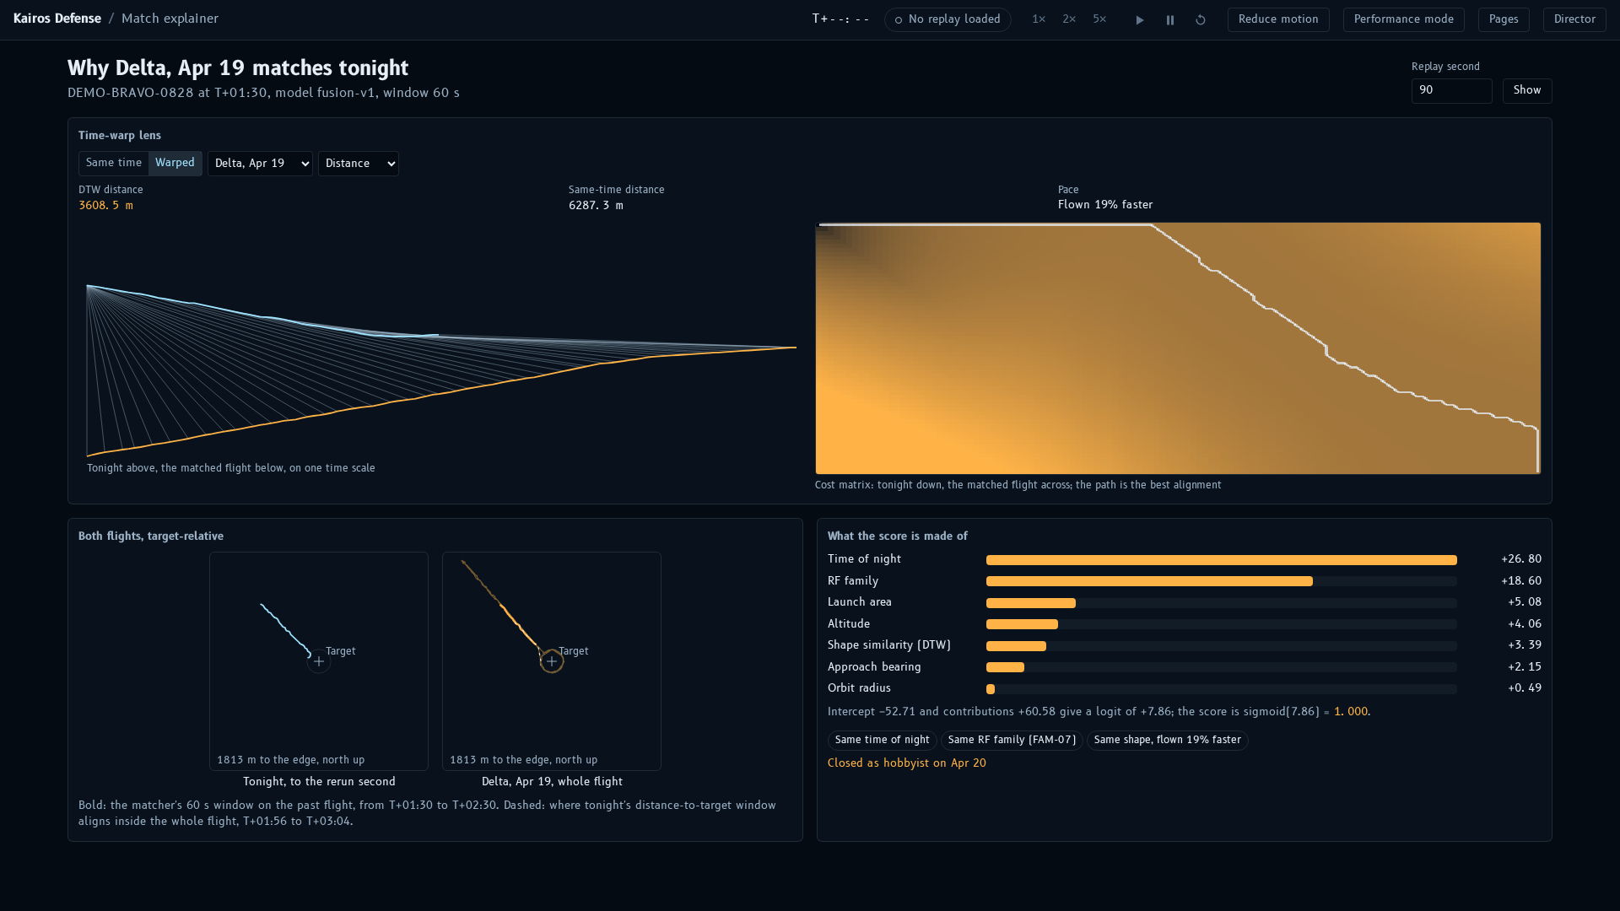
Match explainer for the Delta match: the time-warp lens, both flights and the score breakdown.

Case board
Shows a case as the memory knew it at any moment. A scrubber moves through time; Known then jumps to the moment Delta closed its incident, Known now to today. Contradictions are outlined in red and never resolved automatically, and every proposed link waits for an analyst to approve or reject it.
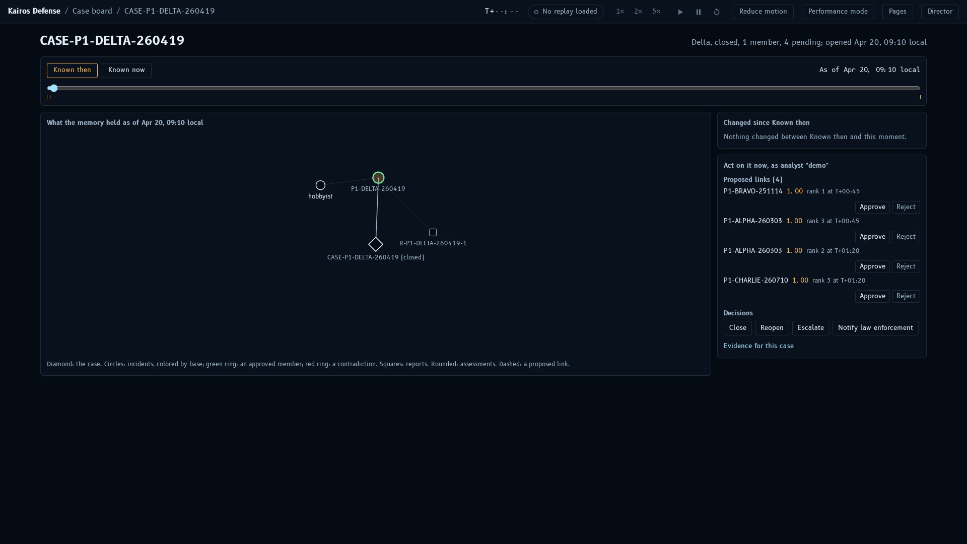
Case board, Known then: Delta's incident assessed as a hobbyist and closed, with no links.

Swarm view
Compares a multi-drone swarm with the swarms seen before. Tonight's drones and their formation are drawn live; the best-matching past swarm appears as an amber ghost, aligned second by second, with the formation's spread and rotation charted for both.
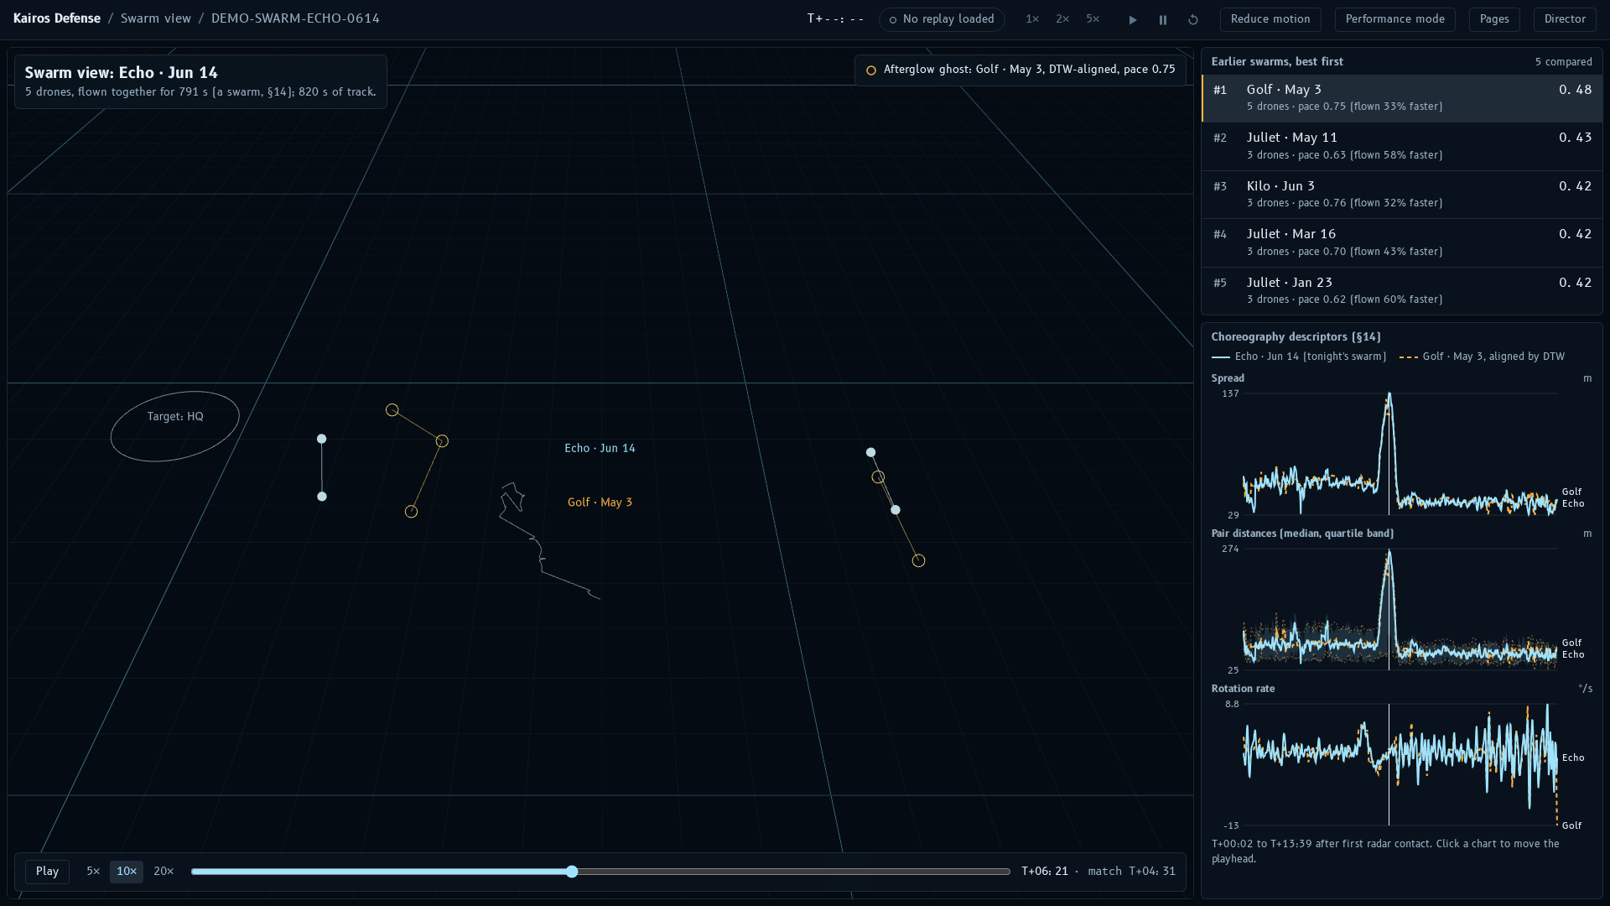
Swarm view: Echo's five drones with the Golf swarm from six weeks earlier as an afterglow ghost.

Evidence
Builds a signed evidence package for a case after approval, showing per-file hashing and every verification check: file hashes, the Ed25519 signature, the continuity of the hash chain and the rows against the ledger. Any exported package can be verified again later.
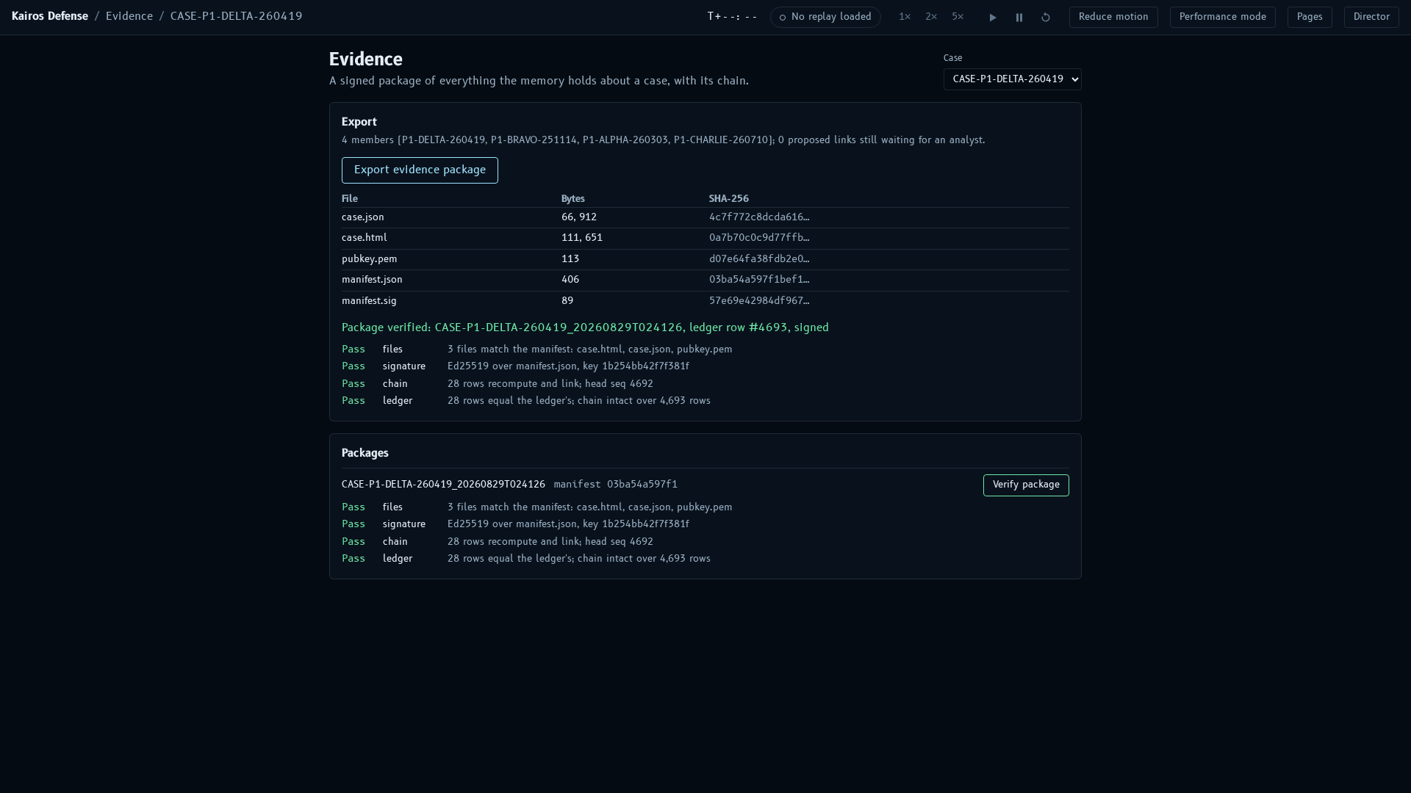
Evidence: an exported package with every verification check passing.

How it works
Stage | What happens | Built with
Synthetic world | A seeded generator creates 12 notional installations in 3 regions, 18 months of nights, about 1,900 flights by hobbyists, probing actors, copycats and swarms, with radar, radio and Remote ID detections, reports and assessments. The same seed always gives identical data. | Python, NumPy, DuckDB
Features and index | Each track becomes 1-second channels (speed, turn rate, distance to target, altitude, vertical speed) measured relative to the target, plus summary signatures and compact window vectors. | DuckDB, LanceDB
Matching | A fast vector search shortlists candidates, dynamic time warping re-ranks them by shape, and a logistic model fuses shape with radio, bearing, time of night, launch area, orbit and altitude. Only flights that started before tonight's are ever searched. | dtaidistance (C), scikit-learn
Report recall | Hybrid search over the reports (meaning plus keywords, fused by rank) filtered by base, time window and distance, with clue linking. | LanceDB full-text and vector search
Forecast | An analog forecast of the exit path and recovery zone from how the matched flights ended. | Python
Case memory | An append-only, bitemporal ledger: every event hash-chained with SHA-256; evidence packages signed with Ed25519. | DuckDB, cryptography
Live replay and API | Replays an incident as if live and streams detections, matches, forecasts and ledger writes to the browser. | FastAPI, WebSocket
Command Center | The 3D theater, instruments and pages described above. | React, three.js, D3
Agent tools | Eight tools for AI assistants through an MCP server, read-only by default; proposals still need human approval. | MCP Python SDK
Evaluation | Measures every target against ground truth that only the evaluation code may read. | Python
Business logic depends only on small interfaces, so the stores can later be replaced by KDB-X and the memory by Kairos without changing tests, evaluation or the interface.

Measured results
From the evaluation harness on the synthetic dataset (final build, 29 October 2026):
Measure | Result | Target
Same operator found in the top 5 at T+120 s (Recall@5) | 1.00 | at least 0.80
Same operator in the top 3 by T+90 s (time to match) | 95.7% | at least 70%
A copycat ranked above every true match | 0% | at most 5%
Improvement of DTW over a simple baseline (DTW lift) | +0.52 | at least +0.10
Clue-bearing reports retrieved in the top 5 (report linkage) | 1.00 (65 of 65) | at least 0.70
Recovery forecast, median error at T+90 s | 340 m | at most 400 m
Correct swarm ranked first | 1.00 (4 of 4) | at least 0.80
End-to-end live update, 95th percentile (laptop) | 126 ms | at most 1,500 ms
3D frame rate at 1920 × 1080 (Apple M4 Max) | 59.9 fps | at least 50 fps
Every demo assertion passes except the third top-3 match described above. The code base carries more than 800 fast Python tests, about 170 web unit tests and end-to-end browser tests with accessibility checks.

Guardrails
- Synthetic only. Installations, coordinates, flights, reports and actors are invented. No real place, person, vehicle or plate appears.
- Flights, never people. The system links flights; no feature infers, stores or displays a person's identity.
- Humans approve. The matcher and the agent tools only propose links, closures and exports; an explicit click or command commits them.
- Append-only memory. Nothing is updated or deleted; corrections are new events, and the hash chain shows any tampering.
- No look-ahead. Searches only consider flights and reports from before the query flight started.
- Offline by default. It runs on a laptop with no network; language models and downloadable embeddings are optional.

Running it
On a laptop with uv, Python 3.11 or later, Node 22 and a C compiler:
- uv sync && npm --prefix web install installs everything.
- make data index models eval generates the data, builds the indexes and models, and measures the results.
- make demo, then open http://localhost:8000 and press D for Director mode.
Further reading in the repository:
- docs/USER_GUIDE.md: every screen, the command line, configuration and troubleshooting, with 20 screenshots.
- docs/ONE_PAGER.md: the product on one page.
- docs/DEMO.md: the presenter's runbook.
- docs/demo/kairos-defense-demo.mp4: a narrated 1 min 45 s recording of the demo.
- docs/ROLLBACK.md: how the build history is organized and how to roll back.

