Project2:

Part1:

Code:

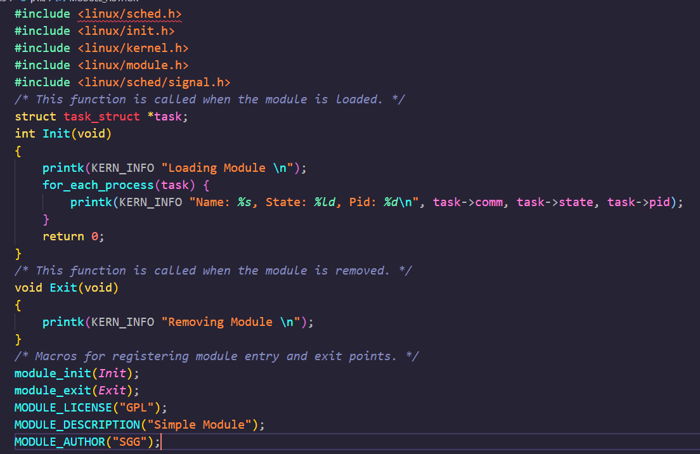

Use for_each_process to access every process in the task list and print their name, state and pid by comm, state and pid.

Code Result:

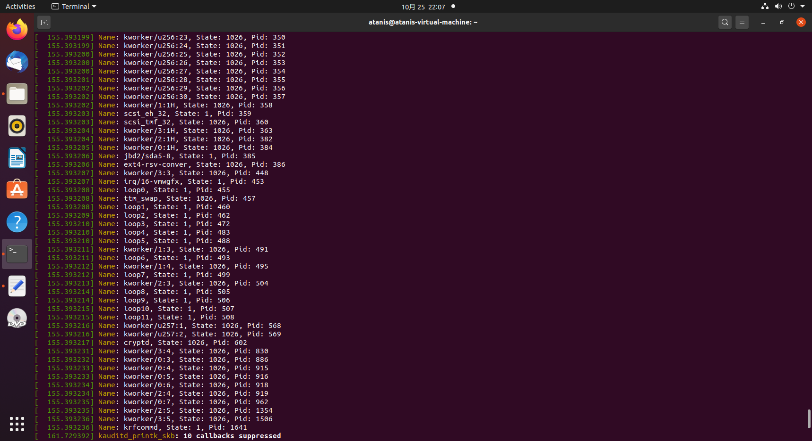

Ps -le result:

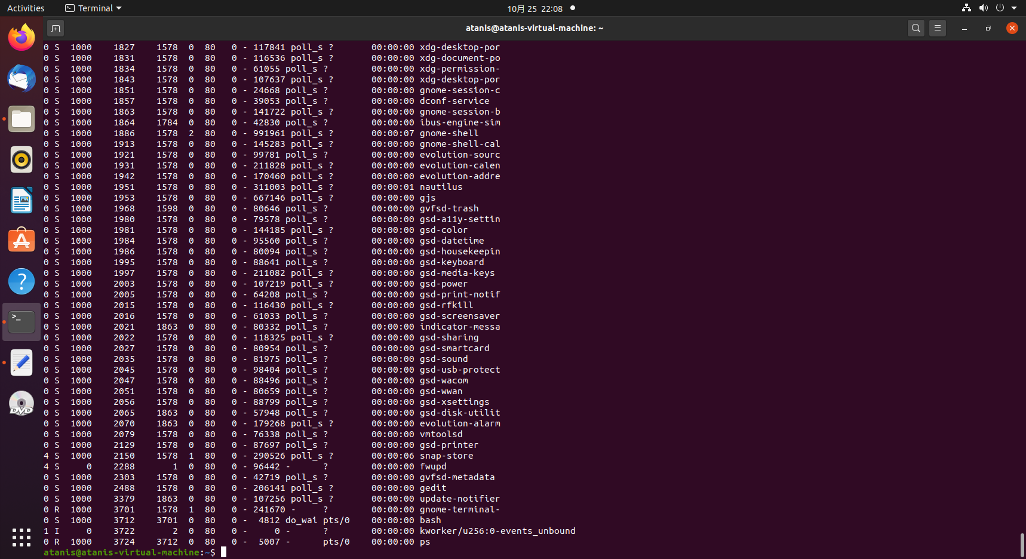

Part2:

Code:

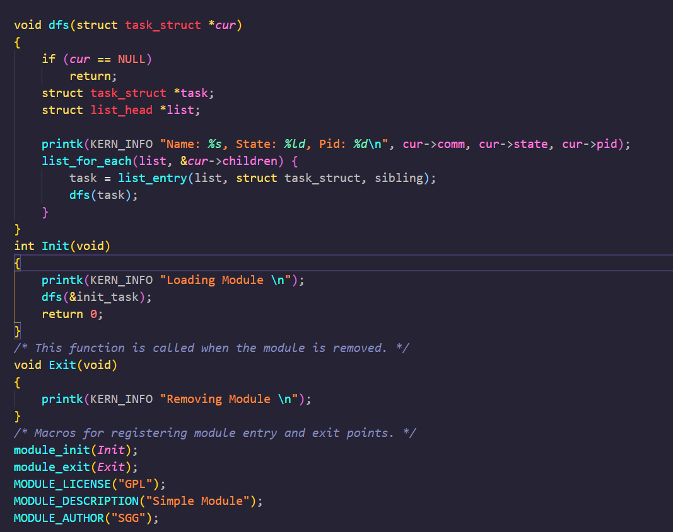

See init_task as the root node. Use list_for_each to access siblings and print them.

Result:

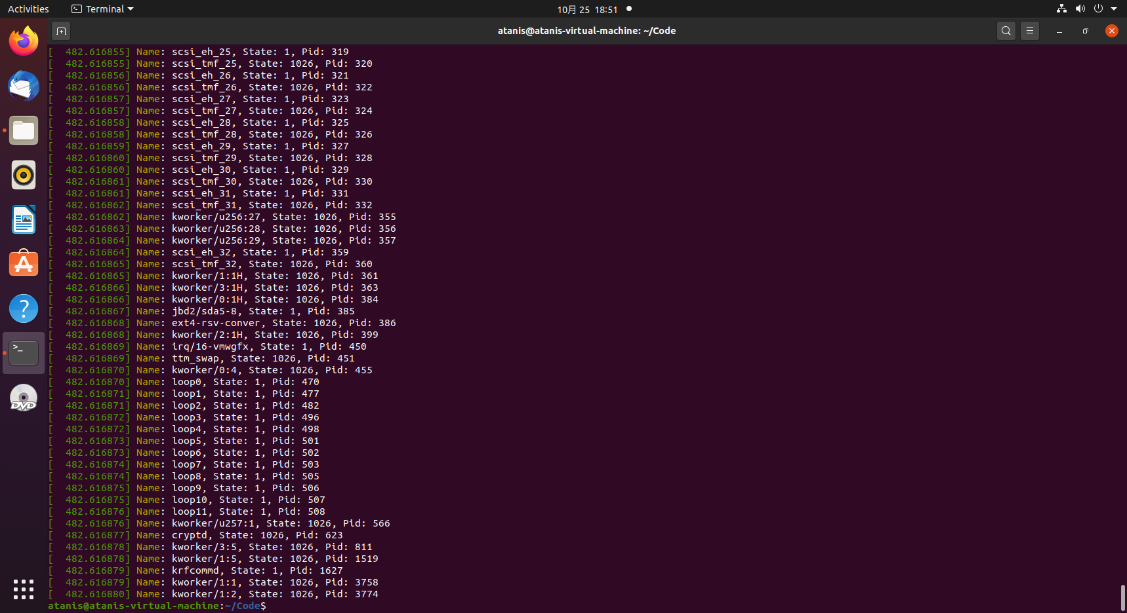

3.2 8(1*2^3)

3.14

0 2603 2600 2600

3.17

X:0,-1,-4,-9,-16

Y:0,1,2,3,4