4.12 1.4

4.15 8,2；

4.17 C:5,P:0；

4.22

Code:

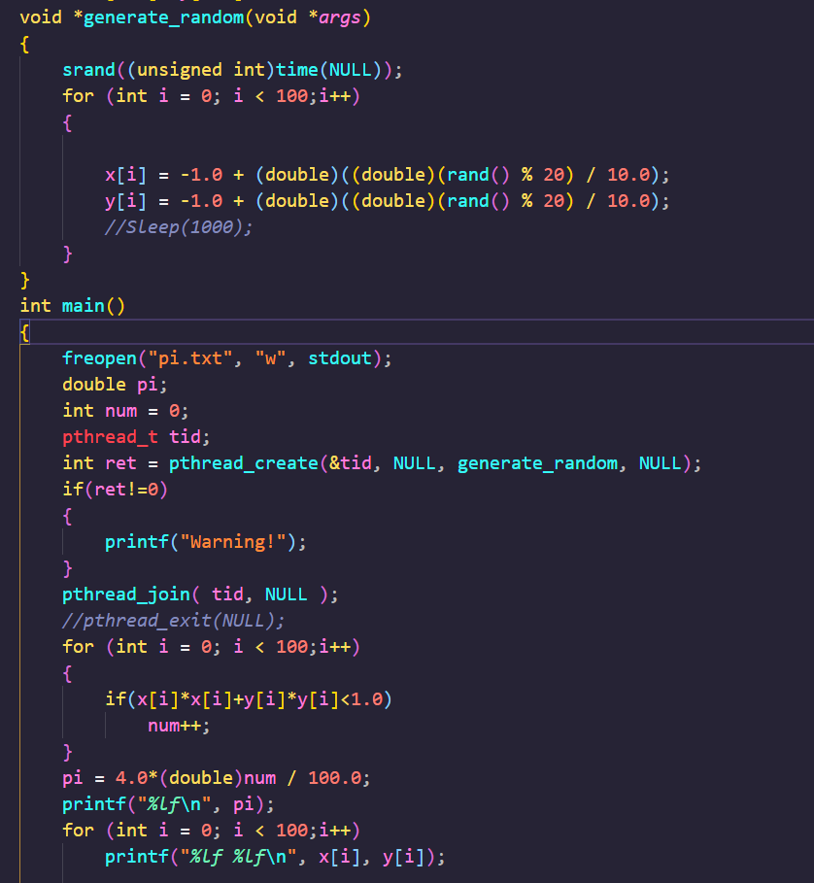

1. generate_random

Use rand() to generate numbers between -1.0 and 1.0 which are stored in x[] and y[]

2. main

2.1Creat pthread tid

2.2Use pthread_create to call generate_random

2.3Use pthread_join let main pthread wait child pthread end

2.4Calculate pi