5.7

The account is 0. The man call withdraw() and woman call deposit().

5.8

Let flag[0]=0 and flag[1]=1.

For thread 1, it can directly because flag[0]=0. For thread 0, it will wait until thread 0 set turn=0. After that thread 1 ends and thread 0 runs and ends. So it is correct.

5.39

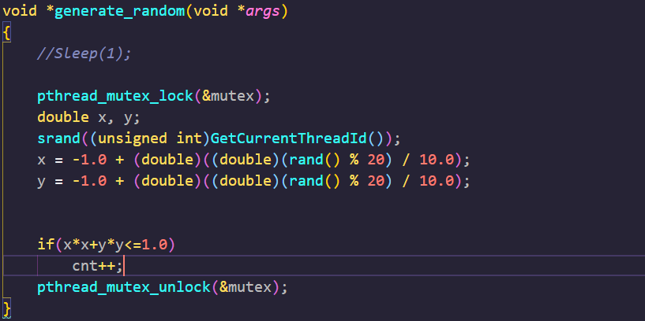

In the child thread lock mutex, use threadId as the seed to generate random number

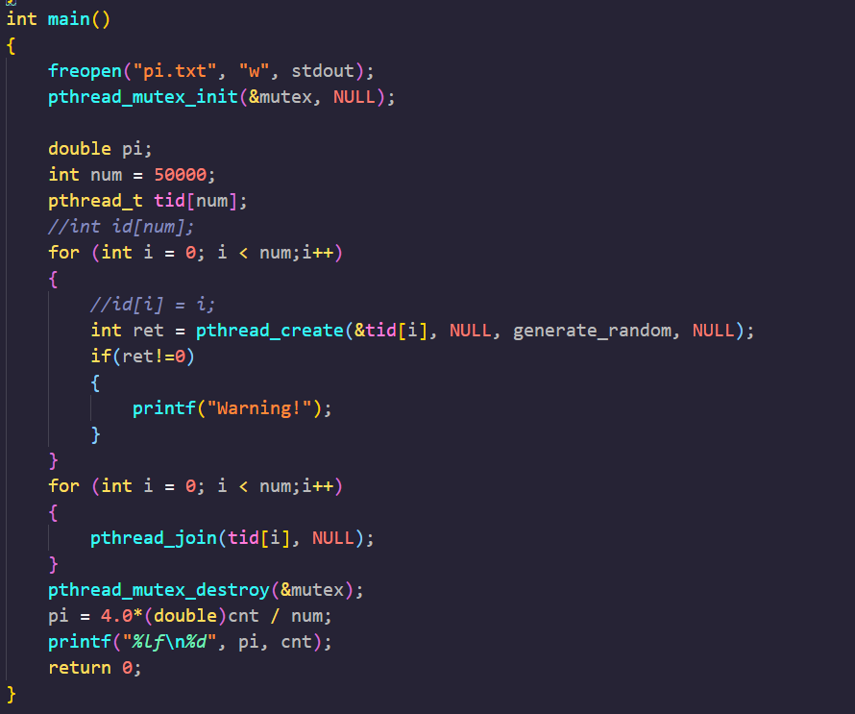

Creat child thread and use pthread_join let main thread wait child thread end.