Banker’s Algorithm

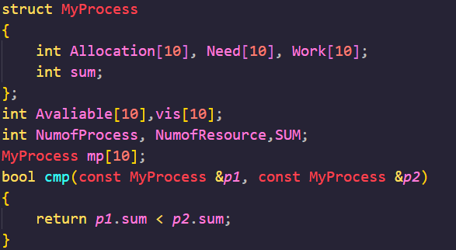

Calculate the num of resources needed by every process and sum. Then sort processes by sum.

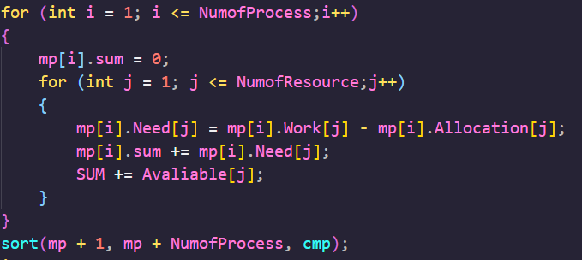

Search for the Process can run. If find add count, set a mark and release resources. If can not find, this is an unsafe state. Code will end when all processes can run.

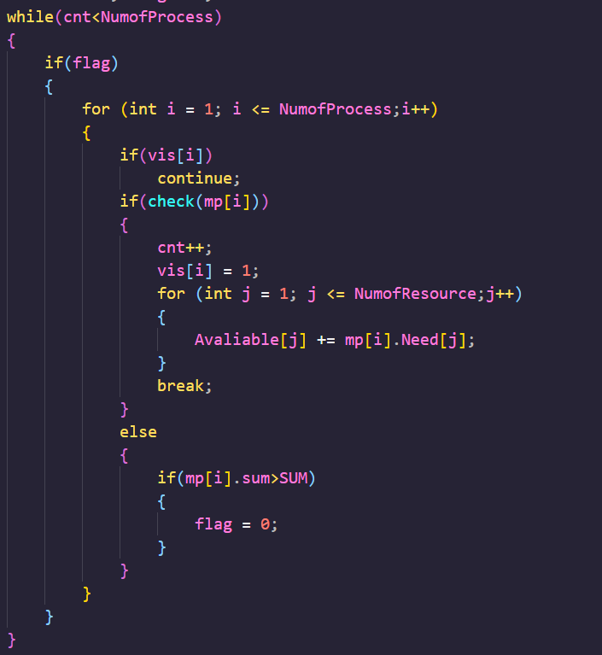

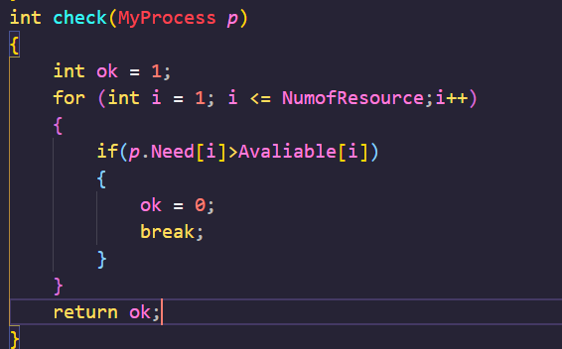

7.11

1. Every road is full, there is no space for a car through the crossroads

2. Car cannot go back

3. The cars which have same direction occupy one crossroad and want to through another crossroad which is occupied by other cars.

4. There is a wait chain that the crossroads of the car want to pass are occupied by other cars.