Key characteristics of distributed system

Scalability:
with increase data scale, performance should remain the same

Horizontal Scale: increase number of server
Vertical scale: increase machine performance: ram, cpu,disk

software support:
horizontal scale: mongodb cassandra
vertical scale: mysql

Reliability:
ability to keep delivering service even some of them fail
this is achieve by redundancy

Availability:
the time system remains operational to perform its required function in a specific time

Efficiency:
how fast the system can response to your request
two standard to measure it:
1.response time or latency:delay of time to get the item
2.throughput or bandwidth:number of items delivered in a period of time

Client-Server Model: achieve by http, socket, go through DNS for ip query, in linux use tool like
dig www.google.com
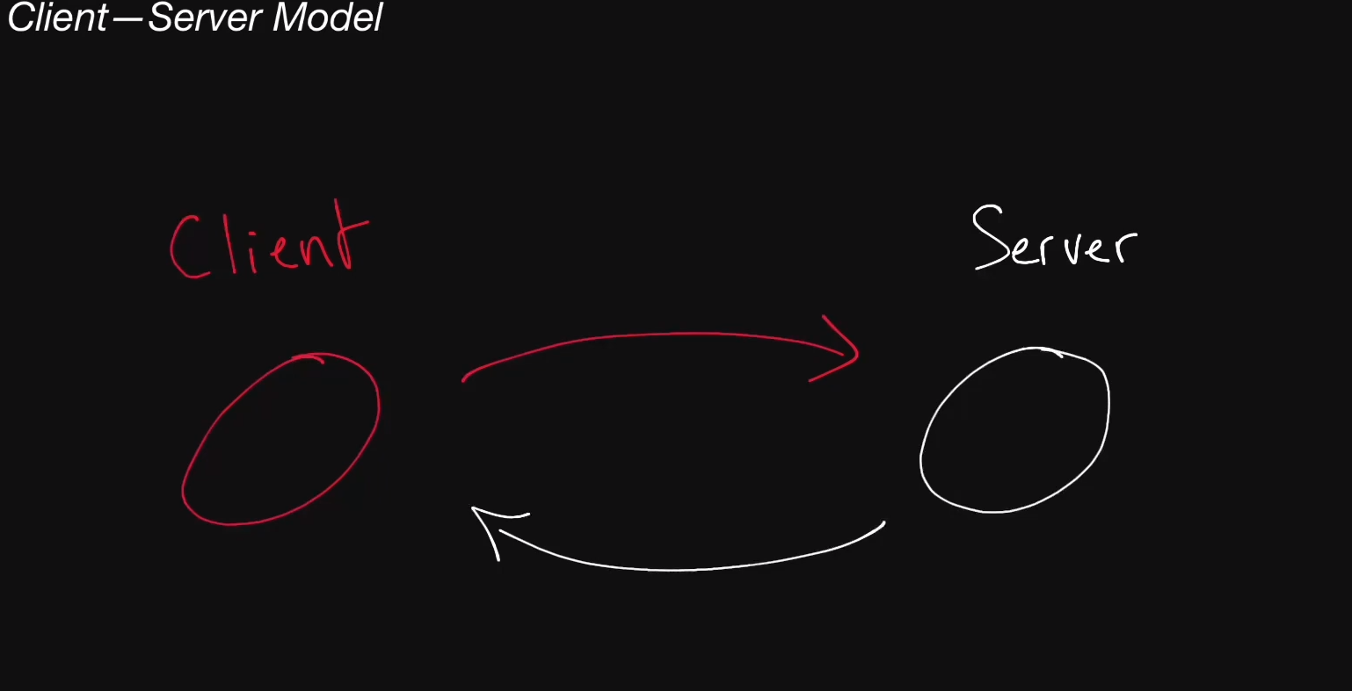

port should also be specific: like http for 80, https 443
linux command example: nc -l 8088 (server) nc 127.0.0.1 8088 (client)

Network protocol:
IP, TCP, HTTP

IP packet two main components:
ip header: (store in bytes include src, dst,total size, version v4/v6) 20-60 bytes
ip data: 2^16 bytes limit
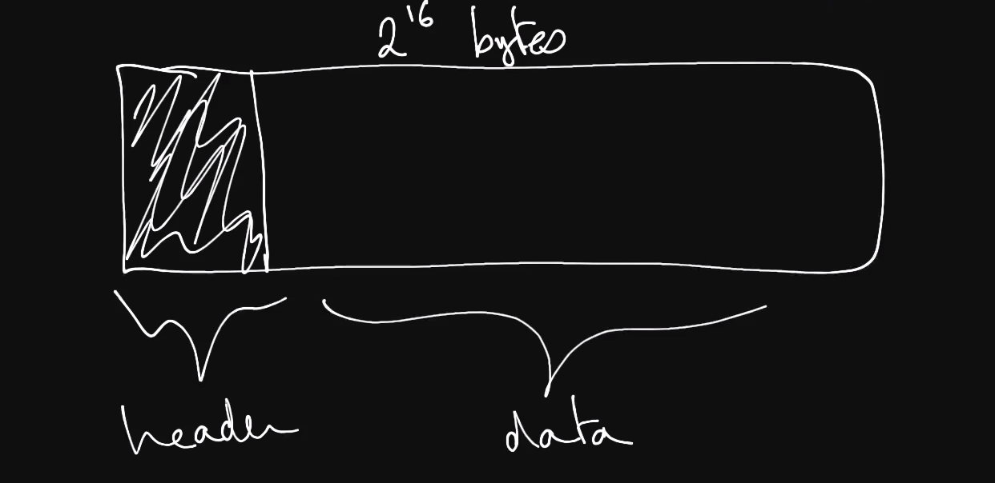
if the data is large, how to do it? Divide into multiple packets, how to make sure reliable?

TCP to control:
tcp build on top of ip packet

For application usage, HTTP build on top of the TCP

Storage:
One main issue: persistence
two category: disk and memory

Load Balancer:
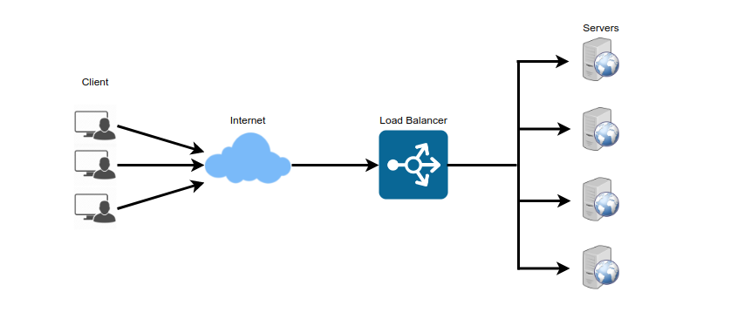
spread the traffic across a cluster of servers to improve responsiveness and availability of application
places you can add load balancer:
user and webserver
webserver and application server
application server and database server
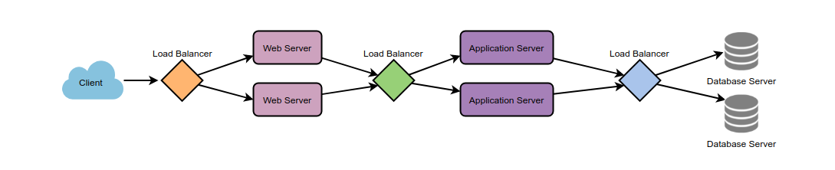
Algorithms to use for balancer:
base line: choose the one which is healthy and can response the correct thing according to the request
types:
least connection method: use the ones with least number of active connection
least response time method: choose the lowest average response time ones
least bandwidth method: choose least Mbps ones
round robin method: when servers are equal specification and not many persistent connections
weighted round robin method: server assign a weight, a higher weight one get assigned
ip hashing: the hash of ip address of client is calculated and redirect

Problem with load balancer: single point failure of load balancer:
solution: redundant load balancer
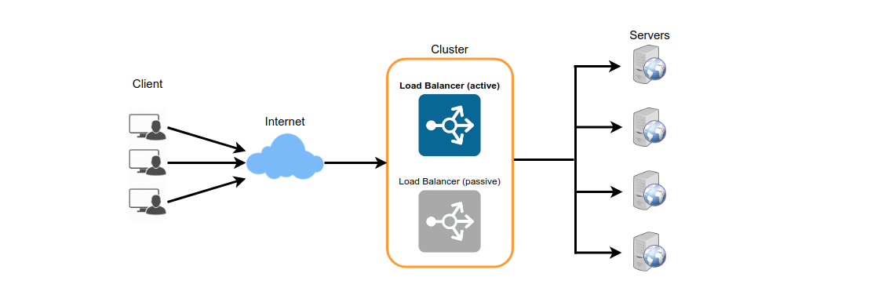
Latency and Throughput
Hardwares:
Disk: include HDD(hard-disk drive) or SSD(solid-state drive) which is non-volatile
Memory: random access memory (RAM) data store in memory will be lost when process die

Latency: time it takes for a certain operation to complete
Throughput: number of operations system can handle in a period of time for server it is measured as request per second (RPS, QPS)
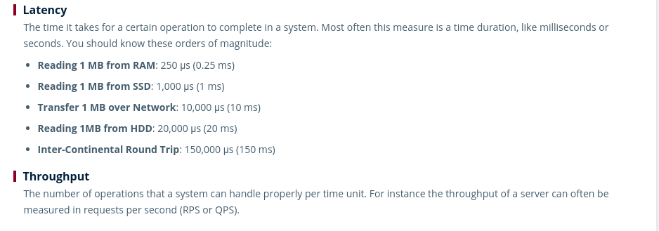
Availability:
High availability is required for most of system, follow the rules of Nines, the time of system up and running in a year in percent can be used to measure availability


Redundancy:
replicate the parts of a system to make it more reliable
SLA:
service level agreement, a collection of guarantees given to a customer by service provider, usually guarantee the availability of a system
SLO:
service level objective

Caching:
in System design level caching: means request or query can get data faster than its original place.
Caching can happens in client(browser cache), server(redis or something), database

Write through cache: operation will trigger write in both cache and database, it is sync for both
Write back cache: async operation to sync data between cache and database, when client edit a post for example, it directly writes into cache and return and database update will be async

in multiple servers which apply caches, it may have issues of stale caches
Solution 1: put the caches into the single cache server(redis)

Cache Hit: when requested data is found in the cache
Cache Miss: not found in cache example like: when a server goes down. Our load balancer will have to forward request to a new server which will have cache miss
Cache eviction policy: the policy to remove items from cache, include FIFO, LRU,LFU (leetcode practice)

CDN: content delivery network. It is a third-party service act like cache for server

Proxies:
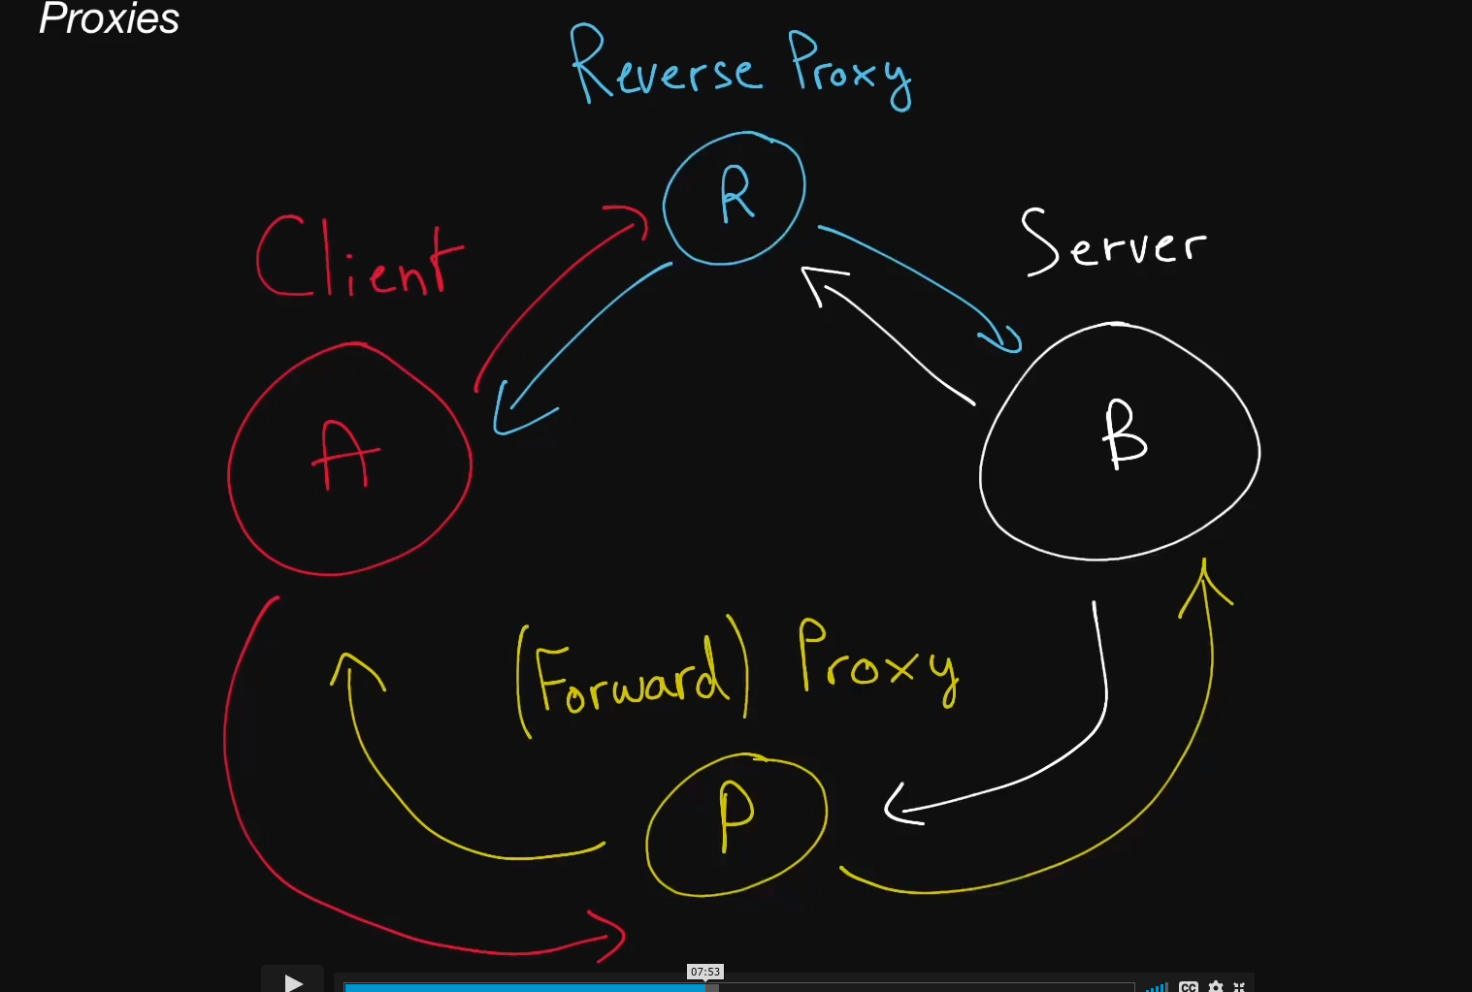
forward proxy:
client send request to p and p forward request to server, server may not able to know client ip
for example like vpn
inverse proxy:
client send request to B and with right configuration, client actually send it to R, then R send to real B
but from client side it think it send to B
The trick is use DNS query to return ip address of Reverse Proxy, it will protect the real server address.
This can be very useful if you want to filter out or ignore some request for your server using reverse proxy, so reverse proxy server can be used for logging matrix. Do not bother the server so much

Also can be applied for load balancer, one of the tool to use is: Nginx

