

**Milestone #3**

4/12/16

Zach Cornell

Caleb Stevenson

Carson Schaefer

**Milestone 3 Report**

**Intended Progress**

As the Test4Time team wrapped up the third milestone of the semester, these were the tasks the team intended to have completed by this time:

* Parent menu up and working
  + Parental controls to create and edit accounts for children
  + Parental controls to choose which apps to block
* Implementation of blocking apps
  + Needed to create a list of applications to be blocked.
  + Block the desired applications
* Fix layout scaling issues
* Main menu up and working
  + List of users
  + Access to all other pages and activities

**Gantt Chart**

This is an updated Gantt Chart for steps the team plans on taking.

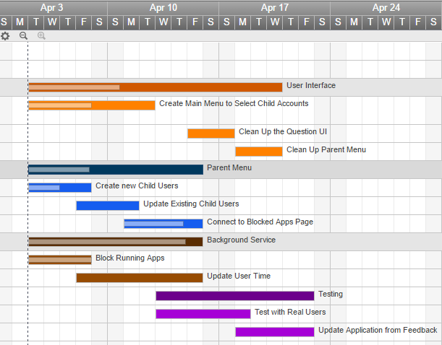

**Progress To Date**

The main achievements for this milestone was the completion of the basic, essential functions of the Test4Time application. Primarily, the team was able to implement the ability to block selected apps from opening. The Test4Time application is even able to block apps if a user decides to kill the Test4Time app because the background service will still be running. The team was able to correctly block apps for older as well as newer Android devices. A part of the function of blocking apps was the screen for the parent to select which apps to block. The team was able to solve the issues with displaying app names and icons correctly, as well as some view issues when an application was selected.

The Test4Time team also created the framework for the parent menu. Currently, this menu allows the parent to add new child accounts and edit those accounts, primarily if they need to update a child’s grade level. Also, within the parent menu is a link to the “Select Blocked Apps” page where they can select what apps their children do not always have access too. The list of child users displayed on the parent menu queries the database to find the list of created accounts and displays their name, grade, and current amount of unused time.

Another area that has made a lot of progress is the main menu. The main menu is what the users see when they first open up the Test4Time app. The page interacts with the database and loads the user’s name into the list of users to pick from. When a user selects their name, it takes them to the questions page which displays the user’s current time, name, and grade level as well as enables them to answer questions or hit the play button to start the timer.

All of the User Interface views are linked together in a working, simple control flow.

**Projected Progress**

The next steps for the team include continued updates to the layout of the questions. Some improvements to the size of some of the sections needs to be adjusted. Layout changes will also include changing the clock in the top corner to display a play button with the time built up underneath it. Further, the interface will need to be connected with the database to track users’ account information. This will allow us to store information regarding time saved, name, and other information securely and easily retrievable to display to the user.

The necessary functions of the project is done, so the rest of the work is mainly fixing up the interfaces and making them simple and user friendly.

**Setbacks**

There were not too many setbacks for the team this milestone. The team had a slight hiccup with the differences in android versions among devices. Newer versions update and remove functions that the team used to block apps, which allowed newer devices to open any app set as blocked. To resolve this, the team had to check what version of android the device was running and then use the appropriate function versions. Other than this setback, the team did not really have too many problems.

**Conclusion**

The team feels that the third milestone was our best milestone. The team really buckled down and worked hard to make some major progress on the project. It was nice for the team to be able to see all of the pieces come together.

The team was also able to hand a copy of the project to our client for him to test and to show his colleagues what has been completed so far. This will also provide us feedback on what kind of visual editing and functionality he would like to make before the project deadline.