February 19th 2018,

12009 Ocean st,   
 Miami FL,   
 42512

Dear Tommy McWire,

I am honored to informed you that you have been accepted in the Master of Science in Nanotechnology at Memorial High University in Wisconsin. We are excited and look forward on working with you.

You and your parents are invited to join us on May 22nd 2018 for a welcoming cocktail in the main hall of the Georges Campbell building. An invitation is enclosed with this letter.

Once again, congratulations. If you have any questions or specific needs, do not hesitate to let us know.

Sincerely,

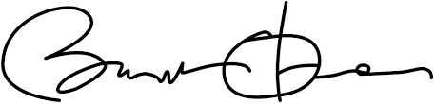

Brian O’Mailer

Director of Admission at Memorial High University