Parallel action: replace text and image

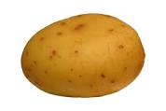

## Potatoes are Great for Our Teeth