Parallel action: replace text and image

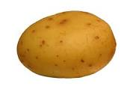

A Potato a Day Keeps the Doctor Away.

