Parallel action: replace text and image

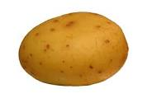

Potatoes are Rich in Vitamins and Minerals

