Parallel action: replace text and image

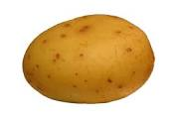

Potatoes are Great for Our Teeth

