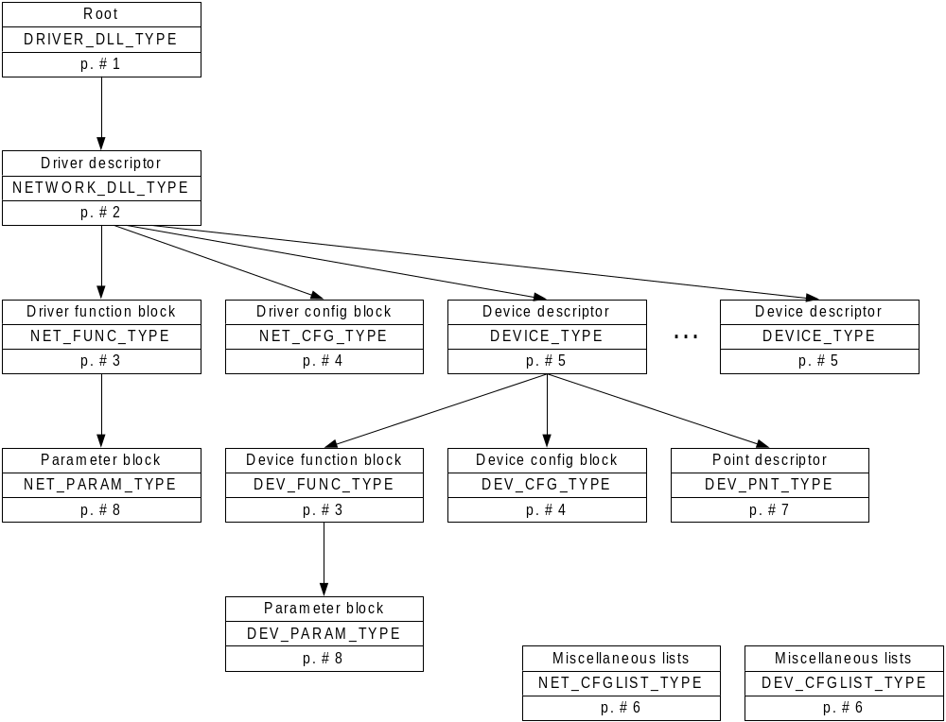

 | CT_ and PT_ formats

Ovidiu Adam on 02/06/98 at 06:35 PM

Quick memo on RCD formats:

CT_TITLE // Sets the title of the current dialog box
"string \0"

CT_CONST //
LONG // default

IDC_STATIC
CT_STATIC // Sets the text in the static
"string \0"

IDC_COMBO // drop list
CT_STRLIST // Loads the droplist with info from DEV/NET_CFG_LIST_TYPE
LONG, // default
DEV/NET_CFGLIST_TYPE

IDC_COMBO // drop list
CT_VALLIST // Loads values into the droplist
LONG // default
LONG // min
LONG // max
LONG // step
"format %ld \0" // "printf" like format

IDC_CHECK
CT_CHECK
LONG // default
LONG // off
LONG // on

IDC_RB_FIRST // first RB in the group
CT_RADIO // RBs in the group mus be in sequential order !!!
WORD // last RB in the group
LONG // default value
DEV/NET_CFGLIST_TYPE

IDC_EDIT
CT_EDIT
"string \0" // default

IDC_COMBO // editable combo
CT_STRDROPEDIT
LONG, // default
DEV/NET_CFGLIST_TYPE

***********************************

PT_CONST
LONG

PT_STRING
"string \0"

IDC_EDIT
PT_(S)VALUE // implicit format %ld or %lu
LONG // default
LONG // min
LONG // max
LONG // step

IDC_COMBO // drop list
PT_VALUE_LIST
LONG // default
LONG // min
LONG // max
LONG // step
"format %ld \0" // "printf" like format

IDC_COMBO // drop list
PT_STRING_LIST
LONG // default
DEV/NET_CFGLIST_TYPE

IDC_EDIT
PT_FLOATVALUE // No default because not supported by the RC compiler

IDC_EDIT
PT_(S)REF // size of the referenced object (1,2,4)

IDC_EDIT
PT_FLOATREF // The referenced object is "internal float" size 8

IDC_EDIT
PT_POINT // The referenced object is "internal bit"

IDC_EDIT
PT_BUFFER // The referenced object is "internal array". Size is 4+4= 8L.

(IDC_EDIT) // Use the edit control at driver level
PT_DEVICE // Calls DevParam()

