***ABSTRACT:***

The sample data set given has files with movie review comments which are already tagged as positive or negative based on the review comments. Create a machine learning model or classifier using naïve bayes technique that can be used to classify new movie reviews.

Using classifiers to solve the problem by sentiment analysis.

***REQUIREMENTS:***

To classify the sentiment of movie reviews into positive and negative ,

In order to achieve that we used clasifiers like naïve bayes ,multinomial,Bernoulli,linear regression with using sklearn module with using movie_review corpora dataset to train the program. We extensively used scipy and sklearn packages to provide various classification.

***CODE:*** submitted as source file

**DESIGN:** 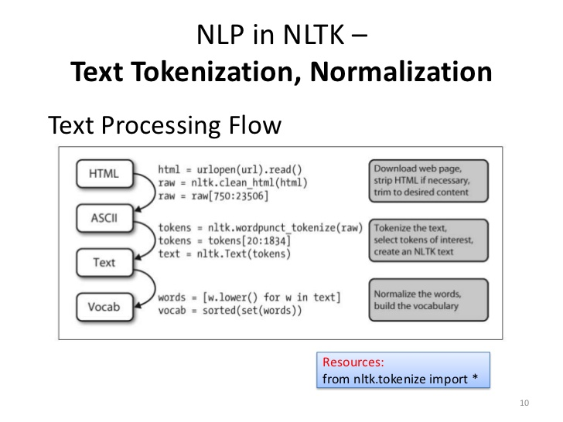

***CONCLUSION AND CHALLENGES:***

We have done a program to classify with multiple classifiers with varying accuracy to provide the solution of the question of classifying.

We faced many challenges from installing the softwares and packages to run the program though python was a new frontier understanding the data analysis was the tough part.

***References:***

We referred various websites and youtube videos,especially in pythonprogramming.net

And youtube channels like sentdex.