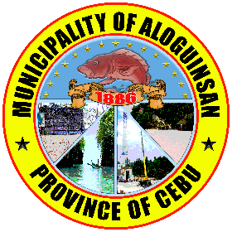Republic of the Philippines

Province of Cebu

**MUNICIPALITY OF ALOGUINSAN**

Municipal Hall Building

Poblacion, Aloguinsan, Cebu

**MUNICIPAL DISASTER RISK REDUCTION AND MANAGEMENT OFFICE**

September 5, 2025

**THE HONORABLE SANGGUNIANG BAYAN**

Municipality of Aloguinsan

Municipal Hall Building

Poblacion, Aloguinsan, Cebu

THRU: RAEL JUDE B. CAMORO

Secretary to the Sangguniang Bayan

Sirs/Madams;

Respectfully indorsed/forwarded to the Sangguniang Bayan for legislative action/measure:

A resolution approving the Local Disaster Risk Reduction and Management Financial and Investment Plan (LDRRMFIP) CY 2026.

Attached are the following:

* MDRRM Council Resolution
* LDRRMFIP CY 2026

Thanking in advance of your favorable consideration of the matter.

Very truly yours,

SHANE M. NAVARRO

MDRRMO