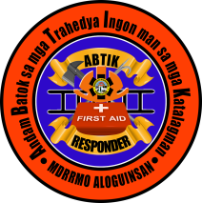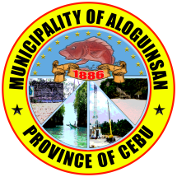Republic of the Philippines

Province of Cebu

Municipality of Aloguinsan

**ABTIK RESPONDER**

ID Number: ______________________________________________

Name: ______________________________________________

Address: ______________________________________________

Contact #: ______________________________________________

Email: ______________________________________________

Gender: ______________________________________________

Birthdate: ______________________________________________

Position: ______________________________________________

Qualifications: ______________________________________________

→ Soft copy of picture ←

**Additional Information for ABTIK ID**

TIN: ______________________________________________

BLOOD TYPE: ______________________________________________

PHILHEALTH: ______________________________________________

IN CASE OF EMERGENCY, PLEASE NOTIFY:

NAME: ______________________________________________

RELATION: ______________________________________________

ADDRESS: ______________________________________________

CONTACT #: ______________________________________________