1.

After deleteMin():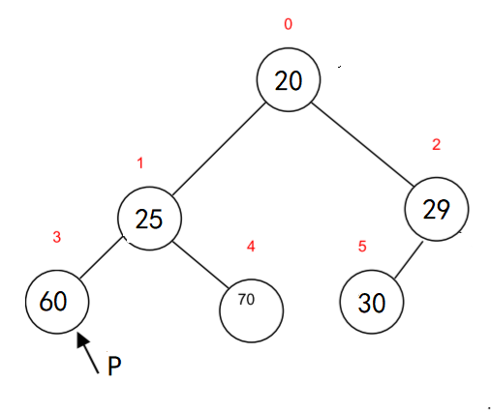

After insert(5):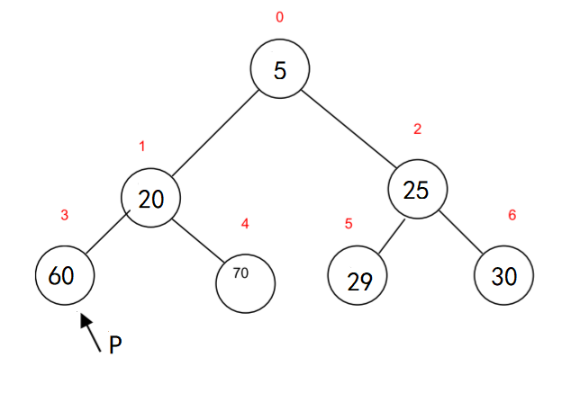

2.

a.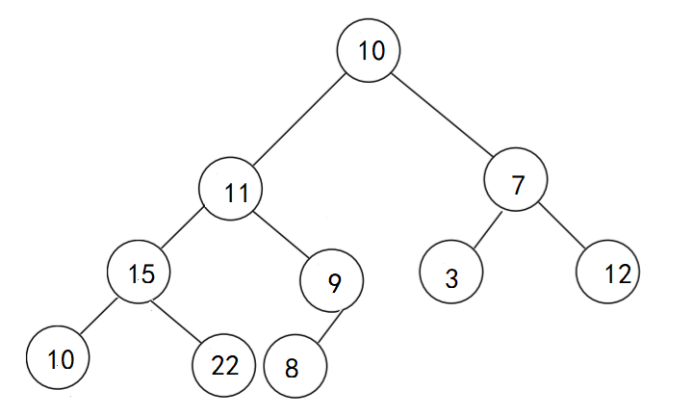

b. 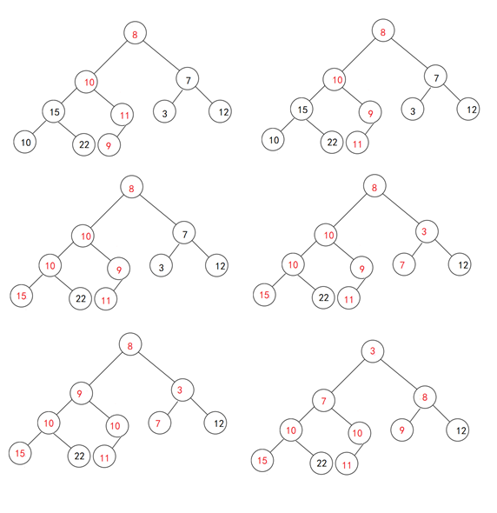

c. 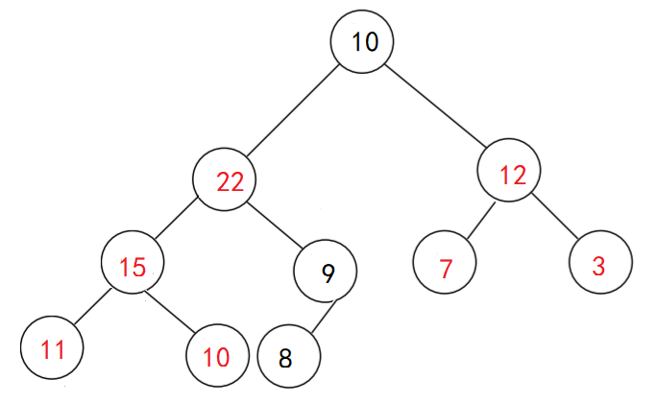

3.

|  |  |  |  |  |  |  |  |  |  |  |  |  |
| --- | --- | --- | --- | --- | --- | --- | --- | --- | --- | --- | --- | --- |
|  | Yi | A | M | C | Y | Y | M | A | M | C | M | Y |
| xi | 0 | 0 | 0 | 0 | 0 | 0 | 0 | 0 | 0 | 0 | 0 | 0 |
| A | 0 | ↖1 | ←1 | ←1 | ←1 | ←1 | ←1 | ↖1 | ←1 | ←1 | ←1 | ←1 |
| C | 0 | ↑1 | ↑1 | ↖2 | ←2 | ←2 | ←2 | ←2 | ←2 | ↖2 | ←2 | ←2 |
| C | 0 | ↑1 | ↑1 | ↖2 | ↑2 | ↑2 | ↑2 | ↑2 | ↑2 | ↖3 | ←3 | ←3 |
| Y | 0 | ↑1 | ↑1 | ↑2 | ↖3 | ↖3 | ←3 | ←3 | ←3 | ←3 | ←3 | ↖4 |
| M | 0 | ↑1 | ↖2 | ↑2 | ↑3 | ↑3 | ↖4 | ←4 | ↖4 | ←4 | ↖4 | ←4 |
| C | 0 | ↑1 | ↑2 | ↖3 | ↑3 | ↑3 | ↑4 | ↑4 | ↑4 | ↖5 | ←5 | ←5 |
| A | 0 | ↖1 | ↑2 | ↑3 | ↑3 | ↑3 | ↑4 | ↖5 | ←5 | ↑5 | ↑5 | ↑5 |
| C | 0 | ↑1 | ↑2 | ↖3 | ↑3 | ↑3 | ↑4 | ↑5 | ↑5 | ↖6 | ←6 | ←6 |

CAMYCA

4.

D0=

|  |  |  |  |  |
| --- | --- | --- | --- | --- |
| 0 | 2 | ∞ | 1 | 8 |
| 6 | 0 | 3 | 2 | ∞ |
| ∞ | ∞ | 0 | 4 | ∞ |
| ∞ | ∞ | 2 | 0 | 3 |
| 3 | ∞ | ∞ | ∞ | 0 |

D1=

|  |  |  |  |  |
| --- | --- | --- | --- | --- |
| 0 | 2 | ∞ | 1 | 8 |
| 6 | 0 | 3 | 2 | 14 |
| ∞ | ∞ | 0 | 4 | ∞ |
| ∞ | ∞ | 2 | 0 | 3 |
| 3 | 5 | ∞ | 4 | 0 |

D2=

|  |  |  |  |  |
| --- | --- | --- | --- | --- |
| 0 | 2 | 5 | 1 | 8 |
| 6 | 0 | 3 | 2 | 14 |
| ∞ | ∞ | 0 | 4 | ∞ |
| ∞ | ∞ | 2 | 0 | 3 |
| 3 | 5 | ∞ | 4 | 0 |

D3=

|  |  |  |  |  |
| --- | --- | --- | --- | --- |
| 0 | 2 | 5 | 1 | 8 |
| 6 | 0 | 3 | 2 | 14 |
| ∞ | ∞ | 0 | 4 | ∞ |
| ∞ | ∞ | 2 | 0 | 3 |
| 3 | 5 | ∞ | 4 | 0 |

D4=

|  |  |  |  |  |
| --- | --- | --- | --- | --- |
| 0 | 2 | 5 | 1 | 8 |
| 6 | 0 | 3 | 2 | 14 |
| ∞ | ∞ | 0 | 4 | 7 |
| ∞ | ∞ | 2 | 0 | 3 |
| 3 | 5 | ∞ | 4 | 0 |

D5=

|  |  |  |  |  |
| --- | --- | --- | --- | --- |
| 0 | 2 | 5 | 1 | 8 |
| 6 | 0 | 3 | 2 | 14 |
| ∞ | ∞ | 0 | 4 | 7 |
| 6 | ∞ | 2 | 0 | 3 |
| 3 | 5 | ∞ | 4 | 0 |

|  |  |  |  |  |
| --- | --- | --- | --- | --- |
| 0 | 0 | 2 | 0 | 0 |
| 0 | 0 | 0 | 0 | 1 |
| 0 | 0 | 0 | 0 | 4 |
| 5 | 0 | 0 | 0 | 0 |
| 0 | 1 | 0 | 1 | 0 |

P-table