Problem4

Set1

ε (Epsilon) Tolerance = 0.001

η (Eta) Stepsize= 0.05

theta

3.8155

4.5318

-1.8935

Set2

ε (Epsilon) = 0.002

η (Eta) Stepsize= 0.1

theta

3.8188

4.5267

-1.8945

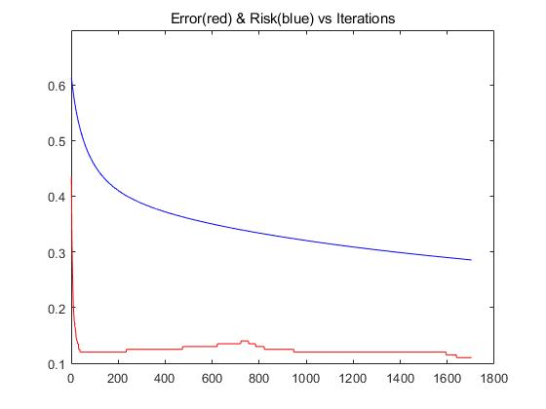

Set3

ε (Epsilon) = 0.002

η (Eta) Stepsize= 0.5

theta

20.8243

12.9276

-8.8045

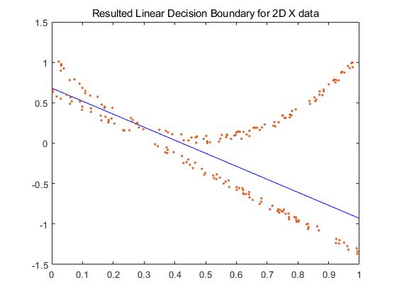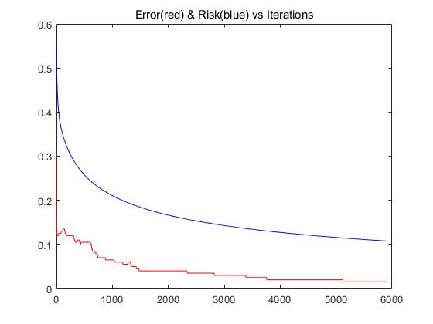

Set4

ε (Epsilon) = 0.001

η (Eta) Stepsize= 0.5

theta

33.2381

19.1403

-13.4841

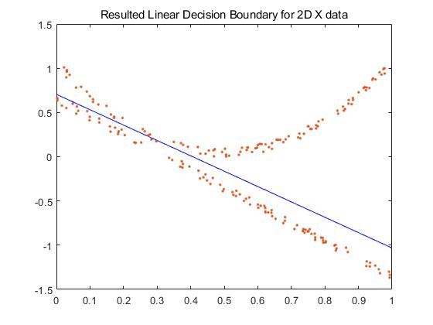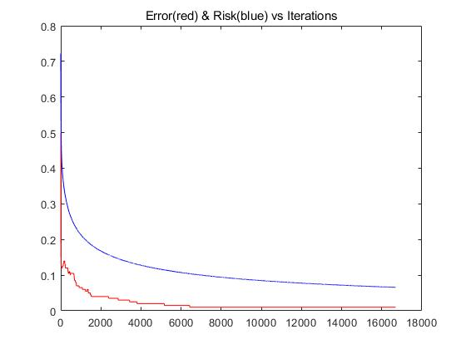

Set 5

ε (Epsilon) = 0.001

η (Eta) Stepsize=5

theta

101.6544

52.7610

-38.3417

