# Problem Set 3

## 1. Delay-Bandwidth Product for Links in Series

Consider three nodes in series. Node A is connected to node B via a 150 Mbps fiber optic link, 2500 km in length. Node B is connected to node C via a 1 Mbps link, 2 km in length. The links are full duplex. The rate of transmission errors on the links, the time to switch a packet at node B, and the time to transmit an ACK are all negligible. A large file is to be sent from node A to node C, and there is no other traffic on the links. Packets are 1.5 KB, including headers.

1. Ignoring reliability and packet headers, what is the maximum throughput that can be achieved (in Mbps)? Explain.

According to the P&D textbook 1.5, the speed of light in optical fiber is . Since the time to transmit of an ACK is negligible, I use the one-way latency here.

The transfer time of A to B is:

The transfer time of B to C is:

Thus, the total transfer time is

The maximum throughput can achieve is:

**The maximum throughput that can be achieved is 0.49 Mbps.**

1. What is the round trip time from A to C?

**Thus the round trip time from A to C is 0.02502 s**

1. What is the roundtrip bandwidth delay product for the path from A to C? (Specify the units you use).
2. Suppose an end-to-end sliding window protocol is used with SWS=RWS. What size of SWS is optimal?

Since the bottleneck of this path is 1 Mbps, the transmit time of this file is:

According to b, the one-trip-delay between A and C is 12.51 ms.

Then, the optimal window size is:

**Thus, the optimal size of SWS is 3.**

1. Why wouldn't you want SWS to be many times larger than the value you suggested in part d?

Since this protocol deliver 3 packet every RTT seconds, if the SWS value is much larger than 3, the overall delay will be too large, other connection might become idle and the resource is wasted.

## 2. Media Access Control

Suppose two nodes, A and B, are attached to opposite ends of a 450 m cable, and that they each have one frame of 500 bits (including all headers and preambles) to send to each other. Both nodes attempt to transmit at time t = 0. Suppose there are four repeaters between A and B, each inserting a 10-bit delay. Assume the transmission rate is 10 Mbps, and CSMA/CD with backoff intervals of multiples of 512 bits is used. After the first collision, A draws K = 0 and B draws K = 1 in the exponential backoff protocol. Ignore the jam signal.

1. What is the one-way propagation delay (including repeater delays) between A and B in seconds? Assume that the signal propagation speed is .

The speed-of-light propagation delay is:

Plus the overall repeater delays:

**The one-way propagation delay is .**

1. At what time (in seconds) is A’s packet completely delivered at B?

The time to transmit taken by the first collision is:

After the first collision, A resends the frame immediately because it choses K = 0, and takes

Plus two speed of light propagation delay

**At time , A’s packet completely delivered at B.**

1. Now suppose that only A has a packet to send and that the repeaters are replaced with bridges. Suppose that each bridge has a 10-bit processing delay in addition to a store-and-forward delay. At what time, in seconds, is A’s packet delivered at B?

If the store-and-forward bridges are used, the transmit delay of one link will be:

There are 5 links between A and B, thus, the transmit delay is .

Plus 4 processing delay,

And the speed-of-light propagation delay, .

At time , A’s packet is delivered at B.

## 3. Ethernet Timing

This problem is about the Ethernet/IEEE 802.11 access protocol. To be definite, suppose that if a host detects a transmission while it is transmitting a frame, then: (i) if the host has already transmitted the 64 bit preamble, the host stops transmitting the frame and sends a 32 bit jamming sequence; (ii) Else the host finishes transmitting the 64 bit preamble and then sends a 32 bit jamming sequence. For simplicity, assume a collision is detected as soon as an interfering signal first begins to reach a host. Suppose the packets are 512 bits long, which is the minimum length allowed. Hosts A and B are the only active hosts on a 10 Mbps Ethernet and the propagation time between them is 20 μS, or 200 bit durations. Suppose A begins transmitting a frame at time t = 0, and just before the beginning of the frame reaches B, B begins sending a frame, and then almost immediately B detects a collision.

1. Does A finish transmitting the frame before it detects that there was a collision? Explain.
2. What time does A finish sending a jamming signal? What time does B finish sending a jamming signal?
3. What time does A first hear an idle channel again? What time does B first hear an idle channel again?
4. Suppose each host next decides to retransmit immediately after hearing the channel idle. After the resulting (second) collision: When does A next hear the channel idle? When does B next hear the channel idle?
5. Suppose after the second collision, A decides to wait 512 bit durations to retransmit (if it hears silence after that long) and B decides to retransmit immediately after hearing a silent channel. Is the transmission of host B successful?
6. At the time A was planning to send its second retransmission, it senses a carrier present. Suppose at that particular time A decides to wait 3 x 51.2μs more until its next retransmission. What time does host A finish sending its packet?

## 4. Server Bandwidth

Consider a server with direct memory access (DMA) in and out of main memory. Assume the server's I/O bus speed is 800Mbps and the memory bandwidth is 920Mbps.

1. How many switched 1.5Mbps links could be supported by the server?
2. Suppose the server switching time is such that it can forward packets at the rate of 1500 packets per second. Determine the throughput as a function of the packet size.
3. At what packet size does the memory bandwidth become the limiting factor?

## 5. Switch Fabrics

Banyan and Batcher networks are two types of self-routing fabrics often used to construct large switches from simpler components. A single stage of a *n* ´ *n* Banyan network consists of *n*/2 switches of dimension 2 ´ 2. An *n* ´ *n* Batcher network can be made from two Batcher networks of size *n*/2 ´ *n*/2 plus a merge network with *n*/2 log2*n* switches.

1. For n = 64, how many stages are required to route packets from the inputs to the outputs of a Banyan Network?
2. How many 2 ´ 2 switches are required for the network in part a)?
3. Write down a recurrence relation T(n) for the number of switches in a Batcher network of size *n* ´ *n*.
4. Give the number of switches required for n = 32.

## 6. Spanning Tree Algorithm for Intelligent Bridges

Suppose the Perlman spanning tree algorithm and the bridge learning algorithm for forwarding are used for the network shown below.

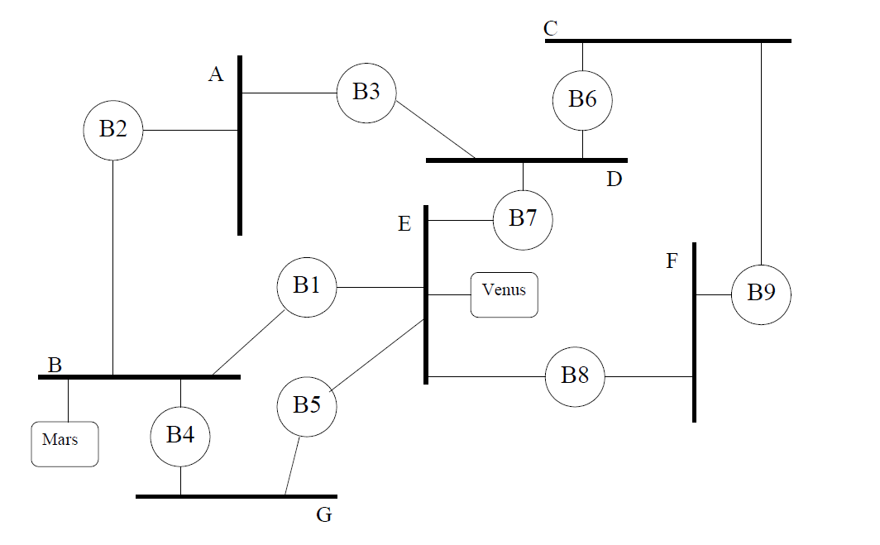

1. Indicate which bridge is root, which ports are root ports (i.e. the preferred port for reaching the root bridge), which bridge is the designated bridge for each LAN, and which ports are designated ports (i.e. the ports that connect some LAN to its given designated bridge). Hint: bridges that are not designated bridges for any LAN, and ports that are not either root ports or designated ports do not play a role in the routing of packets. The remaining bridges together with the LANs form a spanning tree.
2. Suppose after the configuration is complete, host Mars attaches to LAN B and host Venus attaches to LAN E. Suppose Mars sends a message to Venus, then Venus sends a message to Mars, then Mars sends a second message to Venus. For each of the three messages, indicate which LANs the message is heard on.