An Ontology-Based Knowledge Graph for Haikou-Centered Architectural Heritage: A Case Study of the Li Clan Ancestral Hall in Luoyi Village
Ontology-Based Heritage Knowledge Modeling and Web Evidence Validation
Zhiyuan Cheng*
College of Civil Engineering and Architecture, Hainan University, Haikou, 20223005212@hainanu.edu.cn
Abstract
Haikou’s architectural heritage is documented through survey drawings, photographs, local records, inscriptions, repair files, and web evidence, yet these materials are often fragmented and difficult to reuse across conservation tasks. This study develops an ontology-based knowledge graph workflow for Haikou-centered architectural heritage. The proposed Haikou Architectural Heritage Ontology combines top-down alignment with heritage-information standards and bottom-up extraction of case-specific concepts. Using the Li Clan Ancestral Hall in Luoyi Village as a validation case, the workflow integrates data governance, persistent identification, entity-relation modeling, Neo4j property-graph storage, and competency-question validation. The resulting graph links the building, spatial units, components, materials, construction and repair events, clan memory, cultural functions, documentary sources, and protection status. A web-evidence pilot further evaluates evidence fusion and text-image alignment: source-reliability and alias matching improve mean reciprocal rank from 0.8286 to 0.9000, while bilingual alias bridging raises Top-1 text-image accuracy from 0.7500 to 1.0000. The study provides a traceable and reusable framework for semantic retrieval, conservation interpretation, and future HBIM and cross-site knowledge integration.
CCS CONCEPTS
Artificial intelligence • Knowledge representation and reasoning • Ontology engineering
Keywords
Haikou architectural heritage; ontology-based knowledge graph; ontology engineering; data governance
- Introduction
Architectural heritage is a key carrier of regional history. In Haikou and northern Hainan, ancestral halls, Qilou streets, temples, and traditional dwellings preserve evidence of clan organization, migration, ritual practice, local materials, and tropical building adaptation. Existing digitization work has improved documentation through drawings, photographs, and three-dimensional survey, yet these records often remain isolated as files. Users can search for a name, but cannot easily ask which components belong to a hall, which repair events changed a facade, or which cultural functions are linked to a spatial unit. Similar limits of isolated digital records have also been emphasized in architectural conservation and built-heritage information studies, which argue that survey data must be transformed into semantically linked knowledge before they can support conservation decision-making [1,12].
Knowledge graphs address this limitation by representing heritage information as entities, attributes, and relations. Ontology design provides the schema layer that defines classes such as building, component, person, place, event, material, and cultural function. This study therefore constructs a compact ontology-based framework and verifies it with the Li Clan Ancestral Hall in Luoyi Village. The aim is to convert fragmented heritage records into structured knowledge that supports semantic retrieval, visualization, and future conservation services. In ontology engineering, this step follows the logic of making a shared conceptualization explicit and portable across applications, which remains a foundational principle for knowledge-graph construction [7].
Recent studies confirm that heritage knowledge modeling is moving from simple archival databases toward semantically enriched systems that can connect geometry, historical interpretation, conservation records, and user-oriented services. Research on Huizhou and Hakka architectural heritage shows that local building traditions require domain vocabularies that reflect craft, ritual, and settlement structure rather than only generic architectural categories [4,14,16]. This paper adopts the same problem awareness for Haikou-centered heritage and turns the Li Clan Ancestral Hall into a pilot graph that can later be extended to additional sites.

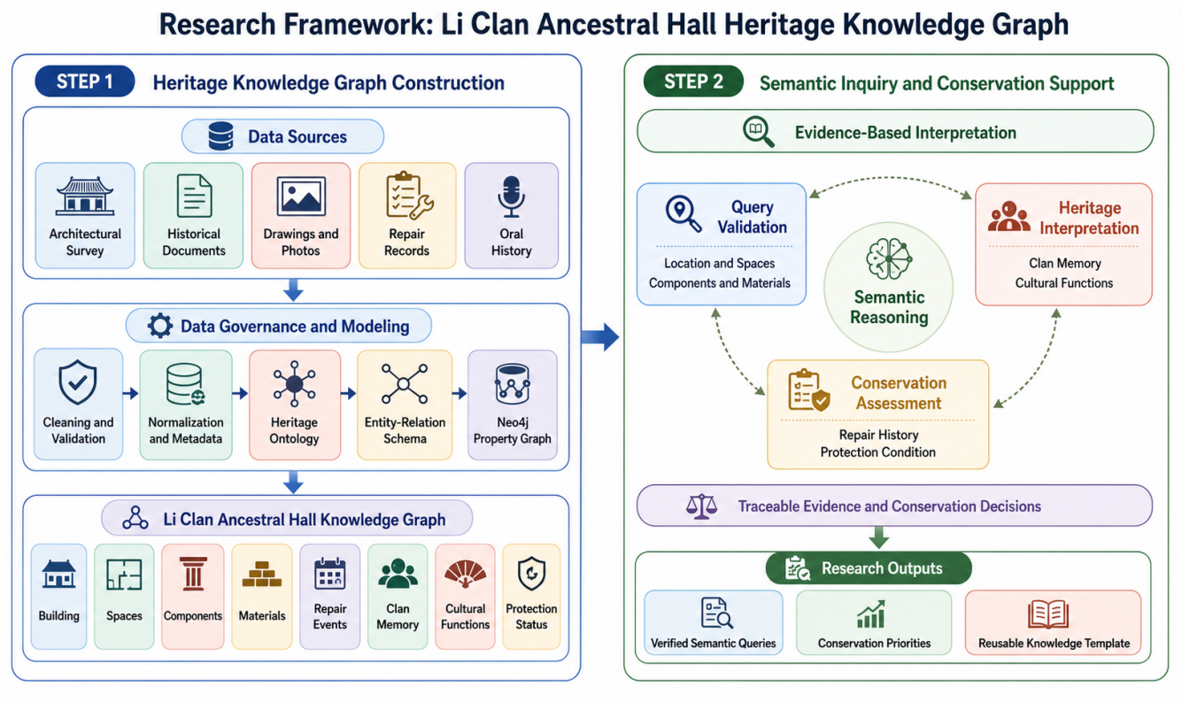
Figure 1: Framework of the methodology.
- Data and Method
The workflow begins with data governance. Spatial records, including plans, elevations, sections, detail drawings, model views, and field photographs, are standardized before graph construction. Spatial data should use a unified coordinate or project reference system, while dates are normalized to ISO-style records where possible. Each entity receives a persistent identifier, for example LYC:BUILD:0001 for the main building and LYC:COMP:COL-001 for a specific column. Source metadata record device, date, operator, accuracy, license, and provenance. This emphasis on provenance is consistent with recent interoperability research, which treats the traceability of data exchange as a prerequisite for reliable reuse across BIM, ontology, and common-data-environment workflows [10].
Data preprocessing has three streams. First, geometric data are segmented into spatial units such as front hall, courtyard, main hall, side wings, roof system, plinth, windows, plaques, and steps. Second, images and text-bearing objects are processed through image quality control, OCR where applicable, and manual verification. Third, materials and conditions are controlled by vocabularies, including wood, stone, tile, lime, crack, weathering, decay, repair trace, and missing part. Figures 3-8 show the main visual data types used in this process. Comparable HBIM studies also start by stabilizing survey and semantic inputs before higher-level modeling, because unstable source naming or inconsistent geometry quickly propagates through the entire conservation pipeline [6,8].
The method used here combines top-down and bottom-up operations. The top-down side references established cultural-heritage and semantic-web thinking, especially ontology clarity, class hierarchy, and cross-platform semantics. The bottom-up side extracts local concepts from the actual case, such as ancestral hall layout, plaque, decorative window, ridge tile, repair trace, clan worship, and commemorative relation. The value of this mixed strategy is that the model remains interoperable without erasing local architectural specificity, an issue also raised in broader HBIM and semantic heritage reviews [2,15].
After preprocessing, the case data are converted into a graph-ready package consisting of entity sheets, controlled vocabularies, image references, and source notes. Each assertion is intended to retain a backlink to evidence, whether a measured drawing, a field photo, an inscription, a local historical record, or a secondary study. This arrangement reduces the risk that the graph will become a visually impressive but weakly verifiable summary.
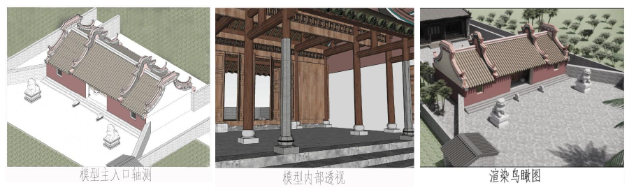
Figure 2: Internal and external model-based spatial data.
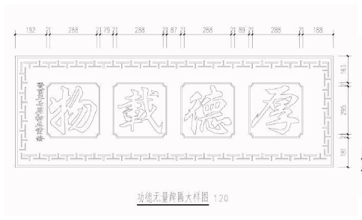  Figure 3: Plaque component instance. | 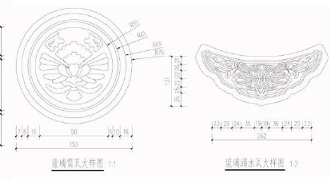  Figure 4: Cylindrical tile and drip-tile component instances.

- Ontology and Case Graph
The Haikou Architectural Heritage Ontology (HAHO) combines top-down reference to CIDOC-CRM and building information vocabularies with bottom-up concepts extracted from the Li Clan Ancestral Hall case. Core classes include ArchitecturalHeritage, Place, HistoricalPerson, ConstructionEvent, SpatialUnit, ArchitecturalComponent, MaterialCraft, and CulturalFunction. Object properties include locatedIn, consistsOf, hasBuilder, commemorates, renovatedIn, hasMaterial, hasFunction, protectedAs, and documentedBy. Data properties include preferred name, alternative name, construction period, area, orientation, structure, current condition, source, and confidence level. The overall schema follows the long-standing view that ontology should capture both stable conceptual structure and extensible relations so that additional heritage cases can be added without redesigning the entire model [7,11].
In the case graph, the Li Clan Ancestral Hall is modeled as an instance of AncestralHall. It is located in Luoyi Village, Chengmai County, Hainan Province; built in the Ming dynasty; expanded during the Qing Qianlong period; repaired during the Qing Guangxu period and in 2008; and designated as a Hainan provincial cultural relic protection unit in 2009. The building has a five-bay, two-entry courtyard layout, faces south, and uses a stone-and-wood structure. Its functions include ancestral worship and clan deliberation. The instance layer therefore links architectural form, chronology, repair history, social memory, and protection designation in one queryable graph rather than in disconnected narrative notes.
At the implementation level, ontology classes are not treated as abstract labels only. They serve as containers for graph population, query constraints, and future interoperability with HBIM models and semantic repositories. This design direction is consistent with recent work that connects ontological models with information management tools for cultural heritage conservation and semantic sharing [1,5,10].
The summary table and Figures 8 illustrate a compact but operational modeling sequence: define classes, define properties, bind local case terms to those classes, and then instantiate the case graph with evidence-backed triples. This sequence is especially important for regional heritage because it prevents local knowledge from being flattened into generic labels that lose architectural or ritual nuance.
Table 1: Core ontology classes and case examples.
Class | Meaning | Case example
ArchitecturalHeritage | Historic building or complex | Li Clan Ancestral Hall
Place | Geographic or administrative location | Luoyi Village; Hainan Province
ConstructionEvent | Building, expansion, repair, or designation event | Ming construction; 2008 repair
ArchitecturalComponent | Physical part or detail | Column; roof tile; plaque; decorative window
CulturalFunction | Social or ritual use | Ancestral worship; clan deliberation
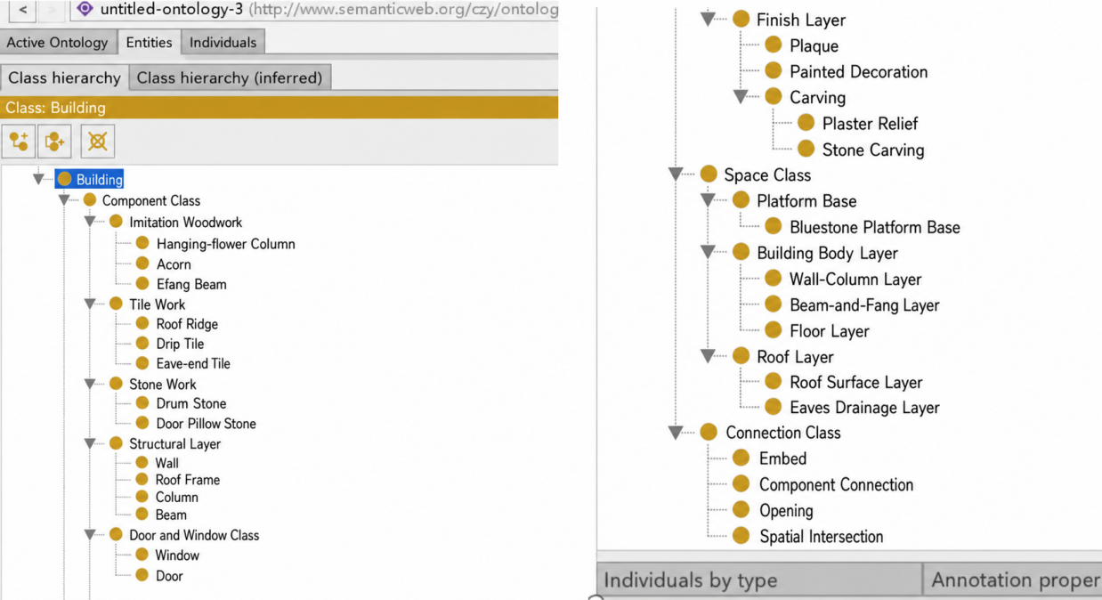
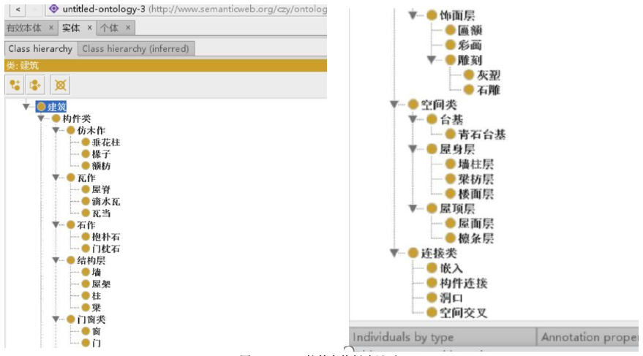
Figure 5: Protégé class-creation interface.
- Results and Discussion
The pilot graph makes implicit relations explicit. It connects the building with its village, clan actors, construction and repair events, protection status, spatial units, components, materials, and documentary sources. A user can move from a component to its material and condition, from a repair event to affected parts, or from a cultural function to the spatial units that support it. This is more useful than keyword retrieval because it supports semantic paths rather than isolated document matches. This shift from file retrieval to relation retrieval is also central to ontology-based platform studies in the wider cultural-heritage field [3].
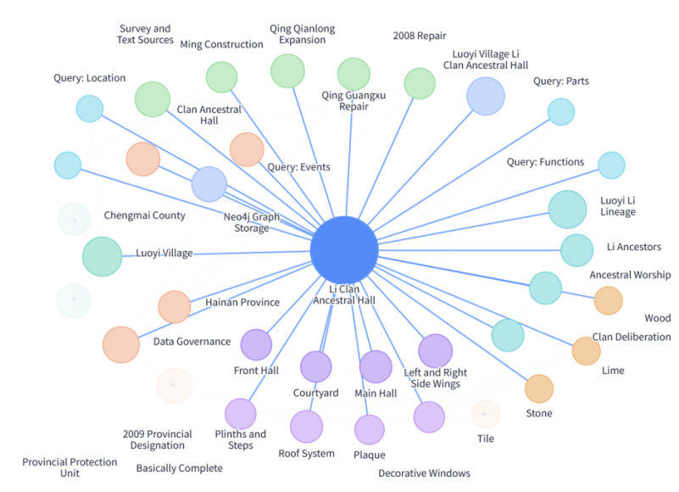
Figure 5: The constructed knowledge graph.
The model also improves reuse. By mapping local concepts to CIDOC-CRM-compatible classes and preserving source provenance, the graph can later connect with HBIM, linked data, intelligent question answering, public interpretation, and tourism recommendation. The current limitation is that the case is still small, some historical facts require further archival verification, and several source figures retain Chinese annotations that should be redrawn in English for strict international submission. Similar limitations appear in many heritage-semantic workflows: detailed local meaning is easier to preserve than complete interoperability, so each extension step must balance specificity and cross-platform compatibility [10,12].
Validation is organized around competency questions rather than only visual inspection. The graph should answer where the heritage building is located, which events are associated with it, which spatial units and components compose it, which materials are used, which sources document a component, and which cultural functions are represented by the building. These questions test whether the ontology supports actual research and conservation tasks. The same logic of competency-question validation is valuable for preventing semantic overdesign, because a graph is useful only if it can answer concrete heritage questions better than a folder of disconnected files.
For practice, the compact graph can support three application directions. Conservation managers can trace components, conditions, repair records, and documentation sources. Researchers can compare layout, craft, material, and clan-memory patterns across sites once more Haikou heritage buildings are added. Public-facing systems can use the graph for guided interpretation, question answering, and digital humanities education. These directions align with current HBIM and semantically enriched conservation research, which is increasingly oriented toward lifecycle management, risk awareness, and public communication rather than static record storage alone [9,13].
A further implication is comparative scalability. Once multiple ancestral halls, traditional dwellings, or Qilou buildings are added to the same ontology, the graph can support cross-site analysis of layout types, component usage, material deterioration, and cultural functions. This kind of expansion is essential if Haikou-centered heritage research is to move from single-case description to regional knowledge discovery.
- System Implementation and Semantic Validation
The implementation layer transforms entity sheets into nodes, relation sheets into typed edges, and source registers into evidence records. Indexes on persistent identifiers and preferred names support retrieval, while aliases are preserved to resolve spelling, transliteration, and bilingual variation. This property-graph implementation can later interoperate with HBIM, linked data, question answering, and conservation-management services [7-10].
Validation is defined through competency questions. The graph must answer where the building is located, which spaces and components compose it, which materials are used, which repair events affected a part, which source documents an assertion, and which cultural functions are associated with the hall. Each successful answer must return an entity path together with its available evidence link. This makes semantic-query validation a test of traceability and research usefulness rather than a visual inspection exercise.
S(q,e) = alpha L(q,e) + beta A(q,e) + gamma R(e), where alpha + beta + gamma = 1.
For web evidence, candidate snippets are ranked with a transparent composite score. L represents lexical similarity, A represents alias agreement, and R represents source reliability. The formulation supports evidence inspection: a trusted source or confirmed bilingual alias can raise a candidate's rank without concealing the underlying lexical match.
- Results, Pilot Experiment, and Data Analysis
The populated graph exposes paths that are difficult to recover from disconnected files. A user can navigate from a component to its material and condition, from a repair event to affected parts, or from a cultural function to supporting spatial units. This supports conservation management, comparative research, public interpretation, and future regional expansion. The same data model can scale to additional ancestral halls, traditional dwellings, and Qilou buildings while preserving local semantics [11,12].
The web-evidence pilot draws on public descriptions of the hall from a local government release, a mainstream-media photo caption, and an official historical-cultural article [13]. Two tasks are evaluated: evidence fusion ranks snippets that support a target fact, and text-image alignment matches a query to a caption or figure description. Top-1 accuracy measures whether the highest-ranked candidate is correct; mean reciprocal rank (MRR) measures the position of the first correct candidate. The pilot is a proof of method rather than a claim of large-scale generalization.
Table 3: Pilot results for the integrated semantic-evidence method.
Task | Metric | Lexical Baseline | Integrated Method | Finding
Evidence fusion | Top-1 support accuracy | 0.8000 | 0.8000 | First-result accuracy retained
Evidence fusion | MRR | 0.8286 | 0.9000 | More stable evidence ranking
Text-image alignment | Top-1 accuracy | 0.7500 | 1.0000 | Alias bridge resolves mismatch
Text-image alignment | MRR | 0.8750 | 1.0000 | Correct caption ranked first
The data analysis identifies two effects. Adding aliases and source-reliability information leaves evidence-fusion Top-1 accuracy unchanged but improves MRR from 0.8286 to 0.9000, indicating more consistent ranking of supporting evidence. Bilingual alias bridging raises both text-image metrics to 1.0000 in the pilot. These results demonstrate the value of provenance-aware data preparation, but the limited source set remains a clear limitation.
- Discussion and Conclusion
This paper presents an ontology-based knowledge graph workflow for Haikou-centered architectural heritage and demonstrates it through the Li Clan Ancestral Hall in Luoyi Village. The workflow integrates data governance, identifier design, ontology modeling, entity extraction, graph storage, and semantic validation. The pilot case shows that a knowledge graph can transform scattered survey and documentary records into structured, queryable, and reusable heritage knowledge. Future work should expand the graph to more Haikou heritage sites, refine local vocabularies, redraw all figures in English, and integrate point-cloud, HBIM, and linked-data resources. In this sense, the present compact manuscript is not only a case report but also a small-scale method statement for semantically organizing regional architectural heritage.
Integrating the research data method into the case-study paper changes the contribution from a descriptive graph to an auditable information system. The resulting framework explicitly joins data governance, ontology modeling, graph implementation, and semantic validation. It allows conservation stakeholders to inspect evidence chains while giving researchers a reusable model for cross-site comparison.
The current graph remains a single-case prototype, and some historical facts require further archival verification. Future work should extend the ontology to more Haikou sites, add point-cloud and HBIM data, strengthen condition observations, and test the evidence service with a larger benchmark. Within these limits, the Li Clan Ancestral Hall case demonstrates how carefully governed data can become structured, queryable, and conservation-relevant heritage knowledge.
The approach is compatible with current research trajectories in architectural conservation, including semantic interoperability, HBIM enrichment, and evidence-centered digital preservation [5,6]. Its practical value lies in making local heritage knowledge easier to preserve, query, compare, and communicate without losing the particularity of the Li Clan Ancestral Hall case.
REFERENCES
- Acierno, M., Cursi, S., Simeone, D., & Fiorani, D. (2017). Architectural heritage knowledge modelling: An ontology-based framework for conservation process. Journal of Cultural Heritage, 24, 124-133. https://doi.org/10.1016/j.culher.2016.09.010
- Avila, F., Blanca-Hoyos, A., Puertas, E., & Gallego, R. (2024). HBIM: Background, current trends, and future prospects. Applied Sciences, 14(23), 11191. https://doi.org/10.3390/app142311191
- Casillo, M., De Santo, M., Mosca, R., Santaniello, D., et al. (2023). Sharing the knowledge: Exploring cultural heritage through an ontology-based platform. Journal of Ambient Intelligence and Humanized Computing, 14, 12317-12327. https://doi.org/10.1007/s12652-023-04652-3
- Chen, Y. (2023). Construction of a Huizhou architecture repair question-answering system based on knowledge graph [Master's thesis, Anhui Jianzhu University]. https://doi.org/10.27784/d.cnki.gahjz.2023.000548
- Dammag, B. Q. D., Jian, D., Dammag, A. Q., Alshawabkeh, Y., Almutery, S., Habibullah, A., & Baik, A. (2025). Modeling ontology-based decay analysis and HBIM for the conservation of architectural heritage: The Big Gate and adjacent curtain walls in Ibb, Yemen. Buildings, 15(15), 2795. https://doi.org/10.3390/buildings15152795
- Giuliani, F., Gaglio, F., Martino, M., & De Falco, A. (2024). A HBIM pipeline for the conservation of large-scale architectural heritage: The city walls of Pisa. Heritage Science, 12, Article 35. https://doi.org/10.1186/s40494-024-01141-4
- Gruber, T. R. (1993). A translation approach to portable ontology specifications. Knowledge Acquisition, 5(2), 199-220. https://doi.org/10.1006/knac.1993.1008
- Hamed, W., & El Antably, A. (2023). Knowledge-based HBIM for conservation: The case of Yahya al-Shabih Mausoleum. Digital Applications in Archaeology and Cultural Heritage, 30, e00278. https://doi.org/10.1016/j.daach.2023.e00278
- Hussein, K. A., Abrahim, A. R., Mohammed, A. S., & Ali, K. A. (2024). Digital preservation of heritage urban facades: An integrated approach using historic building information modeling and shape grammar analysis. Digital Applications in Archaeology and Cultural Heritage, 35, e00383. https://doi.org/10.1016/j.daach.2024.e00383
- Moyano, J., Pili, A., Nieto-Julian, J. E., Della Torre, S., & Bruno, S. (2023). Semantic interoperability for cultural heritage conservation: Workflow from ontologies to a tool for managing and sharing data. Journal of Building Engineering, 80, 107965. https://doi.org/10.1016/j.jobe.2023.107965
- Noardo, F. (2016). Architectural heritage ontology: Concepts and some practical issues. In Proceedings of the 2nd International Conference on Geographical Information Systems Theory, Applications and Management (pp. 168-179). SCITEPRESS. https://doi.org/10.5220/0005830901680179
- Noor, S., Shah, L., Adil, M., Gohar, N., Saman, G. E., Jamil, S., Baker, T., Dustdar, S., Suarez-Figueroa, M. C., & Qayum, F. (2019). Modeling and representation of built cultural heritage data using semantic web technologies and building information model. Computational and Mathematical Organization Theory, 25, 247-270. https://doi.org/10.1007/s10588-018-09285-y
- Parrinello, S., & Pettineo, A. (2025). Databases and information models for semantic and evolutionary analysis in fortified cultural heritage. Heritage, 8(1), 29. https://doi.org/10.3390/heritage8010029
- Peng, H., Chen, Y., & Lei, J. (2025). Construction of an ontology model for Hakka residential architectural cultural heritage: A case study of Ganzhou City. Journal of Jiangxi University of Science and Technology, 46(2), 98-106. https://doi.org/10.13265/j.cnki.jxlgdxxb.2025.02.012
- Wang, J., & Li, L. (2025). Visual analysis of BIM research at home and abroad based on knowledge graph. Urban Mass Transit, 28(1), 159-163. https://doi.org/10.16037/j.1007-869x.2025.01.029
- Yang, C. (2021). Research on the construction of an ontology-based Huizhou architecture knowledge graph [Master's thesis, Anhui Jianzhu University]. https://doi.org/10.27784/d.cnki.gahjz.2021.000155
- Chengmai County Media Center. (2024). Millennium-old Luoyi Village (mentions Li Clan Ancestral Hall as a provincial cultural relic protection unit) [Online]. https://chengmai.hainan.gov.cn/chengmai/bmgz/202405/eb8e13be16344c068adf5ca20d892e76.shtml
- People's Daily Online (Hainan). (2022). Luoyi Village in Chengmai: integrating agriculture and tourism (includes photo caption of Li Clan Ancestral Hall) [Online]. http://hi.people.com.cn/n2/2022/0716/c231190-40041041.html
- Hainan Daily (republished by Hainan Government). (2010). The story of Luoyi Village (describes Li Clan Ancestral Hall layout, orientation, and floor area) [Online]. https://en.hainan.gov.cn/hainan/lsyg/201007/4e6d9282e546418c9c186ec48290950a.shtml

* Zhiyuan Cheng,College of Civil Engineering and Architecture, Hainan University, Haikou, 20223005212@hainanu.edu.cn

