Here write your title
author_1^{*,1,✉}, author_2^{*,1,3}, and author_3²
* These authors contributed equally to this work.
¹ Department 1, Institution 1, City 1, Country 1
² Department 2, Institution 2, City 2, Country 2
³ Current address: Department 3, Institution 3, City 3, Country 3
✉ Correspondence: author_1 <author_1@example.com>

Abstract
Write your abstract here.
Keywords: keyword_1; keyword_2; keyword_3

Highlights
- Write highlight 1 here.
- Write highlight 2 here.
- Write highlight 3 here.

1. Introduction
Write your introduction here.
Use parenthetical citations such as (Chen et al., 2024), narrative citations such as Ma, Crespo Tapia, et al. (2024), and multiple citations such as (Ma, Crespo Tapia, et al., 2024; Ma, Tempelaars, et al., 2024; Ren et al., 2025). Replace these example citations with sources relevant to your manuscript.

2. Materials and Methods
Describe the materials and analysis methods here.

2.1 Method subsection 1
Write the first method subsection here.
A table can be included with Markdown style (Table 1).
Table 1: Example static table.
Group | Sample size | Mean value
control | 3 | 10.2
treatment | 3 | 12.8

A table generated from R can also be included, such as Table 2.
Table 2: Example table generated from R.
group | sample_size | mean_value
control | 3 | 10.2
treatment | 3 | 12.8

A table generated from Python can also be included, such as Table 3.
Table 3: Example table generated from Python.
group | sample_size | mean_value
control | 3 | 10.2
treatment | 3 | 12.8

An appendix table and figure can be referenced as Table A.1 and Figure A.1.

2.2 Method subsection 2
Write the second method subsection here.
Refer to another section with syntax such as Section 1 and Section 2.2 when needed.

3. Results
Report the results here.

3.1 Result subsection 1
Write the first result subsection here.
A figure can be included from an image file (Figure 1).
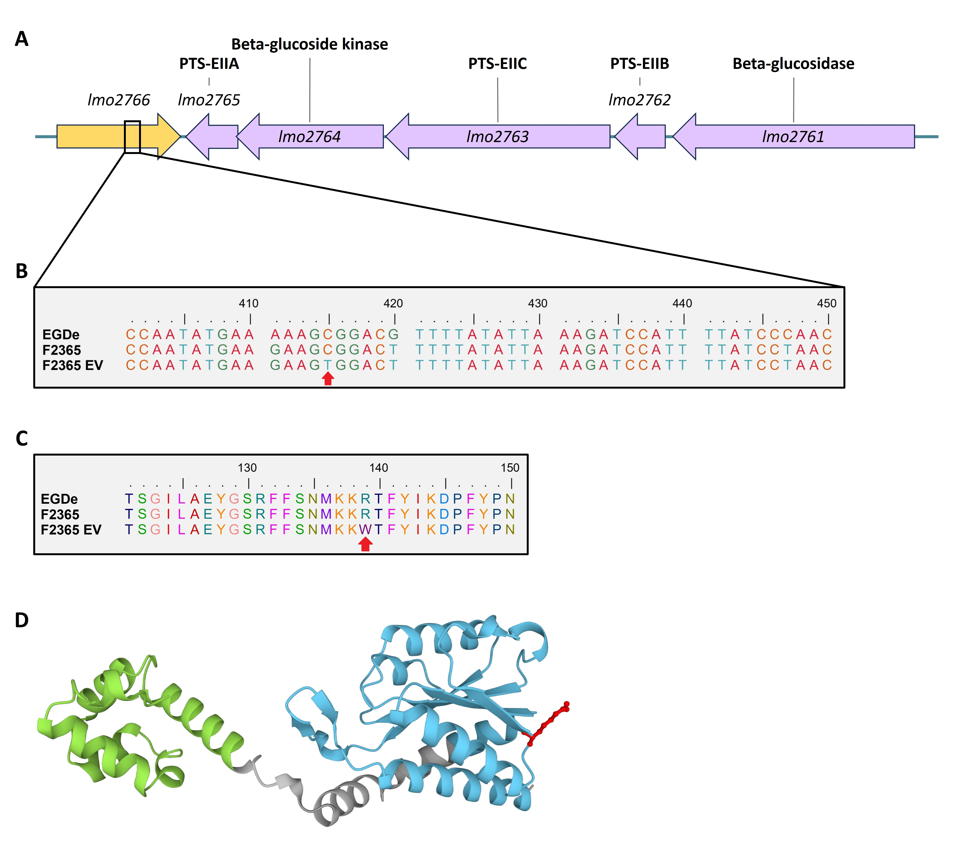
Figure 1: Example figure included from an image file.
Figures can be generated with R or Python, and it is recommended to save the figures in advance and use eval: false to reduce rendering time.
A figure generated from R (Figure 2).
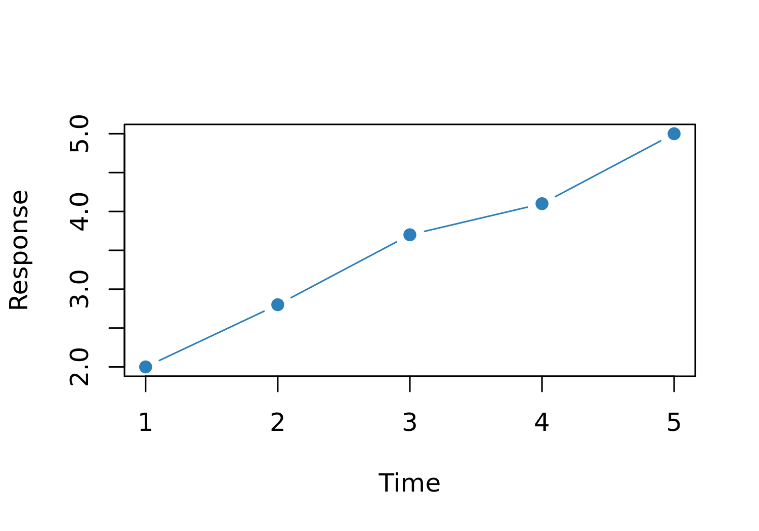
Figure 2: Example figure generated from R and saved at 300 dpi.
A figure generated from Python (Figure 3).
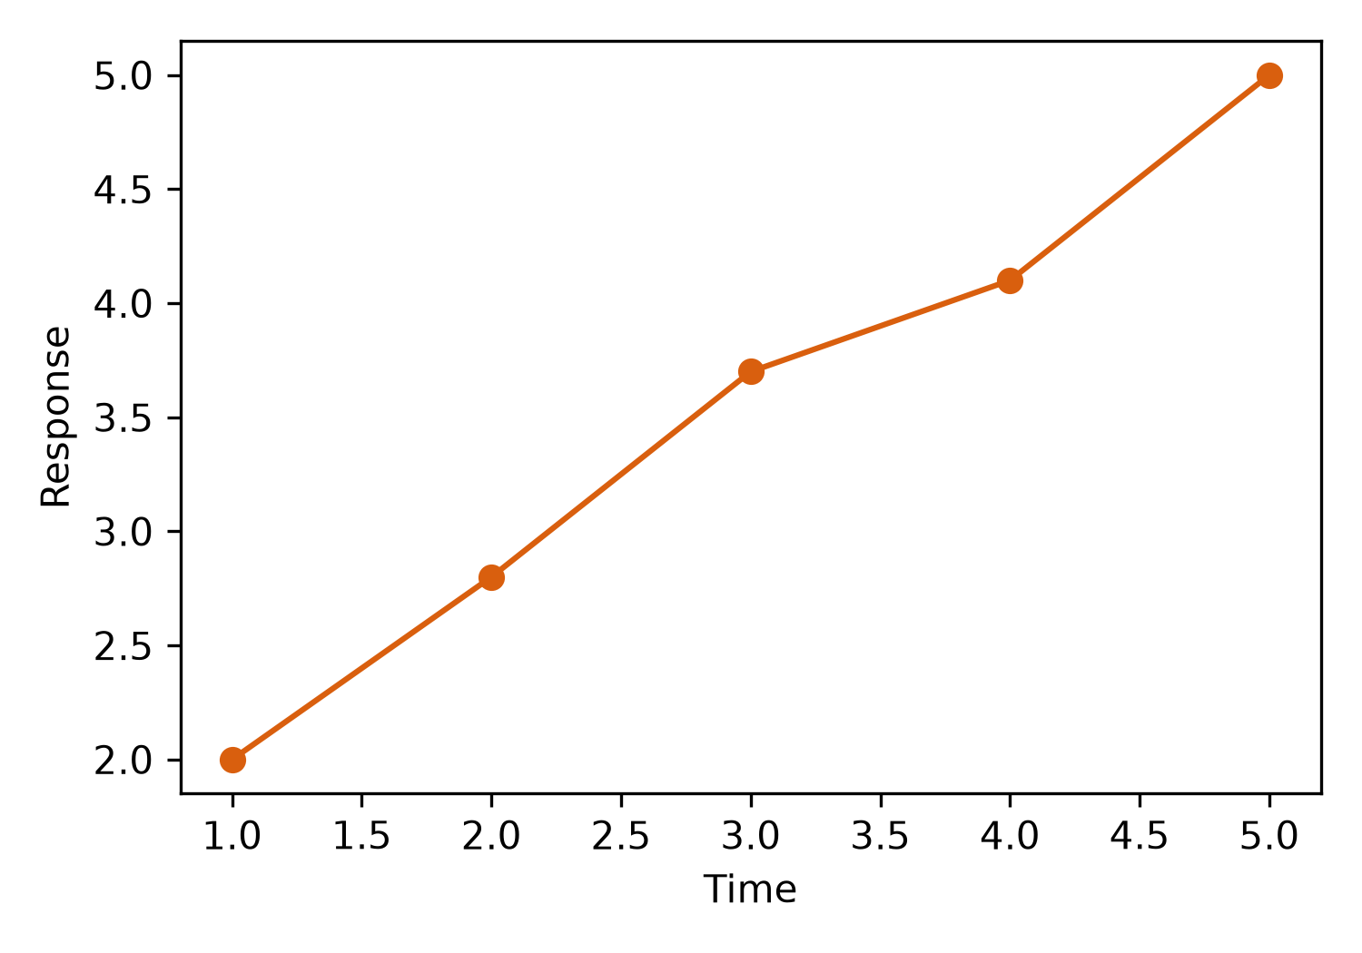
Figure 3: Example figure generated from Python and saved at 300 dpi.

3.2 Result subsection 2
Inline code can be used to express analysis results directly in the text.
A simple inline R calculation is 1 + 2 = 3.
For a more complex calculation, values can first be prepared in a hidden R code chunk.
The mean of 4 values calculated with R is 11.8.
Python calculations can also be prepared in a hidden chunk and inserted with an inline R expression through reticulate.
The mean of 4 values calculated with Python is 11.8.
Inline expressions can also reuse complex text, reducing typing effort and the chance of errors.
For example, L. monocytogenes and EGDe lacR^{887del} lmo2766^{C415T} can be defined once and used consistently throughout the manuscript.

4. Discussion
Interpret the findings here.

5. Conclusions
Write the main conclusions here.

Author Contributions
Describe each author’s contributions here using the contribution terminology required by the target journal.

Declaration of Competing Interest
Write the competing-interest declaration required by the target journal here.

Data Availability
State where the supporting data can be accessed here.

Acknowledgments
Write acknowledgments and funding information here.

Declaration of Generative AI and AI-Assisted Technologies
If required by the target journal, describe any use of generative AI or AI-assisted technologies during manuscript preparation.

References
Chen, J., Ma, X., He, J., Wang, Y., Ren, Y., Qi, L., Song, L., Ruan, L., Fan, C., Jiang, J., Bao, Y., Huang, T., Cheng, J., Liu, X., Chen, F., Huang, Y., Zhao, N., & Guo, C. (2024, June 17). Intra-genomic genes-to-genes correlation enables genome representaion. https://doi.org/10.1101/2024.06.12.598634 (Pre-published)
Ma, X., Crespo Tapia, N., Koomen, J., van Mastrigt, O., Zwietering, M. H., Den Besten, H. M. W., & Abee, T. (2024). Activation of a silent lactose utilization pathway in an evolved Listeria monocytogenes F2365 outbreak isolate. Food Res. Int., 189, 114554. https://doi.org/10.1016/j.foodres.2024.114554
Ma, X., Tempelaars, M. H., Zwietering, M. H., Boeren, S., O’Byrne, C. P., den Besten, H. M. W., & Abee, T. (2024). A single point mutation in the Listeria Monocytogenes ribosomal gene rpsU enables SigB activation independently of the stressosome and the anti-sigma factor antagonist RsbV. Front. Microbiol., 15. https://doi.org/10.3389/fmicb.2024.1304325
Ren, Q., Ma, X., Boeren, S., Keijzer, P., Wichers, H. J., & Hettinga, K. A. (2025). Effects of dry heating on the cleavage of casein and whey protein into peptides under simulated infant digestion. Food Chem., 468, 142397. https://doi.org/10.1016/j.foodchem.2024.142397

6. Appendices
Write appendix content here.
Table A.1: Example appendix table caption.
Item | Description
variable_1 | Describe variable 1 here
variable_2 | Describe variable 2 here


Figure A.1: Example appendix figure caption.

