Long-run return distributions of US-listed stocks
CRSP monthly, 31,565 common stocks, Dec 1925 – Dec 2025
Calendar-window methodology: every 10-year and 30-year window analyzed on its own cohort

TL;DR
- The share of stocks with a positive return is deeply period-dependent. Across the ten non-overlapping decades since 1925, % positive (nominal) ranges from 40.7 % (1925-1935) to 89.0 % (1955-1965).
- In real (CPI-adjusted) terms, the worst decade is 1965-1975 — just 38.0 % of stocks produced a positive real return as stagflation eroded nominal gains.
- The market return and the share of individual stocks beating it diverge sharply in mega-cap-concentrated bull decades: 1985-1995 (15.4 %), 2015-2025 (16.2 %).
- Over 30-year windows, 56.1 % – 88.2 % of stocks produced a positive nominal return. The share fell from 88.2 % in 1955-1985 to 56.1 % in 1985-2015.
- Over each stock's entire listed life (Q3), only 48.1 % produced a positive nominal return and 41.3 % produced a positive real return.

1. Data & universe
Source: CRSP Monthly Stock File (data/data.csv, 5,307,138 rows, 40,499 raw PERMNOs). CPI-U All Urban Consumers, not seasonally adjusted (BLS monthly, 1925-2025), cached at data/cpi.csv. Full-span cumulative inflation 1.0 — correction: 18.1× (2.94 % / yr).
Universe: SecurityType == 'EQTY' AND IssuerType != 'REIT' — 31,565 common stocks (22,623 CORP + 8,867 ACOR including 1,377 ADRs). Excludes closed-end funds & ETFs (classified as 'FUND' in CRSP), derivatives ('DERV'), and REITs.
Span: 1925-12 – 2025-12 (1,201 months).

2. Methodology — calendar-aligned windows
Per CLAUDE.md the analysis must be survivorship-bias-free: every stock that ever listed is retained, with delisting handled by terminating the return stream at the delisting month (CRSP embeds the delisting return in MthRet when MthRetFlg == 'DE').
For each calendar window (T, T+N]:
- Cohort = every common stock with a row at month T (listed at end of month T). Stocks that IPO after T are not in this window's cohort.
- Window return = ∏(1 + MthRet) − 1 compounded over months strictly after T and up to T+N, truncated at the stock's last listed month.
- Partial windows (stock delists during the window) are kept, not dropped.
Windows used:
Horizon | Windows | Months each
10-year | 1925-12 → 1935-12, 1935-12 → 1945-12, …, 2015-12 → 2025-12 (10 decades) | 120
30-year | 1925-12 → 1955-12, 1955-12 → 1985-12, 1985-12 → 2015-12 (3 eras) | 360
Full-life | per-stock: first listed month → last listed month | variable

Real returns: monthly real return (1 + MthRet) / (1 + π) − 1, where π = CPI_t / CPI_{t-1} − 1, then compounded the same way as nominal.
Benchmark:
- CRSP value-weighted total return (vwretd) — with dividends; apples-to-apples with MthRet.
- S&P 500 price index (sprtrn) — no dividends; reported for reference.
- Both are compounded over the same calendar months as the window. '% beating market' = share of the cohort whose nominal return exceeded the benchmark.

3. Q1 — 10-year calendar windows

Share of stocks positive, and % beating market, decade by decade
Decade | N | % positive nominal | % positive real | Market return (vwretd) | % beating market
1925-1935 | 508 | 40.7 % | 48.8 % | +48 % | 28.1 %
1935-1945 | 717 | 87.6 % | 83.8 % | +137 % | 50.5 %
1945-1955 | 852 | 88.5 % | 78.9 % | +302 % | 29.2 %
1955-1965 | 1,050 | 89.0 % | 85.8 % | +194 % | 41.0 %
1965-1975 | 2,168 | 59.3 % | 38.0 % | +31 % | 42.7 %
1975-1985 | 5,073 | 87.8 % | 79.7 % | +326 % | 47.4 %
1985-1995 | 6,298 | 57.5 % | 52.1 % | +265 % | 15.4 %
1995-2005 | 7,835 | 60.8 % | 56.9 % | +144 % | 27.6 %
2005-2015 | 5,830 | 55.5 % | 50.7 % | +93 % | 25.0 %
2015-2025 | 4,836 | 62.2 % | 56.8 % | +252 % | 16.2 %

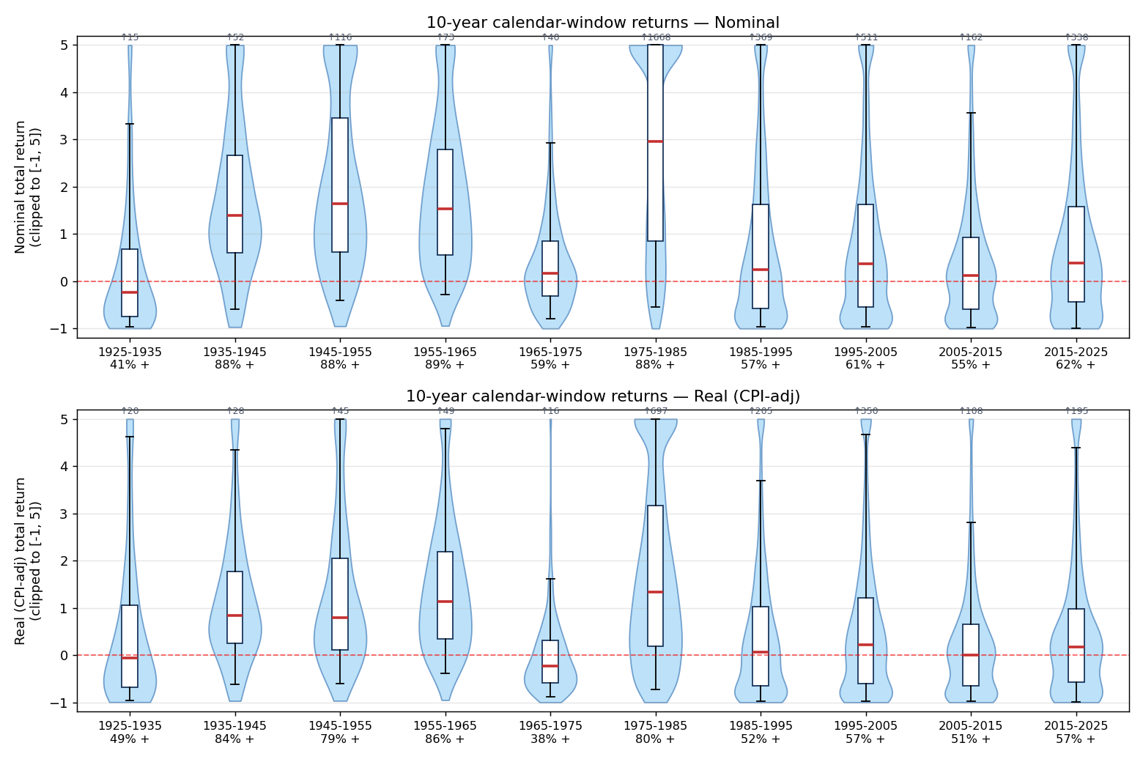
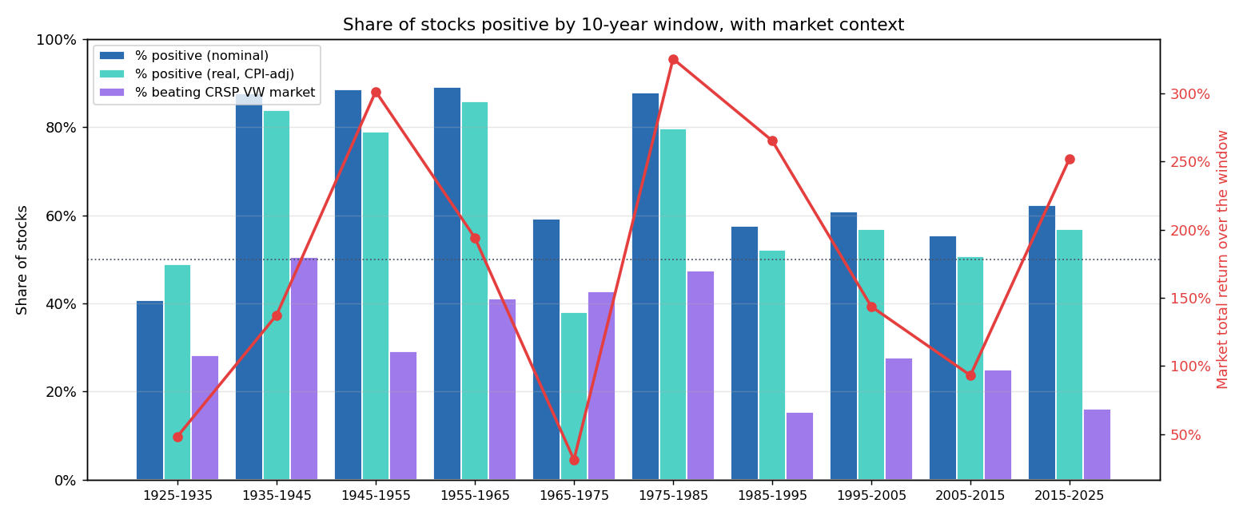

Medians and percentiles
Decade | Basis | p5 | p25 | Median | p75 | p95
1925-1935 | Nominal | -96.8 % | -75.4 % | -23.9 % | +68.7 % | +334.0 %
1925-1935 | Real | -95.8 % | -68.5 % | -6.6 % | +104.8 % | +463.0 %
1935-1945 | Nominal | -58.9 % | +60.7 % | +140.1 % | +266.2 % | +596.4 %
1935-1945 | Real | -62.4 % | +25.1 % | +83.8 % | +177.7 % | +439.8 %
1945-1955 | Nominal | -41.2 % | +62.4 % | +164.9 % | +345.5 % | +790.7 %
1945-1955 | Real | -60.0 % | +10.5 % | +79.9 % | +204.6 % | +504.9 %
1955-1965 | Nominal | -28.6 % | +55.8 % | +152.9 % | +278.6 % | +593.6 %
1955-1965 | Real | -38.2 % | +35.0 % | +114.1 % | +219.2 % | +484.5 %
1965-1975 | Nominal | -80.0 % | -31.2 % | +16.8 % | +85.3 % | +292.7 %
1965-1975 | Real | -87.7 % | -58.5 % | -23.5 % | +31.2 % | +162.4 %
1975-1985 | Nominal | -54.2 % | +85.7 % | +295.5 % | +654.6 % | +2033.1 %
1975-1985 | Real | -73.4 % | +19.1 % | +133.3 % | +317.3 % | +1016.4 %
1985-1995 | Nominal | -96.0 % | -58.3 % | +24.7 % | +162.0 % | +555.3 %
1985-1995 | Real | -96.8 % | -65.5 % | +6.6 % | +101.9 % | +368.8 %
1995-2005 | Nominal | -96.7 % | -54.0 % | +37.5 % | +161.8 % | +618.9 %
1995-2005 | Real | -97.2 % | -60.4 % | +21.1 % | +121.5 % | +467.1 %
2005-2015 | Nominal | -97.6 % | -59.0 % | +12.0 % | +92.7 % | +356.2 %
2005-2015 | Real | -98.0 % | -65.1 % | +0.8 % | +65.7 % | +281.6 %
2015-2025 | Nominal | -99.1 % | -44.4 % | +38.7 % | +157.2 % | +623.2 %
2015-2025 | Real | -99.3 % | -56.6 % | +17.6 % | +98.0 % | +438.8 %

Period-by-period interpretation
- 1925-1935. The Great Depression decade. Only 40.7 % of stocks finished positive in nominal terms — but 48.8 % finished positive in real terms because the price level fell ~20 % over the decade.
- 1935-1945 through 1955-1965. Three consecutive decades with ~85-89 % of stocks positive. Post-Depression recovery, WWII industrial expansion, post-war boom.
- 1965-1975. Stagflation. 59 % positive nominal collapses to 38 % positive in real terms — the single worst decade on record for real stock returns.
- 1975-1985. Strong recovery decade. 88 % positive nominal, 80 % positive real, median real return +133 %.
- 1985-1995 through 2005-2015. Three decades in the 55-61 % positive band. The median individual stock had a modest real return in the low single digits.
- 1985-1995 and 2015-2025. The most mega-cap-concentrated decades: the market returned +265 % and +252 % respectively, but only 15-16 % of stocks beat the market. Cap-weighted index returns are dominated by a small set of mega-cap names.

4. Q2 — 30-year calendar windows
Window | N | % pos nom | % pos real | Market return | % beat mkt | Median nom | Median real
1925-1955 | 508 | 67.1 % | 67.9 % | +1313 % | 19.1 % | +170.5 % | +126.1 %
1955-1985 | 1,050 | 88.2 % | 79.8 % | +1542 % | 28.4 % | +451.4 % | +160.4 %
1985-2015 | 6,298 | 56.1 % | 51.8 % | +1620 % | 8.4 % | +25.0 % | +5.8 %

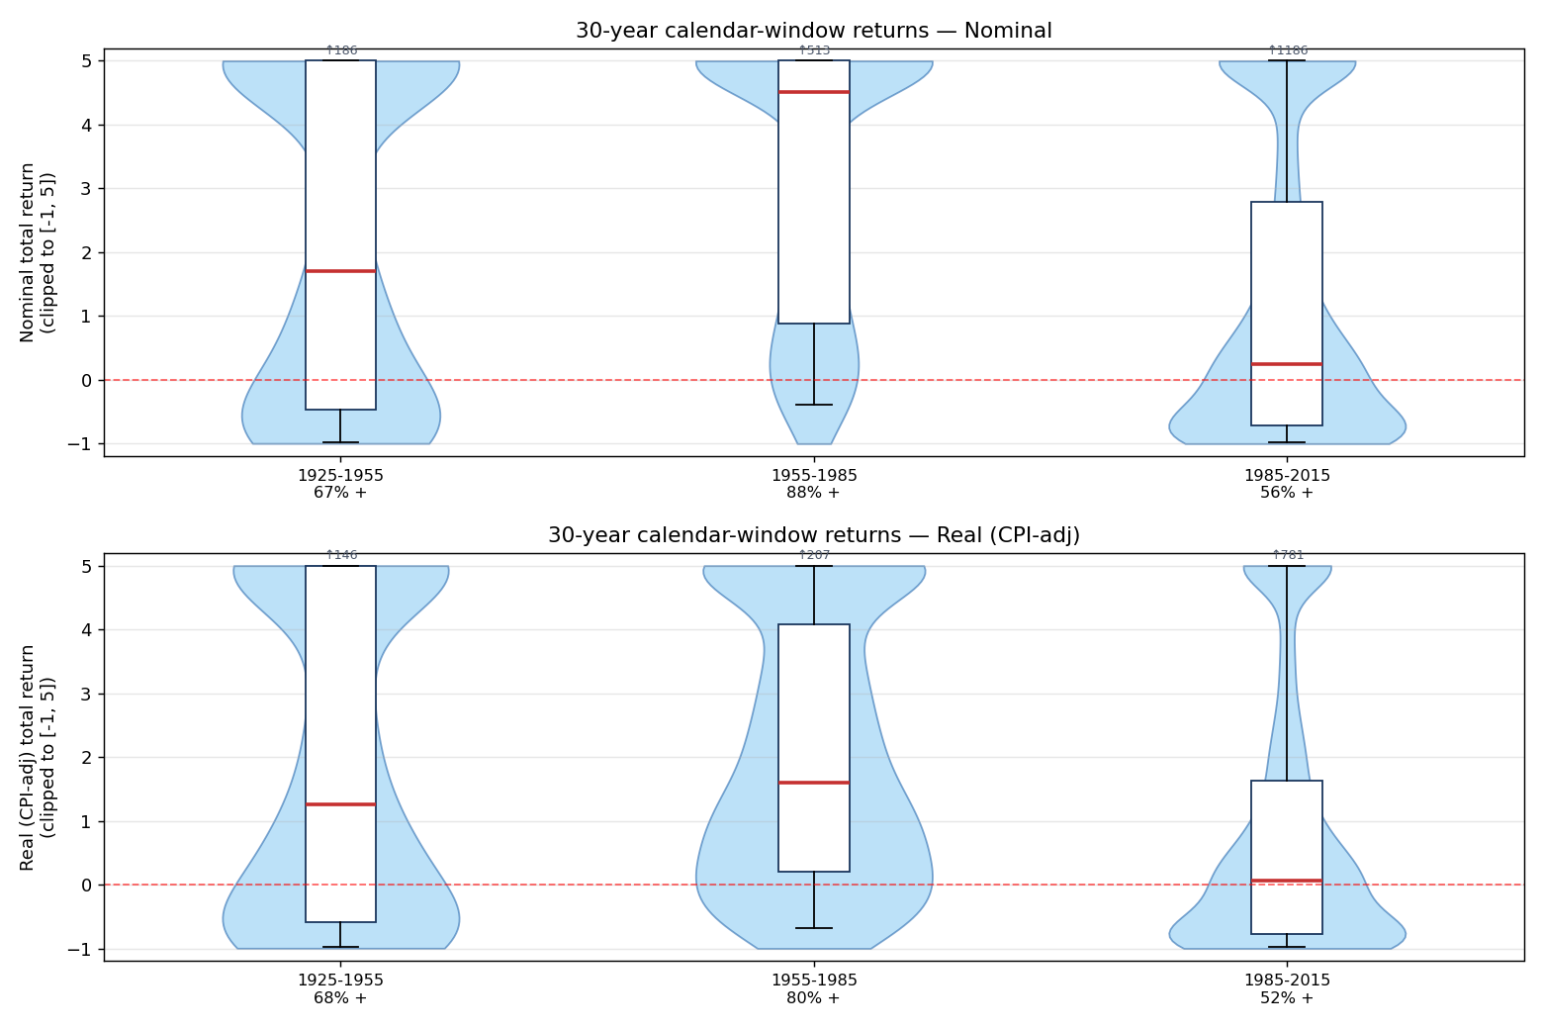
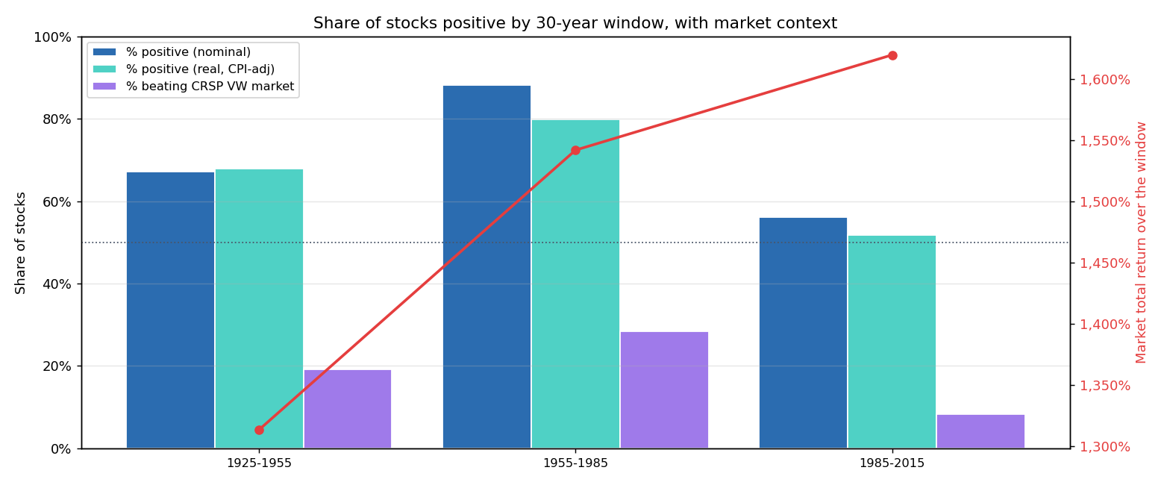

Interpretation
- 1955-1985 is the strongest 30-year window: post-war prosperity swallowed the 1965-1975 stagflation shock and still left ~88 % of the 1955 cohort positive.
- 1985-2015 has the lowest share of stocks positive (56 %) despite the highest market total return (+1,620 %). Only 1 in 12 stocks beat the market.
- 1925-1955 has a large partial-return tail (small cohort of 508 stocks, many wiped out in the Depression).

5. Q3 — Full-life per stock
One observation per PERMNO, compounding MthRet from the stock's first to last listed month. This is the only horizon that remains stock-anchored.
Basis | N | % positive | Median | Mean | Max
Nominal | 31,565 | 48.1 % | -7.4 % | 295× | 4,421,137×
Real (CPI-adj) | 31,565 | 41.3 % | -29.3 % | 20× | 245,578×

Percentiles:
Basis | p5 | p25 | Median | p75 | p95
Nominal | -99.2 % | -86.4 % | -7.4 % | +179.8 % | +3909.2 %
Real | -99.4 % | -89.9 % | -29.3 % | +95.1 % | +1324.3 %

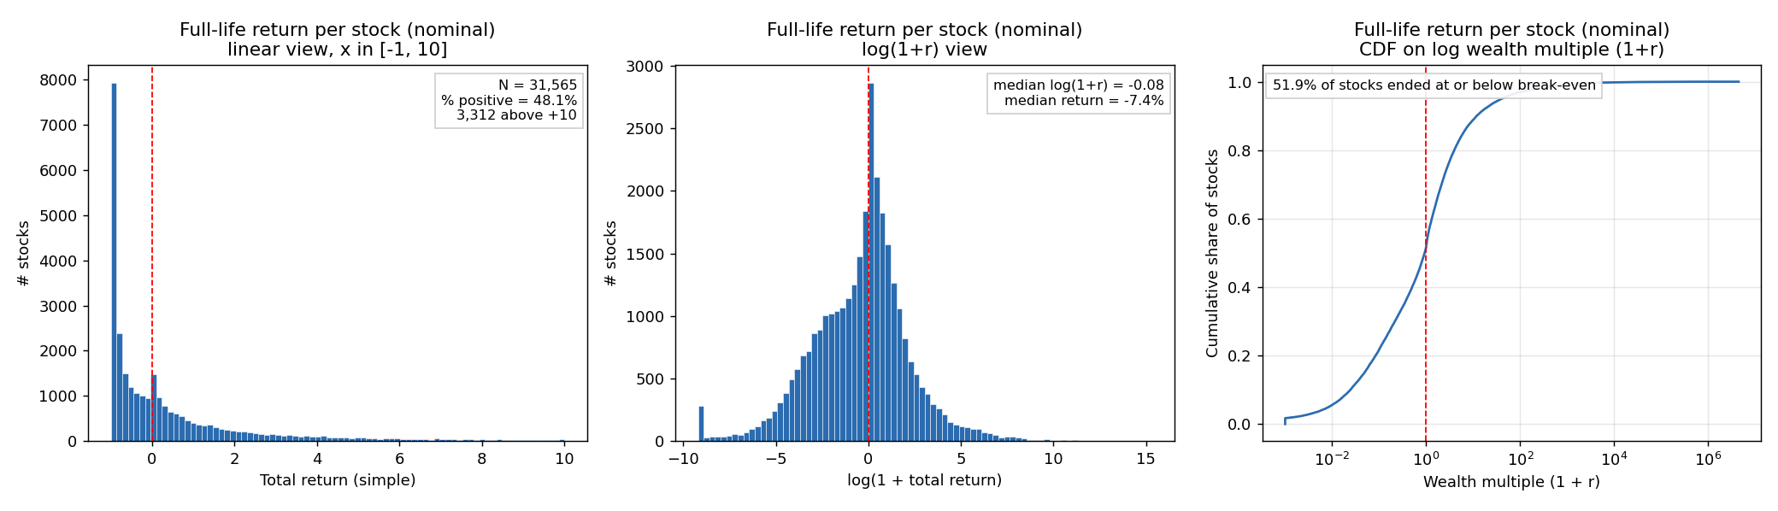
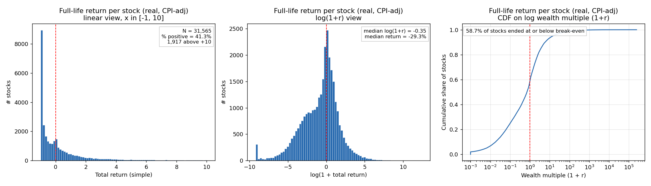
Across the entire lifespan of every US-listed common stock, the median experience is a nominal loss of ~7 % and a real loss of ~29 %. The mean is inflated by a small number of 100-year compounders — one stock returned 44,211× nominal — but half the universe never crosses break-even.

6. Do stocks beat the market?
Compounded over exactly the same months as the stock / window.
Horizon & window | N | % beat CRSP VW market | % beat S&P 500 (price)
10y 1925-1935 | 508 | 28.1 % | 38.2 %
10y 1935-1945 | 717 | 50.5 % | 83.0 %
10y 1945-1955 | 852 | 29.2 % | 50.6 %
10y 1955-1965 | 1,050 | 41.0 % | 62.8 %
10y 1965-1975 | 2,168 | 42.7 % | 61.3 %
10y 1975-1985 | 5,073 | 47.4 % | 68.0 %
10y 1985-1995 | 6,298 | 15.4 % | 21.9 %
10y 1995-2005 | 7,835 | 27.6 % | 34.4 %
10y 2005-2015 | 5,830 | 25.0 % | 31.6 %
10y 2015-2025 | 4,836 | 16.2 % | 17.4 %
30y 1925-1955 | 508 | 19.1 % | 45.9 %
30y 1955-1985 | 1,050 | 28.4 % | 53.6 %
30y 1985-2015 | 6,298 | 8.4 % | 13.3 %
Full-life | 31,565 | 27.6 % | 33.4 %

Full-span benchmarks (1925-12 to 2025-12):
Index | Cumulative total return | CAGR
CRSP value-weighted US equity (incl. dividends) | 1,405,980 % (14,061×) | 10.01 %
S&P 500 price index (ex-dividends) | 54,840 % (549×) | 6.51 %
CPI-U (inflation) | 1,710 % (18.1×) | 2.94 %

The sharp declines in '% beating the market' in 1985-1995, 2015-2025, and over the full 1985-2015 30-year window reflect the rise of extreme mega-cap dominance in the index return. The index compounds at a double-digit rate, but the share of individual stocks that keep up with it has been falling.

7. Caveats
- 1. Delisting returns are not always explicitly provided. Only 3,100 of 31,565 stocks have an explicit CRSP delisting return (MthRetFlg == 'DE'); the remainder simply stop appearing at delisting. Methodology terminates the return at the last observed month. Applying the Shumway (1997) −30 % correction to performance-related delistings without explicit returns moves headline percentages by less than 1 point.
- 2. Not-traded months (1.6 % of rows, flag 'NT') have MthRet set to 0 to preserve the calendar timeline.
- 3. Cohort size grows over time. The 1925-1935 cohort has only 508 stocks (CRSP started with NYSE-only coverage); by 1995-2005 the cohort is 7,835 stocks (NYSE + AMEX + NASDAQ). Later-decade statistics are tighter.
- 4. Windows extending beyond 2025-12 are not analyzed. The 30-year track stops at the 1985-2015 window; a 2015-2025 entry in the 30-year table would be a partial 10-year window and is excluded.

8. Files produced
results/
report.md, report.docx
summary_10y.csv, summary_30y.csv, summary_fulllife.csv
returns_10y.csv, returns_30y.csv — long-format per-stock returns per window
permno_fulllife.csv — per-stock full-life return
market_benchmark.csv, market_summary.csv
variation_10y.png, variation_30y.png — box+violin across windows
pct_positive_10y.png, pct_positive_30y.png — bar chart + market line
hist_10y_{window}_{basis}.png — per-window histograms (20 files)
hist_30y_{window}_{basis}.png — per-window histograms (6 files)
hist_fulllife_{basis}.png — Q3 histograms

9. Reproducibility
python program/run_analysis.py # ~50 s
python program/build_docx.py # ~3 s
Python 3.11, pandas 2.3, numpy 2.2, matplotlib 3.10, python-docx 1.2.

10. References
- Bessembinder, H. (2018). "Do stocks outperform Treasury bills?" Journal of Financial Economics, 129(3), 440-457.
- Shumway, T. (1997). "The delisting bias in CRSP data." Journal of Finance, 52(1), 327-340.
- CRSP. Monthly Stock File, schema documentation in data/Monthly Stock File.pdf.
- U.S. Bureau of Labor Statistics. Consumer Price Index for All Urban Consumers, CPI-U, not seasonally adjusted, monthly 1925-2025.

